A Look at the Green Revolution
The green revolution was an attempt by agricultural scientists to find ways to feed the world's burgeoning population. The effort began in 1943, when the Rockefeller Foundation funded a group of U.S. agricultural scientists to set up a research project in Mexico aimed at increasing that country's wheat production. Only seven years later scientists distributed the first green revolution wheat seeds. The project was eventually expanded to include research on maize as well. By 1967 green revolution scientists were exporting their work to other parts of the world and had added rice to their research agenda (Figure 8.D). Norman Borlaug, one of the founders of the green revolution, went on to win the Nobel Peace Prize in 1970 for an important component of the project: promoting world peace through the elimination of hunger.
The initial focus of the green revolution was on the development of seed varieties that would produce higher yields than those traditionally used in the target areas. However, in developing new, higher yielding varieties, agricultural scientists soon discovered that plants were limited in the amount of nitrogen they could absorb and use. The scientists' solution was to increase the nitrogen absorption capacity of plants by delivering nitrogen-based fertilizers in water (this led to the need to build major water and irrigation development projects). Then the scientists discovered that the increased nitrogen and water caused the plants to develop tall stalks.
The tall stalks, with heavy heads of seed on top, fell over easily, thus reducing the amount of seed that could be harvested. The scientists went back to the drawing board and came up with dwarf varieties of grains that would support the heavy heads of seeds without falling over. Then another problem arose; the short plants were growing in very moist conditions, which encouraged the growth of diseases and pests. The scientists responded by developing a range of pesticides.
Thus, the green revolution came to constitute a package of inputs: new "miracle seeds," water, fertilizers, and pesticides. Farmers had to use all of the inputs—and use them properly—to achieve the yields the scientists produced in their experimental plots (Figure 8.E). Green revolution crops, if properly watered, fertilized, and treated for pests, can generate yields two to five times larger than those of traditional crops. In some countries, yields are high enough to engage in export trade, thus generating important sources of foreign exchange. Furthermore, the creation of varieties that produce faster maturing crops has allowed some farmers to plant two or more crops per year on the same land, thus increasing their individual production—and wealth—considerably.
Thanks to green revolution innovations, rice production in Asia grew 66 percent between 1965 and 1985. India, for example, became largely self-sufficient in rice and wheat by the 1980s. Worldwide, green revolution seeds and agricultural techniques accounted for almost 90 percent of the increase in world grain output in the 1960s and about 70 percent in the 1970s. In the late 1980s and 1990s at least 80 percent of the additional production of grains could be attributed to the use of green revolution techniques. Figure 8.F shows the distribution of maize production worldwide. Thus, although hunger and famine persist, many argue that they would be much worse if the green revolution had never occurred.
The green revolution, however, has not been an unqualified success everywhere in the world. One important reason is that wheat, rice, and maize are unsuitable as crops in many areas, and research on more suitable crops, such as sorghum and millet, has lagged far behind. In Africa poor soils and lack of water make progress even more difficult to achieve. Another important factor is the vulnerability of the new seed strains to pest and disease infestation, often after only a couple of years of planting. Whereas traditional varieties often have a built-in resistance to the pests and diseases characteristic of an area, the genetically engineered varieties often lack such resistance.
Another problem is that green revolution technology has decreased the need for human labor. In southeastern Brazil machines replaced workers, creating significant unemployment. Green revolution technology and training have also tended to exclude women, who play important roles in food production. In addition, the new agricultural chemicals, especially pesticides, have contributed to ecosystem pollution and worker poisonings, and the more intensive use of irrigation has created salt buildup in soils (salinization) and water scarcity.
Yet another criticism is that the green revolution has magnified social inequities by allowing more wealth and power to accrue to a small number of agriculturalists while causing greater poverty and landlessness among poorer segments of the population. In Mexico a black market developed in green revolution seeds, fertilizers, and pesticides when poorer farmers, who were coerced into using them, accrued high debts that they could not begin to repay. Many ended up losing their lands and becoming migrant laborers or moved to the cities and joined the urban poor. Some critics who have monitored the effects of the green revolution suggest that political and economic conditions may, in fact, be more important than levels of production with regard to a country's food security.
Even regarding quality, the green revolution crops often fall short. The new seed varieties may produce grains that are less nutritious, less palatable, or less flavorful. The chemical fertilizers and pesticides that must be used are derived from fossil fuels—mainly oil—and are thus subject to the vagaries of world oil prices. Furthermore, the use of these chemicals, as well as monocropping practices, has produced worrisome levels of environmental contamination and soil erosion. In many countries these practices have posed substantial threats to public health, especially among farm workers who are frequently exposed to poisonous (if not lethal) chemicals. Water developments have benefited some regions, bur less well-endowed areas have experienced a deterioration of already existing regional inequities. Worse, pressures to build water projects and co acquire foreign exchange to pay for importation of green revolution inputs have increased pressure on countries to grow even more crops for export, often at the expense of production for local consumption.

In recent years scientists have endeavored to develop seeds with greater pest and disease resistance and more drought tolerance. The new focus is best revealed in Africa. The International Institute of Tropical Agriculture in Ibadan, Nigeria, focuses on foods for the humid and subhumid tropics of Africa, including cassava (imported to Africa from South America by the Portuguese in the sixteenth century), yams, sweet potatoes, maize, soybeans, and cowpeas. The International Crops Research Institute for the Semi-Arid Tropics (located in Hyderabad, India, but with a major research center near Niamey, Niger) focuses on researching staples of the Sahel region, such as sorghum, millet, pigeonpea, and groundnut. Research in Africa on new varieties emphasizes testing under very adverse conditions (such as no plowing or fertilizing). New varieties are chosen not just for good yield but because they will provide stable yields over good and bad years. A focus also exists on developing plants that will increase production of fodder and fuel residues, as well as of food, and that give optimal yields when intertilled—a very common practice in Africa. In the Sahel, scientists are working on crops that mature more quickly to compensate for the serous drop in the average length of the rainy season recently experienced in the region.
There are two final criticisms that have raised concern about the overall benefits of the green revolution. The first is that it has decreased the production of bio-mass fuels—wood, crop residues, and dung—traditionally used in many peripheral areas of the world. For example, in India, as tractors have replaced draft an-mats, less dung is produced and thus less is available as fuel. Instead, a greater reliance is being placed upon oil to fuel both tractors and other energy needs; this means that if farmers are to be successful, they increasingly must depend upon the most costly of energy resources. The second is that the green revolution has contributed to a worldwide loss of genetic diversity by replacing a wide range of local crops and varieties with a narrow range of high-yielding varieties of a few crops. Planting single varieties over large areas (monocultures) has made agriculture more vulnerable to disease and pests.
Although the green revolution has come under much justified attack over the years, it has focused attention on finding innovative new ways to feed the world's peoples. In the process the world system has been expanded into hitherto very remote regions, and
important knowledge has been gained about how to conduct science and how to understand the role that agriculture plays at all geographical scales of resolution, from the global to the local (Figure 8.G).

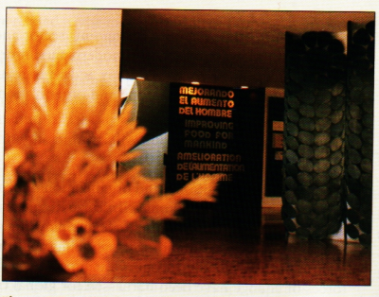

Figure 8.D The CIYMMT headquarters The Centre International de Mejorimiento de Maiz yTrigo (CIMMYT) (International Center for the Improvement of Maize and Wheat) in Texcocu, Mexico, is involved in plant breeding and research. High-yield-variety seeds were developed here for the Green Revolution. The center holds the world's premiere collection of corn and wheat germplasm. Modern, refrigerated storage vaults store many thousands or" varieties. Today, in addition to the static, cold storage, scientists are working with farmers to preserve seeds dynamically.

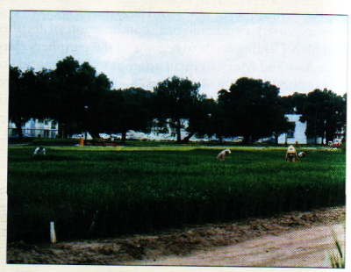

Figure 8.E Green revolution experimental plots The CIMMYT includes numerous plots for breeding and testing seed varieties.
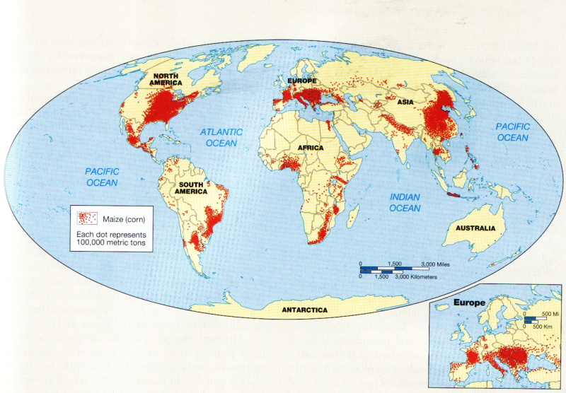
Figure 8.F Global distribution of maize production The widespread production of grains throughout the globe, particularly maize, has been one of the successes of the green revolution (After J. P. Goode,). C. Hudson, and E. P, Espanshade, Jr., Rand McM'ally'5 Coode's World Atlas, 20th ed., Rand McNally, 2000, p. 41.)

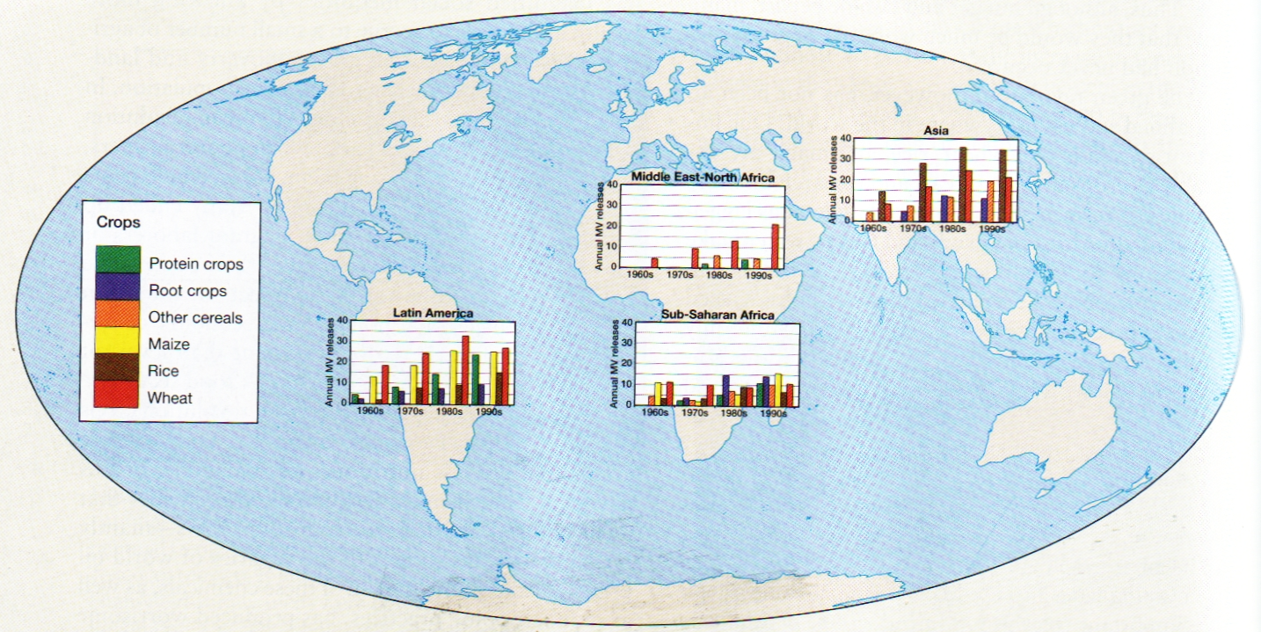
Figure 8.G Effects of the green revolution
This map illustrates the increased yields of protein crops, root crops, other cereals maize, rice and wheat brought about by the green revolution in selected countries in Latin America, Asia, Sub-Saharan Africa and the Middle East and North Africa. (Data from; R. E. Evenson and D. Gollin, "Assessing the Impact of the Green Revolution, 1960-2000," Science 300 (2 May 2005), p. 7 59.)

