Phase diagram reading

Example 2
Consider this phase diagram:
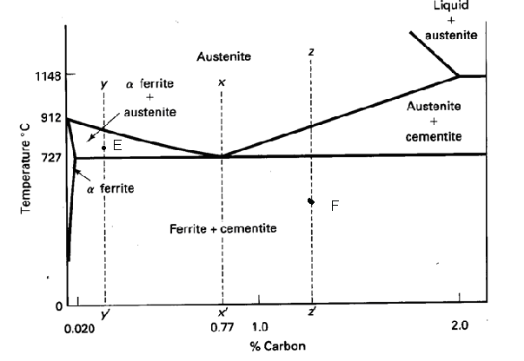

Questions:
- Write the species: ………………………………………….
- This phase diagram cross-section describes the (choice: unary binary ternary quaternary) …………….. system.
- Describe axis:
Axis x is …………………………………value given in …………..
Axis y is ………………………………… value given in …………..
The constant system variable(s) is (are)………………………………………..
- How many phases can coexist in phase equilibrium in this system at maxima? …………………………….
- How many phases we can see on this phase diagram cross-section at maxima? ……….
- Write all regions (that we can find on this phase diagram cross-section)
Single-phase regions: ……………………………………………………….
Two-phase regions: ………………………………………………………….
Three-phase regions: ………………………………………………………..
Another regions: …………………………………………………………….
- What phases we can find in equilibrium state at conditions given by point
T=500°C, 1wt%Carbon
T=800°C, 1.5wt%Carbon
T=912°C, 2wt%Carbon

- Estimate the carbon solubility in ferrite at eutectoid temperature.
…………………………….

- Estimate the temperature, pressure, total composition of the system, and the compositions of the phases given by points E
E…………………………………………………………….….
Calculate phase ratio of the equilibrated phases in the system given by point E.

- Write some tie-line into phase diagram cross-section, each in different phase field.

- Describe what happens with the system given by point F when you will heat up the system to 1200°C (suppose equilibrium at each temperature step).

- Look the phase diagram cross-section and mark the eutectoid point.

