5. PROPERTIES OF MATERIALS

1. Speaking. Think about the things listed below. Can you describe them to the person sitting next to you? Think about the material they are/were made of, the size, shape, colour, country of origin etc. You partners may ask questions. Then swap roles.
-your memorable birthday present / your last Christmas present
-your favourite piece of clothing or jewelery (dress, t-shirt, jumper, shoes, ring, necklace etc.)
-your favourite toy when you were small
- you favourite electronic device
- something you could never be without
- something that you would like to have / to give someone close to you

2. DESCRIBING IN CHEMISTRY. Introduction.
What materials do you know?
In about one minute, write down names of as many materials as you can think of.

3. Discuss these questions:

a) What materials can you see in this classroom? What objects are made of them?
b) Give examples of 3 objects made of plastic, glass, wood. Can you compare these materials?
c) What material is your watch / wallet / pen / book / shoes / computer / phone / bottle made of?
d) Do you know these modern materials: gore-tex, teflon, latex? Where are they used? Can you give exmaples of some other modern materials? Why are they now used?
e) What is your favourite material for clothing? Do you prefer natural or synthetic materials? Why?
f) What material are you wearing right now? Look at the label. What is the chemical composition of this material?
g) Give examples of things which were originally made of natural materials and now are made of plastics. Why are plastics now used? Are there any disadvantages?
h) What are some traditional and modern building materials? Give examples.

Useful phrases – giving examples:

There are many traditional building materials, e.g.
for example stone.
for instance
such as
like
e.g. we read as “for example, for instance, such as, like”
i.e. we read as “this means / which means”
Stone is an example of a traditional building material.
a case
an instance
an illustration
Stone exemplifies a traditional building material.
illustrates
There are many traditional building materials. A good illustration of this is stone. To be specific / to illustrate, we can mention stone.
4. Read the following adjectives describing properties and give more examples of materials or things with this property. Use the phrases typical for giving examples. Then form nouns from the adjectives:¹
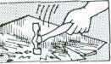 | A brittle material or thing breaks easily;  eg. glass, egg,. .  noun: | 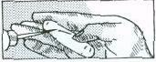 | A soft material is easy to stratch  e.g. chalk  noun:
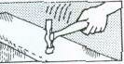 | A tough material / thing does not break easily;  eg steel,. . .  noun: | 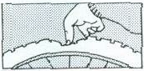 | A flexible material bends easily: eg. rubber, ..  noun:
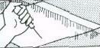 | A hard material is difficult to scratch. eg glass, .. .  noun: | 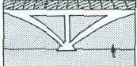 | A rigid material does not bend easily; eg concrete,...  noun:

5. Now ask and answer these questions in pairs:
a) Example: Why does a glass break if you drop it? Because it is brittle.
b) Why doesn't a plastic glass break?
c) Why is butter easy to cut?
d) Why can a diamond cut glass?
e) Why do the branches of a tree bend in the wind?
f) Why don't the walls of a house bend in the wind?
g) Which is more flexible: a wooden ruler or a plastic ruler?
h) What are the different properties of green wood (on a tree) and dry wood?

6. Now complete these:
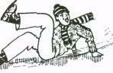 | Some materials have a smooth surface;  they produce little friction when they are rubbed; eg ice,...  noun: | 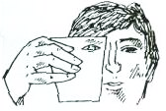 | You can see through transparent materials; eg water,. …  noun:
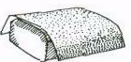 | Some materials have a rough surface and produce a lot of friction;  eg sandpaper, . ..  noun: | 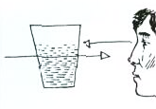 | You cannot see through translucent materials but the light passes through them;  eg dirty water, . . .  noun:
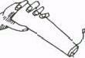 | Soluble materials dissolve easily; eg salt,…  noun: | 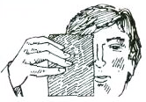 | You cannot see through opaque materials and the light cannot pass through them; eg metal,. . .  noun:
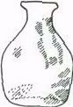 | Materials which are insoluble do not dissolve; eg glass,...  noun: | 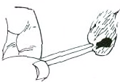 | Combustible materials burn easily eg wood,...  noun:

7. Listening:²
Listen to some properties of materials. Make notes in the form of a table.

material | property | verbal structure
Example: salt | soluble | dissolves easily

8. Read this and underline the right properties:
A material which is used for making clothes must be solid/fluid, brittle/tough, soft/hard, rigid/flexible, smooth/rough, opaque/transparent and soluble/insoluble.

Now complete these sentences. Then ask and answer questions about them.
- One material with these properties is wool. Others are …………… and ………………… .
- Steel is not generally used for clothes because it is ………………… .
- Glass is unsuitable because it is ……………….., ……………… and ……………….. .
- For the body of a car we need a material which is……………….., ……………………. and …………………, eg …………………………. .
- For a window …………………………………………………………., eg
- For a cooking pot ………………………………………………………, eg. …………….

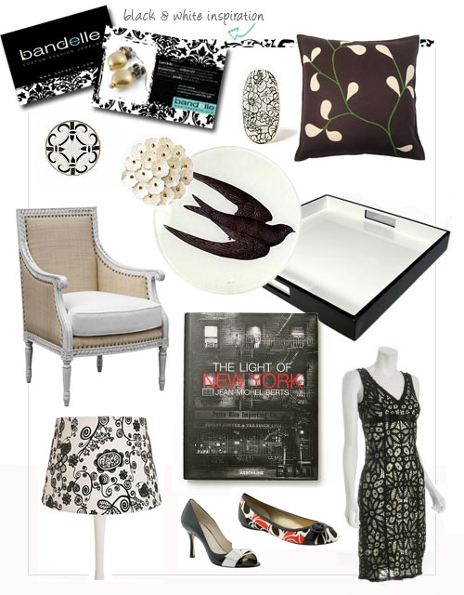

9. Some other properties of materials. Form adjectives from these nouns.³

Czech translation | Noun | Adjective
- pružnost | elasticity | elastic
- křehkost | fragility
- kujnost | malleability
- tažnost | ductility
- vodivost | conductivity
- žáruvzdornost | heat-resistance
- zápalnost | flammability
- jedovatost, toxicita | toxicity
- reaktivita | reactivity
- netečnost | inertness
- lehkost | lightness
- těžkost | heaviness
- savost, absorpčnost | absorbency
- viskozita, lepkavost | viscosity
- hustota | density
- trvanlivost, odolnost | durability
- odolnost proti korozi | corrosion resistance
- síla | strength

10. Choose the right word in a sentence:

a) A conductive / conductivity material can be used to conduct electricity.
b) If a material is easy to stretch under stress, we call it elastic / elasticity.
c) If you want to improve durable / durability of a machine, clean it regularly.
d) Hard / hardness is an important property of steel.
e) Concrete is used for building because it is strong / strength.

11. Speaking: One student describes something, using as many adjectives as he or she can. You can describe the colour, size, shape, origin, appearance, use etc. The second one asks questions. See if your partner can guess what it is.
- Describe two materials.
- Now choose two objects from this room.
- Finally, describe something such as an animal, plant, machine, substance, famous structure or invention.

Useful phrases:
The object | is | slightly  relatively  quite  extremely  very | small  soluble in water  hot  silvery  old

The | colour  shape  durability | of | the object | is | blue  circular  high

12. HOMEWORK⁴

Science and Technology: Fill in the gap with the correct word.

  - …………….. are being carried out to find a cure for cancer.
Experiences Experiments Trials Research

  - Microscopes ………………..very small objects many times to make them visible.
magnify enlarge expand increase

  - Radio signals are now often ……………..by satellite.
received delivered transmitted dispersed

  - Computers are able to ………………… vast amounts of data very quickly.
process digest convert adapt

  - Solar power stations are able to ……………….. the energy of the sun.
convert maximise drive harness

  - Other …………… energy sources include wind and wave power.
renewable recyclable returnable reusable

  - In some types of power station steam is used to ………………turbines.
force turn drive rotate

  - Mercury is a …………….at room temperature
fluid liquid solid gas

  - Hydrogen and oxygen are the two ……………….. that make up water.
compounds atoms molecules elements

  - All …………..is composed of atoms.
stuff material substance matter

  - The ……………… of lead is greater than that of aluminium.
rigidity weight density volume

  - When water is heated it …………………..more quickly.
evaporates condenses melts solidifies

  - The ………………….. of iron and oxygen produces rust.
reaction separation decomposition composition

  - Chemists study the composition of natural ………………..
substances machines mixtures alloys

  - The ………………………….. of water is 100°C.
melting point boiling point point of condensation freezing point

Adapted from: ¹ Bates, Martin and Dudley-Evans, Tony: Nucleus of General Science. Longman 1990.
² From Nucleus of General Science. Unit 1, Listening Practice 2.
³Jirků, Dana et al. English for Future Engineers. Praha: ČVUT, 2007.
⁴ J.Harbord: Topic-based Vocabulary.

Week 5 – Properties of Materials - Vocabulary
brittle (adj) / brittleness (n) | křehký / křehkost
tough (adj) / toughness (n) | pevný / pevnost
hard (adj) / hardness (n) | tvrdý / tvrdost
soft (adj) / softness (n) | měkký / měkost
flexible (adj) / flexibility (n) | ohebný / ohebnost
rigid (adj) / rigidity (n) | tuhý / tuhost
smooth (adj) / smoothness (n) | hladký / hladkost
rough (adj) / roughness (n) | drsný / drsnost
soluble (adj) / solubility (n) | rozpustný / rozpustnost
insoluble (adj) | nerozpustný
transparent (adj) / transparency (n) | průhledný / průhlednost
translucent (adj) / translucency (n) | průsvitný / průsvitnost
opaque (adj) / opacity (n) | neprůhledný / neprůhlednost
combustible (adj) / combustibility (n) | hořlavý / hořlavost
non-combustible (adj) | nehořlavý
This material bends easily. | Tento materiál se lehce ohýbá.
This material is easy to scratch. | Tento materiál se lehce poškrábe.
dissolve in water (v+n) | rozpustit se ve vodě
steel (n) | ocel
concrete (n) | beton
elastic (adj) / elasticity (n) | pružný / pružnost
fragile (adj) / fragility (n) | křehký / křehkost
malleable (adj) / malleability (n) | kujný / kujnost
ductile(adj) / ductility (n) | tažný / tažnost
conductive (adj) / conductor (n)/ conductivity (n) | vodivý / vodič / vodivost
heat-resistant (adj) / heat-resistance (n) | žáruvzdorný / žáruvzdornost
absorbent (adj) / absorbency (n) | savý / savost
flammable (adj) /flammability(n) | zápalný / zápalnost
toxic (adj) / toxicity (n) | toxický, jedovatý / jedovatost
durable (adj) / durability (n) | odolný / odolnost
dense (adj) / density (n) | hustý, olejnatý / husota
viscous (adj) / viscosity (n) | viskózní / viskozita
reactive (adj) / reactivity (n) | reaktivní / reaktivita
inert (adj) / inertness (n) | netečný
heavy (adj) / heaviness (n) | těžký / těžkost
light (adj) / lightness (n) | lehký / lehkost
strong (adj) / strength (n) | silný / síla
It is made of …. | Je to vyrobeno z …
advantage / disadvantage (n) | výhoda / nevýhoda
e.g., for example, for instance | například
i.e., which means | což znamená
To illustrate … To be specific, | Abychom ilustrovali …
such as, like | jako například
Stone is a case / an example / an instance / an illustration of a traditional building material. | Kámen je příklad tradičního stavebního materiálu.
Stone exemplifies / illustrates a traditional building material. | Kámen představuje tradiční stavební materiál.

