LESSON 3: PROPERTIES OF MATERIALS (by courtesy of A.Rozkošná)
1. Think about items listed below. Can you describe them to the person sitting next to you? Think about the material they are/were made of, the size, colour, etc.
-your memorable birthday present
-your last Christmas present
-your favourite piece of clothing (dress, t-shirt, jumper, shoes, etc.)
-your favourite toy when you were small
-a piece of jewellery that you would like to have/ to give someone close to you

2. DESCRIBING IN CHEMISTRY. Introduction.
What materials do you know?
In about one minute, write down names of as many materials as you can think of.

3. Discuss these questions:
a) What is your favourite material for clothing? Do you prefer natural or synthetic materials?
b) What are advantages of natural fabrics over synthetic ones?
c) What are advantages of synthetic fabrics over natural ones?
d) Give examples of things which were originally made of natural materials and now are made of plastics. Why are plastics now used? Are there any disadvantages?
e) What are some traditional and modern building materials? Give examples.
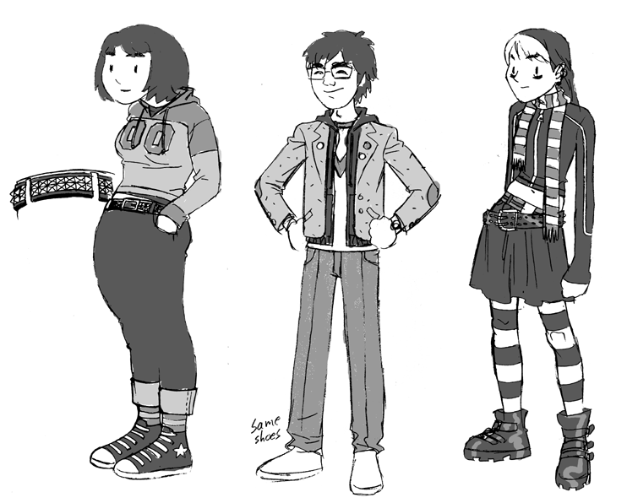

4. Read the following adjectives describing properties and give more examples of materials or things with this property. Form nouns from the adjectives:¹
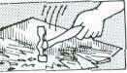 | A brittle material or thing breaks easily;  eg. (for example, for instance, such as, like) glass, egg,. .  noun: |  | 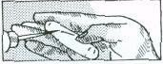 |  | A soft material is easy to scratch  e.g. chalk  noun:
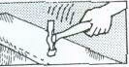 | A tough material / thing does not break easily;  eg steel,. . .  noun: |  | 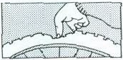 |  | A flexible material bends easily: eg. rubber, ..  noun:
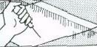 | A hard material is difficult to scratch. eg glass, .. .  noun: |  | 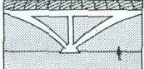 |  | A rigid material does not bend easily; eg concrete,...  noun:
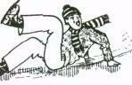 |  | Some materials have a smooth surface;  they produce little friction when they are rubbed; eg ice,...  noun: |  | 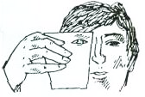 |  | You can see through transparent materials; eg water,. …  noun:
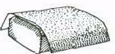 |  | Some materials have a rough surface and produce a lot of friction;  eg sandpaper, . ..  noun: |  | 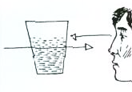 |  | You cannot see through translucent materials but the light passes through them;  eg dirty water, . . .  noun:
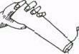 |  | Soluble materials dissolve easily; eg salt,…  noun: |  | 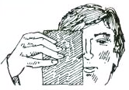 |  | You cannot see through opaque materials and the light cannot pass through them; eg metal,. . .  noun:
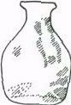 |  | Materials which are insoluble do not dissolve; eg glass,...  noun: |  | 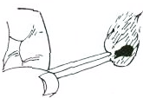 |  | Combustible materials burn easily eg wood,...  noun:

5. Now ask and answer these questions in pairs:
a) Example: Why does a glass break if you drop it? Because it is brittle.
b) Why doesn't a plastic glass break?
c) Why is butter easy to cut?
d) Why can a diamond cut glass?
e) Why do the branches of a tree bend in the wind?
f) Why don't the walls of a house bend in the wind?
g) Which is more flexible: a wooden ruler or a plastic ruler?
h) What are the different properties of green wood (on a tree) and dry wood?

6. Complete the sentences below with appropriate words from exercise 4
a. The carbonates and phosphates of all metals are _______________ in water but _______________ in dilute acids.
b. The pale pink colour of quartz, which can range from ______________ to translucent, is known as rose quartz.
c. Some colloids are ______________ because of the Tyndal effect, which is the scattering of light by particles in the colloids.
d. System Soft Shot is a booster for dry and ____________ hair.
e. _______________ materials are liable to catch fire very easily and burn.
f. _______________ is an important property of steel.
g. This PVC tubing offers excellent wear resistance and rubber-like _________________.
h. A _____________ substance or object is stiff & does not bend, stretch or twist easily.

7. Listening:
Listen to some properties of materials. Make notes in the form of a table.
From Nucleus of General Science. Unit 1, Listening Practice 2.
material property verbal structure Example: salt soluble dissolves easily



8. Some other properties of materials. Form adjectives from these nouns.

Czech translation | Noun | Adjective
- pružnost | elasticity | elastic
- křehkost | fragility
- tažnost | malleability
- kujnost | ductility
- vodivost | conductivity
- žáruvzdornost | heat-resistance
- zápalnost | flammability
- jedovatost, toxicita | toxicity
- reaktivita | reactivity
- netečnost | inertness
- lehkost | lightness
- těžkost | heaviness
- savost, absorpčnost | absorbency
- viskozita, lepkavost | viscosity
- hustota | density
- trvanlivost, odolnost | durability
- odolnost proti korozi | corrosion resistance
- síla | strength

9. Choose the right word in a sentence:
a) A conductive / conductivity material can be used to conduct electricity.
b) If a material is easy to stretch under stress, we call it elastic / elasticity.
c) If you want to improve durable / durability of a machine, clean it regularly.
d) Hard / hardness is an important property of steel.
e) Concrete is used for building because it is strong / strength.

Now choose 1 noun and 1 adjective from the table in Exercise 10 and use it in a sentence. Then read the sentences to your neighbours.

10. Speaking:

Work in pairs. One student describes something, using as many adjectives as he or she can. The second one should guess what it is (ask yes/no questions if you cannot find the answer). You can describe the colour, size, shape, origin, appearance, use etc. Then swap roles.
Useful phrases:
The object | is | slightly  relatively  quite  extremely  very | small  soluble in water  hot  silvery  old

The | colour  shape  durability | of | the object | is | blue  circular  high

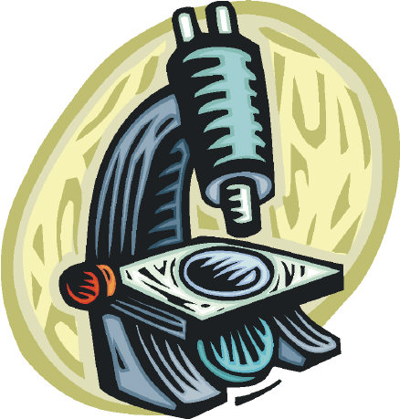

12. HOMEWORK³

Science and Technology: Fill in the gap with the correct word.

  - …………….. are being carried out to find a cure for cancer.
Experiences Experiments Trials Research

  - Microscopes ………………..very small objects many times to make them visible.
magnify enlarge expand increase

  - Radio signals are now often ……………..by satellite.
received delivered transmiting dispersed

  - Computers are able to ………………… vast amounts of data very quickly.
digest convert adapt process

  - Solar power stations are able to ……………….. the energy of the sun.
maximise drive convert harness

  - Other …………… energy sources include wind and wave power.
recyclable returnable reusable renewable

  - In some types of power station steam is used to ………………turbines.
force turn drive rotate

  - Mercury is …………….at room temperature
fluid liquid solid gas

  - Hydrogen and oxygen are the two ……………….. that make up water.
compounds atoms molecules elements

  - All …………..is composed of atoms.
stuff material substance matter

  - The ……………… of lead is greater than that of aluminium.
viscosity absorbency density volume

  - When water is heated it …………………..more quickly.
evaporates condenses melts solidifies

  - The ………………….. of iron and oxygen produces rust.
reaction separation decomposition composition

  - Chemists study the composition of natural ………………..
substances machines mixtures alloys

  - The ………………………….. of water is 100°C.
melting point boiling point point of condensation freezing point

Adapted from: ¹Jirků, Dana et al. English for Future Engineers. Praha: ČVUT, 2007.
² Bates, Martin and Dudley-Evans, Tony: Nucleus of General Science. Longman 1990.
³ J.Harbord: Topic-based Vocabulary.

GRAMMAR REVISION: tenses

I. Put verbs in brackets in the correct form and tense

Glass 1.(have)_________ many useful properties, but it 2.(be)_________ not a tough material, in fact it 3.(be)__________ very brittle. However, for many years already car producers 4.(use)__________ specially tough glass, with which they 5.(make)_________ car windows. Wood is a good building material but it is combustible. In the past people 6.(build)__________ mainly wooden houses and now we can observe that this kind of lodging 7.(become)__________ more and more popular. People like the cosy atmosphere and the nice smell that such material 8.(produce)___________. Who 9.(know)_____________, maybe in the future, with yet another kind of modern technology we 10.(be able)____________ to live in fir but non-combustible cottages?

