LESSON 5: COMPARING THE ELEMENTS

1. There are 10 differences between these two pictures. Find them and describe them in pairs. (E.g. The house in the first picture has more windows than the house in the second picture).
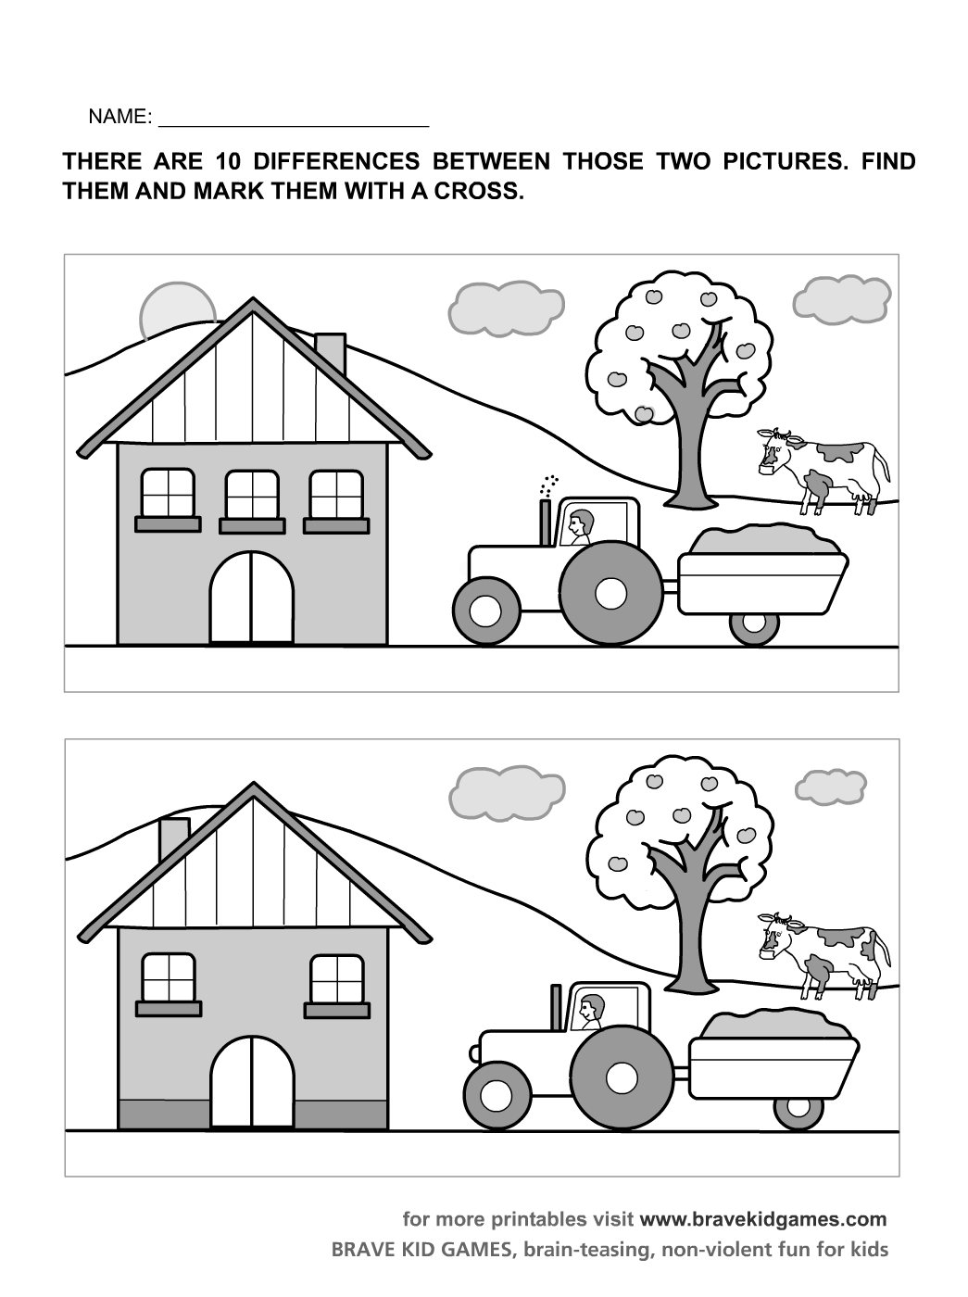
2. Discuss the following questions:
- How often do we use comparing and contrasting in everyday life?
- Try to remember what you have compared today or yesterday.
- Try to compare: studying arts and science, the foods in two countries that you know, boys and girls hobbies or interests, men’s and women’s remuneration, an American car with one from another country …
- What can you compare in chemistry? Think about chemistry books, various diagrams, graphs, chemical tables, statistics.

3. Listening - Dictation: Abundance of the most common elements by mass.¹
Listen to the recording and note down the elements and the figures (percentages).
Reading numbers: 0.05 %: nought point nought five percent, 50-60 %: fifty to sixty percent
Earth´s crust  Element % | Sea Water  Element % | Whole Earth  Element %
Speaking. Work in pairs. Forms sentences comparing the elements, using these expressions: slightly / a bit / much / far / a lot more – less … than … ; not as much … as …
Example: In the Earth´s crust THERE IS much more aluminium than oxygen (not as much Al as O). In sea water we can find slightly less sulphur than magnesium.

Article: THE WONDER METALS

4. Vocabulary:
words from our previous lessons: major (adj), element (n), compound (n), convert (v), metal (n), experiment (v), common (adj), combine with … to form (v), occur (v), alloy (n), property (n), durable (adj)

new vocabulary:
search for a technique (v+n) – hledat  techniku | corrode/form rust (v) – korodovat/rezivět
search for a technique (v+n) – hledat  techniku | rust resistant/resistant to corrosion (adj) – odolný proti korozi
make a discovery (v+n) – učinit objev | stainless steel (adj+n) – nerezová ocel
all but 20 – všechny kromě 20 | cast iron (adj+n) – litina
rarely (adv) – málokdy, zřídka | abundant(adj) /abundance(n) – hojný/hojnost
extract (v) – vytěžit, extrahovat | emerge (v) – objevit se
due to – kvůli | present in (adj+prep) – přítomný v …
major component (adj+n) – hlavní složka | supply (n) – zásoba
relatively (adv) – relativně | withstand heat (v+n) – odolat teplu
chemically active(adv+adj) – chemicky aktivní | remain (v) – zůstávat, zbývat

5. Read the text and find out what wonder metals are used in the construction industry.

1 | The study of metals began in the Middle Ages when alchemists searched for a technique to convert “base metals”, like lead, to gold. They never succeeded in making gold but at least by experimenting with the metals (in contrast to the ancient Greeks, who only speculated about them) they made discoveries.
2 | All but 20 of the over 100 elements identified to date are metals but only 7 of these are common in the earth´s crust. Iron, the most widely used metal, is rarely found in the free state (not combined with other metals) and must be extracted from naturally occurring compounds (ores) such as hematite, magnetite, and pyrite. The beautiful colors of rocks are due to these iron compounds. In fact, iron pyrite is often called fool´s gold because of the similarity of its color to gold. Iron is very strongly magnetic, and the fact that the earth is a magnet itself tipped scientists off to the fact that iron is a major component of the earth´s core, or centre.
3 | Pure iron is a relatively soft, silvery metal that is very active chemically (that is, it combines with oxygen to corrode or form rust). It is usually mixed with other elements or compounds to form alloys such as steel, stainless steel, or cast iron, which are more durable and rust resistant than pure iron.
4 | Aluminum is the most abundant metal, but it was not used until a century ago because it is so active chemically and difficult to extract. Like iron it is soft, but in contrast to iron and steel, aluminum is very light and more resistant to corrosion. These qualities make it useful for airplanes, trains, automobiles, and rockets.
5 | In the 1940s, magnesium emerged as an important metal. Although it is less abundant in the earth, more chemically active, and harder to extract than aluminum, it is present in sea water and that means there is almost an endless supply of it.
6 | In the space age, the extraordinary properties of titanium have made it the new wonder metal. Lighter and stronger than steel, it is more resistant to corrosion and able to withstand heat.
7 | The remaining major metals are sodium, potassium, and calcium, all too active chemically (they react violently with water) for use in construction.

6. Read the text once again and find the answers to these questions:
1. What is the chemical substance called fool’s gold?
2. What are the most common alloys formed with iron?
3. What is the advantage of aluminium over iron?
4. Where does magnesium occur?
5. Which elements react violently with water?

Now check the typical comparing vocabulary:

SHOWING SIMILARITIES

Magnesium is | like  as important as similar to  comparable to | aluminum.

The properties of these metals are | equal / identical.  similar / comparable.

Magnesium | resembles  parallels | aluminum in many ways.

Both carbon dioxide and hydrogen are gases.
Carbon dioxide and hydrogen are both gases.

SHOWING DIFFERENCES

Iron | is unlike  is different from  differs from | aluminum.

Iron is | (far/much) heavier than  less expensive than  not as soft as | aluminum.

Unlike iron,  In contrast to iron,  Compared to iron,  In comparison to iron, | aluminum is light.

Iron is heavy, | whereas / while/whilst aluminum is light.

Iron is a | relatively  comparatively | soft metal.

7. Listen to these statements about three metals: iron, aluminum and lead. Complete the chart.²

 | IRON | ALUMINIUM | LEAD
Density
Does it corrode?
Is it easy to extract?

Check the answers in pairs.
Now write 1-3 sentences, comparing these metals.
E.g. In contrast to iron, aluminium doesn´t corrode.

8. Tables, charts, and graphs are useful for organizing information.
Circle the answer that best completes the statement according to the information in the chart.

The Physical Properties of Six Metals
Metal | Specific Gravity | Melting Point (°C) | Boiling Point (°C) | Atomic Radius (Å) | Ionic Radius (Å)
Group I
Copper  Silver  Gold | 8.9  10.5  19.3 | 1083  960  1063 | 2595  2212  2966 | 1.17  1.34  1.34 | .96  1.26  1.37
Group II
Zinc  Cadmium  Mercury | 7.14  8.65  13.60 | 420  321  -38.87 | 907  765  357 | 1.25  1.41  1.44 | .74  .96  1.1

a) The atomic radius of cadmium is …………………… that of mercury.
1. as high as 2. not as high as
b) ……………………….. mercury, cadmium has a high boiling point.
1. Like 2. Compared to
c) The specific gravity of cadmium and copper are ……………………………. .
1. similar 2. identical
d) Compared to the other metals in this table, gold has ………………… specific gravity.
1. a relatively high 2. the highest
e) The properties of cadmium and zinc are …………………… .
1. comparable 2. identical
f) Copper and gold have ……………………. high boiling points.
1. comparatively 2. equally (=identically)
g) The melting points of the Group II metals are …………………. those of Group I.
1. lower than 2. as low as
h) The ionic radius of copper is …………………….. to that of cadmium.
1. similar 2. equal

9. Speaking. Work in pairs. Describe the table in Exercise 8. Use the typical comparing vocabulary. Use these phrases to describe the table:
This is a table which shows …
As you can see on the right side of the table, …
This shows / illustrates / demonstrates / refers to …
Here we can see … As you can see, …
OK. Let’s take a look at …
The first / second / next / column – row shows that …

10. Read the text and then order the seven metals according to their melting points.
List the metal with the highest melting point first.

The melting point of platinum is high compared to most metals but not as high as that of chromium. The melting point of zinc is less than half the melting point of gold and approximately three times the melting point of sodium. Mercury has the lowest melting point of all the metals. Copper and gold have similar melting points, but the melting point of copper is slightly higher than gold and lower than platinum.

11. Work in small groups. Write a short text, comparing two items of your choice.
Use the standard structures, phrases and vocabulary. Then read it aloud to everybody.

Lesson 5 – Comparing the Elements - Vocabulary
search for a technique (v+n) | hledat techniku
make a discovery (v+n) | učinit objev
all but 20 | všechny kromě 20
rarely (adv) | málokdy, zřídka
extract (v) | vytěžit, extrahovat
due to | kvůli
major component (adj+n) | hlavní složka
relatively (adv) | relativně
chemically active(adv+adj) | chemicky aktivní
corrode/form rust (v) | korodovat/rezivět
rust resistant/resistant to corrosion (adj) | odolný proti korozi
stainless steel (adj+n) | nerezová ocel
cast iron (adj+n) | litina
abundant(adj) /abundance(n) | hojný/hojnost
emerge (v) | objevit se
present in (adj+prep) | přítomný v …
supply (n) | zásoba
withstand heat (v+n) | odolat teplu
remain (v) | zůstávat, zbývat
similar to … | podobný jako …
comparable to … | srovnatelný s …
Magnesium resembles / paralells aluminium. | Hořčík připomíná hliník.
Iron is unlike / different than /differs from aluminium. | Železo se liší od hliníku.
Both carbon dioxide and hydrogen are gases. | Jak oxid uhličitý, tak vodík jsou plyny.
Iron is not as soft as aluminium. | Železo není tak měkké jako hliník.
Unlike / In contrast to … | Na rozdíl od …
Compared to / in comparison with … | Ve srovnání s …
Iron is heavy, whereas / while / whilst aluminum is light. | Železo je těžké, zatímco hliník je lehký.
identical (adj) / identically (adv) | identický, totožný / identicky
equal (adj) / equally (adv) | stejný, rovnocenný / stejně, rovnocenně
Iron is heavier than aluminium | Železo je těžší než hliník.
Aluminium is less heavy than iron. | Hliník je méně těžký než železo.
Mercury has the lowest melting point of all metals. | Rtuť má nejnižší bod tání ze všech kovů.
This is a table which shows … | Tato tabulka ukazuje …
As you can see on the right side of the table, | Jak vidíte na pravé straně tabulky …
This shows / illustrates / demonstrates / refers to … | Toto ukazuje / ilustruje / demonstruje / odkazuje k …
Here we can see … As you can see, … | Tady vidíme … Jak vidíme …
OK. Let’s take a look at … | Dobrá. Podívejme se na …
The first / second / next / column – row shows that … | První / druhý / další sloupec – řada ukazuje, že …

GRAMMAR REVISION: Comparing⁴

2. stupeň (comparative) light → lighter lehký → lehčí

Example: How shall we travel? By car or by train?
Let´s go by train. It´s cheaper.
Don´t go by train. It´s more expensive.

a) koncovka –er: jednoslabičná přídavná jména a dvouslabičná přídavná jména končící na –y po souhlásce (light → lighter, y→ier: heavy→heavier)
b) pomocí výrazu more:všechna ostatní přídavná jména a také příslovce, která končí na –ly.
(abundant → more abundant, heavily → more heavily)
c) nepravidelné tvary: good/well→better, bad/badly→worse, far→further (nebo farther)
little→less, old → older/elder (elder brother – o členech rodiny)

- před druhým stupněm lze použít následující výrazy: far (= a lot), much, a lot, a bit, a little, slightly (= a little); e.g. much heavier – mnohem těžší, slightly lighter – o trochu lehčí
- Let´s go by car. It´s much cheaper. (nebo It´s a lot cheaper.) Pojeďme autem. Je to mnohem levnější.

3. stupeň (superlative) the lightest nejlehčí
Example:
- What is the longest river in the world?
- What was the most enjoyable holiday you´ve ever had?

a) light → lighter → the lightest, heavy → heavier →the heaviest
b) abundant → more abundant → the most abundant
c) good → the best, bad → the worst, far → the furthest, little → the least, old → the eldest

Po třetím stupni používáme předložku in s místy(města, budovy, atd.):
- What is the longest river in the world?
S časovým určením se běžně užívá of:
- What was the happiest day of your life?

V kladných větách a v otázkách používejte konstrukci as.....as (NE so...as):
- I´m sorry I´m late. I got here as fast as I could. Omlouvám se, jdu pozdě. Dorazil jsem jak nejrychleji to šlo.
- There´s plenty of food. You can have as much as you like. Je tu spousta jídla. Můžete sníst kolik chcete.

Také narazíte na konstrukci twice as....as, three times as...as, atd.:
- Petrol is twice as expensive as it was a few years ago. Benzin je dvakrát dražší než býval před několika lety.

Říkejte the same as (NE the same like):
- Ann gets the same salary as me. nebo Ann´s salary is the same as mine. Anna má stejný plat jako já.

Than me / than I am.Obvykle se používá:
- You are taller than me. (NE than I)
- He is not as clever as her (NE as she).

Less..... (than) je podobné jako not as ....(as):
- I spent less money than you. Utratila jsem méně peněz než vy.

Exercises:

a) Přečtěte si úvodní věty a dokončete větu další. Použijte tvary s –er nebo more... .
  - Yesterday the temperature was nine degrees. Today it´s only six degrees. It´s colder today than it was yesterday.
  - The journey takes four hours by car and five hours by train. It takes.................................................................................................................
  - Dave and I went for a run. I ran ten kilometres. Dave stopped after eight kilometres. I ran .................................................................................................
Chris and Joe both did badly in the exam. Chris got 20% but Joe only got 15%. Joe did ..................................................................................................................

b) Jaký je druhý+třetí stupeň těchto slov?

1. small – smaller – the smallest
2. ugly
3. dectrucive
4. unpleasant
5. far

c) Použijte slov v závorkách a dokončete věty. Použijte much / a bit + druhý stupeň, popř. than:
- Her illness was much more serious than we thought at first. (much / serious)
- This bag is too small. I need something ................................................... (much / big)
- I´m afraid the problem is ................................................ it seems. (much / complicated)
- You looked depressed this morning but you look ............................................................ now. (a bit / happy)
- I enjoyed our visit to the museum. It was ....................................................................... I expected. (far / interesting)

d) Dokončete věty, použijte as......as:
- I´m quite tall but you are taller. I´m not as tall as you.
- My salary is high but yours is higher. My salary isn´t .....................................................
- You know a bit about cars but I know more. You don´t ..................................................
- It´s still cold but it was colder yesterday. It isn´t .............................................................

e) Vytvořte věty, kde použijete the same as:
- Sally and Kate are both 22 years old. Sally is the same age as Kate.
- You and I both have dark brown hair. Your hair .............................................................
- I arrived at 10:25 and so did you. I ..................................................................................
- My birthday is 5 April. Tom´s birthday is 5 April, too. My ............................................

f) Dokončete věty. Použijte than.... nebo as .......:
- I can´t reach as high as you. You are taller than me.
- He doesn´t know much. I know more .......................................................................
- I don´t work particularly hard. Most people work as hard .......................................
- We were very surprised. Nobody was more surprised .............................................
- She´s not a very good player. I´m a better player ....................................................

Sources: Lesson based on Zimmerman, F.: English for Science, Prentice Hall, Inc., London, 1989.
¹Bates, Martin and Dudley-Evans, Tony: Nucleus of General Science. Longman 1990. Unit 9, Listening Practice 1.
² Bates, Martin and Dudley-Evans, Tony: Nucleus of General Science. Longman 1990. Unit 5, Listening Practice 2
³ Raymond Murphy: English Grammar in Use (A self-study reference and practice book for intermediate students), second edition, Cambridge University Press 1994. Adapted frrom Marie Sabolová.
.

