LESSON 7: GREATEST DISCOVERIES IN CHEMISTRY
- Think about an invention or a discovery throughout the history of a human mankind that in your opinion was the most important (or you are most greatful for)

- Put the discoveries/inventions on the board in the order of importance (1 being the most important). Be ready to justify your decision.

- Put the discoveries below in the right order (from the earliest to the latest one)
- Discovering oxygen
- Combining atoms
- Atomic weight
- Synthetic urea
- Periodic table
- Electricity transforms chemicals
- Radioactivity
- Plastics
- Electrons form bonds
- Atoms signature light

- In your pairs prepare a short presentation on one of the discoveries above (your teacher will tell you which one)

- Watch the video on Atoms Signature Light and answer the questions
(source: http://science.discovery.com/videos/greatest-discoveries-chemistry, visited 17.09.2011)
Useful vocabulary:
ENGLISH | CZECH | ENGLISH | CZECH
to conduct an experiment | provést pokus | to spread | rozprostřit, rozpřáhnout
to determine | určit, zjistit | device | zařízení, přístroj
to indicate | ukázat, být známkou | spectrum (pl.:spectra) | spektrum
flame | plamen | burner | hořák
shade | odstín, tón | to pass through | projít
to remind of sth/sb | připomenout něco | ribbon | stuha
prism | prizma | bar code | čárový kód
to feature | obsahovat | legacy | dědictví, odkaz
tool | nástroj, nářadí | exploration | průzkum, (pro)bádání

- What are the names of the two scientists who discovered the phenomenon?
- How was the first spectroscope built? Why?
- What did the combinations of bright colours and dark lines indicate? What do they compare them with in the film?
- Which two elements were discovered by the two scientists, thanks to this method?
- What else did they discover?
- Is the method used in the modern science?

- SPECTROSCOPY TODAY; Read the part of the article assigned to you by your teacher and then tell the other students in your group what it is about

Uses of Infrared Spectroscopy
By Deyanda Flint, eHow Contributor
  - Infrared spectroscopy is defined as a method for the identification of substances based on their absorption of infrared wavelengths. It is a study of how the molecules of substances can absorb infrared radiation and transform it into heat. Infrared spectroscopy utilizes a machine that applies infrared rays to a substance. The job of the machine, called an infrared spectrometer, is to record the number of wavelengths absorbed by a substance. Infrared spectroscopy has many benefits in the field of science and technology.

Forensic Analysis and Crime Investigation
  - Since infrared spectroscopy is useful for the identification and confirmation of the identity of materials and substances, the method is beneficial to the field of forensic analysis. With the aid of integrated computer databases and machines capable of performing infrared spectroscopy, almost any substance or material can be identified. Computer databases have records of known infrared absorbance graphs. Infrared spectroscopy plays an important role in crime investigation because it can help authorities to solve crimes and locate criminal offenders. The evidence gathered from the scene of the crime can be examined closely with the use of this method. The results can provide clues to a criminal's whereabouts. For example, infrared spectroscopy can be used to find a car model by simply subjecting a paint chip to infrared spectroscopy.

Chemical Analysis: Testing Pill Quality
  - According to "Medical News Today," scientists at the University of Maryland have been successful in using the method of near-infrared spectroscopy (NIR) to make a prediction regarding quick dissolution of pills inside the body. The success of the experiment can help drug manufacturers in checking the quality of pills to benefit consumers in the health industry. Pills can be tested for consistencies because any imbalance in pill ingredients can prove to be lethal. The Food and Drug Association (FDA) can also use the method of infrared spectroscopy for checking and identifying materials in the manufacture of medicines. The FDA regulates drug companies and protects consumers from potential health disasters.

Chemistry Applications
  - Using infrared spectroscopy, it is possible to measure the degree of polymerization in chemical compounds. Polymerization happens when monomer molecules undergo chemical reaction to form polymer chains. Infrared spectroscopy can measure the changes in the nature and quantity of molecular bonds. Portable instruments that can measure infrared spectroscopy are used in field trials. This method is important for researchers in identifying more uses of different substances to improve the lives of modern society. Medical breakthroughs are not far behind. The analysis of molecular compounds can lead to the discovery of new chemical compounds that can produce useful products.
(source:http://www.ehow.com/list_5920264_uses-infrared-spectroscopy.html#ixzz1YFJFgbYw, visited 17.09.2011)

Article vocabulary:
infrared - infračervené
absorption - vstřebávání
utilize - využit
apply - aplikovat
to record - zaznamenat

forensic analysis – forenzní analýzy
confirmation - potvrzení
to solve crimes – vyřešit zločiny
locate - lokalizovat
offender - pachatel
evidence - důkaz
clues - stopy
whereabouts – místo pobytu
by subjecting - podrobením
a chip of paint -

dissolution - rozpuštění
make prediction - předpovědět
consistency - důslednost
lethal - smrtící
identify - identifikovat
regulate - regulovat
drug companies – farmaceutické společnosti

chemical compounds - sloučeniny
monomer molecules – monomerní molekuly
portable - přenosný
field trials – terenní studia
breakthrough – průlom

VII. THE BUNSEN BURNER: A.Label the picture with the words or phrases below:IGNITION, OUTER CONE, BASE, ORIFICE, GAS HOSE, TOP, VERY FAST MOVING STREAM OF GAS, BARREL, AIR & GAS MIXED TOGETHER, OUTER CONE, INNER CONE, AIR IS DRAWN IN BY THE FAST MOVING JET OF METHANE GAS, AIR VENTS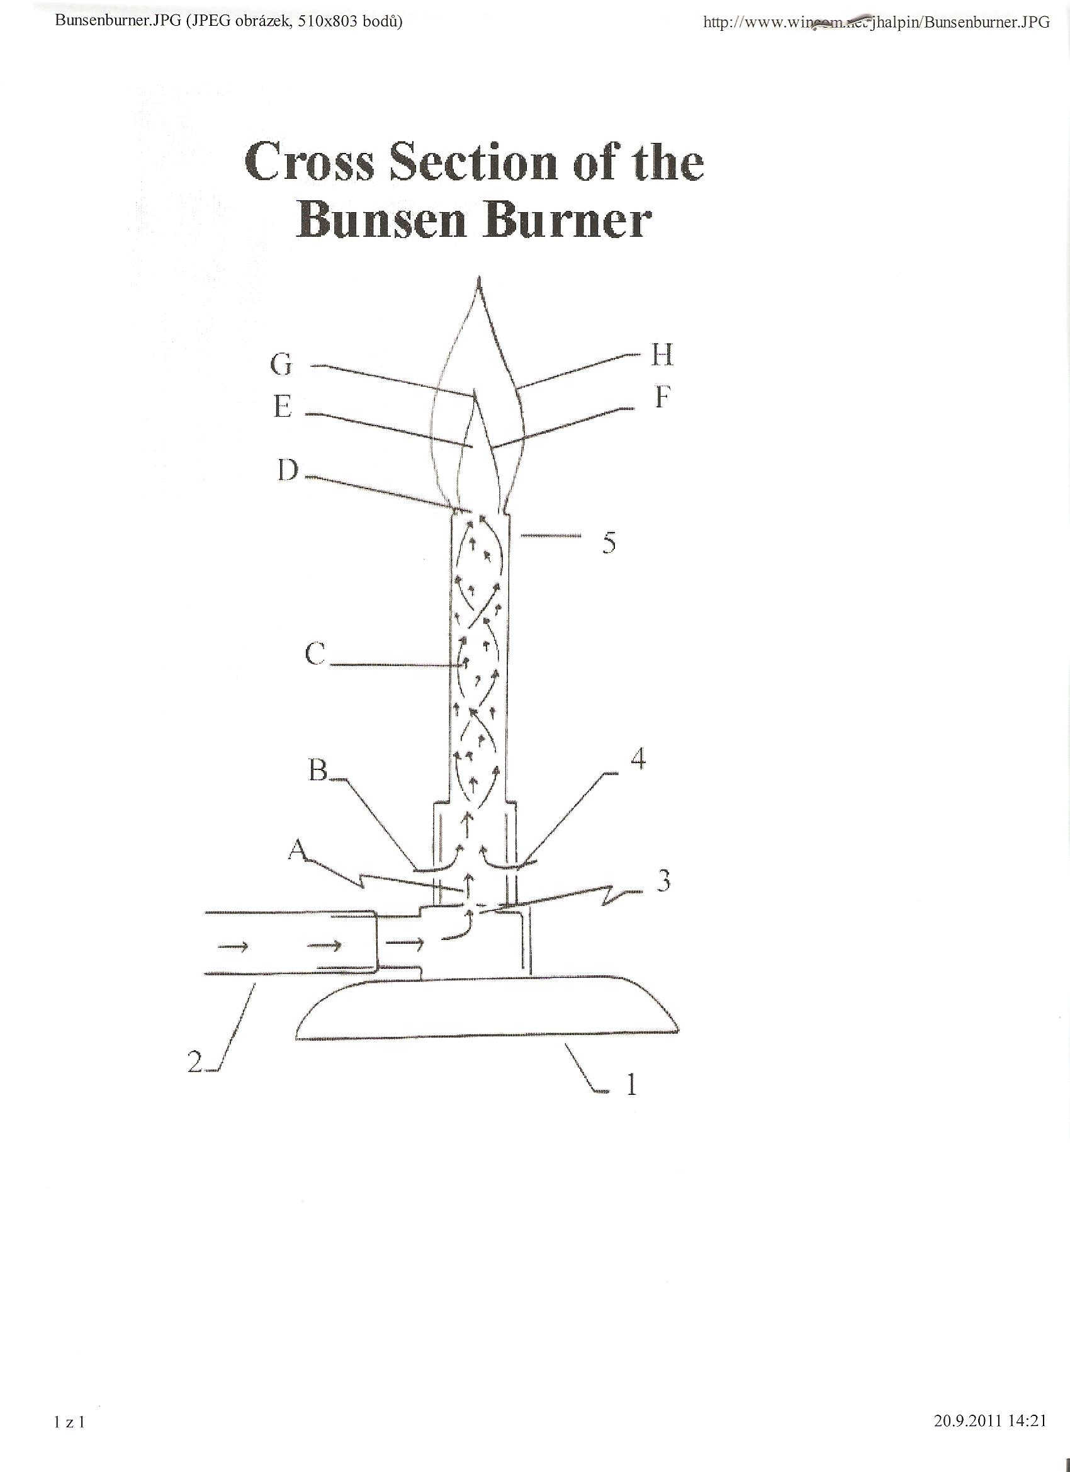

- Complete the text below with descriptions from the picture

The diagram depicts the exposed cross section of the Bunsen burner as though it had been cut down the middle. The dotted lines represent the flow of gas through the burner. The 1_______________ supports the Bunsen burner holding it in an upright position. Natural gas is provided in pressurized gas pipelines. When the gas valve is opened, gas rushes into the 2________________ and through a small 3________________. It is a 4____________________ (e.g. air escaping from a balloon). As methane gas rushes up into the 5___________________, it passes 6______________, which permit air to enter the Bunsen burner. This 7______________________ . Then the 8__________________in the barrel insure a “good mixture” for burning. The mixture leaves the barrel at the _________________. There is very little heat at this point. 9________________ occurs above the barrel of the burner (Light the burner here!). If properly adjusted, the flame of the burner will have an10 ________________ and an 11____________________ above it. The 12_________________________ is at the tip of the inner cone.

