4. GM FOOD

1. SPEAKING. Warm-up: Work in pairs. Try to answer these questions¹

a) Which sciences do you connect with DNA?
c) Can you explain these terms: gene, genome, DNA, RNA, genetic experiments, cloning?
b) Do you know of any results from genetic experimentation?
Have you heard of these things? If not, can you guess their meaning?
Dolly the sheep The strawmato The liger clones

2. Vocabulary. Match these words and phrases to their definitions

controversial the top prize in a competition
to modify something a note which tells you what something is
technical likely to cause disagreement
a label connected to science
regulations to change or alter something
a gold medal laws or rules

3. LISTENING^{2.} Section 1. Listen to Professor Crystal talking about an abbreviation that has come from the modern science of genetic engineering.

a) What is the abbreviation? __ __
b) Which two things can the abbreviation stand for? - genetically modified
- genetic modified
- genetically modification
- genetic modification
c) Which of the words is: a noun, an adjective, an adverb?

4. Read these statements and try to make a guess: Are they true or false?

Listen again. Are the following statements are true or false, according to Professor Crystal? If they are false, say what is true.

a) GM food first appeared around 1995 T/F
b) People were happy to accept GM food T/F
c) GM food is not controversial now T/F

5. GM foods are controversial. Special regulations were introduced.

What do you think food producers and restaurant owners had to do?

a) Not sell or use GM foods
b) State clearly when they used GM foods
c) Have a license to use GM foods

Listen to Section 2 of the talk and check your ideas. Were you correct?

6. Are the following sentences true or false? Listen and check.

a) Professor Crystal talks about restaurant, café and bar owners T/F
b) You might read a notice about GM foods in a restaurant T/F
c) Everyone knows what GM means T/F

7. READING. Look at the tapescript and find words or phrases that mean he same as these words (synonyms):
a) changed or modified (Section 1) -
b) meet or come across (Section 1) -
c) from that time (Section 2) -
d) kinds or types (Section 2)-

Listening Section 1
In the mid-1990s there was a new big, controversy that came in, wasn’t there, about
genetically modified foods: foodstuffs containing genetically altered plant or animal
material. And it wasn’t long before an abbreviation came along to summarise all these:
genetically modified – G.M. or "genetic modification". Now that’s a pretty technical
abbreviation; you might not expect to encounter it very often, but actually, you do.
Because it was controversial at the time and people didn’t know whether to put this stuff
into their foods or not (and it still is controversial), you began to see it on signs –

Listening Section 2
Because it was controversial at the time and people didn’t know whether to put this stuff
into their foods or not (and it still is controversial), you began to see it on signs –
especially after 1996, when the food labelling regulations came in, and they applied in
Britain in, 1999 I think it was – and from that point on, people had to say, if you were a
restaurant owner or a café owner, you had to say whether your foods had G.M. in them or
not – and so you walk into a restaurant these days, and you might well see a sign on the
wall saying "no G.M. foods here" or "the following foodstuffs have G.M. products inside".
And people I've often asked them often asked you know, what do you think G.M. means?
And they guess all sorts of things. Some people have told me it means "good morning
food". Somebody else told me it was a "gold medal" food. Well – it doesn’t mean any of
those things. It means "genetically modified", that’s all!

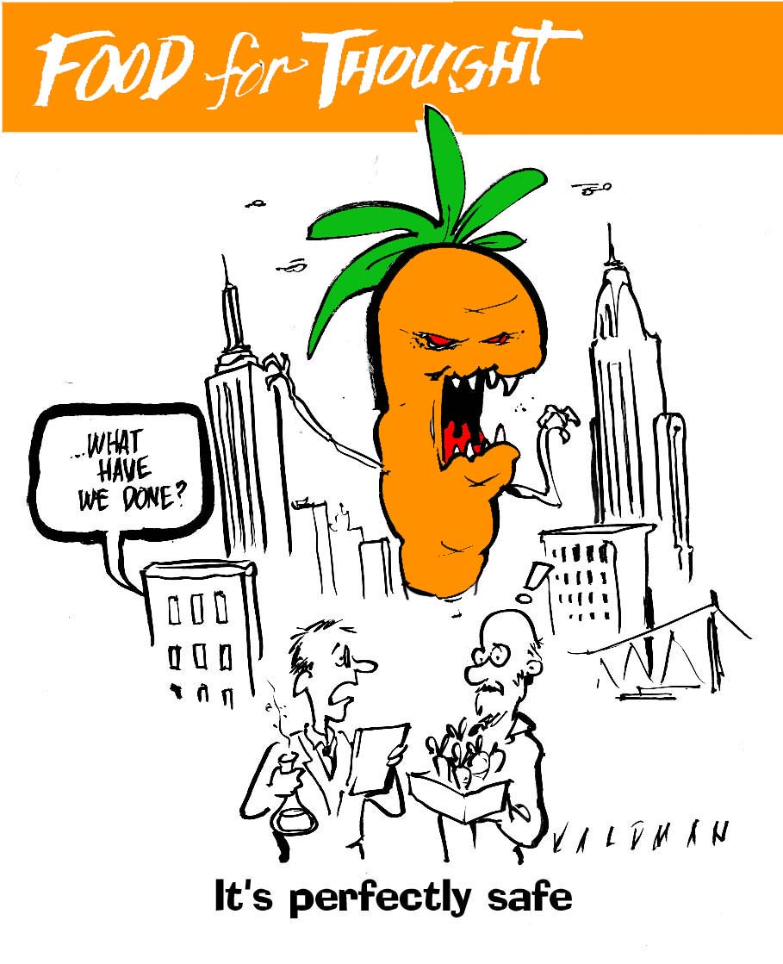

8. SPEAKING. Work in small groups. Discuss the following questions³:
- What do you think about GM vegetables? Is it better to use natural food although it might not produce as much or should we use GM crops?
- What do you think about GM farm animals? Would you eat pork from a GM pig? What do you think about scientific testing on animals?
- What are the possible advantages and disadvantages of GM food? (think about nature and the environment, trusting science, private companies, farmers, pesticide, consumers).
- What is the situation with regard to GM food in your country? Is it a controversial topic? Can farmers produce GM crops? Is your food labelled to tell you about the GM content?
- Do you ever read labels on food packaging? Are you interested in knowing the chemical composition of our food? Do you care if it is a local product?
- Have you ever bought organic food? Why? Why not? Which kind?
- Do you think pets should be cloned? Why or why not? Would you like to have a clone of your pet?
- What do you think of genetic experiments and their results (Dolly the sheep, the liger, strawmato...)? What ethical problems are connected to genetics?
- Do you think people should be allowed to clone people or organs of people? Why?
- If you could copy your brain for future generations, would you?
- Can you imagine some other possible uses of genetic experiments in the future? Give examples.
Useful phrases for argumenting:⁴  The first thing to be considered is ...  It is a fact that ...  There is no doubt that ...  One of the main arguments in favour X is that ... against  Different points of view:  While it is true to say that ...  On the other hand, ... but ... ... however ...  It is not always the case that ...  On the contrary, ...  It is often suggested that ...  This (question) can be looked at from several points of view. Firstly ...  Opponents of ... take a very different view.  This (problem) should be considered in relation to ...  It can be examined in terms of ...  ... must be taken into account ...  It depends. It depends on … | 

Agrement/disagreement:
I agree with X when he says that ...
I disagree with X when he says that ...

Conclusions
in conclusion in brief overall thus
to conclude to summarize then finally
to sum up briefly altogether therefore in addition
... but ... ... however

9. LANGUAGE: Abbreviations.

Science and technology provides many abbreviations that enter the general
language. Do you recognise these abbreviations?
a) How are the following said? Are they spelt out or said as a single word?

LASER CD DVD VHS

RADAR EMAIL SCUBA WWW

b) Look at these organisations. What do you know about them?
What are they responsible for? What do they do?
Can you say what each letter in these abbreviations stands for?
Example: NATO stands for North Atlantic Treaty Organisation

BBC CNN UN IBM NATO

10. These abbreviations above are all nouns for things. Only Email is also a verb.
What is unusual about GM?

Put the correct form of GM in the sentences below – genetic modification or
genetically modified?

a) Our essay title is, ‘ Is ________________ _______________ a good thing for human kind?
b) I don’t want bread which is made from ________________ __________________ flour.
c) ___________________ ___________________ rice could be grown more easily.
d) I think _______________ __________________ should be allowed, after more tests.
e) If a farmer uses ____________ ____________ seeds, he must tell the government officials.

11. Have you ever come across the abbreviation „FAQ“ while browsing the Internet?
Do you know what it means?

FAQ comes from the first letters of a phrase or set of words.
It is not the name of an organisation or company.
This is the way abbreviations often come in to the language. They are created.
Look at the examples of possible abbreviations created in the same way as FAQ.
BDC badly driven car RLD really lovely day
VUL very useful lesson RAQ rarely asked question

Look at the language patterns:
adverb adjective noun
rarely asked question
modifier adjective noun
very useful lesson

Now, try to create your own new abbreviations.
Think about common things in your life.

For more abbreviations used for e-mail or SMS writing visit http://www.sharpened.net/glossary/acronyms.php

- HOMEWORK⁵

Word-formation (Slovotvorba – změna slovních druhů) - SUFFIXES (Přípony):

Nouns (n -podstatná jména): - ment, - ness, - tion, - - ity, - ance, - ist, -er (replacement, richness, formation, flexibility, assistance, chemist, fighter)
Adjectives (adj - přídavná jména) - able, -ible, -ine, - ous, - ic, -ing, -ed (countable, flexible, saline, famous, toxic, interesting, prepared)
Verbs (v - slovesa): - ify, - ize, - ate, - en (intensify, minimize, activate, frighten)
Adverbs (adv - příslovce): - ly, - ally (quickly, technically)
Ovšem často jsou změny složitější: např. long (adj) – length (n)

Někdy u určitého slovního druhu není žádná přípona – např. profitable (adj) - profit (n)

Někdy nemá příponu žádný slovní druh (tzv. konverze - stejné slovo pro více slovních druhů)

Např. a stone bridge – a bridge stone – to stone somebody
stone – adj / n / v

EXERCISES:

- Decide if the words in bold are used to fulfil the function of a verb (v), noun (n) or adjective (adj).

Examples: Number the sentences from one to five. (v)
I can´t remember your phone number. (n)
There is a number plate at the back of the car. (adj.)

- The car has an excellent design.
- Henry´s father is a design specialist.
- I´m afraid I cannot control my life.
- There is a control at the top of the machine.
- Press the control key.
- I study chemistry.
- The latest study shows that the quality of water in our rivers is getting better.

- Complete the chart below:

Noun | Adjective
1. similarity | similar
2. | elastic
3. | prepared
4. conductive
5. | important
6. hardness
7. | fragile

- Now use the right form of the word from exercise c) in a sentence.⁴
Example:
- You can always find similarity in such examples.

2. When producing swimsuits, …………………………. of material is needed.
3. Teachers reported on poor ………………………. of students for the tests.
4. Metals are known for their high electric ………………………………… .
5. This is a very ……………………….. subject.
6. It was very ……………….. to pass all my exams.
7. Human bones are very ………………………. ………….

- Read the text and then write the correct form of the word in CAPITALS to complete the gaps.

Human Fetal Stem Cell Therapy
Human Fetal Stem Cell Therapy is a medical
……………………. during which Human Fetal Stem Cells TO TREAT
are transplanted into a patient. These ……………. building CELL
blocks are ………………administered intravenously and USUAL
subcutaneously (under the skin). It is a ……………… procedure, PAIN
which takes place in ………………………. one hour, and has no APPROXIMATE
negative side ……………….. EFFECTIVE
The Fetal Stem Cell Therapy …………….. out, detects and then SEARCH
attempts to repair any damage or ………………………. DEFICIENT
which is discovered. It also releases ………………. factors that GROW
………………… the body's own repair mechanisms. STIMULATION

Medra’s Medical …………………. William C. Rader, MD. TO DIRECT
has ………………….. over one thousand patients with Human TREATMENT
Fetal Stem Cells, ……………………. children and adults INCLUSIVE
suffering from many of mankind’s most …………………….. DEVASTATION
diseases, some of which up until …………………… had been RECENT
considered to be untreatable.

Sources: ^{1,,3} Available at http://iteslj.org/questions/
- Available at http://www.bbc.co.uk/worldservice/learningenglish/radio/specials/1728_uptodate/page5.shtml
⁴ Adapted from Oreská, Alžbeta. Activity book English for chemists.. Bratislava : STU, 2005..
Lesson based on BBC Learning English.

