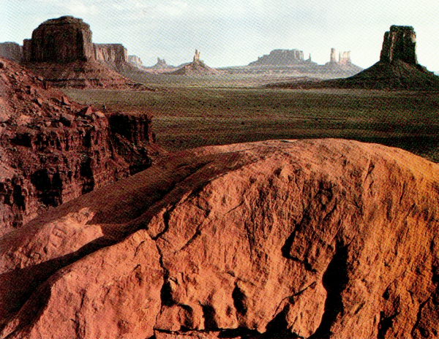
79
Figure 2-15. These landforms in Monument Valley, Arizona, are made of sandstone. What class of rock does sandstone belong to?

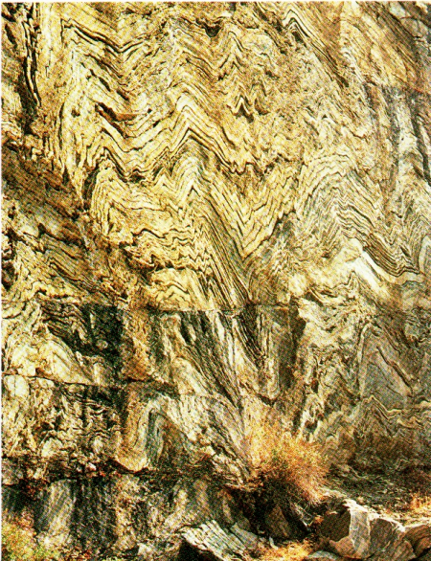
Figure 2-16, These layersof schist were photographed at King's Canyon National Park.
What could have caused the bending and folding ot the rock laysrs?
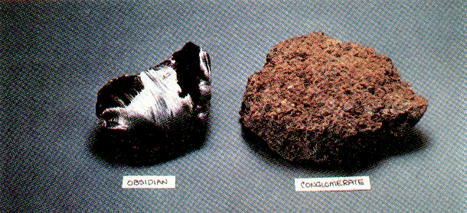
Figure 2-19. Specimens of eight rocks: Considered as four pairs, each rock on the right is a metamorphic form of the rock on its left.
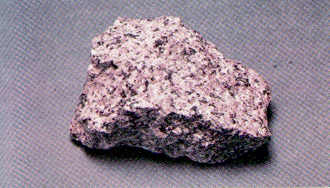  A – granite | 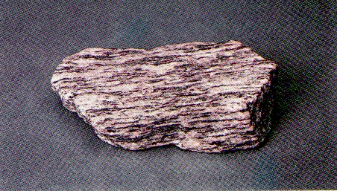  B – gneiss
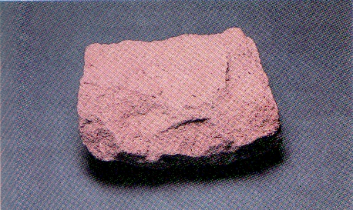  C – sandstone | 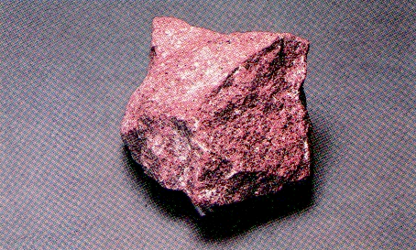  D – quartzite
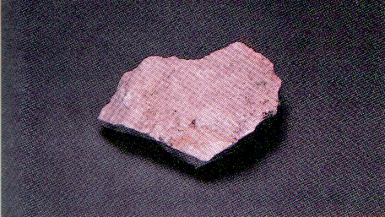  E – limestone | 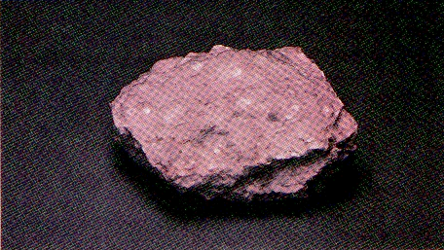  F – marble
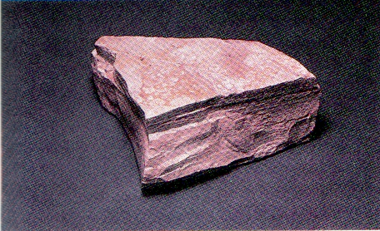  G – shale | 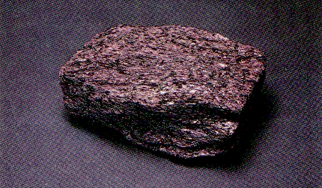  H – schist

