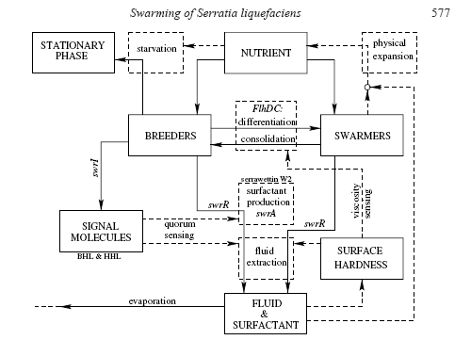
Bees a kol. (2002): Quantitative effects of medium Hardness and Nutrient Availability on the swarming motility of Serratia liquefaciens. Bulletin of mathematical Biology. 64: 565-587
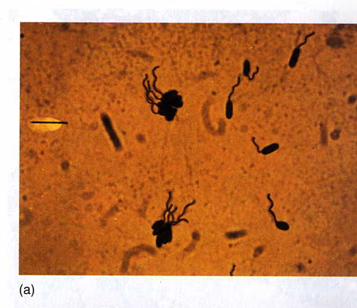

Pseudomonas andropogonis

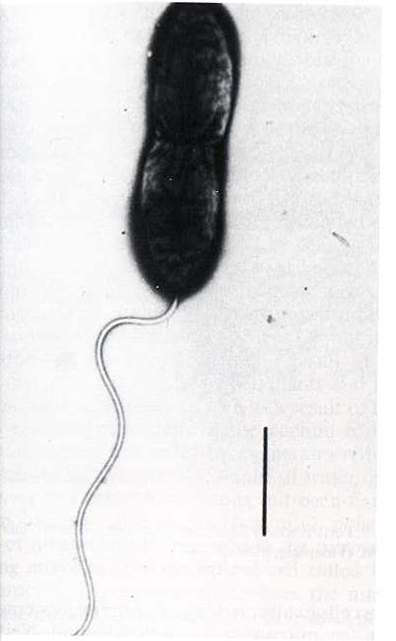

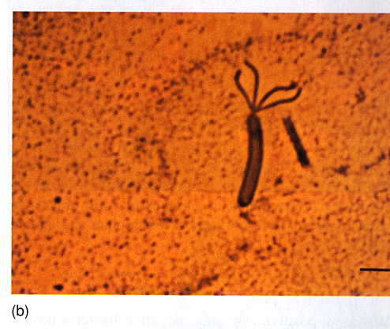
Pseudomonas

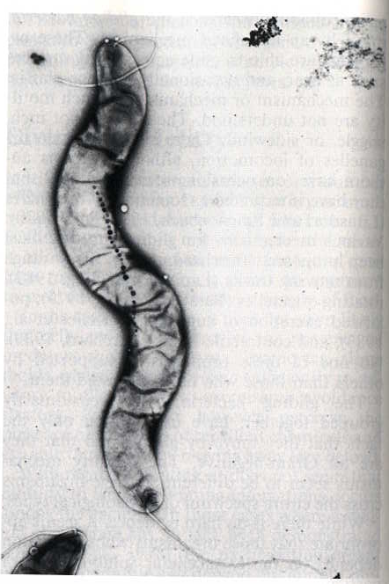

Spirillum volutans
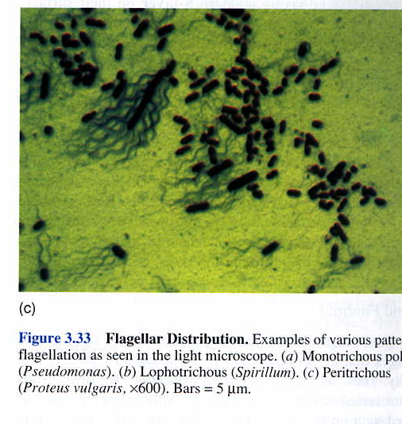

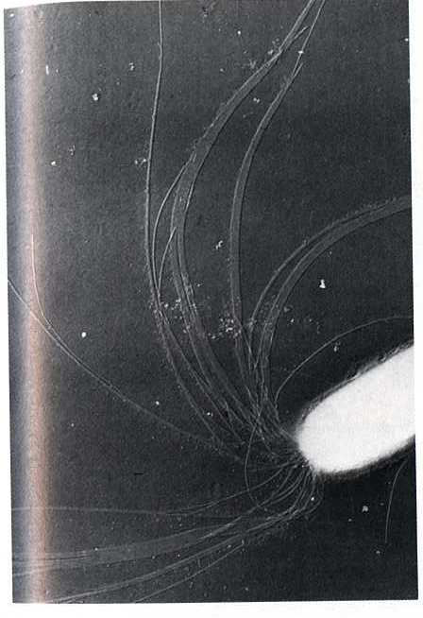

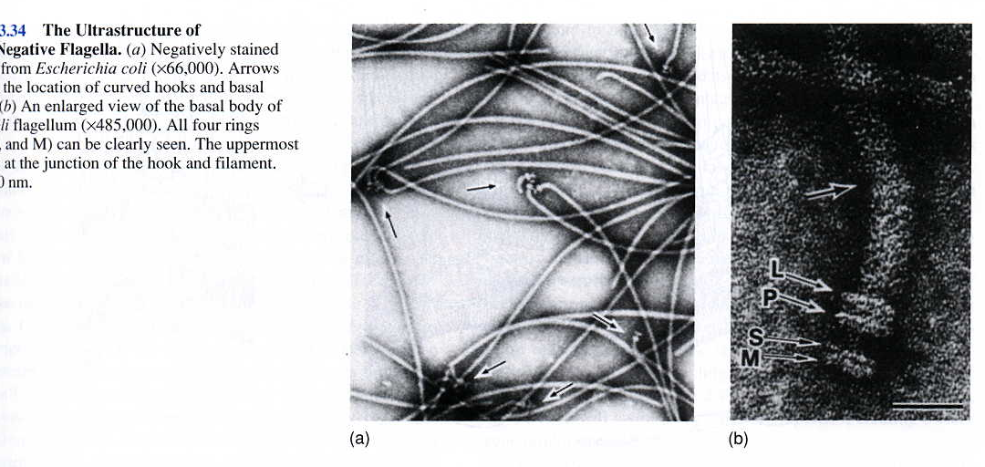

Proteus vulgaris

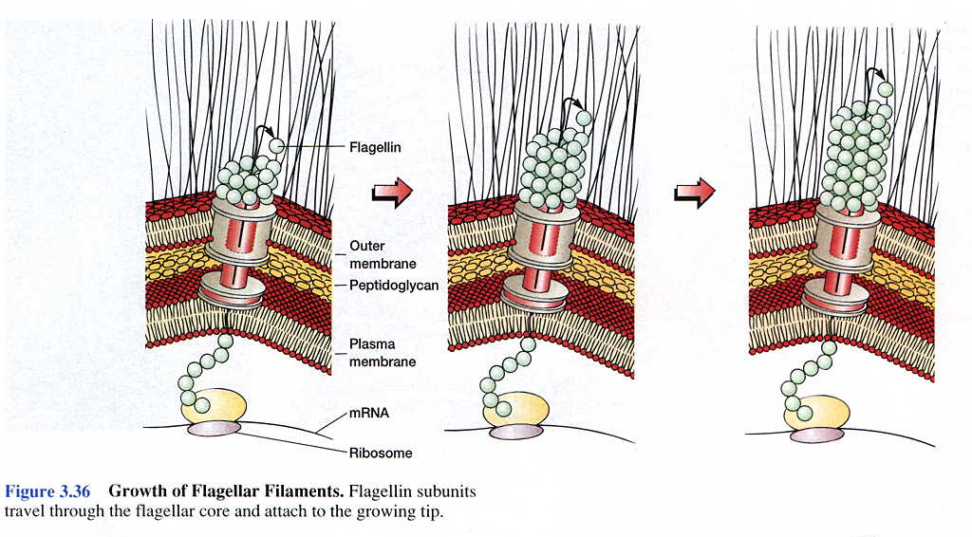

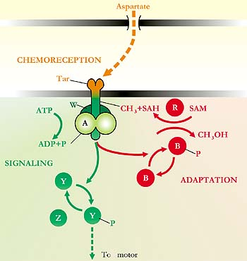
Chemotaxis
This diagram shows some of the components required for chemotaxis toward the amino acid aspartate. Information flows from the outside of the cell (shown at the top) by way of porins, the periplasmic space, and the cytoplasmic membrane, to the inside of the cell (shown at the bottom), and then to the flagellar motors (not shown). Dashed arrows indicate physical displacement of chemicals by diffusion. Solid arrows indicate chemical modifications of proteins—phosphorylation or methylation. The cytoplasmic components, all Che proteins (CheW, CheA, CheR, CheB, CheY, CheZ), are identified by their fourth letter only. The receptor complex consists of two molecules of Tar, two of W, and two of A, with Tar spanning the cytoplasmic membrane. Chemoreception is depicted in orange, signaling in green (for “go”), adaptation in red (for “stop”). Tar is a protein required for taxis toward aspartate and away from certain repellents. ATP is adenosine triphosphate, the phosphate donor. SAM is S-adenosylmethionine, the methyl donor. The other chemicals shown are ADP, adenosine diphosphate; SAH, S-adenosylhomocysteine; CH₃, the methyl group; CH₃OH, methanol; and P, inorganic phosphate.

