**LESSON 5: THE ATOM AND BONDING (adapted from A. Rozkošná)**

**A) SPEAKING: In the News**

**In today´s lesson you are going to read a BBC newspaper article. Work in small groups and answer these questions:**

* Do you like reading newspapers and magazines? How often do you read them?
* What is your favourite magazine / newspaper? What sections of a newspaper do you like to read? What is your favourite topic - politics / cars / fashion / computers / science / cooking / sport ?
* How often do you watch the news on TV? What are your favourite broadcasting companies?
* How often do you watch the news on the Internet? What are your favourite websites? What is your favourite activity on the Internet?
* Do you ever read scientific news? Do you know periodicals like Science Daily, The New Scientist etc. – or similar magazines in Czech?
* Have you ever read a magazine / newspaper article in English?
* Do you think it's important to read the newspaper and know what is going on in the world? Why or why not? What would the world be like without news?

**B) LISTENING:**

**BONDING**

**Available at** <http://bcs.whfreeman.com/thelifewire/content/chp02/02020.html>(Click on ANIMATION – NARRATED)

1. **COVALENT BONDS**

**Vocabulary**

1. **Watch the animation and answer the question: What elements or compounds are mentioned?**
2. **Listen again and fill in the gaps:**

A covalent bond results when two atoms share electrons. In the case of two______________, each ____________its single electron with the other. This sharing allows each to fill its electron shell with two electrons. The pair of shared electrons __________a covalent single bond.

Let´s now consider _____________, an atom with eight electrons. Two electrons fill the_________________, and the other six electrons reside in the next shell. This outer shell needs two more electrons to complete it (the____________). Two ___________atoms form a covalent double bond by sharing two electron pairs from their outer shells.

Carbon is perhaps the most ___________________ on Earth, in large part because it contains only four electrons in a shell that can __________eight. To fill its outer shell, carbon forms four covalent bonds with up to four other atoms.

In a molecule _____________________, carbon shares electrons with_________________ , forming four covalent single bonds. Although this molecule is relatively simple, carbon often forms _____________________of large, complex molecules. With each carbon atom able to bond to four other atoms, _____________ molecules are incredibly diverse.

Triple bonds are rare, but nitrogen gas molecules (the most abundant molecule in_____________________) form triple bonds. The two nitrogen atoms share__________________, allowing each to have eight electrons in its outermost electron shell.

**Now answer these questions:**

1. What is a covalent bond?
2. Which element forms a single covalent bond?
3. What is the most versatile element?
4. What is the most abundant molecule in the air?
5. What kind of bonds does it form?
6. **IONIC BONDS**
7. **Watch the animation and note down key words.**
8. **Watch it again and make notes of the main points.**
9. **Work with your neighbour. With the help of the pictures, describe ionic bonds.**

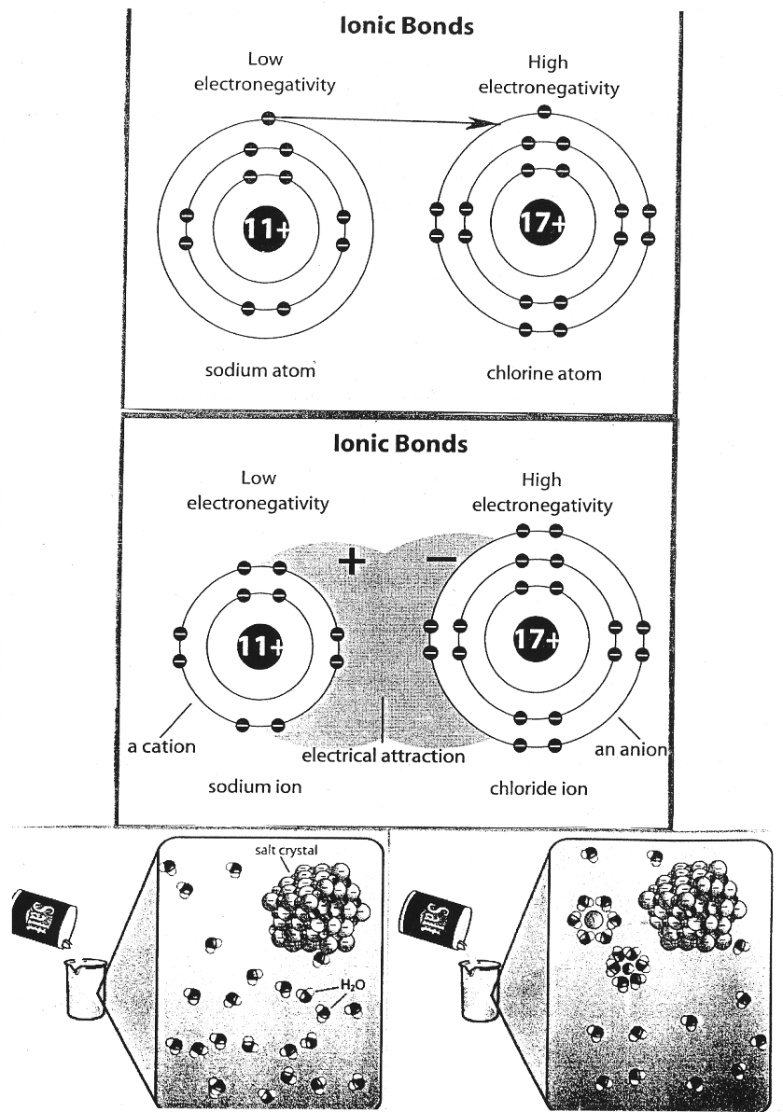

<http://bcs.whfreeman.com/thelifewire/content/chp02/02020.html>(Click on ANIMATION – NARRATED)

**Fastest View of Molecular Motion**

**READING ACTIVITIES**

**1. Read the first part of the text (until the headline “Ultra-fast process”) and try to answer the following questions:**

1. What was the timescale that the researchers watched molecules on?
2. Where could the study be used in the future?
3. Where was the study published?
4. What instrument was used at the experiment?
5. At what university were the researchers based?

**2. Read the whole text and give the English equivalents of the following Czech expressions:**

1. vědci provedli pozorování
2. jedna atosekunda se rovná miliardtině miliardtiny sekundy
3. pochopení podstaty
4. vynalézt novou techniku
5. excitovaný ionizovaný stav
6. uvolní se rentgenové paprsky
7. účinek na pohyb v molekule
8. řízení chemických reakcí
9. provádět testování

**Fastest view of molecular motion**

|  |  |  |  |
| --- | --- | --- | --- |
| **Scientists have made the fastest ever observations of motion in a molecule.**  They "watched" parts of a molecule moving on an attosecond timescale - where one attosecond equals one billion-billionth of a second.  The researchers say the study gives a new in-depth understanding of chemical processes and could be used in future technologies such as quantum computing.  The study, which relies on short pulses of light from a specially built laser, was published in the journal Science.  "Understanding how something changes in time means really understanding its essence, and we are now looking at changes on a very, very fast timescale," said team member Dr John Tisch, of Imperial College London, UK.  **Ultra-fast process**  The researchers devised a new technique to "see" the motion of protons, one of the building blocks of an atom, in molecules of hydrogen and methane.  The technique involves firing a very short but intense laser pulse at a molecule, which rips an electron away, leaving the molecule in an excited ionised state. | **1**  **2**  **3**  **4**  **5**  **6**  **7** | The electron is then drawn back to the molecule, and when it collides a very short burst of x-rays is released.  "That has encoded information within it about the state of the molecule at the point of re-collision, and can give us information about the motion of the protons in this molecule," Dr Tisch told the BBC News website.  The process is ultra-fast, and the team was able to observe the effect the laser had on motion in the molecules with an accuracy of 100 attoseconds - the fastest ever recorded.  The team said being able to see detailed molecular motion would help scientists understand how molecules behaved in chemical processes, thus providing possibilities for controlling molecules.  "Control of this kind underpins future technologies, such as control of chemical reactions, quantum computing and high brightness x-ray light sources for material processing," said Professor Jon Marangos, another Imperial College author on the Science paper.  "We now have a much clearer insight into what is happening within molecules and this allows us to carry out more stringent testing of theories of molecular structure and motion."  **Article Available at** ©<http://news.bbc.co.uk/2/hi/science/nature/4766842.stm>  **From The BBC News** | **8**  **9**  **10**  **11**  **12**  **13** |

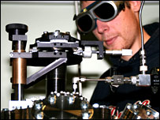

The protons' motion was seen on the attosecond timescale

**POST-READING ACTIVITIES**

**1. Grammar: Complete the word-formation table. The first has been provided as an example.**

|  |  |
| --- | --- |
| **Noun** | **Verb** |
| *observation* | *to observe* |
| researcher |  |
| motion |  |
| effect |  |
| study |  |
|  | to control |
|  | to collide |
|  | to behave |
| testing |  |
| reaction |  |

**Now choose 2-4 of these words and use them in a sentence.**

***Example:***

*There are many different kinds of chemical* ***reactions****.*

**2. Speaking. In pairs, summarize the text, using the vocabulary you have learnt.**

**HOMEWORK: Vocabulary in Context**

**Circle the SYNONYM (=word of similar meaning) of the word in *italics*.**

**1.** Atoms are *infinitesimal* in size.

a. tiny b. huge

**2.** Chemists study the composition of natural *substances*.

a. materials b. machines

**3.** The fish suddenly *emerged* from the water.

a. arose b. disappeared

**4.** All matter is either liquid, solid, or gas, and solids may be *subdivided* into crystalline and amorphous.

a. built up b. broken down

**5.** Plastic products are hard to dispose of because they are almost *indestructible*.

a. unable to be destroyed b. unable to be constructed

**6.** At one time the atom was thought to be *indivisibl*e.

a. unable to be divided b. unable to be seen

**7.** Einstein´s ideas are too *abstract* for many people to understand.

a. practical b. theoretical

**8.** The *reaction* of iron and oxygen produces rust.

a. chemical activity b. separation

**9.** The airplane had to rely on radar in the *dense* fog.

a. thick b. thin

**10.** The moon *revolves* around the earth.

a. stretches b. circles

**11.** The mosquitoes showed their *attraction to* the light.

a. dislike for b. liking for

**12.** Some scientists suspect that the planet Uranus once *collided* with another object in space.

a. crashed b. orbited

**13**. Heat can *convert* a solid to a liquid.

a. condense

b. change

**14.** The ammonia was *diluted* in water to make it weaker.

a. thinned b. thickened

**15** A *catalyst* speeds up a chemical reaction.

a. chemical agent b. forest animal

**16.**  To obtain aluminum, metallurgists must *extract* it from bauxite.

a. remove b. destroy

**Based on:** Zimmerrman, Fran. *English for Science*.New Jersey 1989.

**Lesson adapted from Marie Sabolová**

**Vocabulary – Atom and Bonding**

|  |  |
| --- | --- |
| covalent single bond (adj+adj+n) | jednoduchá kovalentní vazba |
| double bond (adj+n) | dvojná vazba |
| triple bond (adj+n) | trojná vazba |
| versatile (adj) | všestranný |
| backbone (n) | páteř |
| incredibly diverse (adv+adj) | neuvěřitelně rozmanitý |
| to result (v) | být výsledkem |
| to constitute (v) | vytvářet |
| to consider (v) | považovat za, uvažovat o |
| to reside (v) | sídlit, spočívat v |
| carbon-based molecules (adj+n) | molekuly na bázi uhlíku |
| scientists make observations | vědci provádějí pozorování |
| to observe (v) | pozorovat |
| motion (n) | pohyb |
| to move (v) | pohybovat se |
| researchers (n) | výzkumníci |
| scientists (n) | vědci |
| to publish a study (v+n) | publikovat studii |
| to release x-rays (v+n) | uvbolnit rentgenové paprsky |
| to behave (n¨v) | chovat se |
| behaviour (n) | chování |
| effect (n) | vliv |
| to affect (v) | mít vliv |
| excited ionised state (adj+adj+n) | excitovaný ionizovaný stav |
| timescale (n) | časová škála |
| encoded information (adj+n) | zakódovaná informace |
| understanding the essence (n+n) | pochopení podstaty |
| accuracy (n) | přesnost |
| to fire a laser pulse | vypálit laserový impuls |
| to devise a new technique | vynalézt novou techniku |
| to rip an electron away | odtrhnout elektron |
| to draw back (v) | vtáhnout zpět |
| to collide (v) | srazit se, kolidovat |
| collision (n) | srážka, kolize |
| to provide (v) | poskytnout |
| to rely on (v) | záviset na |
| control of chemical reactions | řízení chemických reakcí |
| carry out testing (v+n) | provádět testování |
| to collide (v) | srážet se, kolidovat |