**JAF03 Lesson 7 Graphs and calculations**

1. **Discuss:**
2. How would you describe the relationship between mathematics and physics?
3. What is your personal relationship towards mathematics?
4. How much mathematics have you had to deal with during your studies?
5. What is the most useful type of maths course for a physicist?
6. How do you understand the statement that “to a physicist, mathematics is a toolbox”?
7. **Calculations - revision**
8. **Which two words collocate with the following adjectives?**

*minute enormous substantial*

*surprising tiny*

___________________,_________________

*significant considerable*

1. **How could you describe number 2 in mathematical terms?**
2. **Read these numbers:**
3. 3,064
4. 3.064
5. 97th
6. 1/3; ¼; 8/5
7. 549 492 889 (a phone number)
8. 9 000 000 000
9. **What basic mathematical operations do you know?**
10. **Read the following formulae:**
    * 1. N = kg.m.s-2
      2. v = u + at
      3. s = ut + at2
      4. K = mc2 ( - 1)
11. **Put the following statements into mathematical notation:**
    * + 1. the squared sum of x and y is equal to the sum of x squared, the product of two x and y, and y squared;
        2. twice the sum of p and 5, diminished by 30;
        3. x to the power of minus 10 is less than cube root of y.
12. **Graphs and charts**

Charts and graphs measure various statistics and are helpful when presenting large amounts of information that need to be understood quickly. This includes: facts and figures, statistical information, profit and loss, polling information, etc.

**What are graphs used for in physics? What information do we have to include when plotting a graph?**

1. **Types of graphs**

**Match the types of graphs on the left below with their respective charts. Then complete the sentences below.**

(<http://office.microsoft.com/en-us/excel-help/available-chart-types-HA010342187.aspx>)

1

3

2

A column chart

A line chart

A pie chart

A bar chart

An area chart

4

5

6

An XY (scatter) chart

A stock chart

A surface chart

A doughnut chart

A bubble chart

A radar chart

9

8

7

11

10

1. A ­­­­­­­­­_________chart is useful when you want to find optimum combinations between two sets of data. As in a topographic map, colours and patterns indicate areas that are in the same range of values.
2. ___________charts show the size of items in one data series, proportional to the sum of the items. The data points in this type of chart are displayed as a percentage of the whole chart.
3. __________ charts emphasize the magnitude of change over time, and can be used to draw attention to the total value across a trend.
4. __________ charts are useful for showing data changes over a period of time or for illustrating comparisons among items.
5. You could use a ________chart to indicate the fluctuation of daily or annual temperatures.
6. Like a pie chart, a __________chart shows the relationship of parts to a whole, but it can contain more than one data series.
7. A __________chart is a graphical method of displaying several data series in the form of a two-dimensional chart of three or more quantitative variables represented on axes starting from the same point.
8. **Language of Graphs and Charts**

http://esl.about.com/od/businessmeetings/a/Language-Of-Graphs-And-Charts.htm

**Useful phrases used to describe common bar charts, line charts and pie charts**

There are a number of specific words and phrases used to describe and discuss graphs and charts. This vocabulary is especially important when presenting to groups of people. Much of the language of graphs and charts relates to movement. In other words, the language of graphs and charts often speaks of small or large movement or differences between various data points. Refer to this language of graphs and charts to help improve your ability to speak about graphs and charts.

The following list the verb and noun used to speak about positive and negative movements, as well as predictions. Example sentences are included in each section.

**Positive**

to climb - a climb  
to ascend - an ascent  
to rise - a rise  
to improve - an improvement  
to recover - a recovery  
to increase - an increase

*Sales have climbed over the past two quarters.  
We've experienced a rise in consumer demand.  
Consumer confidence recovered in the second quarter.  
There has been an increase of 23% since June.  
Have you seen any improvement in customer satisfaction?*

**Negative**

to fall - a fall  
to decline - a decline  
to plunge - a plunge  
to decrease - a decrease  
to worsen - a slip  
to deteriorate - a dip

*Research and development spending has fallen by 30% since January.  
Unfortunately, we've seen a decline over the past three months.  
As you can see, sales have plunged in northwest region.  
Government spending has decreased by 10% over the past two years.  
There's been a slip in profits this past quarter.*

**Predicting Future Movement**

to project - a projection  
to forecast - a forecast  
to predict - a prediction

*We project improved sales in the coming months.  
As you can see from the chart, we forecast increased research and development spending next year.  
We predict improving sales through June.*

**Now transform these sentences using the given word so that they mean the same:**

1. There's been a slight decline in sales.   
   Sales …………………………………….
2. We made a sharp increase in investment.

Investment ………………………………

1. There was an abrupt drop in sales in March.

Sales………………………………………

1. Unfortunately, consumer interest suddenly decreased.   
   There…………………………………………
2. The dramatic growth has come after we invested in a new product line.

We've …………………………………………

1. Profit has been flat over the past two years.

There………………………………………..

1. There has been steady improvement over the past three months.  
   Sales ……………………………………..

**Complete the following tables supplying the appropriate vocabulary.**

|  |  |
| --- | --- |
| **VERB** | **NOUN** |
| to rise |  |
| to increase |  |
| to improve |  |
| to fall |  |
| to decrease |  |
| to recover |  |

|  |  |  |
| --- | --- | --- |
| **ADJECTIVE** | **ADVERB** | **HOW MUCH CHANGE?** |
| slight | slightly | very small |
| sharp |  |  |
| dramatic |  |  |
| steady |  |  |

1. **Practise: Use the following graphs and the vocabulary from the above tables to describe the movement of the various objects concerned. (http://www.webelements.com/periodicity/discovery/bar_chart.html)**

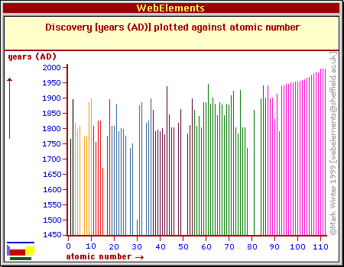

**Practice Interpreting Data:**

(http://staff.tuhsd.k12.az.us/gfoster/standard/bgraph2.htm)

The following examples are provided to help you develop the ability to read information shown on a graph.

1. **Identify the graph that matches each of the following stories:** 
   1. I had just left home when I realized I had forgotten my books so I went back to pick them up.
   2. Things went fine until I had a flat tire.
   3. I started out calmly, but sped up when I realized I was going to be late.

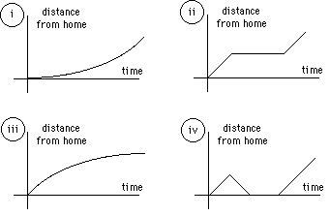

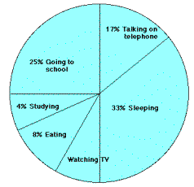

1. **The graph represents the typical day of a teenager. Answer these questions:** 
   1. What per cent of the day is spent watching TV?
   2. How many hours are spent sleeping?
   3. What activity takes up the least amount of time?
   4. What activity takes up a quarter of the day?
   5. What two activities take up 50% of the day?
   6. What two activities take up 25% of the day?

|  |  |  |  |  |  |  |  |  |  |  |  |  |  |
| --- | --- | --- | --- | --- | --- | --- | --- | --- | --- | --- | --- | --- | --- |
| **3. Answer these questions about the data table:**   1. What is the independent variable on this table? 2. What is the dependent variable on this table? 3. Describe the shape of the line graph that this data would produce? | |  |  | | --- | --- | | **Atomic Number** | **Ionization Energy (volts)** | | **2** | **24.46** | | **4** | **9.28** | | **6** | **11.22** | | **8** | **13.55** | | **10** | **21.47** | |

**Vocabulary task – match words with their definitions:**

***extrapolation median discreet variable mode line of best fit mean outlier interpolation trend axis******range continuous variable negative correlation***

1. a line drawn through the center of a figure
2. to estimate a value by following a pattern and staying within the values already known
3. a relationship between two sets of data - it will show a positive correlation, a negative correlation, or no correlation
4. upper extreme minus lower extreme
5. a point separated from the main body of the data
6. to estimate a value by following a pattern and going beyond the values already known
7. the middle value of all the numbers in the sample.
8. the most frequently observed value of the measurements in the sample
9. the sum of all the results included in the sample divided by the number of observations
10. one set of data decreases as the other set of data increases
11. a line on a scatter plot which can be drawn near the points to more clearly show the trend between two sets of data
12. measurements that are distinct, periodic, and unconnected between data points
13. measurements are uninterrupted and connected between data points (e.g. growth of a plant)