CASE STUDIES GUIDELINES

-PAGE 1-

MAIN FEATURES OF THE PROJECT
Name of the Project | Sustainability in practice
Category | Multi-stakeholder involvement
Theme | Rural development, environment  education, project training, sustainability and security
Target Group | School children, university students, rural community, general public, policy-makers, administrators, researchers
Area of Implementation | Rural area in Moravia/Czech Republic  Deblin primary school
Leading Organization(s) | Masaryk University Brno,  Deblin primary school

ABSTRACT:

This educational project describes activities in a study programme undertaken by the Department of Geography, Faculty of Science, Masaryk University, in the Moravian city of Brno. The sustainability teaching/learning was based on the educational taxonomy of Krathwohl (a revision of Bloom´s taxonomy) emphasizing such methods as joint deduction, induction and abduction in study groups, and emphasizing fieldwork in the Deblin-town area, near the city of Brno. It was also based on the cooperation of the university, the Deblin primary school and the Deblin town community. The project also involved the municipal authorities of Tišnov, their Department of Environment and the public administration of the Deblin microregion. We have included the main stakeholders/actors for the Millenium Ecosystem Assessment for their important role in cultural landscape ecosystems sustainability. Studying environmental perception and participation and the application of GIS technology within the framework of multiple methodology in geographical research based on field surveys provided new knowledge.

KEY WORDS::Sustainability, Educational project, Rurality, Spatiality, Community, South Moravia

-PAGE 2-

INTRODUCTION
Regional challenges
The Deblin area, from a geomorphological point of view, is a faulted dome – an elevation with its base at 240 m above sea level and the summit at 540 m a.s.l. It is comprised of a very wide collection of metamorphic and sedimentary rocks covered with earth/slope sediments and soil cover consisting of cambisols, luvisols, pseudogleys and leptosols. The topoclimate is mildly warm and moist with sunny and shady spots. At the foot of the dome five streams can be seen flowing around it with average discharge up to 8 m³.s⁻¹. Their autochthonous tributaries from the Deblin dome are strongly influenced by the dissected terrain. The former Ulmi fraxineta carpini, Carpini terceta, Fagi querceta + typica and Querci fageta were almost de/reterritorialized into cultural forests, cultivated fields, orchards, meadows and villages/country town settlements. It includes 9 municipalities with 3,156 inhabitants in an area of 56.8 km² as a part of the town region of Tisnov, a marginal suburban town of Brno. Deblin is a sub-regional/local node attracted by Tisnov (population: 8,704 inhabitants) and the city of Brno (population: 404,067 inhabitants). Large-scale agriculture (since the 1950s) and Saxon-type forestry (since the 1750s) strongly influenced rural landscaping, causing biodiversity depletion, a monotonous landscape character, accelerated anthropogenous soil erosion and run-off with impacts on the human environment.

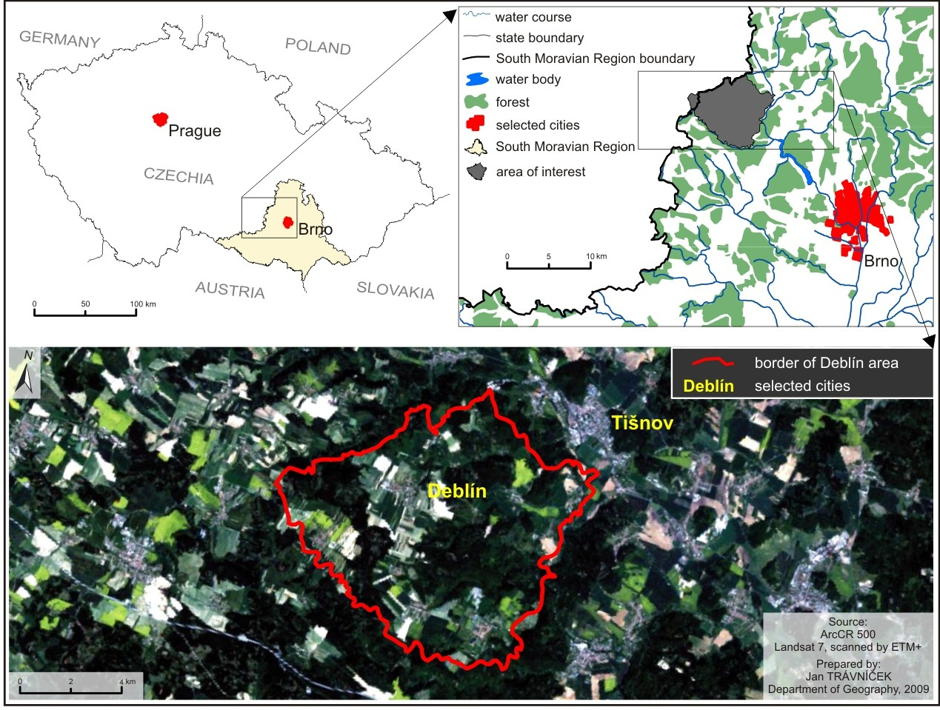
Fig. 1: The spatial delimitation of the area. A geometrically transformed picture from a satellite in natural colors (RGB 3 2 1), May 24th 2001

Objectives
- To commemorate the United Nations Decade of Education for Sustainable Development, Chapter 36 of Agenda 21 on education, training and public awareness in the sense of The United Nations Conference on Environment and Development (UNCED), held in Rio de Janeiro in 1992, Johannesburg Plan of Implementation (World Summit on Sustainable Development /Earth Summit 2002)
- To understand the process how to promote and improve the quality of education, reorient curricula, raise public awareness of the concept of sustainable development in joint primary and tertiary geographical education with respect to Krathwohl´s education objectives (2002) and the Millennium Ecosystem Assessment (Alcamo J. et.al., 2003)
- To apply within the project courses Z0131 – Sustainability (taught during the autumn semester) and Z0132 Urban and Rural Studies (taught during the spring semester) at the Department of Geography, Faculty of Science, Masaryk University in Brno (Czech Republic), including fieldwork as well, e.g. in the Deblin area where geographical education at the Deblin Primary School is coupled with the aforementioned courses
- To analyze the cultural landscape of the Deblin area, landscape ecosystems and their components, the links between human communities and landscape ecosystems, social learning and the construction of the environment, knowledge-power relations in machinist ecology, and various spatialities – nodal, formal, functional, perceptual/vernacular
- To evaluate the living conditions/livelihood in the Deblin area, human-nature relations, ecosystems services, residents’ mobility – commuting to work, social reproduction, local/household economy, and technologies. Using multiple methods in social mapping, mental maps techniques and social action research can provide a different portrayal than common statistical data
- To create alliance among the indigenous population and university students, empower local communities and foster fellowship in good governance with regional public administrations. Improving educational process by accepting advanced technologies such as GIS (geographical informatics systems), a field survey supported by instruments leading to active reterritorialization of the landscape that enforces interactive landscape elements within the framework of the resilient landscape ecosystems that provide their services. The debate on the state of the environment is a starting point in searching for sustainable development.

Partners-Networking Activities
As the project is oriented toward activating local/regional stake-holders, we linked up with several partners from the public, private and academic (research) sector. The partnership was established among:
- Deblin Primary School (project leader, activating the local community through pupils and their parents)
- Masaryk University Brno (Faculty of Science, Institute of Geography) - co-leader
- Ycnega Technologies, Ltd.: a key partner from private sector, helping with technical support for the project, promoting and activating local resources
- Municipal authorities of the town of Tišnov: the Department of Environment is our key partner at the regional governmental level
- Municipal authorities of Deblin: our key partner from the local governmental level
- Technical University of Liberec, Faculty of Education, Department of Geography: another university which participates in research activities; important academic actor
- The Forests of the city of Brno

Partnership means deeper overview of activities inside the regions. We should noticed that these activities were done directly in the Deblín area. These activities are transferable – but with certain awareness of the locality where practiced. If the project is taken as template without local variables, no successful results is implied. That is also the reason why trainers are not being specifically taught – lived reality with deep theoretical background and experiences suggest effective outoputs. Open debates at conferences, seminars, workshops not only in Czech Republic paid attention to children´s and their parents participation as very effective practice in rural community

Structure
The sequencing of the project is very similar for both primary school pupils and the students of the Department of Geography, Masaryk University. The differences are only in the approach which is taken for the different purposes of the university and the primary school; the university strives for sophisticated methodologies and expert opinion, studying a selected area as an object with multiple facets. The primary school mainly participated in the project to raise educational standards through partnership with the university. The common denominator is getting a deep overview of a particular locality in the rural region.

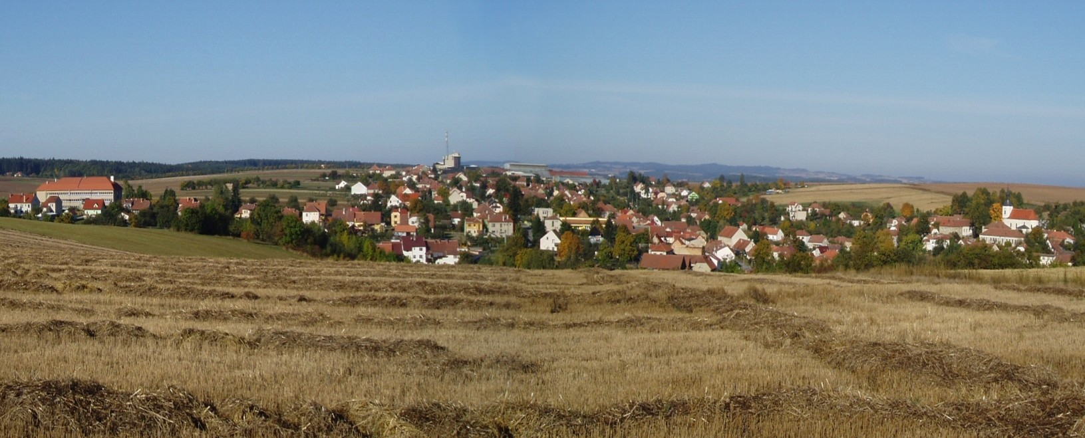Fig. 2: A view of the town of Deblin. The primary school is the large building on the left.

The individual steps are connected and often blended together; further progress is influenced by the results of previous stages:
- Mental mapping – a unique personal presentation of reality, used on a daily basis for spatial mobility and orientation which is evaluated and continually improved (Lynch 1960); mental maps were completed by guided interviews to enable their interpretation.
- Definition of the area linked to the results of the mental mapping.
- Collecting available data and controlled interviews with major actors.
- Profiling the Deblin region as a place, land and landscape.
- Making a list of major problems, examples of problems and their brief interpretation via the team's solutions
- Student and pupil meetings on the Deblin primary school premises and joint field work.
- Generating outputs and public presentation of the results.
- Joint excursions and identification of problems suggested by the general public and local or government authorities.
- Seeking opportunities for financial and organizational backing for further cooperation.

Funding
The project was designed as a low cost and effective way of how to join key stakeholders in the locality. All partners were included without financial support. Pupils worked on the project during their regular lessons, students participated during their semester work and research activities were undertaken for the research itself. The Department of Geography, Faculty of Science, Masaryk University, in particular was the initial point of the project focus and the primary school in Deblin kindly supported it.
However, the continuation of the project is dependant on EU support. The authors obtained support for the project oriented toward the innovation of sustainability learning in the local primary school, which has now been implemented. Under the EU Operational Program Education for Competitiveness activities such as a local geographical textbook (with an atlas) or an open e-learning platform are being developed and other projects (connected to recent research and improving the educational process in learning about and with sustainability) are under preparation.

APPROACH/METHODOLOGY
Learning Activities
In the educational sphere, the proposed model of project teaching (with a methodological basis and research methods) provides an application basis for verifying and exploiting theoretical knowledge and forming skills; during this process students validate, amend or disprove information gained from the available resources. Another important target is the practical application of sustainability principles and policy to concrete topics chosen according to their particular interest. Each of the topics is dealt with by a team of three or four students. They are encouraged to cooperate with students from other study groups and share the results and know-how. At the same time the students learn how to defend their results at public meetings, in published studies or at scientific conferences. This approach does not need special teaching model for active trainers – as described above, lived reality combined with experiences and theoretical toolbox concluded into successful teaching scheme during the project-oriented lessons.

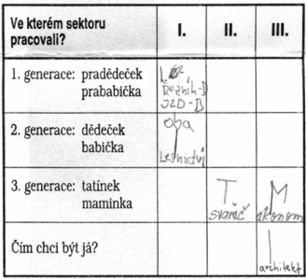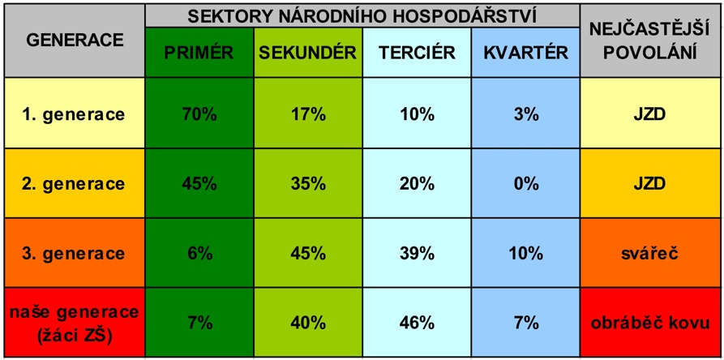
Fig. 3: Work form (left) and the resulting synthesis of research conducted by primary school pupils

The project is of great benefit to primary school pupils as well. It contributes to developing their key competences; they learn how to obtain and critically evaluate information in the selected area, carry out the field verification, propose solutions, and present and argue for their solutions at public meetings (there was a marked improvement in students’ performance of other school subjects and the marks they received). The benefits of the project can be expressed by one pupil’s statement: “I understand now what geography is, how I can use the knowledge I have gained at school and understand which skills I still need to develop.“
All the project has been a team one, including cooperative teachers, students, pupils and their parents with common ideas and practices emphasizing active role of participants however they have ben also individuals with many different personal attitudes, skills not limiting collaborative efforts. ( připsal AH)
Form(s) of learning
- Formal learning (e.g. seminar, lecture in formal education system)
- Non-formal learning (e.g. workshop, course without certification)
- Informal learning (e.g. discussion groups)
- On-line learning (for students from Masaryk university)

Learning approach(es)
- Collaborative learning
- Practically-oriented learning
- Theoretically-oriented learning
- Intergenerational learning
- Project-oriented learning
- Other:
Student center learning

Types and number of learning interactions
- inside a research group (every day by internet and every week face to face)
- between a research group and the general public/community (among decision-makers, shareholders, stakeholders, experts inside, experts outside)
- every month on Thursday an open lecture was held for the community, an open workshop for the community twice a year, and an open expedition in the local/regional landscape twice a year as well.

Innovative aspects of learning activities
Innovative and cooperative working:
- interaction between university courses (Sustainability, Urban and Rural Studies), the primary school, local and regional government, the community and the general public
- pupils from the primary school like having mediators for gaining access to the wider community.

Online Learning Activities
At Masaryk University, Brno, an e-learning platform is used as a part of an internal information system. It includes interactive syllabi with the sharing of study materials, question sets (for testing procedures) and discussion groups. More information can be found online: http://is.muni.cz/?lang=en;furl=%2Fel%2F;ag=el;so=nx. In this platform, fora are used for the sharing of documents, databases of students’ work, discussion groups, question sets, interactive syllabi etc.

In the Deblin primary school an open e-learning platform is being prepared as an educational support (see ’Funding’ below) and a local Project Website is to be commissioned during winter 2010. This website will display the issues currently being resolved within the project. Because of the informal (non-commercial) character of the website no statistics and are being collected at this time. This also correlate with the location where website is uploaded – the university servers, which do not offer detailed statistics.

Research Activities
The educational project is focused on studying (researching) the Deblin area and detailed knowledge (cognition) of the local environment. An inside understanding of community problems from local citizens’ perspectives was identified as a key approach. Geographical research of the local community, and qualitative field research, which has a strong ethnographic orientation in the sense of “thick description“ by Geertz (1993), was applied. Based on participative observation of everyday practices, the concept of deeper data is preferred which portrays the studied reality rather differently than surface data (Cloke et al., 2004).
The methodological basis of the research is the ESPECT/TODS concept (Hynek, Hynek, 2007), which enables a study of the components of social reality both in an integrated way and separately, in terms of spatiality and the emergence of power. ESPECT/TODS include six pillars of environmental sustainability/security: Economy, Society, Politics, Ecology, Culture, and Technology. One can say that the pillars are determinants functioning in the socio-cultural system. Each pillar must be regarded as a product of the other systems’ operations. The interaction of factors that develop in the area under research is not well-balanced or neutral. According to M. Foucault, the dominating factors which may cause heterotopia have spatial effects. The essence of heterotopia is represented by the nucleus of the hexagon encompassing the spatio-temporal dimension of superiority and inferiority. The innovation of this model is the usage of Foucault´s concept of bio-politics.
The importance of so-called multiple method research (e.g. Tashakkori, Teddlie 1998, 2003; Fay, 1996), or using both qualitative and quantitative techniques and paradigms within one study has been on the increase since 2000 with reference to the above resources cited. In this respect, it is important to mention the inspirational usage of abduction in geographical research. The essence of abduction consists in verification of the induction-deduction relationship through field surveys (Holt-Jensen 2001). Another concept applied is the Actor-Network Theory (ANT) by Bruno Latour (2005). ANT is included among the post-structuralist approaches that, among other things, initiate new environmental discourses; as such, it has also been increasingly used in human geography (e.g. Crang, Thrift 2000). ANT also deals with the integration of nature and society, their hybridism and separation, live participants, or actors, and inanimate actants (Whatmore 2002, Murdoch 2006). Consequently, the research methodology is based not only on cooperation between geographical disciplines but also benefits from interdisciplinary cooperation with other, non-geographical sciences, such as ethnography, anthropology, sociology, philosophy or psychology; it can be carried out as a trans-disciplinary science. Other methods and techniques: mental maps, focus group, talks, etc.

How the project functions as a learning network for SD
The idea of networking creates a very important part of sustainable development implementation in at least two senses from the point of view of the project:
- As a heterogeneous assemblage of environmental management practices
- Discourses and knowledge mutually connected among decision-makers, stakeholders, experts, etc. about sustainable development.
Foucault´s view on space, the actor-network theory of Latour, Callon and Law concerning scientific knowledge, and a deeper ethnographic study were the trigger for rethinking the role of a university in social life. Connecting a university and primary school is not so common, and involving public administration was the right step to the rural community as a main target group for embedding sustainable development in rural space. J.Murdoch (2006) was very inspirational for the project.

PROJECT DISCUSSION

Constraints
There were administrative constraints in particular from the top management of public institutions. Old school approaches were typical not only in the principality of the Deblin primary school but also in some uninformed, skeptical and critical (with no constructive solutions) entities from the public/society.

Success Factors (learning activities/outcomes meant to be counted as success)
Success factors were integrated into whole concept, which is based on the shift from a theoretical background (used as set of tools) into the practice. Success derives from several points:
- Network identification
- Discovering one’s own position
- Maintaining the power to influence network parts (nodes and vertexes)
- Preparing positions for new networking and transformation of networks

Challenges (sustainability challenge, transferability challenge, other challenges)
The main challenges are in deepening and expanding the existing concept and the possibility of creating a local action group with broad public participation. Pragmatically understood, the challenge is also in securing additional funds for project development from European public resources.

CONCLUSIONS
Results
Qualitatively oriented cooperation on the Deblin project led to findings and understanding and interpretation of the area from the situated perspective of regional actors. The involvement of the primary school is essential for sustainable development. The primary school is in the position of a gate keeper for understanding the local situated knowledge of Deblin communities in several ways. The first one is represented through the primary school educational/institutional framework that allowed the project team to work with the knowledge base, values and attitudes of the younger generation in the area of interest. The pupils gained an understanding of the principles of sustainability; and they applied the deep knowledge acquired of specific areas during fieldwork in their area. They learned to perceive the process of modifying the landscape and to understand that they are part of the landscape and are responsible for making a positive, negative or neutral impact on their area. They discussed their observations and results with the participating project members, which included an opportunity for providing feedback.
The exchange of views, while respecting the rules of debate, was part of the final public presentation in Deblin where the students and pupils shared their results from the project work with the public. This event represented an important part of understanding locally situated knowledge through the position of the primary school in Deblin communities and the school’s potential to be a relevant part of those communities. That is the second level of work with knowledge-production processes within this project. Topics which were a part of school work did not remain within the school walls only, but were discussed through the communities. The pupils were important facilitators within those processes.
The pupils showed that with appropriate support they also have the capacity to initiate solutions. The pupils’ activities helped to arouse parents’ and local residents’ interest in their locality, develop their sensitivity to sustainability principles and stimulate their active participation in the project. One can also talk about a third level of support for situated knowledge-production processes thanks to the cooperation between the different participating actors mediated through the primary school. From the perspective position of the primary school as a community center it was important to use its educational, social and cultural capital. The primary school is, especially in rural areas, the place with the highest concentration of human capital. This way of using a school’s potential could help to re/construct the school position within its communities, as well as have positive impacts on local communities.
The project proved to be of fundamental importance for the university students as well. While working with other participants they searched for unsustainable elements in an area unknown to them and proposed solutions based on a common consensus.
This project exceeded the common concept of a two-semester workshop culminating in an examination awarded by credits. Positive feedback (collected at the public presentation and discussion among academic supervisors) confirms the value of the project’s approach.
The students successfully applied their theoretical knowledge while working in cooperative multi-disciplinary teams that dealt with selected issues corresponding to their areas of interest.
The actual application of the results both on the ground and in the academic sphere proved to be an important motivational aspect of the project. Many students continue to work on the project individually in their free time. Establishing further links and cooperation with other subjects at the Geographical Institute would be very helpful for them. Therefore, besides the value of the completed research, the project has an added educational value as well.
The common approach to sustainability aims to involve the people living in this area, who influence it in different ways. The pupils´ activities helped to make the inhabitants of the town interested in their environment and develop their understanding and openness.

Lessons Learned
The team of authors has been engaged in project training, focused on urban-rural relationships emphasizing sustainability and safety of the area/landscape/region, on a long-term basis. These questions were dealt with in courses at Masaryk university in Brno: Z0131 Sustainability (autumn semester 2008) and 0132 Urban and Rural Studies (spring semester 2009).
Other lessons learned were obtained through non-formal approaches. The team prepared public presentations with lessons where pupils talked about their findings. We also prepared field activities (field mapping of Significant Landscape Components, field excursions, etc.) both for both pupils and students. Multiplication effects from the project continued to other activities and projects – Fair trade afternoons, a Landscape Behind the School project, GIS lectures based on the peer-to-peer approach, public events connected to the results of pupils’ field work, a project of learning innovation financed by EU, etc.

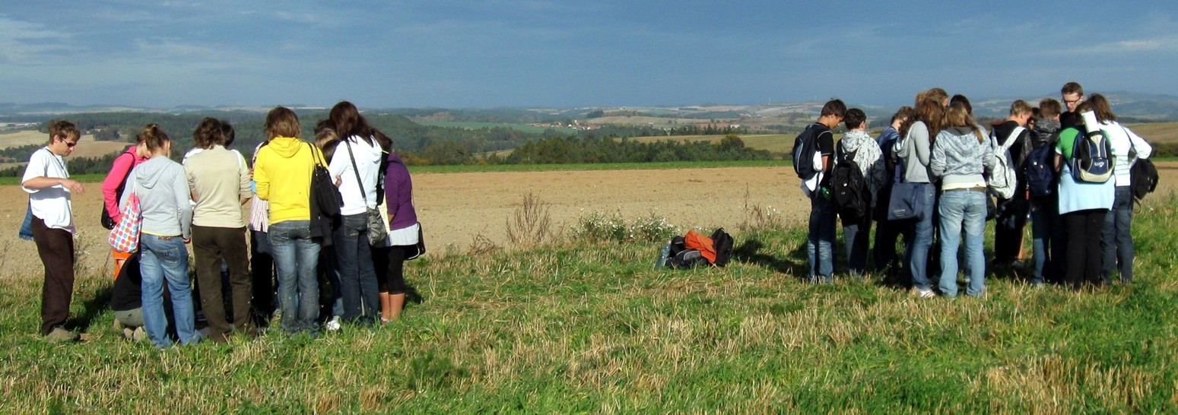
Fig. 4: Terrain excursion centered on Significant Landscape Components in the Deblin area; students of Masaryk University as instructors

Impact on Sustainable Development
Social Sustainability: communities are formed by their socially constructed identities, which are principal to an understanding of their practices. Since we are able to understand the practices and processes of a social construction of identities, we will be able to strengthen those leading to the sustainable development of communities connected to their localities.

Environmental Sustainability: one of the basic processes connected to a socially constructed identification with a locality is embedding. It is represented by everyday practices connected to places and landscape. Orientations toward the secure and sustainable development of the life of communities in their localities pay attention into well-judged planning and practice in their natural environment.

Economic Sustainability: driving falls which is shaping the landscape is economy. This statement demonstrates that the economy is a necessary condition of sustainable development. Communities practicing economic autarky are able to identify, activate and use their endogenous potential with a smart combination and use of global possibilities toward their own sustainable and secure glocal strategy.

Cooperation/coordination: between the aforementioned impacts of the project on the sustainable development of the area there is primarily one which is necessary to ensure the results of the project remain sustainable within the area of interest. After the process of internalization (within the project) which allows the social, environmental and economic aspects to change the strategies of local communities, those strategies need to be coordinated in a manner that allows them to be institutionalized within the life of local communities. It is not only a question of building a functional project network. It is also necessary to coordinate the project in the direction of creating a mechanism which allows the coordination of a project through feedback from the project’s results. To attain this goal /support/cooperation is needed not only at the local level, but also at the regional and global level.

Dissemination of the project have several formats. First of all the public presentation of the outputs in Deblín cultural house with broad public participation, local government included. Secondly the dissemination were written and published in the several journals (e.g. Journal of Tourism, Hospitality and Commerce, Envigogika), conferences (IGU Barcelona …) and relevant websites.

References:

Alcamo J. et al. (2003): Millennium Ecosystem Assessment. Ecosystems and Human Well-being. A Framework for Assessment. A Report of the Conceptual Framework Working Group of the Millennium Ecosystem Assessment. World Resource Institute, Island Press, Washington, 266 pp.
Cloke, P., Cook, I., Crang, P., Goodwin, M., Painter, J., Philo, C. (2004): Practising Human Geography. Sage Publications, London. 416 p.
Crang M., Thrift N. (2000): Thinking Space (Critical Geographies). London: Routledge. 384 p.
Fay, B. (1996): Contemporary philosophy of social science: a multicultural approach. Cambridge, Massachusetts: Blackwell Publishers. 277 p.
Geertz, C. (1983): Local knowledge: further essays in interpretive anthropology. New York: Basic Books, Inc. 244 p.
Holt-Jensen, A.: Geography – History and Concepts. A Student´s Guide. 3rd ed. SAGE Publications, London. 2001. 228 p.
Hynek, A., Hynek, N. (2007): Bridging the gap between the theory and practice of regional sustainability: a political-conceptual analysis. Bratislava, Geografický časopis, Vol. 59, No 1., pp. 49-64.
Krathwohl D. (2002): A Revision of Bloom’s Taxonomy: An Overview. Theory into Practice, Vol. 41, No 4., p. 212-218.
Latour B. (2005): Reassembling the social- an introduction to actor-network-theory. Oxford: Clarendon. 328 p.
Lynch, K. (1960): The Image of the City. Cambridge, Massachusetts: MIT Press. 202 p.
Murdoch, J. (2006): Pos-structuralist geography - a guide to relational space. London, SAGE publ. 220 p.
Tashakkori, A., Teddlie, Ch. (2003): Handbook of mixed methods in social & behavioral research. SAGE Publications, Thousand Oaks. 768 p.
Tashakkori, A., Teddlie, Ch. (1998): Mixed methodology: combining qualitative and quantitative approaches. SAGE Publications, Thousand Oaks. 185 p.
Whatmore, S. (2002): Hybrid Geographies. Natures, Cultures and Spaces. Sage, London. 225 p.

KEY SUCCESS-INNOVATION
- Combination of primary and tertiary education under a framework of public participation
- Identification and mobilization of key actors and endogenous development potentials of local communities through a local primary school
- Empowerment of (local/regional?)decision processes influencing local sustainability
- Implementing participative approaches and glocalization strategy into ordinary life
- Implementing modern technologies (like advanced GIS) combined with post-structuralist points of view and methods into locally resided spatiality
- Practical implementation of LENSUS knowledge triangle of education+research+inovation for regional sustainable development
- Balancing rural insiders and outsiders in knowledge-power assemblages
- Critical side-benefit of the project is raising the public awareness of the local population watching the youngsters to pay a pragmatic respect to and interest in the local environment.

