
Home | Contact Us | A-Z | Help

Homepage > Advice & support > for regional bodies

 | Advice & support for regional bodies
- Home  - Advice & support  - For householders  - For business  - On education  - For the community  - For regional bodies  - For local Government  - Funding  - Volunteering | This page provides information about the way in which the English regions can deliver sustainable development. Follow the links below for more information:  - English regions boost for 'one planet living'  - Strengthening regional delivery  - What is the role of the key regional players?  - Regional Sustainable Development Frameworks  English Regions boost 'one planet living'  As part of Securing the Regions' Futures, Defra has supported each of the 9 English regions in taking forward a range of exciting activities and projects which will help contribute to 'one planet living' and tackle climate change. Each region has made its own new pledge which will galvanise efforts towards achieving 'one planet living'. Each regions aspirational goals / pledges can be seen below:  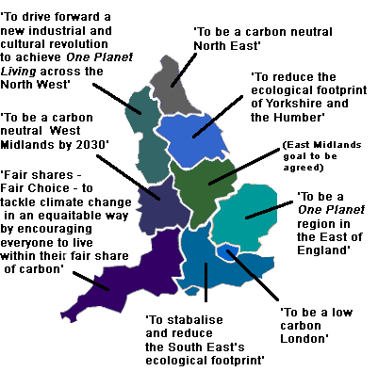  The Regional Sustainable Development Roundtables, Regional Assemblies, Regional Development Agencies and Government Offices are all working together to make these pledges and projects happen on the ground. Defra's contribution of pump-priming funding has attracted over £1,900,000 in match funding from other sources to support a range of activities and projects in each region which will help deliver these aspirational goals. The list of projects can be downloaded below, they can be viewed by theme or by region:  - List of projects / activities by theme (PDF, 41kb)  - List of projects / activities by region (includes contact details for the Regional Sustainable Development Roundtables) (PDF, 32kb)  Strengthening Regional Delivery  The 2005 UK sustainable development strategy sets out a number of commitments to strengthen regional leadership. One of these commitments included inviting the Sustainable Development Commission (SDC) to undertake a review of regional delivery. The Next Steps: An independent review of sustainable development in the English Regions sets out the SDC's findings.  Securing the Regions' Futures represents the Government's response to the SDC review and sets out 20 commitments to further strengthen regional delivery.  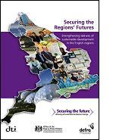  The report was compiled jointly by the Department for Environment, Food and Rural Affairs, the Office of the Deputy Prime Minister and the Department of Trade and Industry. The report highlights the valuable contribution the regions have already made to sustainable development and how they will balance and integrate economic, social and environmental considerations in future. The report aims to provide an enabling framework for enhanced regional delivery of sustainable development.  Key elements include:  - Strengthening and clarifying the role of the Government Offices in delivering sustainable development, through embedding sustainable development across their organisations and operations in line with their new strategic role.  - Supporting the role of Regional Development Agencies and Regional Assemblies in delivering sustainable development.  - Supporting a strengthened role for regional sustainable development roundtables as 'champion bodies'.  - Providing new guidance "Essential Ingredients" to underpin regional high-level strategies (i.e regional sustainable development frameworks, integrated regional strategies and integrated regional frameworks).  - Promoting city-regions, sub-regions and inter-regional strategies to maximise delivery of sustainable development and promote joined-up working.  - Showcasing best practice on sustainable development in the regions a year on from the launch of UK Sustainable Development Strategy: 'Securing the Future'.  What is the Role of Key Regional Players in relation to Sustainable Development?  The Government established Regional Development Agencies (RDAs) to be the strategic drivers of sustainable economic development and to have an influential role in the business community in the English regions. The RDAs have a statutory duty to contribute to sustainable development in the UK and prepare Regional Economic Strategies (RES).  A joint RDA / Defra publication called 'Smart Productivity' (PDF, 4.1MB) was published in July 2006, which reveals how investment in sustainable development initiatives can contribute to long term economic growth, environmental sustainability and social inclusion.  Regional Assemblies scrutinise the work of RDAs and have a statutory duty to prepare Regional Spatial Strategies. They also play a leading role in work on integrating regional strategies and drawing up Regional Sustainable Development Frameworks (RSDFs) with key players and a wide range of regional expert groups and stakeholders.  London has different governance arrangements and has the Greater London Authority, which is made up of a directly elected Mayor and a separately elected Assembly.  Government Offices (GOs) represent central Government Departments in the regions. They work with regional partners to ensure the joined-up delivery of the policies of 9 departments, all of which contribute to sustainable development. Regional Directors of Public Health and their teams work with the Government Office to ensure that the public health dimensions of sustainable development are promoted and considered across a range of different policy areas. They will also work with Strategic Health Authorities to encourage links between RSDFs and the NHS.  Regional Sustainable Development Frameworks (RSDFs), Integrated Regional Strategies (IRS) and Integrated Regional Frameworks (IRF).  The Government believes that the regions are best placed to determine the high-level strategy arrangements they think are most appropriate and that Regional Assemblies should continue to take a lead with partners in establishing these arrangements. However, the Government does not require regions to produce separate RSDFs, IRFs or IRS and it believes there are opportunities to rationalise these documents. Though regions have discretion over the names and numbers of these types of high-level documents, the Government firmly believes that the arrangements in each region must be fully in line with the UK Sustainable Development Strategy, and that this can be achieved by incorporating the 'essential ingredients' listed below. The Government expects Regional Assemblies and other regional partners to fully take into account the UK Sustainable Development Strategy and the essential ingredients below, when they review or prepare their high-level regional strategies.  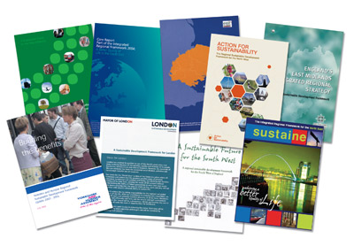
  Essential ingredients on sustainable development for regional high-level strategy / strategies
  - Evidence Base : The region's current and future challenges are clearly set out based on robust social, economic and environmental data, trends, scenarios or analysis. This includes regional data for the national sustainable development indicators and other regional sustainable development indicators.
  - Stakeholder involvement : In taking account of these ingredients and preparing high level strategies in the region, regional stakeholders from social, economic and environmental interests and from all sectors are engaged in the process.
  - Integrated Vision : A shared, overarching and long-term vision for the future of the region is clearly articulated, based on the region's challenges and opportunities, and which integrates the region's social, economic and environmental priorities. The vision is consistent with the national priorities and principles set out in Securing the Future .
  - Aims and objectives : Clear aims and objectives are identified, which will help implement the shared vision for the region's future. These attempt to reconcile strategic issues / conflicts facing the region and move the regional and national headline sustainable development indicators in the right direction. The aims and objectives make the relevant links across regional social, economic and environmental issues and have regard to the priorities and principles in Securing the Future . Clear links are made between other relevant regional and local plans.
  - Indicators, actions and targets : Targets are identified along with accompanying indicators and actions in order to address unsustainable activities / negative trends and meet the region's aims and objectives. Clear links are made to related actions, indicators or targets in other regional or local plans. Actions have owners and timescales identified.
  - Monitoring and reporting : arrangements are identified for monitoring progress on implementation and for reporting to regional stakeholders and the wider public. Monitoring and reporting arrangements capture the region's contribution to delivering the priorities in Securing the Future .
  - Sub regional and local levels : links are made between the 'ingredients' above and the opportunities offered by sub-regions, city-regions and local Sustainable Community Strategies / Local Area Agreements, to help contribute to national and regional sustainable development priorities.
  - Sustainability appraisal : A sustainability appraisal has been conducted on the high-level strategy / strategies in line with available best practice.

