Environmental targets and measures in the strategies and programmes of regional development in the Czech Republic

Alois Hynek, [hynek@sci.muni.cz], Masaryk University Brno, www.geogr.muni.cz/cz/ustav/
Jan Trávníček, [jan.travnicek@mail.muni.cz], Masaryk University Brno, www.geogr.muni.cz/cz/ustav/

Abstract

The presented article examines the state of environmental politics in the Czech Republic, specifically the Moravia Region. This issue area is connected to more theoretical questions of how to understand the relationship between the environment and politics. Thus, after an analysis of the Czech environmental legislation, two related theoretical lenses are discussed: political ecology and environmental security. As will become clear from the discussion, the conceptual distinction which is relevant in this context is of the link between landscape and spatiality. What follows is an outline of an original synthesizing scheme with dimensions. The second part of the article uses the above insights to shed light on spatial landscape ecosystems in South Moravia region of the Czech Republic. In concrete terms, environmental targets and measures of regional environmental development are scrutinized. The article is summed up in the conclusion.

Acknowledgements: The authors would like to thank two anonymous reviewers and the journal editor, Kostis Koutsopoulos, for their perceptive comments on an earlier version of the article.

Key words: regional development, environment, cultural landscape, targets and measures

- Introduction

With respect to the Czech government resolution # 235/98, dated on April 8th, 1998, including the Czech government´s regional policy principles´ new administrative division of the Czech Republic was approved by the Parliament as higher regional self-governing units (HRSGU, kraje in Czech, Act # 347/1997, Statute Book). Their main purpose has been proposed for balance regional development and gradual reduction of their economic and social disparities. In the years 1998-2002 strategies and programmes for regional development of HRSGU were elaborated proposals in further reference to National Strategy of the Czech regional development and sector operational programmes. The main parts of regional strategies were: economic development, social development, culture/education, infrastructure logistics, environment, tourism and external relations.
Teams of experts used methodology as standard practice in EU interpreted for the Czech Republic by DHV Czech Republic (A. Kutscherauer, M. Hučka, 1998) containing sources, organizations, institutions, tools, plans, sector and regional programmes running to implementation, recommendations in targets and measures. This paper recapitulates the experience in control boards, regional coordination group and expert groups based on negotiation and facilitation. The research question posed is the following: How to think about landscape ecosystems and what has been their presence in the South Moravia region?

- Czech national environmental agenda

Shortly after 2002 the new aims and objectives for environmental policy were stated in The Czech National Environmental Policy in the years 2004-2015 and incorporated into regional development strategies and programmes of HRSGU:
- NATURA 2000 – areal regimes and management (including SEA technique)
- EIA/SEA respecting EU Directive 2001/42/ES and Aarhus Convention
- Action plan and monitoring nitrogen pollution of water caused especially by agrochemicals
- Waste recycling including not only collecting sites but also environmental education
- Reduction of toxic substances in surface and underground water
- Fluvial ecosystems management respecting EU frame directive 2000/60/ES and 2001/42/EC – monitoring and planning, measures, public hearing
- Sewage water treatment plants construction and reconstruction (nitrogen and phosphorus reduction)
- PCB/PCT inventory and inspection, decontamination and deactivation
- Biologically decomposable solid communal waste salvage, separation and composting
- Air pollution reduction in integrated programmes and local plans
- Achieving 8% share of renewable energy resources in electricity consumption

- The Politics of Political Ecology or Environmental Security?
Recent scholarship on the link between the realm of politics and environment is fragmented. The two most recognizable strands are represented by the discourses on political ecology and environmental security. After their definitional and conceptual analysis, one realizes that these two discourses significantly overlap. Why, then, not to have just one? The explanation becomes obvious when the disciplinary affinity of contributors to these discourses is examined. While political ecology has emerged as a subfield from the discipline of geography, environmental security can be seen as an issue area burgeoning within the confines of the disciplines of Political Science and International Relations, namely so-called Critical Security Studies. Disciplines thus play the role their name suggests: discursive policing, or disciplining. (Foucault 1981)
The term political ecology can be understood in many ways. From the “managerial perspective”, it is deemed to concern the social and political conditions surrounding the causes, experiences, and management of environmental problems. (Blaikie and Brookfield 1987) Another account tends to conflate it with the term “politics of ecology” referring to political activism and social movements embracing Deep Green Environmentalism. (Atkinson 1991: 18) Finally, as Peter J. Taylor and Brian Wynne (1979: 20) propose, political ecology should be seen as the politics of the application of ecological science. However, none of the above perspectives study the relations between the field of political ecology and philosophy of science and sociology of knowledge. As a result, valuable insights of science studies or science-policy are avoided. A definition compatible with the aim of this article is provided by Tim Forsyth (2003: 4) who suggests that the term “critical” political ecology “may be seen to be the politics of ecology as a scientific legitimization of environmental policy.” Such a definition is highly relevant inasmuch as it takes onboard the idea of socially-constructed science, be it constructivist empiricism, scientific realism or interpretivism. It imagines both nature and ecology as socially constructed objects – even though of different kind, thus leaving space for their deconstructions.
Reflecting on the term environmental security, an evolution of the term in the meaning we nowadays understand it can be explicated by focusing on the disciplines of Political Science and International Relations and their intellectual development after the Cold War. (for the overview of original scholarship on environmental security in the 1980s compare Dalby 2002: 16-19) The subfield of security studies has been largely transformed from the realm previously almost exclusively dealing with the notion of national security into the more diverse waters. The major transformation has consisted in so-called “deepening” and “broadening” of security. With regard to “deepening”, the referent point is no longer the nation state, but also individuals, communities, or global ecosystem. What is more, the “broadening” of security studies leaves us with at least five different sectors – political, economic, societal, environmental, and military- instead of an originally dominant military sector. (Buzan, Waever and Wilde 1998; Krause and Williams 1997) As a result, a distinct research agenda of environmental security emerges. It can be pointed out that environmental security directly challenges previously dominant ontology of the nation state and is largely based on an ongoing anthropological turn, which has opened up a larger canvass of questions appertaining to who is insecure and what their sources of insecurity are. (Dalby 2002: xxiiii) Not only ontology undergoes a significant shift – epistemology follows and reflects the fact that in order to understand a socially-constructed production of danger, interpretive epistemologies and methodologies need to be employed. (Duvall, Weldes and Laffey 1999)
Both portrayed discourses intersect in their attempt to investigate the connection and interplay between previously separated scientific and political agendas; as the point of departure, both of these agendas are treated as social constructs. What is challenged is the perception that tenets of environmental politics can be separated from assumptions and principles of environmental science. The strategy of examining both agendas as largely independent, stems from the conviction that politicians (or political scientists in their roles of political advisers) do not need to understand the issue in its biophysical substance. The fallacy of this point of view is to comprehend science detached and isolated from the realm of political practice, thereby avoiding the politics in the creation of the science itself. (Forsyth 2003: 9) One can invoke Foucault’s notion of the power/knowledge nexus and the way, how one shapes another. These insights have been extended and served as the basis for the construction of the discipline of science studies and sociology of science. It is through the above disciplines that coproduction and hybridization come into being as primary objects of study. Sheila Jasanoff (1996: 393) defines coproduction as “the simultaneous production of knowledge and social order.” Similarly, Bruno Latour (1993) analyzes the emergence of “quasi-objects” on the interface between nature and society. Ecological facts and discourses require for their existence political practices pertaining to environment and vice versa; put it simply, they are mutually embedded, or in the terms of reflexive sociology mutually constituted.
One of the ways through which scientific agendas and political agendas interact is the process of securitisation. Securitisation can be understood as “the move that takes politics beyond the established rules of the game and frames the issue either as a special kind of politics or as above politics.” (Buzan, Waever and de Wilde 1998: 23). It is relevant to say that securitization does not work according to some real, out-there type of threat, but in fact, every issue can become an object of securitization by being lifted from the level of non-politicized to the level of securitized. As one can imagine, the use of scientific knowledge plays very often a crucial role in reframing a given issue and presenting it in a different cognitive frame. The important fact is that the level of securitization of the issue does not equal to the level of politicization of the issue. While the latter would enable the issue to become an object of political debates and political negotiation and bargaining process, the former guarantees to securitizing agents (i.e. who securitizes the issue) a type of ´monopoly´ to present the issue as threat and priority and consequently as a taboo that cannot be an object of political debates. What one faces is therefore a socially constructed and intersubjectively imagined importance framed as a threat that consequently materializes, the threat becomes real.

- What Is Landscape Spatiality, or Spatialities of Landscapes?
Landscape is a common word but also a geographical term. In the use of the latter it has been used very broadly in various contexts: to give but one example, landscape can be understood as an intersection of individual, formal or generic meanings, which are – in our point of view juxtaposed, not contradicted. Landscape is said to represent scenery, or sometimes is denoted to an observed or observable territory in a single view.
Cosgrove (1998) has maintained that landscape is more about the way one sees things, than as a ready image or object. Writings of both Barrows (1923) and Hagget (1983) lay emphasis on the process of forging a relationship between people and land, with human environment as a resulting object of study and human ecology as a discipline studying the former.
A different perspective is offered by C. Troll (1939, 1970) who investigated in his works the complex of causal and reciprocal connections between biological communities and their environment in a particular section of landscape. Troll’s usual analytical level was the pattern of landscape ecosystems at choric/regional level. The paramount objective of such a point was to create a unifying approach which would eventually merge natural science with social geography. It is in this context that the notion of complex metabolism between nature and society underpinned by processes of reproduction and consumption is introduced.
Landscape spatiality can also be understood through an idea of territorial infrastructure. Such infrastructure is constructed as a vital organizational landscape to facilitate social production and reproduction. Relationship between economic production, social reproduction and political governance are constantly reconstructed, or in flux: Be it deindustrialization, urban sprawl, role of the cities – e.g. the shift from welfare to workforce. Cities are replacing states in the construction of social identities, they are landscapes of social production rather than reproduction (cf. Taylor 1996).
The perspective of landscapes as distinct associations of forms, specifically between a physical and cultural dimension, is taken by C. Sauer. The author uses structurationist theory of Giddens, introduced earlier on, to demonstrate that landscapes are products of cultures and also reproducing them through time. In other words, every cultural region includes its matching landscape. This perspective is further elaborated in the strand of human geography drawing on cultural studies with its use of iconography and text metaphors for perceiving and imagining landscapes (cf. Cosgrove and Daniels 1988, Duncan 1988). M. Crang (2001) explicitly talks about double encoding of landscapes: Landscapes are understood as wrapped in another representation, characterized by a simultaneous existence of multiply environments, as a bank of cultural memories. There is also a moral subtext to all the above since landscapes are seen as properties and an ethical argument that they should be owned by those beholding it is being articulated. The process of capturing and controlling the land thus occurs in a non-material way, through their representations in maps and in paintings as well as through fashioning landscapes on the ground using design and architecture. The landscape then, far from being neutral and inert, has social and cultural meanings, a symbolism, hence the word iconography.
In contrast to this approach of understanding landscape spatiality stands out the perspective of land management framed by state and shaped by economy (cf. Blaikie 1985). This perspective has been paying a lot of attention to the discourse on management; problems of landscape can be solved through problem-solving managerial practices of experts. An important question of how politics as policy of resource management and how control over the environment is discursively constructed immediately crops up (Moore 1995, Leach and Mearns 1996).
Moreover, there has been a motley bundle of geographers who have been paying attention to both economic/material processes and discursive constructions, with their interplay as the central issue. M. Crang (2001) evokes the notion of palimsest with the landscape as the record of change: Cultural values change so new forms are required. This process is said to include past practices and knowledges and features series of layers - abiotic, biotized, biotic, anthropized, anthropic, and noospheric. Cultural landscapes are concurrently conceptualized as other spaces/places: They are constructed both materially and discursively, with each construction affecting the other (Allen, Massey, Cochrane 1998).
Finally, we cannot omit Foucault’s contention asserting that the operation of power or the constitution of subjectivity is always connected to an examination of how power, space and subjectivity entail production of space. This idea has been consistently pursued by B. Latour (1993) who coined the term spatialization. According to this author, spatializations are not just physical arrangements of things, but spatial patterns of social action, kind of embodied routine, as well as historical conceptions of space and world. Landscapes are subsequently described as concrete instances of spatialization.
Landscape tradition in Czech geography is very short and as a subject of study belongs almost exceptionally to physical geography while regions are studied mainly by human (in Czech geographical terminology - by social geographers, but in the international sense – human geographers). After XI/89 more attention is paid to urban and rural studies.

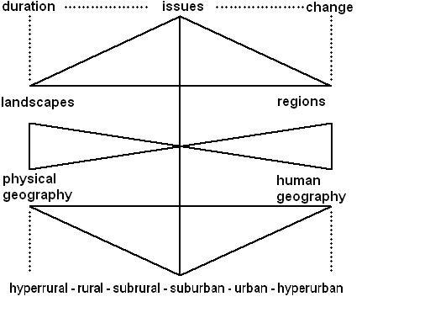
Fig.1: Domains of Czech physical and human geography

- How many pillars to have for sustainability?

The current concept of sustainability is a favourite bone of contention between its defenders and opponents. In defiance of the latter, it is still a living theme. Our contribution appertains to the deepening of the conduct of sustainability by several ideas and practical illustrations.
Having been inspired by the above authors, we advance a model of sustainability in spatial sense – ESPECT/ TODS. The matrix of the model consists of six main poles through which ´reality´ is often depicted, though usually in isolation from one another: E(conomy)-S(ociety)-P(olitics)-E(cology)-C(ulture)-T(echnology). The strategy to arrange them in a hexagon represents an effort to overcome this usual isolation and lack of interconnectedness (i) as well as to emphasize the equality of each and every node (ii). In other words, these poles, or nodes, are artificial subsystems which try to paint ´reality´ through their own intellectual categories and tools. One needs to bear in mind, however, that while science is rough, life is delicate and it is the practice of writing that rectifies this distance (Barthes 1978).
This is what the outer circle signifies – the wholeness, unity, or synthesis through a two-way rotation which implies the need to overcome the dogma of six artificial points of view. The strength of this framework in regard to the outer circle and its underlying hexagon is grounded in the need to hybridize and thus synthesize findings of otherwise six isolated subsystems into a single account; we constantly need to be reminded and aware of the fact that phenomena out there are not created through isolated intellectual subsystems, but are, in fact, coproduced.
As far as the inner rhombus with nodes T(emporality)–O(ppression)–D(ominance)–S(patiality) is concerned, it is based on two sets of dyads (T x S; O x D) and its function is to explore simultaneously spatial and temporal effects of power/knowledge nexus. The oppression-dominance dichotomy can be spatially understood as the relationship between centre and periphery, and temporally as real and imagined lived space in between them. It is also the case with respect to the rhombus that the unity and synthesis is being sought – this effort is again inscribed through a two-way rotary mechanism of the inner circle.
Finally, the inclusion of both the hexagon and rhombus into a single framework reflects the necessity for the researcher of investigating ESPECT and TODS as parallel, complementary and interconnected systems since it is not only through the synthesis of nodes, but also through an examination of processes which coproduce these geometric arrangements, that we can get a better grip on physical, social, and imagined ´reality´.

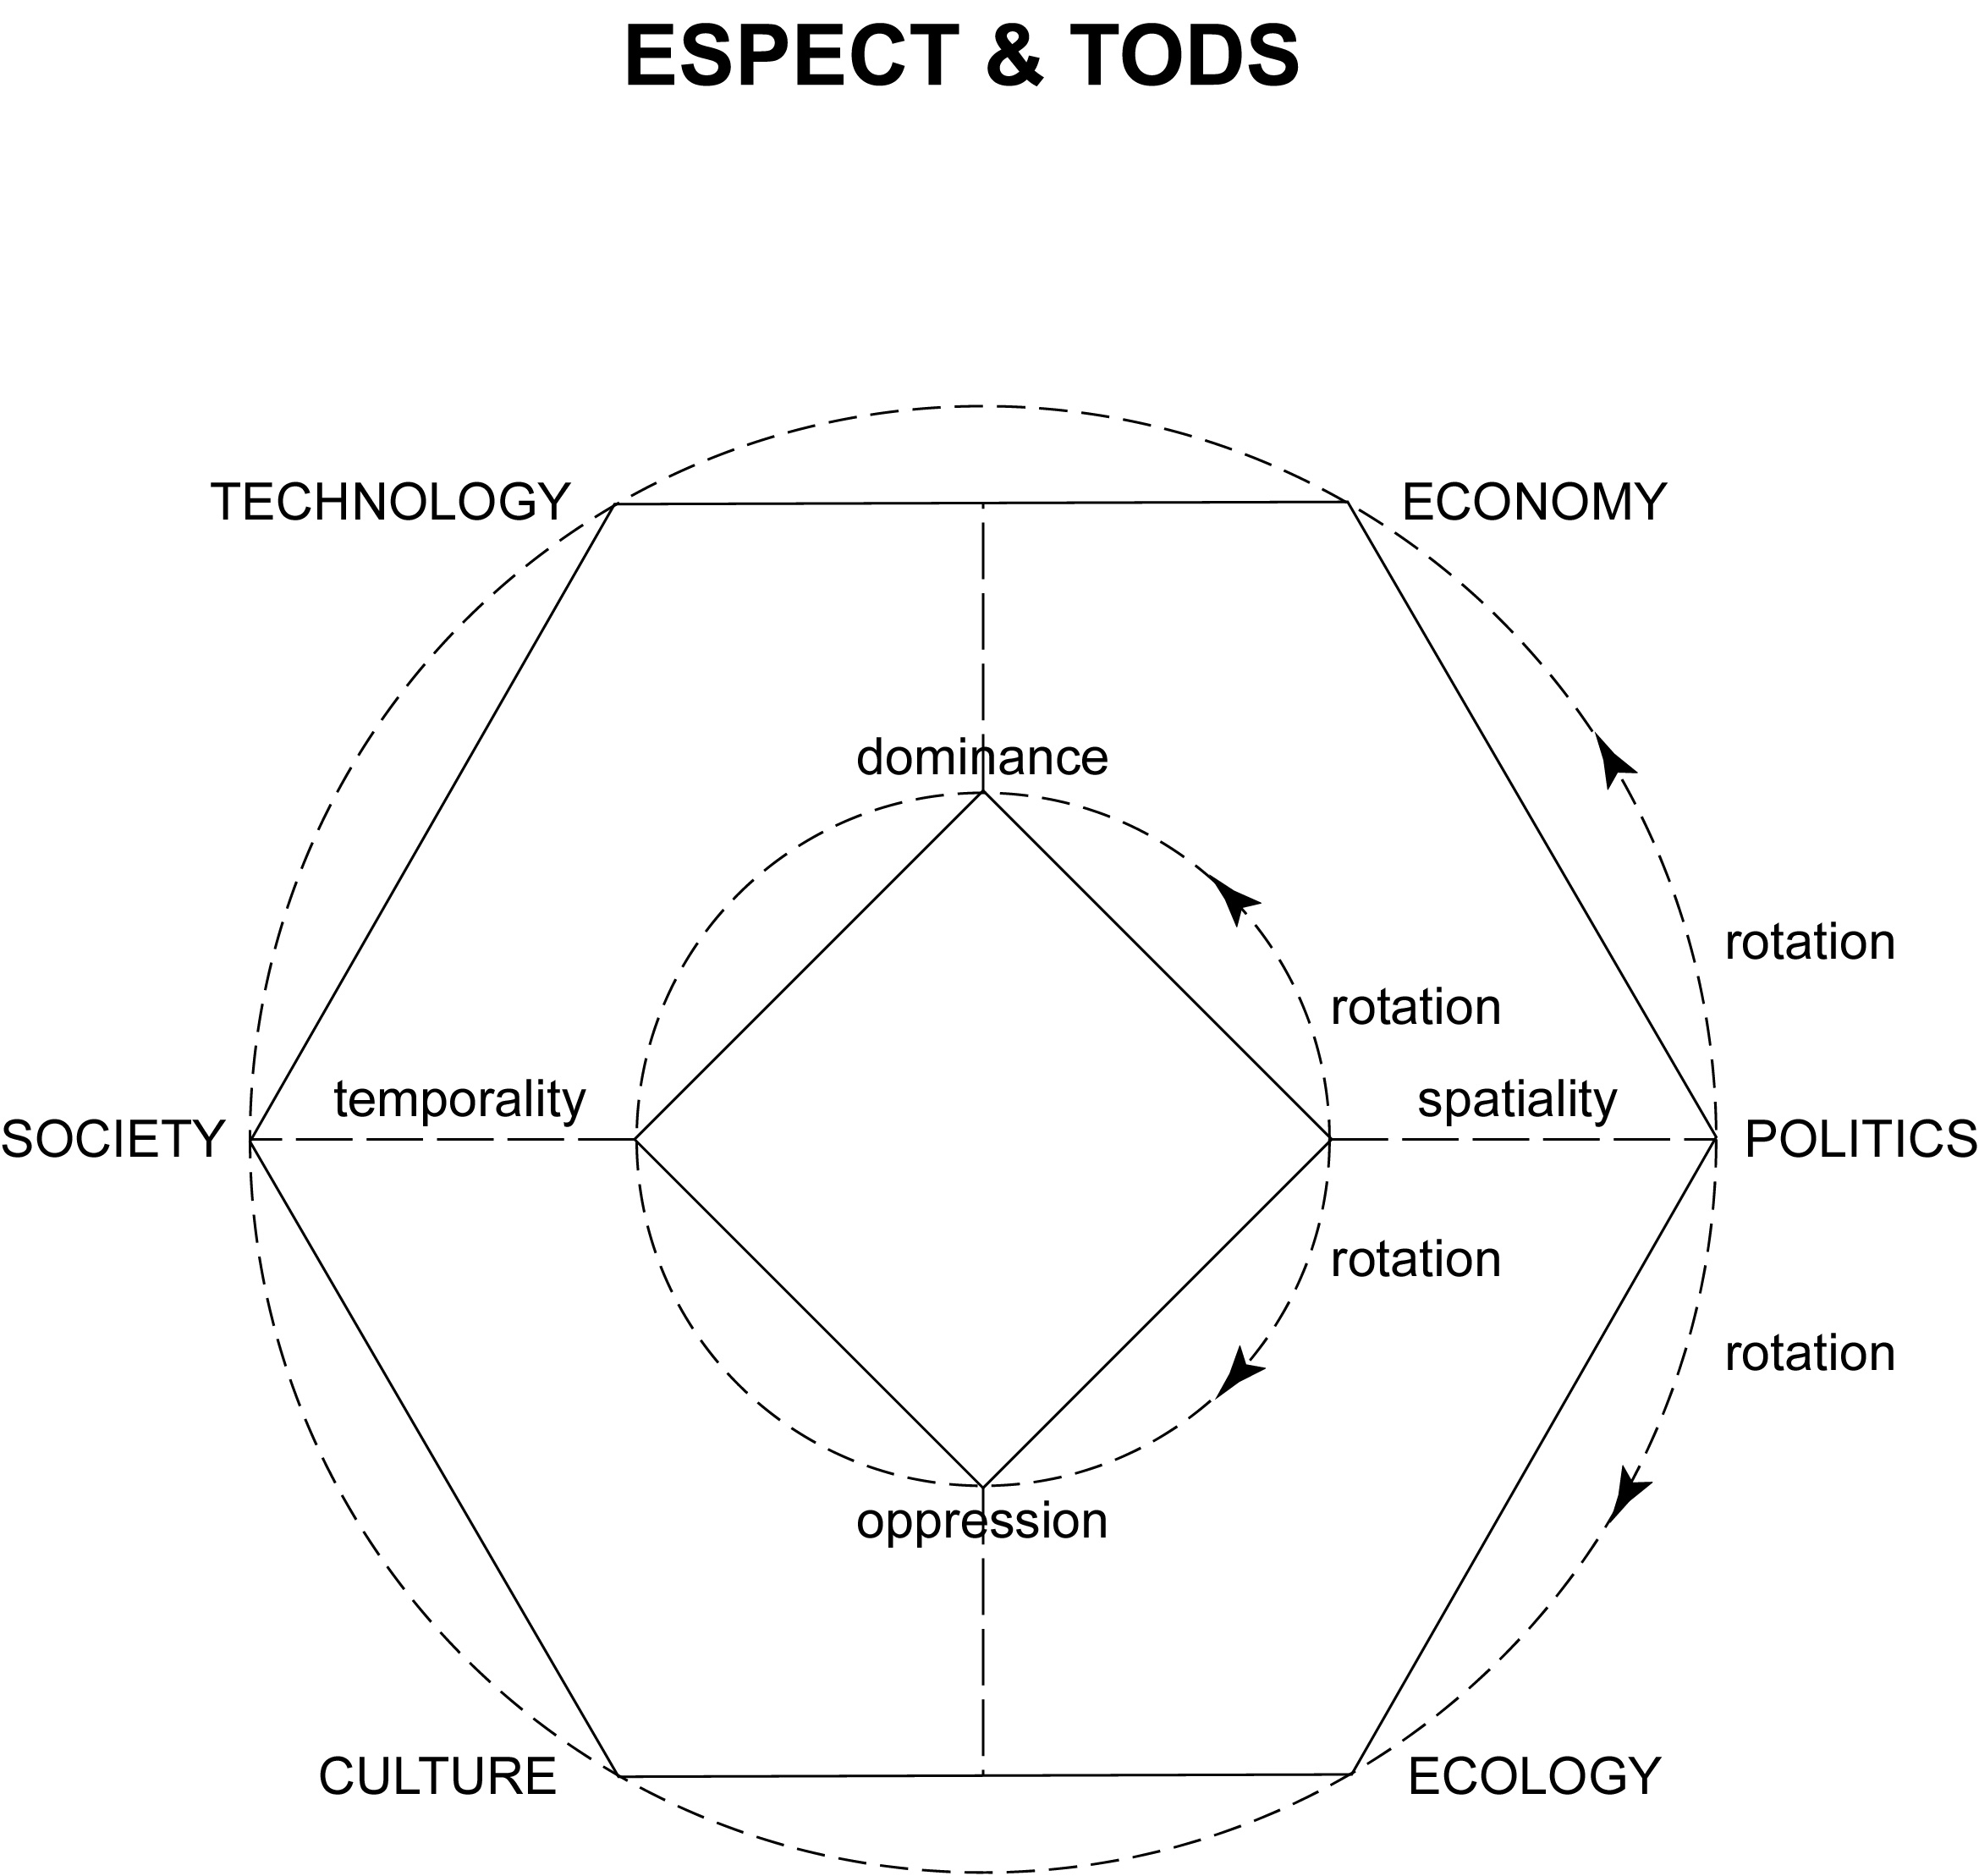

Fig.2: ESPECT & TODS

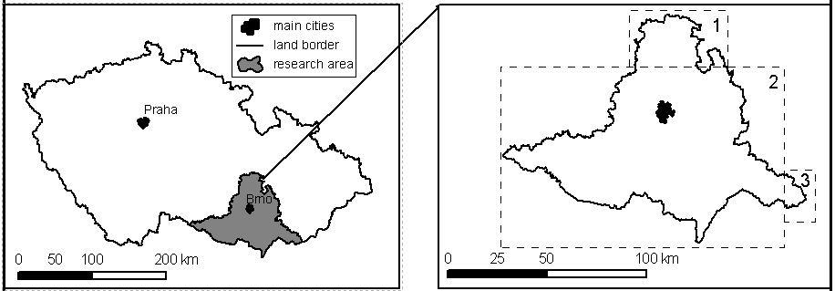

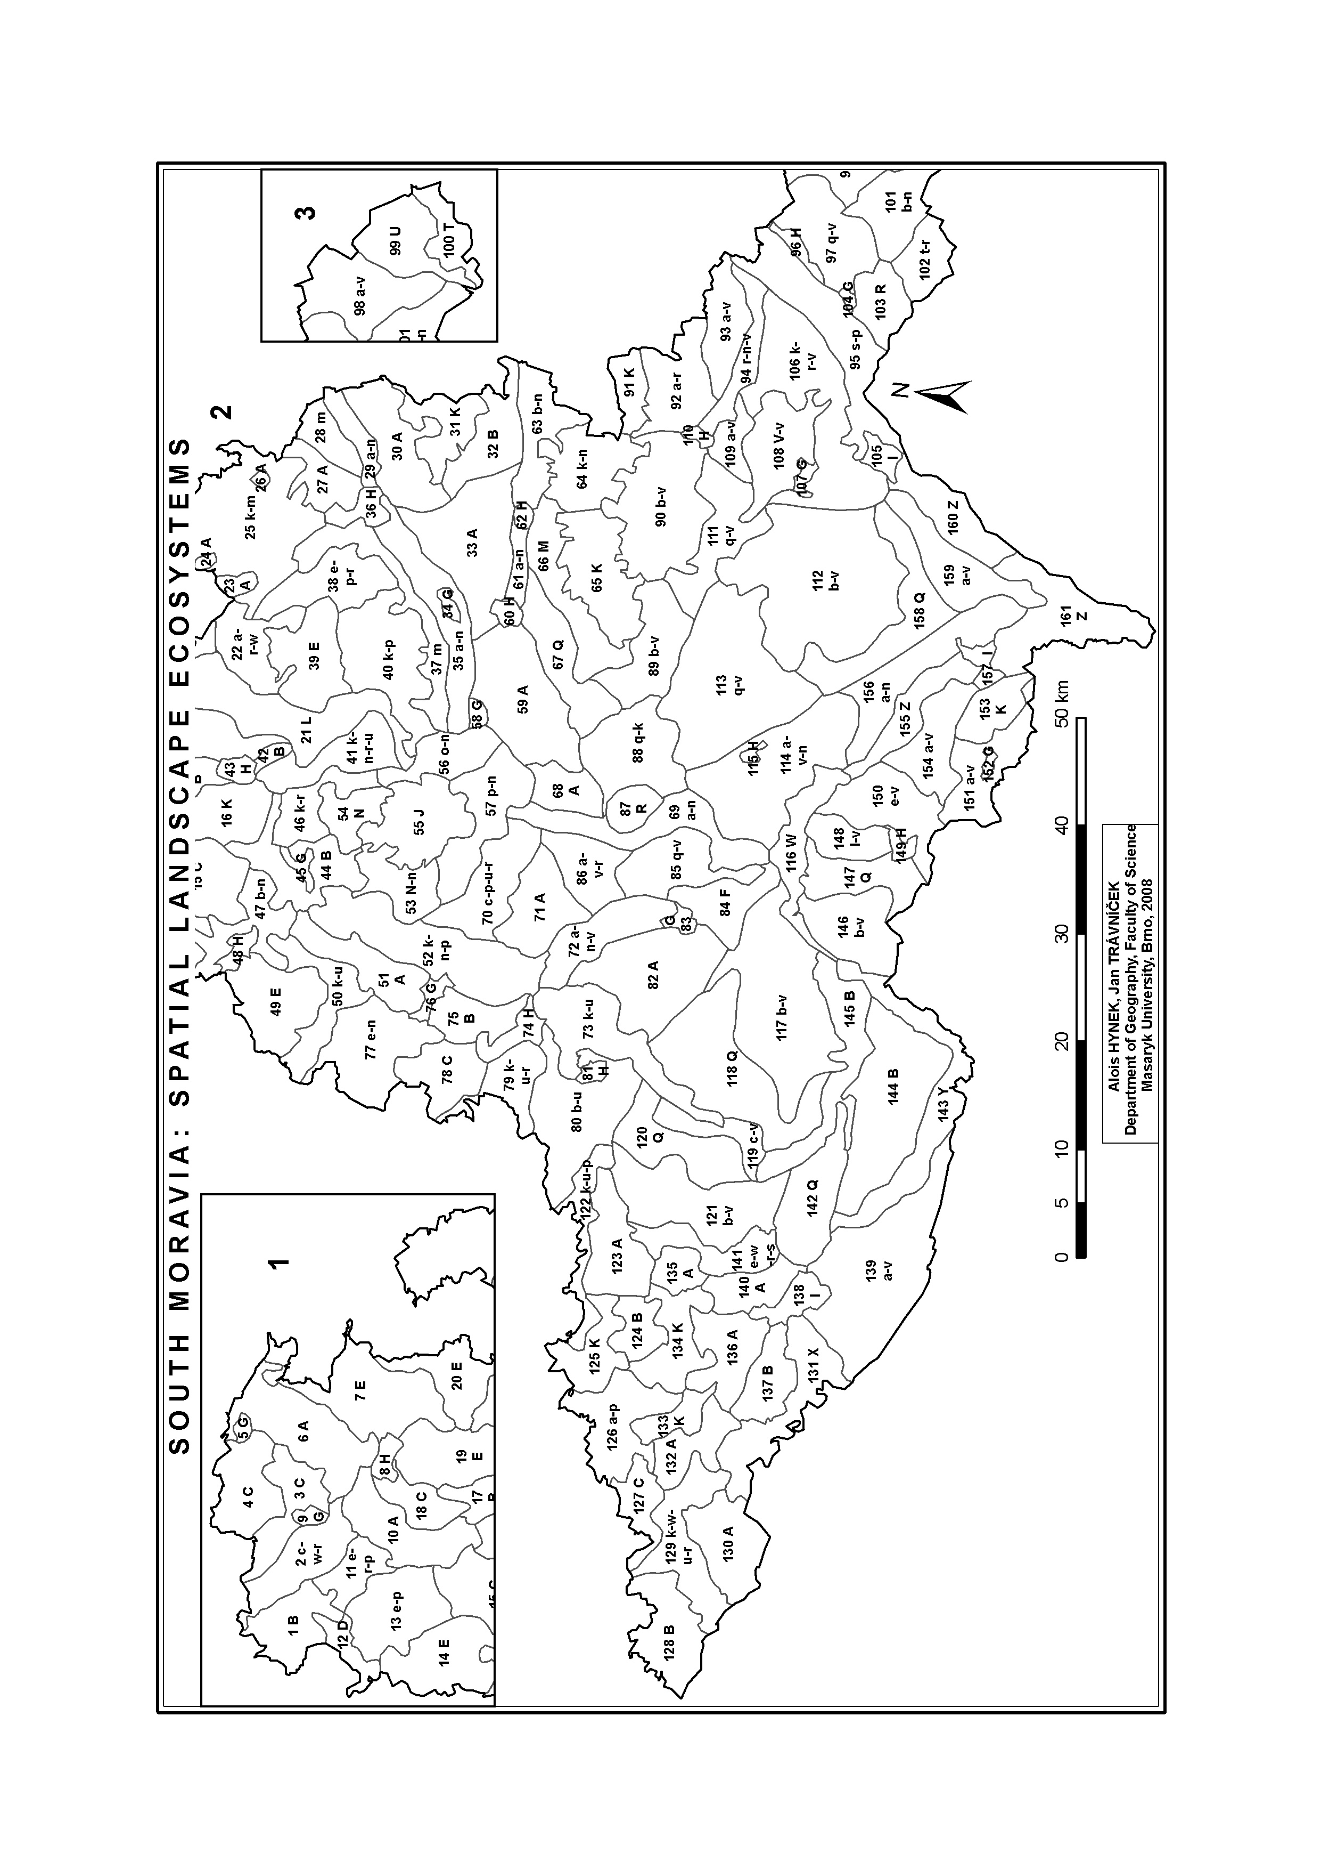

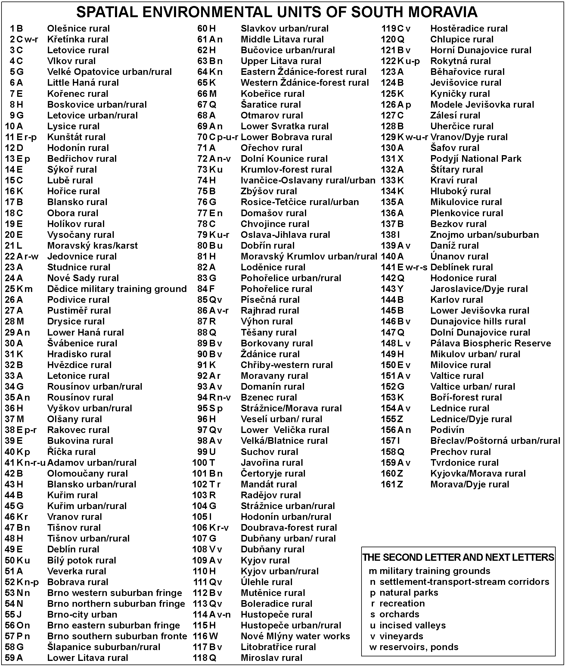

Table 1. List of South Moravian environmental spatial units (see the map)

Primary domain A: Environment
Complete target of priority domain:
Protection and improvement of environmental quality in South Moravia as a basic principle of sustainability, reduction of pollution especially in watercourses and reservoirs
Specific targets (ST)
ST 17. Restoration of small and medium watercourses, taking precautionary measures against floods
Activities
A1. Revitalization of water ecosystems and multiple use of watercourses
To support processing projects which concern revitalization of water ecosystems – riverbeds, riversides, floodplains with wetlands, in conformity with money funds of State Environmental Fund, Ministry of Agriculture and water catchment managements in subsidy titles for the years 2007-11. To comprehend issues of watercourses and reservoirs as part of wider topic – wetlands in the sense of internationally accepted Ramsar Agreement. To emphasize the use of recreational potentials of watercourses in the towns/cities. To come up to expectations of South Moravian programme of Advancement in ducts and sewerage by supporting long-distance ducts as The Vir Reservoir Regional Duct and local prime quality water resources.
A2 Restriction of activities in flooded areas and sensitive measures taken against floods
To respect principles of a newly commissioned Plan of anti-flood measures, searching for new ways of launching into practice, which is based on the restriction of constructing new buildings in flooded areas and increased protection of settlements against floods. Deliberated introduction and testing crisis management in the case of exposure to floods linked with other natural hazards and risks caused by the land use systems. To accept water reservoir systems limits to reduce the risks of their flood conditions and the impact on residents.

ST 18. Enlargement of ecological stability area systems
Activities:
A1 Institutional promotion of area protection of constituent elements in European ecological network (EECONET)
Trustworthy support of introducing protection/conservation referring to all constituent elements in physical ecosystems biodiversity and landscape values, especially area systems of ecological stability, large-area and even small-area nature protection, Natura 2000 system tracts, natural parks and outstanding landscape constituents in cooperation with the Czech Agency for Nature and Landscape Protection and administrations of landscape protected areas and national parks. To participate in the efforts to extend the forested areas in South Moravia through implementing the South Moravian Forest Management Plan for reducing wind soil erosion.
The cornerstone of measures on declared purpose of nature protection, by law, consists in maintenance and renovation of natural balance in landscape, protection of life forms diversity, natural values and beauties, well considered steps in natural resources management, with respect to economic, social, and cultural needs of residents on regional and local levels.
A2. Strengthening the development of settlement sustainability
South Moravian settlement sustainability should be reinforced by the endavour to eliminate hazardous concentration of air pollution, among others PM (particulate matter) 10 emissions and increasing noise level. It is necessary to prevent devastation of urban environment by harmful building intervention. Urban sprawl should be under public administration control for preventing destruction of (semi)natural landscape ecosystems. To subsidy public transport and upgrade communication maintenance.
A3 Sustainability projects processing and assistance in their multi-sources
implementation using EU, national, regional and local ones
Sustainability is a long-term effort issue approached essentially as conceptual mode in all the sectors. Environment/landscape ecosystems and socioeconomic sphere are in close interlocking and it is impossible to achieve sustainability in one sector without achieving it in others. There is upcoming practicable management plan for protection and further development of all values of the Lednice/Valtice area in the Czechia/Austria transborder.

ST 19. Implementation of comprehensive programme in the Svratka-river basin above the Brno reservoir and in the Dyje-river basin above the Vranov reservoir including renovation of their recreational purpose
Activities
A1 Water quality restoration in the Svratka-river
To develop project ´The Clear Svratka-river´ based on keeping contemporary directives concerning the water quality in water bodies and completed proposed measures in the Svratka-river basin. Submit a proposal on sewage water treatment plants in municipalities having 1,000 ´population equivalent´. To utilize the quality drinking water from the Vír Regional Duct ( The upper Svratka-river basin) in the frame of well stocked inhabitants. In aid of water quality supplies local water sources are being accepted. In view of the planned survey covering the Svratka-river basin an analysis of sources, nutrient flows, anti-erodible measures reducing floating debris into the Brno reservoir is intended for construction of small retaining reservoir above it. More effective cooperation is supposed with the neighbour administrative region – The Highland – where the upper Svratka-river source is located.
A2 Preliminary programme for restoration of water quality in the Dyje-river
To appraise initial experience with the programme for restoration of water quality in the Dyje-river concurrent also for the Dyje-river basin above the Vranov reservoir supposing the cooperation among the regions of South Moravia , The Highland and South Bohemia.
A3 Environmental purification of water catchments in South Moravia
To assist in preventive decrease of loading from the sources of pollution in agriculture (agrochemicals, animal waste) and pollution from settlement, industries, services, traffic and housing. To carry out in stages construction of sewage water treatment plants (SWTP) in municipalities with more than 1,000 ´population equivalent´, renovate outdated SWTP. To precede accelerated anthropogenous soil erosion causing, among others, silting up water bodies with sediments, including reservoirs and ponds. To evaluate data on water quality in reservoirs and gradually implement measures of incoming Plan for main basins (2009) referring to irrigation, sewerage, SWTP, floods protection in compliance with Water Act.
ST 20. Solution of human activities impacts upon the environment
Activities
A1. Management of old ecological burdens
To monitore the state of remedy concerning old ecological burdens and prevent the emergence of new ones utilizing GIS technologies in registration of waste dumps in South Moravia. To take part in converting closed old ecological burdens into close nature landscape ecosystems. To avoid neglecting alternative methods for identification of ecological burdens and carry proposals to convert them to environmentally sound state.
A2. Decreasing noise level
New ecological burden also consists of increasing noise level around frequented traffic lines (railways, roads) linked with growing number of vehicles and growing speed. It is especially important to search ways reducing noisiness in settlement. That is the reason for introducing noise protection as noise barriers and bypasses plus inspecting the speed limits on the roads.
A3 Industrial pollution reduction
In the case of industry it is necessary to ensure the agreed/approved norms of environmental pollution respecting environmental pollution limits and encourage the companies which introduce International Standards of Quality ISO, and also user-specific operating regulations EMAS (The Eco-Management and Audit Scheme (EMAS) is the EU voluntary instrument which acknowledges organisations that improve their environmental performance on a continuous basis). To support projects and measures ensuring reduction of industrial pollution and reduction of industrial impacts upon the environment in compliance with legislation in force.
A4. Waste management programmes implementation
To respect the principles of environmental policy of South Moravia in waste management declared in Waste Management Plan for the years 2004-2013. To support waste minimization and recycling. To insist on prevention of waste generation, or. its conversion into material resource. To train population to separate waste and especially to cointinuing process of separated waste. Scrapyards should be successively found in municipalities above 2,000 inhabitants and regional integrated sorting lines.

ST 21 Saving energy projects implementation
Actities:
A1 Subsidies for renewable energy sources use, initiation and implementation of energy saving projects
To subsidy energy saving projects, raise energy from renewable and alternative sources to complete their 8% share in energy consumption respecting national environmental policy targets.
A2. To strive to achieve regional energy independence
To take advantage of European and national funds for reducing energy consumption with a target of reaching gradual regional energetic independence on external sources by supporting public transport, savings in building heating, preferences to goods and services production minimizing waste of energy and support of agriculture and forestry production providing renewable sources of energy, especially biomass.
ST 22 Improving quality of environmental education,training and enlightenment
Activities:
A1 Implementation of environmental education, training and enlightenment concept
To strengthen and coordinate activities in environmental education, training and enlightenment. To endorse inception of centres for practising sustainability education according to European strategy (Vilnius, 2005) in the administrative districts of municipalities with extended powers. To interconnect these centres with NGOs ( non-governmental organisations) and the network of primary and secondary schools. To encourage them to carry out common strategy, programmes and projects to boost introduction of Aarhus Convention, European Convention on Landscape, European Charter of Sustainable Tourism in Protected Areas, Charter of Sustainable Cities and next important international and national documents. To develop environmental education, nurture and enlightenment as a debate of various actors, communities, institutions and experts, including universities and research institutes, following active improvement of the environment by tangible results, projects, plans, programmes with active public participation.
A2. Promoting birth of Local Agenda 21 system (LA 21)
To spread LA 21 to seats with reasonable terms of effective implementation in public hearing of master plans, strategies, programmes and projects of regional/local development. To ensure effective dialogue of public administration, non-governmental organizations, experts, firms engaged in environmental management in accordance with Lisboa and Göteborg strategies and with respect to sound evaluation of the state of the environment after environmental indicators published by the Czech governmental Ministry of the Environment. To reinforce public participation in public hearing, decision-making and implementation of projects improving the quality of the environment and landscape ecosystems.

- Conclusion

Blazing a trail in coordinated landscape management and regional development as a principal tool of spatial environmental sustainability is not an easy task. The necessity of new politics of landscape, more attention to environmental security and opening the issues of governmentality-environmentality-spatiality is placed on the agenda. It is first of all the question of new environmental discourse starting with the rules of it, the roles of actants in the sense of B. Latour (1993). And there are more actors - decision-makers, shareholders, stakeholders, experts causing conflicts of interests for being included not only in one group.
The top-level problem is duality of negotiating process, accepting the otherness of participants, the art of hearing, tolerance and making a clean break with opponents changing it into common effort in following the targets and measures. Could the clean lobbing exit? Instead of disguising coercive forces advancing only their own interests and obsolete approaches absolutely going by European Union and other advanced societies.
The new public administrative division of the Czech Republic (2002) into 14 regions has been followed by intensive effort regarding new concepts and constructs of regional policy with respect to European Union practice and national tradition. The most important of them were analysed in the presented article. One of the important parts in this strategy of the regional development of South Moravia has been environmental quality and sustainability. The European Convention on Landscape, Millennium Ecosystems Assessment, e.g. have been applied in the process of negotiation including politicians/representatives, public servants, local authorities, experts, civil groups and individuals. The issues of cultural landscape improvement, environmental awareness and security, waste management, hydro-cycle renaturalization as well as renewable and alternative sources of energy have been included into everyday environmental agenda and examined accordingly. The paper reflected on rather different status of experts in the social fields of science on one hand and that of political agenda-setting and policy-making on other. It utilized on the interconnection between the authors´ hands-on experience and theoretical concepts dealing with the creation of scientific frameworks and political frames. The last part of the paper contained an environmental map of South Moravia which was intended to serve as an attempt to reconcile an ongoing debate regarding soft or hard sustainability.

References:

Atkinson, A. 1991. Principles of Political Ecology. London: Belhaven.
Bhaskar, R.1979. The Possibility of Naturalism. Atlantic Highlands: Humanities Press.
Blaikie, P. and Brookfield, H. ,eds., 1987. Land Degradation and Society.
London: Methuen.
Buzan, B., Waever, O. and de Wilde, J. 1998. Security: A New Framework for Analysis. London: Lynne Rienner.
Czekaj, J., Hellmich, M., Hucka M., Kutscherauer, A.., Vozab J. 1998. Systems and methodological aspects of regional development strategies in the Czech Republic. DHV, ARR, RRA, 29 pp. (in Czech)
Dalby, S. 2002. Environmental Security. Minneapolis: Minnesota University Press.
Duvall, R., Weldes, J., Laffey, M. et al. 1999. Cultures of Insecurity: States, Communities, and the Production of Danger. Minneapolis: University of Minnesota Press.
Forsyth, T. 2003. Critical Political Ecology. London and New York: Routledge.
Foucault, M. 1981. “The Order of Discourse.” In Young, R. (ed.): Untying the Text: A Post-Structuralist Reader. London: Routledge and Kegan Paul.
Foucault, M. 1972. The Archaeology of Knowledge & The Discourse on Language. New York: Pantheon
Fuchs, S. 1992. The Professional Quest for Truth: A Social Theory of Science and Knowledge. New York: SUNY.
Galvasova, I. et al. 2006. Strategy and Programme of Development for South Moravia. GaREP, Brno, + Minutes of the negotiations of Regional Coordinating Group (in Czech)
Geertz, C. 1973. The Interpretation of Cultures: Selected Essays. New York: Basic Books.
Giddens, A. 1984. The Constitution of Society: Outline of the Theory of Structuration. Cambridge: Polity Press.
Huba M., Ira V. 2006. Integrated approaches landscape and sustainability conception. In Izakovicova, Z. ed. 2006. Smolenice challenge III: Integrated management of landscape – basic sustainability implementation tool. Conference proceedings Smolenice April 18th-19th, 2006, pp.89-93. ( in Slovak)
Hynek, N. 2005. “Sociální konstruktivismus” [“Social Constructivism”]. In Pšeja, Pavel (eds.): Teorie mezinárodních vztahů [“Theories of International Relations”]. Brno: The International Institute of Political Science.
Izakovičová, Z., Miklós, L., Drdoš, J. 1997. Landscape as a Geosystem. Bratislava: Veda. (in Slovak)
Jasanoff, S. 1996. Beyond Epistemology: Relativism and Enlargement in the Politics of Science. Social Studies of Science 26: 2, pp. 393-418.
Jørgensen, K. E. 2001. Four Levels and a Discipline. In Fierke, K. M. and Jørgensen, K.E. (eds.) Constructing International Relations: The Next Generation. New York: M.E. Sharp.
Krause, K. and Williams, M. C. eds., 1997. Critical Security Studies. Minneapolis: Minnesota University Press.
Latour, B. 1993. We Have Never Been Modern. Hemel Hempstead: Harvester Wheatsheaf.
Marsh, D. and Furlong, P. 2002. A Skin not a Sweater: Ontology and Epistemology in Political Science. In Marsh, D. and Stoker, G. eds. Theory and Method in Political Science. London: Palgrave Macmillan.
Marsh, D. and Stoker, G. . eds. 2002. Theory and Method in Political Science. London: Palgrave Macmillan.
Otahel J., Feranec J. 2006. Diagnosis and landscape management (a regional case) In: Izakovicova, Z. ed. Smolenice challenge III: Integrated management of landscape – basic sustainability implementation tool. Conference proceedings, Smolenice April 18th-19th, 2006, pp.105-110. ( in Slovak).
Sayer, A. R. 1992. Method in Social Science: A Realist Approach. London: Routledge.
Searle, J. 1995. The Construction of Social Reality. London: Penguin Books.
Sellars, W. 1997. Empiricism and Philosophy of Mind. Cambridge: Harvard University Press.
Sismondo, S. 1996. Science Without Myth: On Constructions, Reality, and Social Knowledge. New York: SUNY.
Taylor, P. J. and Wynne, B. eds. 1979. PERG: A First Report of the Work of the Political Ecology Research Group. Oxford: PERG.
Weldes, J., Laffey, M., Gusterson, H. and Duvall, R. 1999. Cultures of Insecurity: States, Communities, and the Production of Danger. Minneapolis: University of Minnesota Press.
Wendt, A. 1999. Social Theory of International Politics. Cambridge: CUP.
Wight, C. 2003. Philosophy of Social Science and International Relations. In Carlsnaes, W., Risse, T., Beth A. S. eds. Handbook of International Relations. London: Sage.
Woolgar, S. 1983. Irony in the Social Study of Science. In: Knorr-Cetina, K. D. and Mulkay, M. eds. Science Observed, pp.239-266. Beverly Hills: Sage.
Zhao, S. 1991. Metatheory, Metamethod, Meta-Data-Analysis: What, Why, and How. Sociological Perspectives 34: 3, pp.377-390.

