Darrellhenryite, NaLiAl₂Al₆(BO₃)₃Si₆O₁₈(OH)₃O, a new mineral from the tourmaline supergroup

Milan Novák^{1*}, Andreas Ertl², Pavel Povondra³, Michaela Vašinová Galiová⁴, George R. Rossman⁵, Helmut Pristacz², Markus Prem², Gerald Giester², Petr Gadas¹ and Radek Škoda¹

¹Department of Geological Sciences, Masaryk University, Kotlářská 2, 611 37, Brno, Czech Republic
²Institut für Mineralogie und Kristallographie, Geozentrum, Universität Wien, Althanstrasse 14, A 1090 Wien, Austria
³Department of Geochemistry, Mineralogy and Natural Resources, Charles University, Albertov 6, 128 43 Praha 2, Czech Republic
⁴Department of Chemistry, Masaryk University, Kotlářská 2, 611 37 Brno, Czech Republic
⁵Division of Geological and Planetary Sciences, California Institute of Technology, Pasadena, CA 91125-2500, USA

*E-mail: mnovak@sci.muni.cz

Abstract
Darrellhenryite, a new member of the tourmaline supergroup (relates to the alkali-subgroup 4), is a new Li-bearing tourmaline species derived from closely related elbaite by the substitution ^{Y}Al_{0.5}^{W}O₁ ^{Y}Li_{-0.5}^{W}(OH)₋₁. It occurs in complex (Li-bearing) petalite-subtype pegmatite with common lepidolite, Li-bearing tourmalines, and amblygonite from Nová Ves near Český Krumlov, southern Bohemia, Moldanubian Zone, Czech Republic. This zoned pegmatite dike, crosscuts a serpentinite body enclosed in leucocratic granulites. Darrellhenryite forms columnar crystals (sometimes in parallel arrangement), up to 3 cm long and up 2 cm thick, associated with albite (cleavelandite), minor quartz, K-feldspar, petalite, rare polylithionite and locally rare pollucite. The optical properties and the single-crystal structure study (R1 = 0.019) of darrellhenryite confirm trigonal symmetry, ω = 1.636(2), ε = 1.619(2), birefringence: 0.017, space group R3m, a = 15.809(2), c = 7.089(1) Å, V = 1534.4(4) Å³, and Z = 3. The chemical analysis, in combination with the crystal structure refinement, gives the formula ^{X}(Na_{0.58}Ca_{0.010.41}) ^{Y}(Li_{1.05}Al_{1.95}) ^{Z}Al₆ (BO₃)₃ ^{T}(Si₆O₁₈) ^{V}(OH)₃ ^{W}(O_{0.66}F_{0.34}), which can be simplified to an ideal formula of NaLiAl₂Al₆(BO₃)₃Si₆O₁₈(OH)₃O. The strongest lines of the powder pattern [d in Å (I, hkl)] are 4.180 (39, 211), 3.952 (54, 220), 3.431 (73, 012), 2.925 (100, 122), 2.555 (90, 051), 2.326 (42, 511), 2.029 (42, 223), 2.021 (42, 152), 1.901 (50, 342), 1.643 (49, 603). The density is D_{meas} = 3.03(3) g/cm³, D_{calc} = 3.038 g/cm³. Darrellhenryite is likely related to Li- and B-rich but F-moderate environments in complex pegmatites; no influence of higher activity of O on the darrellhenryite formation is implied from its mineral assemblage. The name is for Darrell J. Henry, Professor of Geology at the Louisiana State University, Baton Rouge, USA, an expert on the mineralogy, petrology, crystal chemistry and nomenclature of tourmaline-supergroup minerals.

Key words: Darrellhenryite, tourmaline group, chemical analyses, crystal structure, Nová Ves, Czech Republic

1. Introduction
Lithium-bearing tourmalines are of considerable scientific interest because of their indicative compositional trends in granitic pegmatites (e.g., Selway et al. 1999, 2002), their complex zoning (e.g., Lussier et al. 2011), and difficulties with their laboratory synthesis (e.g., London 2011). They find use as piezoelectric sensors, and are highly prized by mineral collectors due to the beauty of their crystals which also leads to their use as gemstones (Pezzotta and Laurs 2011). The current nomenclature of the tourmaline supergroup includes eight Li-bearing tourmalines (Henry et al. 2011), four known in nature – elbaite (Vernadsky 1913), fluor-liddicoatite (Dunn et al. 1977), rossmanite (Selway et al. 1998), and fluor-elbaite (Bosi et al. 2011) and four hypothetical species (Table 1). Darrellhenryite, NaLiAl₂Al₆(BO₃)₃Si₆O₁₈(OH)₃O, is a new Li-bearing tourmaline species derived from closely related elbaite by the substitution ^{Y}Al_{0.5}^{W}O₁ ^{Y}Li_{-0.5}^{W}(OH)₋₁. It belongs to oxy-tourmaline series as do povondraite and chrom-alumino-povondraite (Henry et al. 2011) and the more recently described minerals - oxy-schorl (Bačík et al. 2012) and oxy-dravite (Bosi and Skogby 2012). We present chemical analyses, the description of the crystal structure, spectroscopic data and discuss paragenetic position of darrellhenryite in complex granitic pegmatites.
Darrellhenryite was approved by the IMA-CNMNC (proposal no. 2012-026). Its chemical composition relates to the alkali-subgroup 4 (Table 1; Henry et al., 2011), which requires a new root name for this new alkali tourmaline. Darrellhenryite is named in honor of Darrell J. Henry (born 1953), Professor of Geology at the Louisiana State University, Baton Rouge, USA, an expert on the mineralogy, petrology, crystal chemistry and nomenclature of tourmaline-supergroup minerals. The type specimen is deposited with the Department of Mineralogy and Petrography of the Moravian Museum, Zelný trh 6, 659 37 Brno, Czech Republic, catalogue number B10661. Holotype material (the crystal chosen for structure refinement) is deposited at the Smithsonian Institution, National Museum of Natural History, Washington D.C., catalogue number NMNH 175992, and type material is also deposited at this museum, catalogue number NMNH 175993.

2. Occurrence
The mineral occurs in a complex (Li-bearing) pegmatite at Nová Ves near Český Krumlov, southern Bohemia, Czech Republic. The pegmatite belongs to the Moldanubian pegmatite province along with about 100 other lepidolite- and elbaite-subtype pegmatite bodies of the Variscan age (Novák and Povondra, 1995; Novák, 2005; Breiter et al., 2010, Ertl et al. 2004, 2012, Melleton et al. submitted). A symmetrically zoned dyke, up to 8 m thick and about 100 m long, cuts a serpentinite body (Teertstra et al. 1995; Novák and Černý, 1998) enclosed in leucocratic granulites of the Blanský les Massif. From the contact inwards, it consists of: (i) outermost granitic unit with biotite, (ii) coarse-grained albite unit locally with graphic intergrowths Kfs + Qtz and aggregates Ms + Qtz + Tur; (iii) blocky K-feldspar and blocky petalite, and (iv) albite-lepidolite unit, the latter three units also with Li-bearing tourmalines. The Li-bearing primary minerals in the pegmatite are: petalite > lepidolite (trilithionite > polylithionite) > Li-bearing tourmalines (darrellhenryite > fluor-elbaite) > amblygonite. Secondary spodumene after petalite and secondary montebrasite after primary amblygonite are also present. Accessory almandine-spessartine, fluorapatite, beryl, zircon, pollucite, cassiterite, columbite-tantalite, and microlite were found in the pegmatite. It may be classified as a petalite-subtype in the sense of Černý and Ercit (2005) with substantial amounts of lepidolite, Li-bearing tourmalines and amblygonite. Its overall mineral assemblage and proportion of Li-bearing minerals are similar to much larger pegmatites of petalite-subtype Tanco, SE Manitoba, Canada (Stilling et al. 2006) and Utö, Stockholm region, Sweden (Smeds and Černý 1989, Selway et al. 2002); however, the amount of Li-bearing minerals is much lower in the Nová Ves pegmatite.
Darrellhenryite (holotype) forms imperfectly developed, short, columnar crystals and their parallel aggregates, up to 3 cm long and up 2 cm thick, occurring exclusively in the cleavelandite-rich portions of albite-lepidolite unit in the central part of the dyke. The associated minerals also include minor quartz, relics of pale brown, blocky K-feldspar and colorless blocky petalite, rare colourless flakes of polylithionite and locally rare altered pollucite. Very rare inclusions of late muscovite visible only in BSE images occur within the darrellhenryite aggregates.

3. Methods

Chemical composition
Chemical analyses of darrellhenryite were carried out by a variety of methods; a complete wet chemical analysis (Povondra et al. 1985); 13 EMP analyses were done using a Cameca SX 100 electron microprobe. Li₂O was measured by laser ablation-inductively coupled plasma-mass spectrometry (LA-ICP-MS) (8 analyses). H₂O (occurs in the tourmaline structure as OH) was determined by wet chemical analysis, by near-infrared spectra (see Spectroscopic Investigations), and by thermogravimetric analysis (TGA) (3 analyses). Analytical data are given in Table 2. Synthetic multi-layered pseudocrystal (Si/W layers, d=60Å, PC1 in terma of Cameca) was used as reflector for the fluorine analysis. It provides much higher count rate than conventional TAP (thalium acid phtalate) crystal. The substantial overlap of the FK_{α} position with the shoulder of the FeL_{α,β} peak on the pseudocrystals (Witter and Kuehner 2004,) is not significant due to very low Fe content in the darellhenryite. The PHA settings of the detector were used in differential mode (baseline 750 mV and window 3500 mV) to reduce the “Bremsestrahlung” intensity and the influence of the 2nd order of the AlK_{α} peak on the low background position. We choose lepidolite with well defined F content (8.45 wt.% F) as the reference standards. Prior the analysis the special care was taken to exact determination of background positions and the peak maxima of the fluorine F K_{α}. The position of the F K_{α} maxima in darellhenryite and lepidolite is identical. The fluorine peak counting time was 60 s and 30 second on the each background positions and the exponential fit of background was used. Raw data, including B, H and Li content determined by Povondra et al. (1985), were corrected using X-Phi (Merlet, 1994) matrix procedure.

Crystal Structure
The tourmaline fragment was studied on a Bruker AXS Kappa APEX II CCD diffractometer equipped with a monocapillary optics collimator and graphite-monochromatized MoKα radiation. Single-crystal X-ray diffraction data were collected at room temperature (up to ~80° 2θ), integrated and corrected for Lorentz and polarization factors and absorption correction by evaluation of partial multiscans. The structure was refined with SHELXL-97 (Sheldrick 1997) using scattering factors for neutral atoms. The H atom bonded to the O3 atom was located from a difference-Fourier map and subsequently refined. Refinement was performed with anisotropic displacement parameters for all non-hydrogen atoms. Table 3 provides crystal data and details of the structure refinement. Site occupancies were refined according to well-known characteristics of the tourmaline structure (Na was refined at the X site, Al and Li were refined at the Y site; for other details see Table 4). The refinements converged at R1(F) values of ~1.95% (Table 3). The atomic parameters and equivalent isotropic displacement parameters can be requested from the second author. In Table 5 we present selected interatomic distances.
The X-ray powder diffraction (XRD) data for darrellhenryite (pinkish white powder) were collected on a PW 3710 Philips diffractometer using CuKα radiation (40 kV, 40 mA). The irradiated sample area was constantly 12 x 12 mm² (automatic divergence slits gave a constant area for each 2θ angle). The darrellhenryite powder was prepared on a round zero-background silicon holder and dispersed in a few drops of acetone and allowed to dry. The XRD data were collected at 295(1)K over the 2θ range of 5-62° using 0.01° steps and a counting time of 1 sec/step. Silicon SRM 640b was used as internal standard. The powder diffraction data (indexing is based on the structure refinement and only reflections with I_{calc} ≥ 1 are listed) are listed in Table 6.

Spectroscopic Investigations
Near-infrared spectra were obtained with a Nicolet Magna 860 FTIR, a silica beamspliter, and a tungsten-halogen source. Polarized spectra were obtained with a LiIO₃ crystal polarizer. The darrellhenryite sample was prepared as a doubly-polished 1.132 mm thick slab containing the c-axis. A small, clear area was located in the otherwise cracked sample through which the spectrum could be obtained. The OH content was determined from the integrated area of the OH overtone bands in the 6350 to 7300 cm⁻¹ region. Because a calibration of this method specific to this species does not exist, the calibration used in Ertl et al. (2010) for elbaite-schorl series tourmalines was chosen for this study. Optical spectra in the visible to near-infrared region were obtained with a locally built microspectrometer based on diode-array technology as described in Taran and Rossman (2001).

4. Results
Physical and optical properties
Darrellhenryite has vitreous luster and a white streak. The crystals are translucent to transparent with pink to pinkish color. The crystals and their fragments are brittle with conchoidal fracture. Hardness (Mohs) is ~ 7, The measured density of Povondra et al. (1985) is 3.03(3) g cm⁻³. The calculated density is 3.041 g cm⁻³ using the empirical formula of Povondra et al. (1985) and the present unit cell data whereas the calculated density is 3.038 g cm⁻³ using the present empirical formula and unit cell data. Darrellhenryite is non-fluorescent under long, medium and short wave UV light. It is uniaxial (-), ω = 1.636(2), (1.637) ε = 1.619(2), (1.621) (590 nm); birefringence: 0.017 (0.016) (data in parentheses - Povondra et al. 1985). In thin section it is colorless. Larger fragments show pleochroism that varies from near colorless (\\c) to pale pink (⊥c) in mm-thick, clear areas that are free of fractures.
The color is caused primarily by an absorption band centered at ~520 nm in the perpendicular to c polarization (Fig. 1). Weak, sharper features occur at 449 and 457 nm, and a hint of a broad but weak band appears centered at ~700 broad. All of these features and the band in the E\\c direction are characteristic of most pink tourmalines which owe their color to Mn³⁺ believed to be produced by the natural irradiation of Mn²⁺ in the tourmaline. The sample is full of pervasive internal fractures which cause the wave-like appearance in the spectrum (Fig. 1) due to interference fringes. A 10.4 μm thick air gap in this particular sample will produce the fringes in Figure 1. Spectra obtained from different areas in the sample had significant differences in the intensity of the 520 nm manganese band, an indication of inhomogeneous distribution of this chromophore.
Chemical composition
The empirical formulas are calculated on the basis 31 (O,OH,F): (Na_{0.55}K_{0.02}Ca_{0.010.42})_{Σ1.00} (Li_{1.19}Fe_{0.02}Al_{1.96}) _{Σ3.17} Al_{6.00} (BO₃)_{3.00} (Si_{5.99}Al_{0.01})O₁₈ OH)_{3.00}(O_{0.67}F_{0.32}OH_{0.01}) – (Povondra et al. 1985) and (Na_{0.58}Ca_{0.010.41}) _{Σ1.00} (Li_{1.03}Al_{2.02}) _{Σ3.05} Al_{6.00} (BO₃)_{2.98} Si_{6.01}O₁₈ (OH)_{3.00}(O_{0.65}F_{0.35}) – a combination of EMPA, LA-ICP-MS (Li), TGA (H₂O), spectroscopic data, and B₂O₃ taken from Povondra et al. (1985). Both empirical formulas correspond well to the ideal formula: Na_{1.00} (Li_{1.00}Al_{2.00}) _{Σ3.00} Al_{6.00} (BO₃)_{3.00} Si_{6.00} O₁₈ (OH)_{3.00} O_{1.00}. Very low concentrations of other elements (Fe, Mn, K, Ca) are typical as well as moderate contents of F (Table 2). Trace elements obtained using LA-ICP-MS gave concentrations of most trace elements below or close to the detection limits except for low contents of Be ≤ 17, Ni ≤ 11, Cu ≤ 13, Zn ≤ 10 and Sn ≤ 77 (all in ppm) and high contents of Ga = 405-134 ppm comparable to Cu-enriched Li-bearing tourmalines from pegmatites in Brazil, Nigeria and Mozambique (Perretti et al. 2009).
Near-IR Spectrum
Water contents can be determined from the intensity of the OH overtone absorptions in the 7000 cm⁻¹ region of the near-infrared spectrum (Fig. 2). The total integrated area of the spectrum (\\c + 2×⊥c) in Figure 2 is 1092.5 per cm² (normalized to 1 cm thickness). Using the density of 3.038 and dividing by the factor 113 from Ertl et al. (2010), an H₂O concentration of 2.87 wt% is determined. This is in remarkably close agreement with the value in Table 2, 2.86 wt%, determined by classical wet chemical methods and with the value determined by thermogravimetric analysis (TGA) [2.9(1) wt%; Table 2]. This value is also consistent with the proposed darrellhenryite formula.

Crystallography
Single-crystal X-ray studies carried out using a 4-circle diffractometer gave the following data: trigonal symmetry, space group: R3m, a = 15.809(2), c = 7.089(1) Å, V = 1534.4(4) Å³, and Z = 3, crystal structure: R = 0.019. Darrellhenryite is isotypic with elbaite and other rhombohedral (R3m) members of the tourmaline super-group. Refinement details are given in Table 4 and selected bond lengths in Table 5. The refined formula for darrellhenryite, ^{X}(Na_{0.560.44}) ^{Y}(Li_{1.05}Al_{1.95})_{Σ3.00} ^{Z}Al₆ ^{T}(Si₆O₁₈) (BO₃)₃ ^{V}(OH)₃ ^{W}(O_{0.66}F_{0.34}), is in reasonably good agreement with the empirical formula ^{X}(Na_{0.58}Ca_{0.010.41}) ^{Y}(Li_{1.03}Al_{2.02})_{Σ3.05} ^{Z}Al₆ (BO₃)_{2.98} ^{T}(Si₆O₁₈) ^{V}(OH)₃ ^{W}(O_{0.65}F_{0.35}); slight differences are within the limits of the refinement and may also reflect minor chemical zoning confirmed by chemical analyses and different ways of formula elucidation.
An H atom (H3) at the site associated with O3 was easily located in this refinement. Ertl et al. (2002) showed that the bond-angle distortion (σ_{oct}²) of the ZO₆ octahedron in a tourmaline is largely a function of the <Y-O> distance of that tourmaline, although the occupant of the O(3) site (V position in the general formula) also affects that distortion. The covariance, r, of <Y-O> and σ_{oct}² of the ZO₆ octahedron is -0.99 (Fig. 2 in Ertl et al. 2005) for all investigated tourmalines that are occupied by 3 (OH) groups. Darrellhenryite (with ^{Z}σ_{oct}² = 52.85 and <Y-O> ≈ 1.984; Table 5) lies exactly on the V site = 3 (OH) line. Hence, the V site of darrellhenryite is completely occupied by (OH). The refinement shows that the W site is occupied by (O_{0.66}F_{0.34}) (Table 4). Hence, this site is clearly dominated by oxygen.
The T site is completely occupied by Si. A hypothetical refinement of Si ↔ B at the T site gives no clear indication for significant amounts of ^{[4]}B (>0.10 apfu). Hence, in the final refinement the T site was refined only with Si (Table 4). Recently, Lussier et al. (2011) investigated liddicoatite samples from Anjanaboina, Madagascar, which contain essentially no ^{[4]}B. Most of these Al- and Li-rich tourmalines have a <T-O> distance of 1.617(1) Å, which is in good agreement with the <T-O> distance of ~1.616(1) Å in darrellhenryite (Table 5).
The X-ray powder diffraction data for darrellhenryite is presented in Table 6. The 10 reflections with the highest intensity are in bold letters. Unit cell parameters refined from the powder data (Table 6) are as follows: a = 15.820(2), c = 7.093(1) Å, V = 1537.4(6) Å³, very similar to those from the single-crystal X-ray study and data of Povondra et al. (1985).

5. Compositional evolution of tourmalines from the Nová Ves pegmatite and paragenetic position of darrellhenryite
Tourmaline is a common accessory mineral in complex pegmatites of the Moldanubian Zone including the Nová Ves pegmatite (Povondra et al. 1985, Novák and Povondra 1995, Novák et al. 2004, Breiter et al. 2010). Its chemical composition evolves during pegmatite crystallization: black Mg-poor oxy-schorl from the outer albite unit → black oxy-schorl to blue or green Fe-rich fluor-elbaite in muscovite + quartz aggregates from the albite unit → green Fe-rich fluor-elbaite to pink fluor-elbaite to darrellhenryite from outer parts of the albite-lepidolite unit → pink to pinkish darrellhenryite in albite (cleavelandite) from the inner part of the albite-lepidolite unit (Fig. 3). The compositional trends (behavior of Na, Al, Fe, F) are similar to ordinary lepidolite-subtype pegmatites from the Moldanubian Zone (Selway et al., 1999; Novák, 2000); although, most tourmalines from Nová Ves belong to the oxy series (Fig. 3). Rossmanite, a common accessory mineral in the lepidolite-subtype pegmatites (Selway et al. 1998, 1999), is very likely absent in this pegmatite.
Darrellhenryite is evidently the least common Li-bearing tourmaline known only from the locality Nová Ves. The mineral assemblage of darrellhenryite (holotype + other samples) is characterized by abundant albite + minor quartz ± K-feldspar ± petalite (or secondary spodumene) ± rare polylithionite ± pollucite. It differs from other pink Li-bearing tourmalines in complex pegmatites of lepidolite-subtype and elbaite-subtype from the Moldanubian Zone. In lepidolite-subtype pegmatites, pink Li-bearing tourmaline (fluor-elbaite ˃ rossmanite ˃ elbaite; Povondra et al. 1985, Selway et al. 1998, 1999, Novák 2000) is typically associated with common Li-rich micas (trilithionite ˃˃ polylithionite; Černý et al. 1995) + albite ± quartz, and this assemblage indicates high activity of F. In elbaite-subtype pegmatites, red to pink Li-bearing tourmaline (fluor-elbaite ˃˃ fluor-liddicoatite; Povondra et al. 1985, Novák et al. 1999a, 2012) is commonly the only Li-bearing mineral, Li-rich micas (polylithionite; Novák and Povondra 1995, Novák et al. 1999b, Zahradníček and Novák 2012) are absent or very rare; hence, F enters almost exclusively tourmaline. Consequently, composition of associated Li-rich micas and their abundance play a crucial role in the formation of darrellhenryite because they control activities of Li and F in the system. Darrellhenryite is likely related to Li- and B-rich but F-moderate environments characterized by the assemblage albite ± quartz > Li-rich micas. No influence of higher activity of O on the darrellhenryite formation is suggested implied from its mineral assemblage similarly as in the case of oxy-schorl (Bačík et al. 2012).
Due to a low number of complete chemical analyses of Li-bearing tourmalines and because we did not find any chemical analysis of Li-bearing tourmaline corresponding to darrellhenryite, we checked also electron microprobe analyses of Ca-poor Li-bearing tourmalines published to date, where Li and H were commonly calculated assuming e.g., Li = 15 - ∑ Y + Z + T and OH + F = 4, respectively (e.g., Selway et al 1999). Only several analyses of pink Li-bearing tourmalines show a combination of Na-, Al- and F-contents of Na > 0.5 apfu, Al > 7.5 apfu, F < 0.5 apfu, which are indicative for darrellhenryite: Dobrá Voda, Czech Republic (Table 1, anal. No. 9; Selway et al. 1999), Tanco, SE Manitoba (Table 4, anal. No. 5; Selway et al. 2000), and Utö, Sweden (Table 2, anal. No. 7; Selway et al. 2002). They typically show high vacancies at the X site ~0.43-0.48 pfu and low to moderate F = 0.23-0.39 apfu, so they are compositionally close to rossmanite (Selway et al. 1998). Consequently, a detailed study (e.g., EMPA, single crystal X-ray, LA-ICP-MS, SIMS, spectroscopic methods) is required to distinguish the Ca-poor Li-bearing tourmalines - elbaite, fluor-elbaite, rossmanite, darrellhenryite, and hypothetical -Li-O phase (Table 1) - vacant subgroup 4 (Henry et al. 2011).

Acknowledgements
We sincerely thank the reviewers __________ and _____________ for their careful reviews of the manuscript as well as the comments of the members of the CNMNC in IMA, which improved this manuscript significantly. This work was funded by GAP 210/10/0743 to MN, PG and RŠ and by the Austrian Science Fund (FWF) project no. P23012-N19 (AE) with contributions from NSF grant EAR-0947956 (GRR).

REFERENCES
Bačík, P., Cempírek, J., Uher, P., Novák, M., Ozdín, D., Filip, J., Škoda, R., Breiter, K., Klementová, M., Ďuďa, R., and Groat, L. (2012) Oxy-schorl, Na(Fe²⁺₂Al)Al₆Si₆O₁₈(BO₃)₃(OH)₃O, a new mineral from Zlatá Idka, Slovak Republic and Přibyslavice, Czech Republic. American Mineralogist, in press.
Bosi, F. and Skogby, H. (2012) Oxy-dravite, IMA 2012-004a. CNMNC Newsletter No. 14, October 2012, page 1285; Mineralogical Magazine, 76, 1281-1288.
Bosi, F., Andreozzi, G.B., Skogby, H., Lussier, A., Ball, N.A. and Hawthorne, F.C. (2011) Fluor-elbaite, IMA 2011-071. CNMNC Newsletter No. 11, December 2011, p. 2891; Mineralogical Magazine, 75, 2887-2893.
Breiter, K., Cempírek, J., Kadlec, T., Novák, M., and Škoda, R. (2010) Granitic pegmatites and mineralogical museums in Czech Republic. Acta Mineralogica et Petrographica, IMA 2010 Field Guide Series, 6, 1-56.

Černý, P. and Ercit, T.S. (2005) The classification of granitic pegmatites revisited. Canadian Mineralogist, 43, 2005-2026.
Černý, P., Staněk, J., Novák, M., Baastgaard, H., Rieder, M., Ottolini, L., Kavalová, M., and Chapman, R. (1995) Chemical and structural evolution of micas at the Rožná and Dobrá Voda pegmatites, Czech Republic. Mineralogy and Petrology, 55, 177-202.
Dunn, P.J., Appleman, D.E., and Nelen, J.E. (1977) Liddicoatite, a new calcium end-member of the tourmaline group. American Mineralogist, 62, 1121-1124.
Ertl, A., Hughes, J.M., Pertlik, F., Foit F.F. Jr., Wright, S.E., Brandstätter, F., and Marler, B. (2002) Polyhedron distortions in tourmaline. Canadian Mineralogist, 40, 153-162.
Ertl, A., Schuster, R., Prowatke, S., Brandstätter, F., Ludwig, T., Bernhardt, H.-J., Koller, F., and Hughes, J.M. (2004) Mn-rich tourmaline and fluorapatite in a Variscan pegmatite from Eibenstein an der Thaya, Bohemian massif, Lower Austria. European Journal of Mineralogy, 16, 551-560.
Ertl, A., Rossman, G.R., Hughes, J.M., Prowatke, S., and Ludwig, T. (2005) Mn-bearing “oxy-rossmanite” with tetrahedrally coordinated Al and B from Austria: Structure, chemistry, and infrared and optical spectroscopic study. American Mineralogist, 90, 481-487.
Ertl, A., Rossman, G.R., Hughes, J.M., London, D., Wang, Y., O’Leary, J.A., Dyar, M.D., Prowatke, S., Ludwig, T. and Tillmanns, E. (2010) Tourmaline of the elbaite-schorl series from the Himalaya Mine, Mesa Grande, California, U.S.A.: A detailed investigation. American Mineralogist, 95, 24-40.
Ertl, A., Schuster, R., Hughes, J.M., Ludwig, T., Meyer, H.-P., Finger, F., Dyar, M.D., Ruschel, K., Rossman, G.R., Klötzli, U., Brandstätter, F., Lengauer, C.L. and Tillmanns, E. (2012): Li-bearing tourmalines in Variscan pegmatites from the Moldanubian nappes, Lower Austria. European Journal of Mineralogy, 24, 695-715.
Fischer, R.X. and Tillmanns, E. (1988) The equivalent isotropic displacement factor. Acta Crystallographica, C44, 775-776.
Henry, D., Novák, M., Hawthorne, F.C., Ertl, A., Dutrow, B., Uher, P., and Pezzotta, F. (2011) Nomenclature of the tourmaline supergroup-minerals. American Mineralogist, 96, 895-913.

London, D. ( 2011): Experimental synthesis and stability of tourmaline: a historical overview. Canad. Mineral., 49, 117-136.
Lussier, A.J., Abdu, Y., Hawthorne, F.C., Michaelis, V.K., and Kroeker, S. (2011) Oscillatory zoned liddicoatite from Anjanabonoina, Central Madagascar I. Crystal chemistry and structure by SREF and ¹¹B and ²⁷Al MAS NMR spectroscopy. Canadian Mineralogist, 49, 63-88.
Melleton, J., Gloaguen, E., Frei, D., Novák, M., and Breiter, K. (2012) Timing relationships between emplacement of rare-element pegmatites, metamorphism and magmatism: Example from the Variscan Bohemian Massif (Czech Republic). Canadian Mineralogist, 50, in print
Novák, M. (2000) Compositional pathways of tourmaline evolution during primary (magmatic) crystallization in complex (Li) pegmatites of the Moldanubicum, Czech Republic. Atti Societa Italiana di Scienze Naturale e Museo Civico di Storia Naturale Milano, 30, 45-56.
Novák, M. (2005) Granitic pegmatites of the Bohemian Massif (Czech Republic); mineralogical, geochemical and regional classification and geological significance. Acta Musei Moraviae, Scientiae Geologica, 90, 3-75.
Novák, M. and Černý, P. (1998) Niobium-tantalum oxide minerals from complex pegmatites in the Moldanubicum, Czech Republic; primary versus secondary compositional trends. Canadian Mineralogist, 36, 659-672.
Novák, M. and Povondra, P. (1995) Elbaite pegmatites in the Moldanubicum: a new subtype of the rare-element class. Mineralogy and Petrology, 55, 159-176.
Novák, M., Černý, P, Cooper M, Hawthorne F.C., Ottolini L., Xu Z., and Liang J-J. (1999b) Boron-bearing 2M₁ polylithionite and 2M₁ + 1M boromuscovite from an elbaite pegmatite at Řečice, western Moravia, Czech Republic. European Journal of Mineralogy, 11, 669-678.
Novák, M., Povondra, P. and Selway, J.B. (2004) Schorl-oxy-schorl to dravite-oxy-dravite tourmaline from granitic pegmatites; examples from the Moldanubicum, Czech Republic. European Journal of Mineralogy, 16, 323-333.
Novák, M., Selway, J.B., Černý, P., and Hawthorne, F.C. (1999a) Tourmaline of the elbaite-dravite series from an elbaite-subtype pegmatite at Bližná, southern Bohemia, Czech Republic. European Journal of Mineralogy, 11, 557-568.
Novák, M., Škoda, R., Gadas, P., Krmíček, L., and Černý, P. (2012) Contrasting origins of the mixed signature in granitic pegmatites; examples from the Moldanubian Zone, Czech Republic. Canadian Mineralogist Petr Černý Issue, 50, in press.
Peretti, A., Bieri, W.P., Reusser, E., Hametner, K., and Gunther, D. (2009) Chemical variations in multicolored “Paraiba”-type tourmalines from Brazil and Mozambique: implications for origin and authenticity determination. Contributions to Gemology, 9, 1-84. On-line journal: http://swissreports.net/journal/No9/No9.htm
Pezzotta, F. and, Laurs B.M. (2011): Tourmaline: The Kaleidoscopic Gemstone. Elements, 7, 333-338.
Povondra, P., Čech, F., and Staněk, J. (1985) Crystal chemistry of elbaites from some pegmatites of the Czech Massif. Acta Universitatis Carolinae, Geologica, 1-24.
Selway, J.B., Novák, M., Hawthorne, F.C., Černý, P., Ottolini, L., and Kyser, T.K. (1998) Rossmanite, □(LiAl₂)Al₆(Si₆O₁₈)(BO₃)₃(OH)₄, a new alkali-deficient tourmaline: description and crystal structure. American Mineralogist, 83, 896-900.
Selway, J.B., Novák, M., Černý, P., and Hawthorne, F.C. (1999) Compositional evolution of tourmaline in lepidolite-subtype pegmatites. European Journal of Mineralogy, 12, 569-584.
Selway, J.B., Černý, P., Hawthorne, F.C., and Novák, M. (2000) The Tanco pegmatite at Bernic Lake, Manitoba. XIV. Internal tourmaline. Canadian Mineralogist. 38, 1103-1117.
Selway, J.B., Smeds, S.-A., Černý, P., and Hawthorne, F.C. (2002) Compositional evolution of tourmaline in the petalite-subtype Nyköpingsgruvan pegmatites, Utö, Stockholm archipelago, Sweden. GFF, 124, 93-102.
Sheldrick, G. M. (2000) SHELXTL. Version 6.10. Bruker AXS Inc., Madison, Wisconsin, USA
Smeds, S.A. and Černý, P. (1989) Pollucite from the Proterozoic petalite-bearing pegmatites of Uto, Stockholm archipelago, Sweden. GFF, 111, 361-372.
Stilling, A., Černý, P., and Vanstone, P.J. (2006) The Tanco pegmatite at Bernic Lake, Manitoba. XVI. Zonal and bulk compositions and their petrogenetic significance. Canadian Mineralogist, 44, 599-623.
Taran, M.N. and Rossman, G.R. (2001) Optical spectroscopic study of tuhualite and a re-examination of the beryl, cordierite, and osumilite spectra. American Mineralogist, 86, 973–980.
Teertstra, D.K., Černý, P., and Novák, M. (1995) Compositional and textural evolution of pollucite in rare-element pegmatites of the Moldanubicum. Mineralogy and Petrology, 55, 37-52.
Vernadsky, W. (1913) Über die chemische Formel der Turmaline. Zeitschrift für Kristallographie, Kristallogeometrie Kristallphysik, Kristallchemie, 53, 273–288.
Zahradníček, L. and Novák, M. (2012) Lithium-bearing micas from elbaite-subtype pegmatites of Western Moravia, Czech Republic. Acta Musei Moraviae, Scientiae Geologicae, 97, 25–37. (in Czech with English summary)

Table 1. Theoretical compositions of known and potential Li-bearing tourmalines and olenite.*

 | 1 | 2 | 3 | 4 | 5 | 6 | 7 | 8 | 9
SiO₂ | 39.03 | 38.65 | 38.49 | 38.40 | 38.12 | 38.12 | 38.2 | 37.84 | 37.41
Al₂O₃ | 44.15 | 46.46 | 40.82 | 40.73 | 43.12 | 37.73 | 37.81 | 40.13 | 47.61
B₂O₃ | 11.30 | 11.20 | 11.15 | 11.12 | 11.04 | 11.04 | 11.06 | 10.96 | 10.84
Li₂O | 1.62 | 0.80 | 2.39 | 2.39 | 1.58 | 3.16 | 3.17 | 2.35 | -
Na₂O | - | - | 3.31 | 3.30 | 3.28 | - | - | - | 3.22
CaO | - | - | - | - | - | 5.93 | 5.94 | 5.89 | -
H₂O | 3.90 | 2.90 | 3.85 | 2.88 | 2.86 | 2.86 | 3.82 | 2.84 | 0.93
F | - | - |  | 2.02 | - | 2.01 | - | - | -
X site | □ | □ | Na | Na | Na | Ca | Ca | Ca | Na
Y site | LiAl₂ | Li₀.₅Al₂.₅ | Li₁.₅Al₁.₅ | Li₁.₅Al₁.₅ | Li₁Al₂ | Li₂Al₁ | Li₂Al₁ | Li₁.₅Al₁.₅ | Al₃
Z site | Al₆ | Al₆ | Al₆ | Al₆ | Al₆ | Al₆ | Al₆ | Al₆ | Al₆
B site | B₃ | B₃ | B₃ | B₃ | B₃ | B₃ | B₃ | B₃ | B₃
T site | Si₆ | Si₆ | Si₆ | Si₆ | Si₆ | Si₆ | Si₆ | Si₆ | Si₆
V site | (OH)₃ | (OH)₃ | (OH)₃ | (OH)₃ | (OH)₃ | (OH)₃ | (OH)₃ | (OH)₃ | O₃
W site | OH | O | OH | F | O | F | OH | O | OH

*1: rossmanite LiAl₂Al₆Si₆O₁₈(BO₃)₃(OH)₃OH; 2: -Li-O root name Li_{0.5}Al_{2.5}Al₆Si₆O₁₈(BO₃)₃(OH)₃O; 3: elbaite NaLi_{1.5}Al_{1.5}Al₆Si₆O₁₈(BO₃)₃(OH)₃OH; 4: fluor-elbaite NaLi_{1.5}Al_{1.5}Al₆Si₆O₁₈(BO₃)₃(OH)₃F; 5: darrellhenryite NaLiAl₂Al₆Si₆O₁₈(BO₃)₃(OH)₃O; 6: fluor-liddicoatite CaLi₂AlAl₆Si₆O₁₈(BO₃)₃(OH)₃F; 7: liddicoatite CaLi₂AlAl₆Si₆O₁₈(BO₃)₃(OH)₃OH; 8: Ca-Li-O root name CaLi_{1.5}Al_{1.5}Al₆Si₆O₁₈(BO₃)₃(OH)₃O; 9: olenite NaAl₃Al₆Si₆O₁₈(BO₃)₃(O)₃OH.
Table 2. Analytical data for darrellhenryite.
Constituent | wt%ª | wt%^{b} | Range^{b} | SD^{b} | Probe Standard
SiO₂ | 37.94 | 38.38 | 38.69-38.12 | 0.17 | almandine
Al₂O₃ | 42.77 | 43.49 | 43.75-43.10 | 0.16 | grossular
B₂O₃ | 11.01 | 11.01ª
FeO | 0.17
MnO | 0.02 | 0.02 | 0.11-0.00 | 0.04 | spessartine
CaO | 0.07 | 0.05 | 0.09-0.00 | 0.03 | fluorapatite
Li₂O | 1.88 | 1.63 | 1.87-1.37 | 0.21 | NIST 610
Na₂O | 1.81 | 1.92 | 2.03-1.78 | 0.07 | albite
K₂O | 0.12
H₂O | 2.86 | 2.86ª
F | 0.64 | 0.71 | 0.78-0.61 | 0.07 | topaz
O = F | -0.27 | -0.30
Total | 99.02 | 99.77
ªWet chemical analysis from Povondra et al. (1985). ^{b}Electron microprobe, LA-ICP-MS (Li₂O), TGA: 2.9(1) wt% H₂O, near-infrared spectroscopy: 2.87 wt% H₂O; similar to the wet chemical analysis.

Table 3: Crystallographic data and refinement details for darrellhenrite from Nová Ves, southern Bohemia, Czech Republic.

a, c (Å) | 15.809(2), 7.089(1)
V (Å³) | 1534.4(7)
Crystal dimensions (mm) | 0.15 x 0.15 x 0.10
Collection mode, 2θ_{max} (°) | full sphere, 79.95
h, k, l ranges | -28/28, -28/27, -12/12
Number of frames | 620
Total reflections measured | 19944
Unique reflections | 2249
R1*(F), wR2†(F²), R_{int}‡ (%) | 1.95%, 4.32%, 3.50%
Flack x parameter | 0.016(59)
'Observed' refls. [F_{o} > 4σ_{(Fo)}] | 2169
Extinct. Coefficient | 0.00517(26)
No. of refined parameters | 95
Goodness-of-Fit§ | 1.065
Δσ_{min}, Δσ_{max} (e/Å³) | -0.57, 0.64

Note: X-ray radiation: MoKα (λ = 0.71073 Å); Z: 3; space group: R3m (no. 160); multi-scan absorption correction; refinement on F². Frame width, scan time, detector distance: 3°, 15 s, 35 mm. Scan mode: sets of ϖ and θ scans.
* R1 = Σ| |F_{o}| – |F_{c}| | / Σ|F_{o}|
† wR2 = {Σ[w(F_{o}² – F_{c}²)²] / Σ[w(F_{o}²)²]}^{1/2}
w = 1 / [σ²(F_{o}²) + (aP)² + bP], P = [2F_{c}² + Max(F_{o}²,0)] / 3
‡ R_{int} = Σ|F_{o}² – F_{o}²(mean)| / Σ[F_{o}²]
§ GooF = S = {Σ[w(F_{o}² – F_{c}²)²] / (n–p)}^{1/2}
Table 4: Table of atom parameters in darrellhenrite from Nová Ves, southern Bohemia, Czech Republic.
Site | x | y | z | U_{eq} | Occ.
X | 0 | 0 | 0.7509(3) | 0.0199(6) | Na_{0.56(1)}
Y | 0.87800(4) | 1/2x | 0.34846(7) | 0.0068(2) | Al_{0.651(3)}Li_{0.349}
Z | 0.70347(2) | 0.74017(2) | 0.37588(3) | 0.00539(5) | A_{1.00}
B | 0.89096(4) | 2x | 0.5307(2) | 0.0057(2) | B_{1.00}
T | 0.80823(1) | 0.81027(2) | 0.98406(3) | 0.00450(4) | Si_{1.00}
H3 | 0.740(2) | 1/2x | 0.600(4) | 0.051(8) | H_{1.00}
O1 | 0 | 0 | 0.2079(2) | 0.0252(6) | O_{0.66(4)}F_{0.34}
O2 | 0.93962(3) | 2x | 0.4938(1) | 0.0125(2) | O_{1.00}
O3 | 0.73727(8) | 1/2x | 0.4772(1) | 0.0124(2) | O_{1.00}
O4 | 0.90589(3) | 2x | 0.9106(1) | 0.0085(1) | O_{1.00}
O5 | 0.81242(7) | 1/2x | 0.8883(1) | 0.0091(1) | O_{1.00}
O6 | 0.80533(4) | 0.81595(4) | 0.21009(8) | 0.0070(1) | O_{1.00}
O7 | 0.71341(4) | 0.71375(4) | 0.90703(7) | 0.00641(9) | O_{1.00}
O8 | 0.79052(4) | 0.72987(4) | 0.54631(8) | 0.0071(1) | O_{1.00}

Note: Definition for U_{eq} see Fischer and Tillmanns (1988).
Table 5: Selected interatomic distances in darrellhenrite from Nová Ves, southern Bohemia, Czech Republic.

X-
O2 x3 | 2.461(2)
O5 x3 | 2.747(1)
O4 x3 | 2.815(1)
Mean | 2.674(1)
Y-
O1 | 1.9450(11)
O2 x2 | 1.9552(7)
O6 x2 | 1.9574(7)
O3 | 2.1320(12)
Mean | 1.9837(9)
Z-
O6 | 1.8656(6)
O7 | 1.8815(6)
O8 | 1.8850(6)
O8’ | 1.8985(7)
O7’ | 1.9425(6)
O3 | 1.9598(5)
Mean | 1.9055(6)
T-
O7 | 1.6069(7)
O6 | 1.6081(6)
O4 | 1.6180(4)
O5 | 1.6326(4)
Mean | 1.6164(5)
B-
O2 | 1.358(2)
O8 (x2) | 1.3799(9)
Mean | 1.373(1)

Standard deviation in brackets.
Table 6. X-ray powder diffraction data for darrellhenryite.

d_{meas} (Å) | d_{calc} (Å) | I_{meas} | h | k | l
7.906 | 7.911 | 5 | 1 | 1 | 0
6.295 | 6.299 | 15 | 1 | 0 | 1
4.924 | 4.927 | 18 | 0 | 2 | 1
4.575 | 4.578 | 7 | 3 | 0 | 0
4.180 | 4.183 | 39 | 2 | 1 | 1
3.952 | 3.954 | 54 | 2 | 2 | 0
3.431 | 3.434 | 73 | 0 | 1 | 2
3.353 | 3.355 | 18 | 1 | 3 | 1
3.084 | 3.086 | 8 | 4 | 0 | 1
2.989 | 2.991 | 14 | 4 | 1 | 0
2.925 | 2.927 | 100 | 1 | 2 | 2
2.873 | 2.875 | 4 | 3 | 2 | 1
2.592 | 2.594 | 11 | 3 | 1 | 2
2.555 | 2.557 | 90 | 0 | 5 | 1
2.433 | 2.435 | 1 | 2 | 4 | 1
2.364 | 2.366 | 38 | 0 | 0 | 3
2.355 | 2.356 | 31 | 2 | 3 | 2
2.326 | 2.328 | 42 | 5 | 1 | 1
2.284 | 2.286 | 3 | 6 | 0 | 0
2.266 | 2.267 | 2 | 1 | 1 | 3
2.168 | 2.170 | 13 | 5 | 0 | 2
2.147 | 2.148 | 21 | 4 | 3 | 1
2.100 | 2.101 | 25 | 3 | 0 | 3
2.090 | 2.091 | 14 | 4 | 2 | 2
2.029 | 2.030 | 42 | 2 | 2 | 3
2.021 | 2.023 | 42 | 1 | 5 | 2
2.004 | 2.005 | 10 | 1 | 6 | 1
1.978 | 1.979 | 4 | 4 | 4 | 0
1.901 | 1.902 | 50 | 3 | 4 | 2
1.887 | 1.888 | 6 | 3 | 5 | 1
1.854 | 1.855 | 12 | 4 | 1 | 3
1.835 | 1.837 | 9 | 6 | 2 | 1
1.816 | 1.817 | 3 | 7 | 1 | 0
1.802 | 1.803 | 1 | 6 | 1 | 2
1.759 | 1.760 | 15 | 1 | 0 | 4
1.718 | 1.719 | 5 | 0 | 2 | 4
1.674 | 1.675 | 6 | 2 | 6 | 2
1.643 | 1.644 | 49 | 6 | 0 | 3
1.629 | 1.630 | 27 | 2 | 7 | 1
1.608 | 1.609 | 2 | 5 | 2 | 3
1.582 | 1.583 | 20 | 5 | 5 | 0
1.576 | 1.577 | 9 | 4 | 0 | 4
1.565 | 1.566 | 4 | 8 | 1 | 1
1.544 | 1.545 | 6 | 3 | 2 | 4
1.534 | 1.535 | 8 | 4 | 6 | 1
1.523 | 1.524 | 9 | 9 | 0 | 0
1.514 | 1.515 | 11 | 7 | 2 | 2
1.508 | 1.508 | 3 | 7 | 3 | 1

Note: d-values in Å. The unit-cell data parameters refined from the powder data (CuKα radiation) are a = 15.820(2), c = 7.093(1) Å.
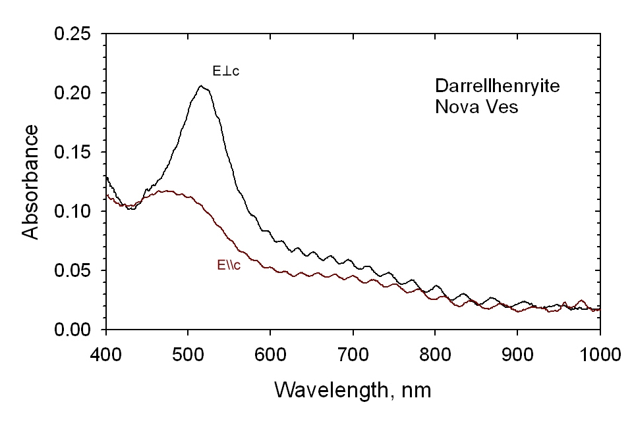
Figure 1. Optical absorption spectrum of darrellhenyrite normalized to 1.0 mm thickness.

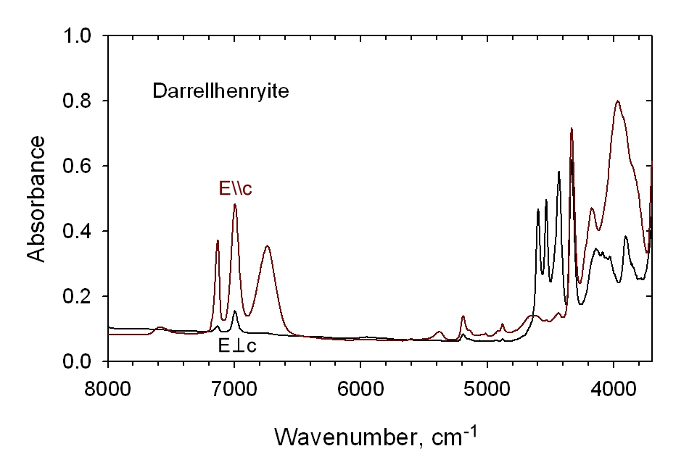
Figure 2. Near-IR spectrum of darrellhenryite (sample grr3075).

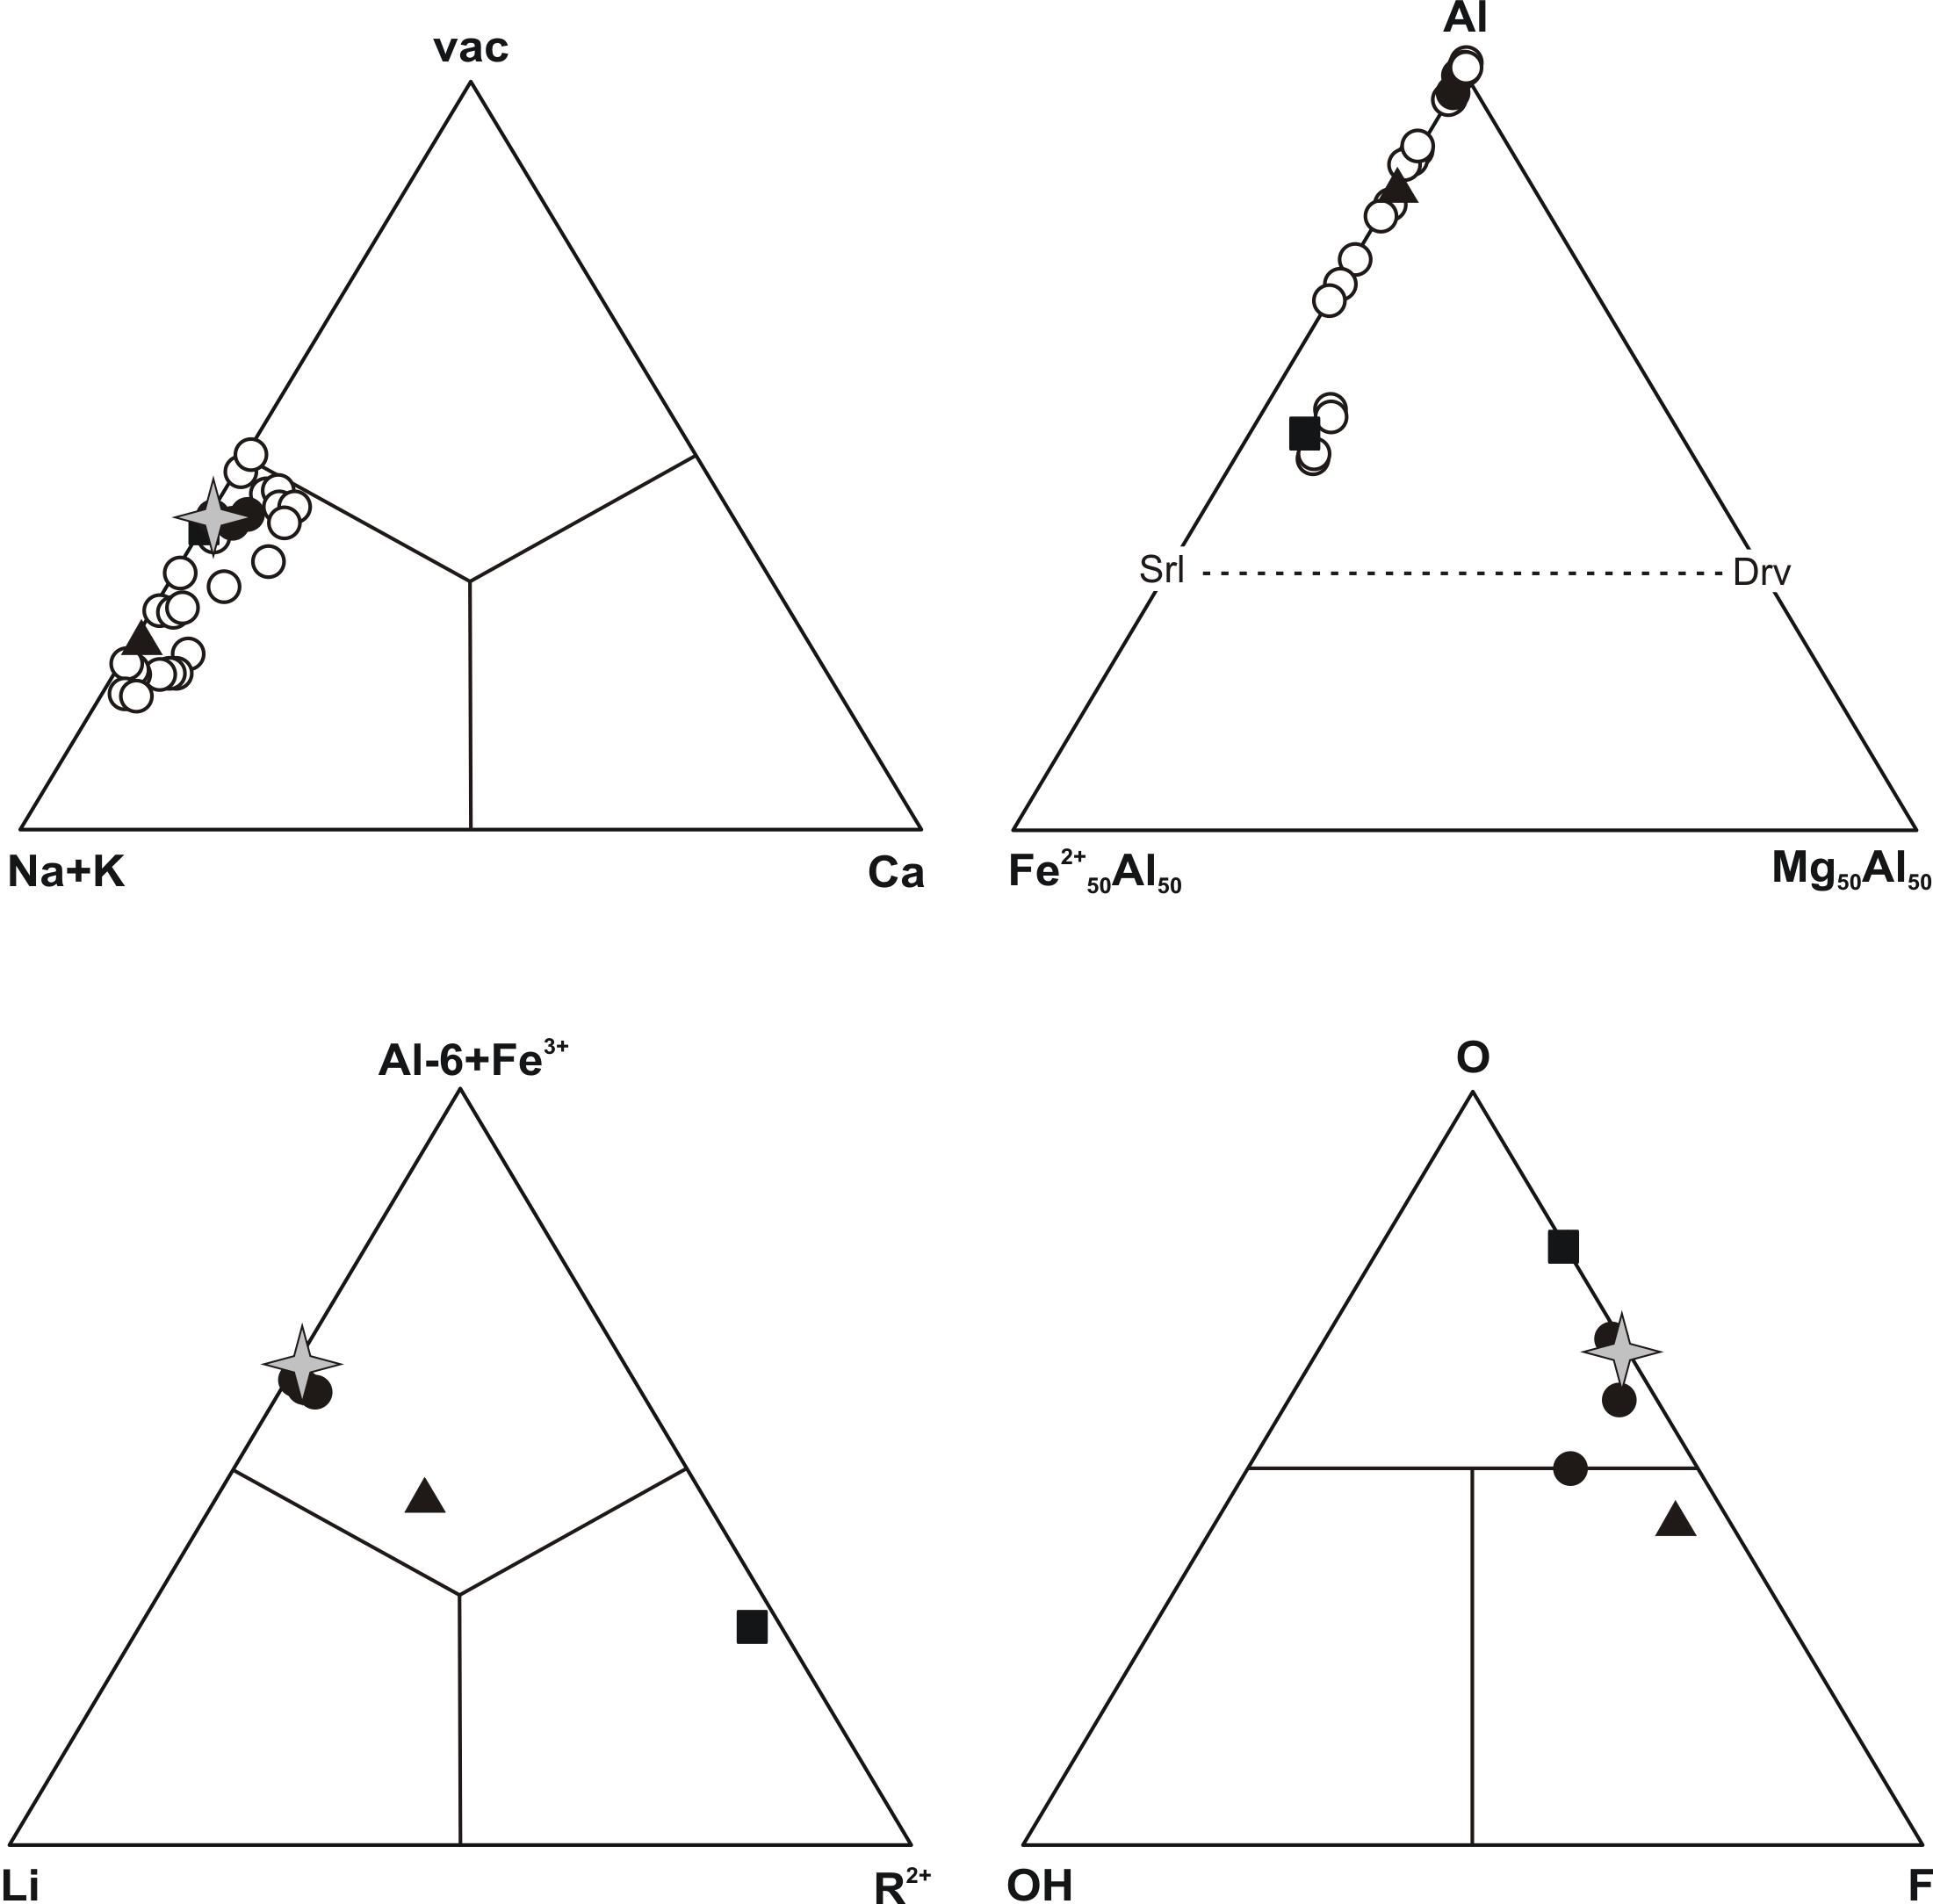

Figure. 3. Chemical composition of tourmalines from the Nová Ves pegmatite. Open circles - EMPA data; solid symbols - wet chemical analyses (Povondra et al. 1985): squire -black oxy-schorl, tringle - green Fe-rich fluor-elbaite, circles - pink darrelhenryite to darellhenryite - fluor-elbaite; diamond - type material (Table 2, analysis b).

