**HIGHER EDUCATION – STUDYING AT MASARYK UNIVERSITY**

1. **Why have you chosen to study at Masaryk University? Tick possible answers and add more.**

**Because:**

* It has a good reputation and it is one of the leading universities in the Czech Republic.
* It is close to my home place, I do not have to travel far for my studies.
* It supports student mobility. It has a Credit Transfer System, which means students can follow up their studies at foreign institutions.
* It accepts students with physical disabilities, it has a centre for helping students with special needs.
* It uses information technologies in all academic areas – for registration, e-learning, communicating, and informing.
* It has a recently built scientific centre of international research in new modern disciplines.
* Other …

1. **Vocabulary**

**These are names of some departments and scientific disciplines. Can you pronounce them?**

|  |  |
| --- | --- |
| biophysical chemistry  general chemistry  department of biochemistry  centre for biomolecular research  chemoinformatics and bioinformatics | chemistry of conservation-restoration  applied biochemistry  department of chemistry  analytical chemistry  centre for environmental chemistry and ecotoxicology |

CEITEC

The Central European Institute of Technology is an independent institute at Masaryk Universitywhich includes the leading Brno universities and research institutes who joined forces in order to establish a centre of scientific excellence. CEITEC priorities include international research cooperation as well as its interdisciplinary character. Its unique facilities create a base for addressing questions in the fields of nanotechnologies, microtechnologies, structural biology, genomics and proteomics, advanced materials, and biomedicine.

extract from CEITEC presentation in is.muni.cz

**Group words / phrases from the text into this table:**

|  |  |  |  |
| --- | --- | --- | --- |
| **adjective phrases** | **verbs, verb phrases** | **prepositional phrases** | **connectors** |
|  |  |  |  |

1. **Structure of MU**

**Look at each group of words and indicate which one does not belong there.**

1. consist of continue comprise contain
2. be made of be made be composed of be made up of
3. divide classify group deal with

**There are some more names on the strips of paper that you will get. In pairs, can you sort them out and describe how you classified them? Use the verbs form exercise 3.**

1. **Read this student’s introduction of himself. Try to guess the missing words. Then listen and compare.**

Hello. My name is Libor Novák and I come from Jeseník, a small town with a population of about 10,000, in the mountains of northern Moravia but I’m …………………**1** living and studying in Brno. I study Chemistry at the Faculty of ………………….**2**, which is very demanding but I am enjoying the challenge. I’m in the second year of a five-year …………………. **3** which means that next year I’ll be able to start specializing by choosing ………………… **4** in those areas which interest me most.

Before coming here I attended the grammar school in Jeseník where my favourite subjects were Mathematics and Chemistry. On the other hand, I found languages more difficult and had to put in a lot of extra work to ……………….. **5** my school leaving exams.

At the moment I am living in the ………………….**6** of residence in Komárov although next year I will have to leave and find a place to stay privately since there are not enough rooms for all the students who want them. I ………………. **7** a double room with another student from Jihlava called Radek Kašpar who studies Geology. He would have studied Physics if it had been possible but he didn’t get a high enough mark in his ………………. **8** exams.

1. **Pavel Zemánek is a postgraduate student. You want to ask him some questions.**

Where (to come from)?

What (to study, currently)?

What (to do research in)?

Why (to update CV)?

What (like to do)?

Where (to live, currently)?

Who (to share a flat)?

Why (to share a flat)?

**Listen to the recording about Pavel Zemánek and answer the questions above.**

1. **Look at the diagrams and complete any missing words:**

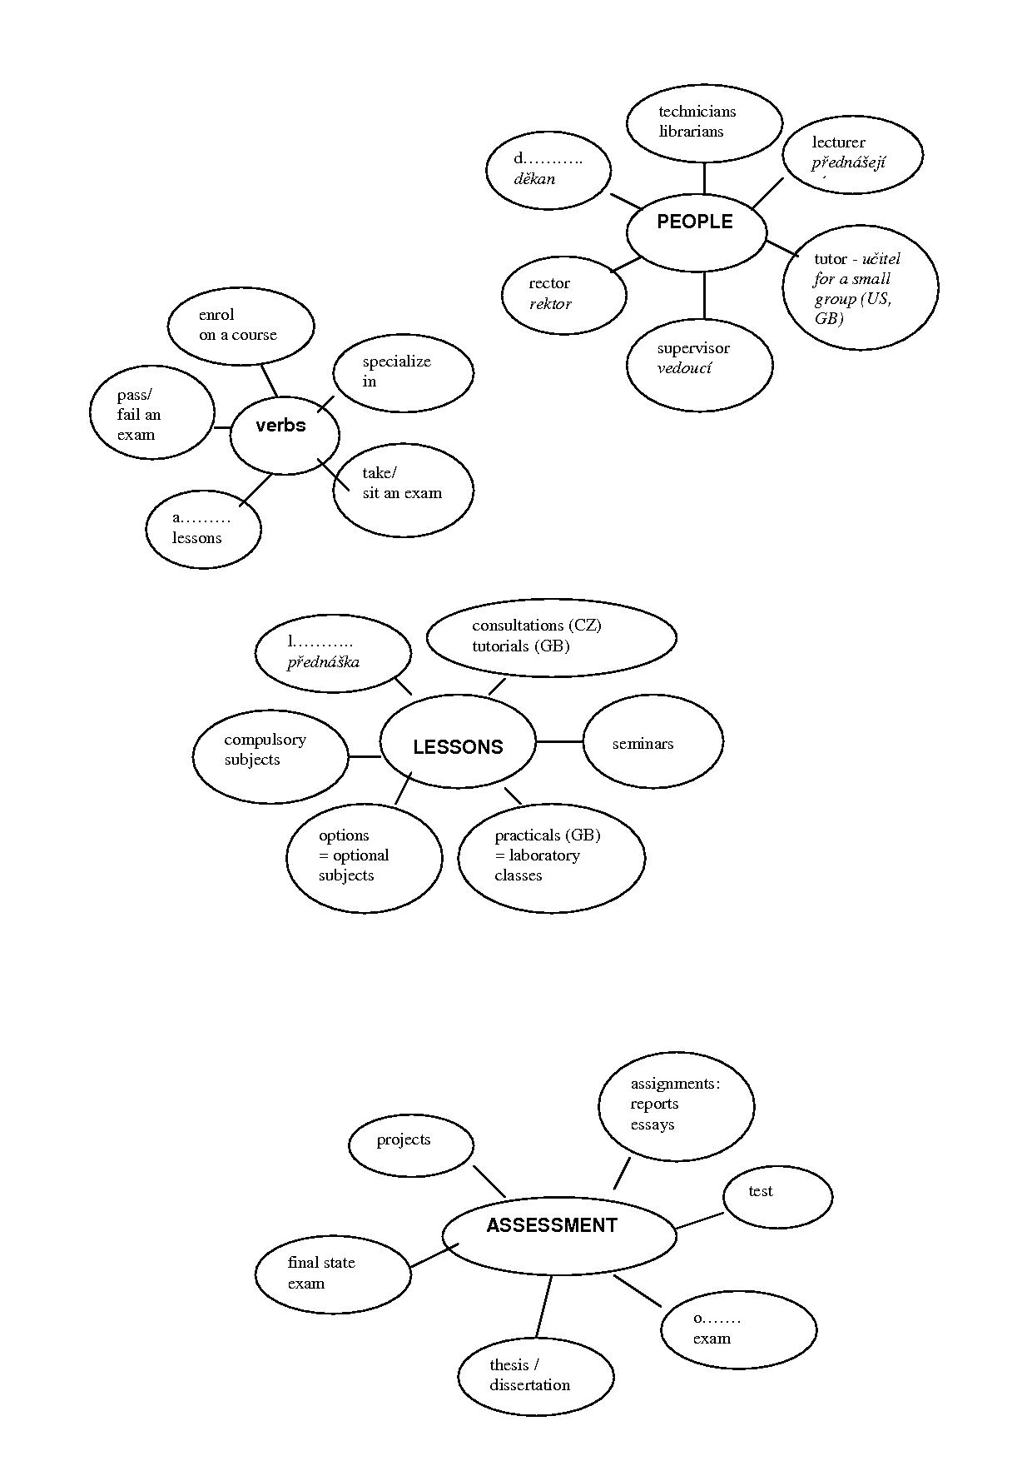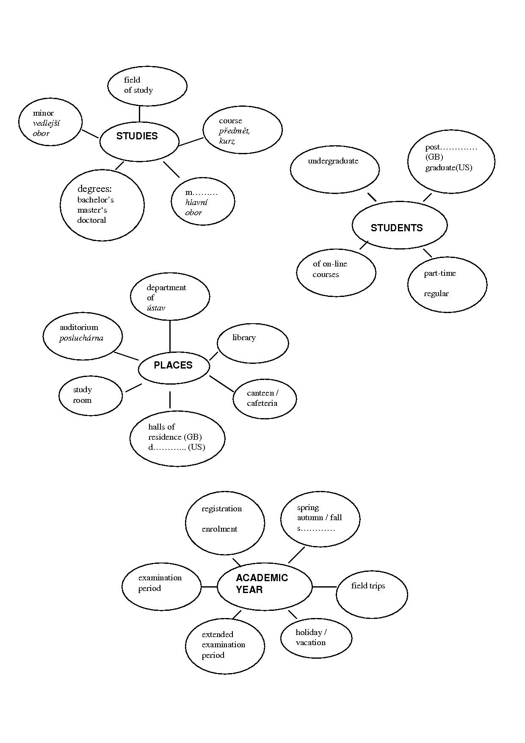

**Answer the questions on your studies.**

How is the academic year organized?

What lessons do you have?

How do you study?

Who are the university staff ?

How are you assessed?

Are there any differences between the Czech Republic and Great Britain?

LISTENING

**You will listen to a woman talking about higher education.**

1. **What purpose does the listening programme have?**
2. to inform about the process of entering universities in Britain
3. to explain why it is best to study in Britain at Oxford or Cambridge
4. to instruct on communication with UCCA who help students
5. **Decide which of the statements are true and which are false (T/F)**

Each university has a separate entrance exam. T/F

National school-leaving exams are called A levels in England. T/F

The students choose the universities and the courses they are interested in by looking at prospectuses. T/F

The prospectuses are available only in the school careers offices. T/F

UCCA stands for Universities Central Council on Admissions. T/F

The students apply directly to the universities themselves. T/F

You can apply for admission to more than 5 universities. T/F

The academic year starts in September. T/F

**REVISION: Using the vocabulary from previous exercises prepare a short talk about yourself. The phrases below will help you – change them if you want.**

Hello. My name is ………………… and I come from ……………… I’m currently living and studying in ………………...

I study ………….…at … .……..University at the Faculty of ……………………...

My field of study / major is …………………………………………..

I’m in the …………………… year of a ……………………year course.

At the end of my course I would like to get a ……… Degree (Master´s/Bachelor´s/Doctoral).

I started my course/studies ……………………………(e.g. end of September).

In the ………………. year I’ll be able to start specializing by choosing options in those areas which interest me most.

In the future I would like to specialize in ………………………………………………………

I´m attending (some) lectures / seminars in ………………………………………… .

Before coming here I attended the grammar school / technical college in …………… where my favourite subjects were ……………………………………………………………..

I passed my school-leaving exams from ………………………………….. .

At the moment I am living in the halls of residence / a rented flat / a house in ……….…

I share a room / flat with …………….… who studies ……………. . In my free time I ………

Lesson adapted from H. Němcová, English for Biologists

A. Rozkošná, English for Chemists

**HOMEWORK**

* **Read the texts on British and American universities (IS, study materials: Higher education UK, US, USxUK).** **Then complete the tables.**

Who would say the following sentences? An American (A) or a British (B) student?

|  |  |
| --- | --- |
| Are you faculty or student? |  |
| The faculty will have to come to a decision on this? |  |
| I attended Masaryk University. |  |
| I went to university in Slovakia. |  |
| She graduated from university in 2011 |  |
| They took some fascinating courses at college. |  |
| I went to secondary school in Boskovice, then I went to university in Brno. |  |
| Paul went to school at Stanford. |  |
| He is a freshman. |  |
| sophomore, junior, senior |  |
| first year student, second-year student, third-year student, fourth-year student |  |

|  |  |  |  |  |
| --- | --- | --- | --- | --- |
| **Type of study**  **UK** | **Degree awards** | **Length of the course** | **Abbreviation (science)** | **Degree in full (science)** |
|  |  | 3-4 | B.Sc | Bachelor of Science |
| Postgraduate | Master´s degree | 1-2 |  | Master of Science |
|  |  | 3-more | Ph.D |  |

|  |  |  |  |  |  |
| --- | --- | --- | --- | --- | --- |
| **Type of study**  **US** | **Degree awards** | **Length of the course** | **Courses** | **Abbreviation (science)** | **Degree in full (science)** |
| undergraduate | community college → |  | terminal→employment |  |  |
|  |  | 2 years | academic→transfer to a 4-year college/univ. | A.S. | Associate in Science |
|  |  | 4 years  freshman sophomore junior senior | * core (1-2) (general basic/ distribution requirements) * major (3-4) * elective | B.S. | Bachelor of Science |
|  | Master´s degree | 1-2 |  |  | Master of Science |
|  | Doctorate degree |  |  | Ph.D. (Sc.D.) | Doctor of Philosophy |