**ENGLISH LANGUAGE SKILLS**

**Reading**

Kinds of reading strategies:

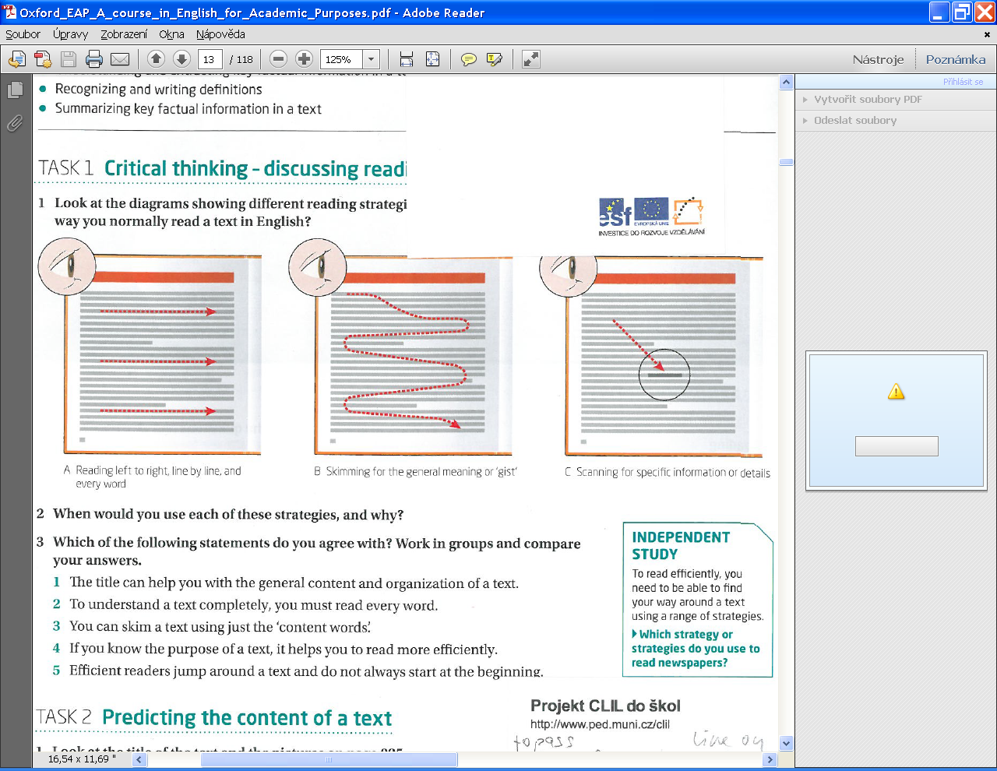

Which of them do you use to read newspapers?

Useful websites

<http://www.uefap.com/reading/readfram.htm> advice, exercises

<http://scholar.google.cz/> search engine for specialist literature

**Speaking**

* Logical and precise
* Certain degree of formality
* Structured speaking – in presentations

Useful websites

<http://www.uefap.com/speaking/spkfram.htm> advice, exercises

<http://www.eslfast.com/robot/> short everyday conversations

<http://www.eslgold.com/speaking/speaking_situations.html> phrases for different situations

**Listening**

* Understanding the main idea (ignore the words and phrases you do not understand and form your idea of the content)
* Understanding specific information (e.g. numbers or special terms, you are not interested in the overall idea)

Useful websites

<http://elllo.org/> listening exercises

<http://www.esl-lab.com/> listening exercises

<http://academicearth.org/> university lectures and courses

<http://www.ted.com/> presentations on different topics

**Writing**

* Formal style, correct grammar
* Well-organized, structured

Useful websites:

<http://www.uefap.com/writing/writfram.htm> advice, exercises

<http://www.phrasebank.manchester.ac.uk/> frequently used phrases

**Grammar**

What you need to know:

* Tenses : simple and continuous forms of present, past and present perfect tense
* + questions in these forms
* + passives
* Expressing future
* Modals
* Pronouns
* Adjectives (comparisons, superlatives)
* Adverbs
* -ing form, infinitive form
* Countability / uncountability, expressing quantity
* Conjunctions, prepositions
* If-clauses, relative clauses, expressing purpose

Useful websites

<http://www.ego4u.com/>

<http://www.e-gramatica.com/>

<http://www.englishpage.com/grammar/>

<http://esl.about.com/>

**Vocabulary**

* Special terms
* Academic vocabulary
* Collocations
* Avoiding phrasal verbs – these are informal

Useful websites

<http://www.uefap.com/vocab/vocfram.htm> theory and exercises

<http://a4esl.org/a/v3.html> or <http://a4esl.org/a/v5.html> exercises on general, academic, specialist vocabulary