CONSERVATION AND ANALYTICAL CHEMISTRY

1. Work in pairs. Ask and answer questions about art:
1. Do you visit museums when you go to another city (e.g. of science, history…)? When was the last time you went to a museum? Have you ever been to any famous museums?
2. Have you ever visited an art museum? Have you ever gone to an exhibition? When and where?
3. What famous painters do you know? What are they famous for?
4. Who is the most famous artist in your country? What kind of art does he or she do?
5. Do you like modern art? Do you understand modern art?
6. In your opinion, is design an important part of culture?
7. Do you think of cartoons and comics as art? Do you think graffiti is art?
8. What is the difference between studying an art school and studying science?
9. How can chemistry help in preserving pieces of art?

2. Read the short text below and search for expressions referring to methods used by analytical chemists. Do you know what they mean?

The Influence that Synthetic Painting Materials had on the Technique of Pablo Picasso
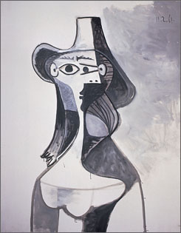
Fourteen paintings by Pablo Picasso (1881-1973) were selected in order to carry out detailed examination analysis of the materials and documentation of the painting techniques used by the artist. Information was gathered from literature sources, curatorial files and conservation records as well as from the paintings themselves.
The examination procedure involved detailed surface examination, use of raking light and ultraviolet light, infrared photography, stereo microscopy and x-radiography. Samples were taken from each painting so that binding media, pigments and general structure could be identified. Cross-sections were made for viewing in visible and ultraviolet light. Pigments and extenders were identified by optical and electron microscopy, ultraviolet fluorescence staining tests, energy dispersive X-ray analysis and X-ray diffraction. Binding media have been characterized by Fourier transform infrared spectroscopy and pyrolysis - gas chromatography - mass spectrometry.

Some methods are summarized below. Complete the missing expressions. ¹
canvas aids adhesive reveal varnishes evaluate priming embed

Microscopic Analysis
The artifact is examined with a microscope to help (1)______________ its overall condition. This can give a preliminary assessment of damages and (2)______________ previous restoration efforts. A polarizing microscope can be used to analyze the type of pigments used.

Cross-sectional Analysis
A tiny sample of paint used by the artist is extracted from an already damaged area and (3)______________ in a Plexiglas cube. Microscopic examination reveals the types of pigments used, the layering of the paint, and the style in which the artist builds-up his colors.

Ultraviolet Radiation
Observation under ultraviolet light gives valuable information on the (4)______________ and glazes used and shows areas of previous restorations. Organic materials absorb ultraviolet radiation and then emit it at lower energy (in the visible region) a phenomenon known as fluorescence. If an artifact has been broken and then glued together using an (5)______________ followed by repainting, viewing under UV-light will make the break obvious due to the adhesive’s fluorescence.

Infrared Spectroscopy
Infrared spectroscopy gives information about the types of pigments or dyes used. On subjecting a thin transparent film of a compound to infrared light, certain frequencies are absorbed. This (6)______________ in identifying its composition.

X-Radiography
This method possesses the ability to penetrate layers of paint and reveals information about the (7)______________ layer, the (8)______________, and any damages hidden under the paint. It is used to detect lead-based pigments in the paint. White lead was extensively used and often mixed with other pigments in old paintings.

3. LISTENING: How to use a Spectronic-20 spectrophotometer²

Vocabulary:

proper (adj) transmittance(n) knob(n) adjust (v) specimens (n) insert (v) align (v) rinse (v)

Complete the following text:
To use a Spectronic-20 spectrophotometer turn on …. …………………. First choose the proper …………………... .Then, with the ………………… ………………..empty, set the per cent transmittance equal to zero ……. ………….. using the power switch zero knob. To record absorbance specimens set the mode to …………………….. . Insert the cuvette half filled with the ……………. …………………. into the sample chamber aligning the mark on the ………………. with the mark on the sample chamber. Close the sample chamber …………………….. and adjust the light control knob until the absorbance reads ……………….. This is the same as setting the per cent transmittance ……………….. …… 100 per cent. ………………… the blank solution and keep it for later use.

Now rearrange the following sentences in correct order:
A) Remove the sample cuvette and turn off the instrument if no one else is waiting to use it.
B) Half fill the cuvette with the sample solution and insert it into the sample chamber and close the sample chamber cover. Without changing any of the settings read the absorbance or per cent transmittance from the meter or readout.
C) Rinse the cuvette at least three times with a small amount of the sample solution.

READING: Conservation Past and Present¹

In the past restoration was performed by artists of the same discipline. The main objective of the effort was to improve the aesthetic appearance and conceal the fact that the article was damaged and repaired. The materials used were limited to beeswax, paraffin wax, flour paste, plaster, glue, gum Arabic, and powder pigments, but restorers employed innumerable methods of repair. Their repair procedures were secretive and the restoration went undocumented. Secret recipes and procedures were used and were only passed to others through apprenticeships. Often restorers added their own touch and made changes they thought were appropriate without considering the original intent of the artist. There are extraordinary examples of how restorers of the past added their own style and sense of history to the original work.

Ian McClure, a paintings conservator and the Director of the Hamilton Kerr Institute’s conservation center at the Fitzwilliam Museum (Cambridge, England) since 1983, describes the unexpected results from the painting of Henry Prince of Wales on horseback by Robert Peake the Elder. He wrote that the painting showed the Prince of Wales in splendid armor on horseback with a tree spreading behind him and the Prince’s plaque bearing his insignia hanging from a branch (Figure 1). Microscopic analysis showed two different painting styles; the prince and the horse were painted with meticulous details executed in thin-layered paint while the landscape was broadly executed and thickly painted. Subsequent examination by infrared reflectography and X-radiography gave images that clearly showed a totally different underlying landscape. The decision on whether to remove the over paint or keep it required a sense of the painting’s history and the time frame during which it was produced. The painting was commissioned by the Prince and it dates to 1610. Further cross-sectional analysis of a pigment sample embedded in a Plexiglas cube revealed more information about its provenance. It established that the over-paint was added a minimum of thirty years after the death of the Prince in November of 1612. Consequently, it was concluded that the over-paint was not historically important and it was added in an effort to “improve” the painting. Because the underlying paint surface proved to be in good condition, a decision was made to proceed with the restoration. Upon cleaning, five different restorations to repair damages and cover the loss of paint were detected. On completion, the elegant horse with the flowing mane was transformed to a white sturdy tilting horse. Behind the Prince was a naked winged man resembling Father Time carrying the Prince’s lance and helmet with a luxuriant colored plume. The plaque bearing the insignia of the Prince now appears on a brick wall behind the Prince and beyond the wall is a garden, which is described as similar to the Prince’s garden at Richmond Palace (Figure 2).

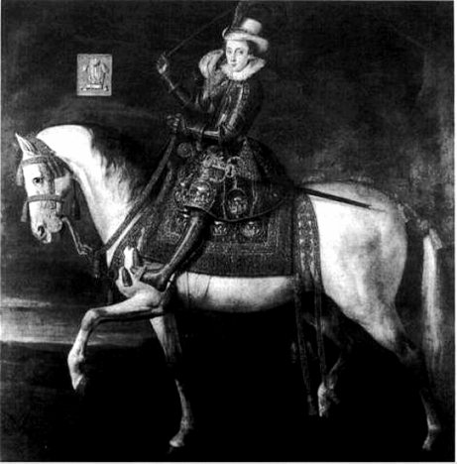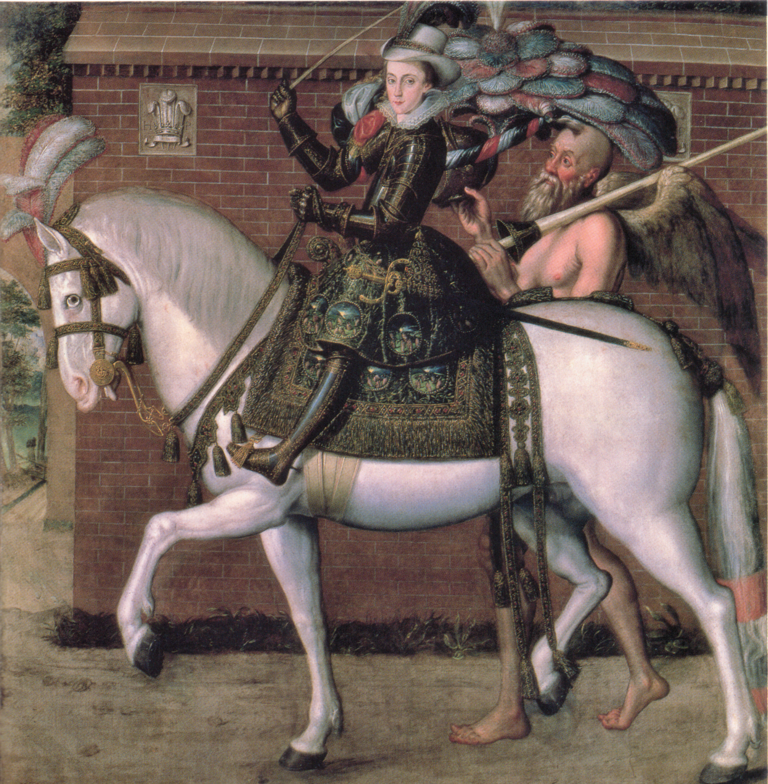

FIGURE 1. ROBERT PEAKE THE ELDER: HENRY PRINCE OF WALES ON HORSEBACK, C. 1610–12, BEFORE RESTORATION. OIL ON CANVAS, 231 × 219.5 CM. ©PARHAM PARK.

FIGURE 2. HENRY PRINCE OF WALES ON HORSEBACK, AFTER RESTORATION. ©THE HAMILTON KERR INSTITUTE.

1. Read the first paragraph and identify words with the same meaning as described below:
1. to hide; cover or keep from sight
2. working for a skilled person in order to learn a profession
3. suitable or fitting for a particular purpose
4. mind and will focused on a specific purpose

2. Which words in the 1st paragraph in your opinion belong to B2 level? Give examples.
Nouns | Adjectives | Verbs

3. Complete the vocabulary to name objects in the original painting.

4. Questions
1. How did Ian McClure describe the painting before restoration?
2. What differences in painting styles appeared after the analysis?
3. What did the restorers consider before removing the over-paint?
4. What methods were applied to examine what was under the paint?
5. Who and when requested the painting?
6. When and why was the painting changed?
7. How many restorations were detected?

5. In pairs, compare the two pictures on page 3.

LISTENING: Art and Science of Conservation https://www.youtube.com/watch?v=UeDG8XDt2mc
Watch the video and decide whether the statements are true or false.
- Paul Jett speaks about collections in two museums.
- In the paper lab they prepare work of art for transport between galleries.
- When you look at the paintings without magnification, they seem perfect.
- Emily Jacobson identifies cracks and loose areas of pigment.
- The collections include Islamic manuscripts.
- The painting in the Chinese Painting Studio comes from the 6th century.
- Chinese brushes seem harsh but in fact they are gentle.
- Conservators work quickly because the water can discolour the painting.
- The dagger is made of iron from a meteorite.
- For Paul Jett, work in the museum is really hard.
Homework
- Read the text and find four examples of the expression of purpose. ¹

To improve the visual aesthetic effects restorers sometimes used materials without experimentally testing them, causing further deterioration of the artifact in the long run. Such was the case in the previous restoration of the Sistine Chapel. Seeping water and humidity caused the pigments of the fresco paint to flake. Animal glue was used by restorers to fix the pigments and to replenish some luster that had been lost due to the salt deposits (efflorescence) on the surface of Michelangelo’s frescoes. In addition to hundreds of years of soot and grime, the glue had darkened and yellowed muting the bright fresco colors. Moreover, the glue lost its elasticity with time; it hardened and cracked causing the pigments to flake. All of this conspired to show Michelangelo as an expert in painting the human figure, but a dull colorist. Furthermore, he was accused of not being trained in the school tradition of fresco painting. The restoration, undertaken by the Vatican Museums (1980–1994) vindicated him and portrayed him as both a master of colors and of pure orthodox methods. The defense of Michelangelo’s reputation is better understood by explaining the chemical composition of fresco painting. The pigment is mixed with water and applied on fresh lime (calcium hydroxide) mixed with sand. The lime reacts with the carbon dioxide in the air and forms calcium carbonate (marble). The shiny surface is formed on drying, and seals the pigment in the plaster. The painter has to be efficient and quick, for this method allows no transgressions or second thoughts. Only rarely was it found that Michelangelo repainted a-secco (dry plaster) to add minor retouching.

- Make questions to fit these answers:

1. Not being trained in fresco painting.

2. Fresh lime.

3. Carbon dioxide.

4. On drying.

5. Because it allows no second thoughts.

- Expressing purpose: Connect the pairs of sentences into one. ³
- I went into hospital. I had to have an operation.
- I phoned the police station. I wanted to report that my car had been stolen.
- I whispered. I didn’t want anybody else to hear our conversation.
- Please arrive early. We want to be able to start the meeting on time.
- I slowed down. I wanted the car behind to be able to overtake.
- She locked the door. She didn’t want to be disturbed.
Sources: ¹ http://chemeducator.org/sbibs/s0002001/spapers/21rk897.pdf
- Available at http://employees.oneonta.edu/viningwj/videos/

