DRUGS AND MEDICINES
Do the pictures show drugs or medicines?
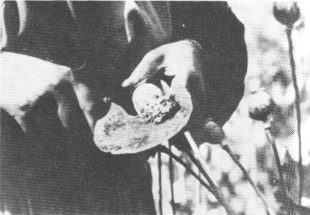  a) Scraping raw opium | 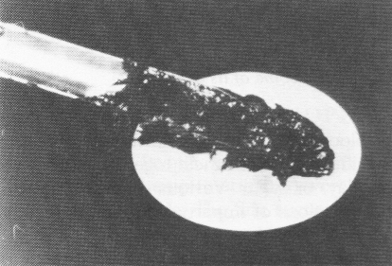  b) Opium gum | 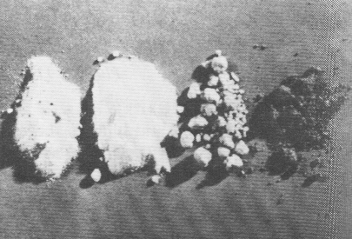  c) Smoking opium, codeine, heroin and morphine
Figure 11.5 Morphine is the narcotic isolated from raw opium. Codeine and heroin are derivatives of morphine.
- Can you pronounce these words?
relief synthetic isolate analgesic morphine antipyretic modify
esterify diacetyl induce cure euphoria injection
2. Match the headings and the paragraphs:
a) Erroneous recommendations
b) Properties of aspirin
c) The way of heroin production
d) Properties of salicylic acid
e) Pain relievers in early societies
5. What do the following years refer to?

1860 1763

1899 1874

1890
6. Answer the Questions:

  - What did early societies use as pain relievers?
  - Why did chemists want to modify the molecule of salicylic acid?
  - What properties does aspirin have?
  - What is a tablet of aspirin composed of?
  - What is morphine?
  - What effects does it have in human body?
  - What error did the Bayer Company make as for heroin?
  - How does heroin differ in its effects from morphine?
Physiological properties of selected esters  People have long sought relief from pain. Alcohol, opium, cocaine, and Indian hemp (marijuana) were used as medicines for relief of pain in some early societies.  The first successful synthetic pain relievers were derivatives of salicylic acid (Figure 11.4). Salicylic acid was first isolated from willow bark in 1860, although an English clergyman named Edward Stone had reported to the Royal Society as early as 1763 that an extract of willow bark was useful in reducing fever.  Salicylic acid is itself a good analgesic (pain reliever) and antipyretic (fever reducer), but it is very sour and irritating when taken by mouth. Chemists sought to modify the structure of the molecule to remove this undesirable property while retaining (or even improving) the desirable properties. Acetylsalicylic acid (aspirin) was first introduced in 1899 and soon became the largest-selling drug in the world.  Aspirin is an analgesic and antipyretic. It reduces inflammation and hinders the clotting of blood. An aspirin tablet usually contains 325 mg of acetylsalicylic acid. The tablet is held together with some sort of inert binder, such as starch, clay, or sugar. Various brands of aspirin have been extensively tested. The conclusions of impartial studies are invariably the same: the only significant difference between brands is price.  Morphine, an opium alkaloid, is a narcotic, that is, a drug that produces both sedation (narcosis) and relief of pain (analgesia) (Figure 11.5). It is also strongly addictive. Chemists, therefore, also sought to modify the properties of morphine. Morphine is both a phenol and an alcohol. When both of these groups are esterified, heroin (diacetylmorphine) is produced.  Chemists at the Bayer Company first prepared this morphine derivative in 1874. Heroin is Bayer's trade name for diacetylmorphine. Heroin receded little attention until 1890, when it was proposed as an antidote for morphine addiction! Shortly thereafter, Bayer was widely advertising heroin as a sedative for coughs, often in the same advertisement with aspirin (Figure 11.6). It was soon found that heroin induced addiction more quickly than morphine, however, and that heroin addiction was harder to cure. The physiological action of heroin is similar to that of morphine, except that heroin produces a stronger feeling of euphoria for a longer period of time. Heroin is so strongly addictive that it seems that one or two injections are sufficient to induce dependence in some individuals. Heroin is not legal in the United States, even by prescription. Some individuals are lobbying for legalization of the drug for use with terminally ill people who have great pain.  Many thousands of morphine derivatives have been synthesized over the years. Only a few show significant analgesic activity. Most are strongly addictive. In fact, it now seems likely that the same molecular features that provide relief of pain also create chemical dependence.  Adopted from a textbook: D.M.Feigl, General, organic, and biological chemistry. | 1  2  3  4  5  6  7
DRUGS
Source: H.Němcová, English for Biologists

There are six classes of drugs. Try to categorize the following substances (12).
- Psychostimulants /ˈstɪmyələnt/
- Hallucinogenous drugs (hallucinogens) /həˈlusənədʒən/
- Opiates /n., adj. ˈoʊpiɪt, -ˌeɪt; v. ˈoʊpiˌeɪt/
- Cannabis drugs
- Analgetics, hypnotics, tranquillisers: /hɪpˈnɒtɪk/, /ˈtræŋkwəˌlaɪzər/
- Volatile substances (těkavé) /ˈvɒlətl, -tɪl or, especially Brit., -ˌtaɪl/

marihuana
codeine

ecstasy
hashish
amphetamine (speed)
LSD

cocaine
crack
pervitine = methamphetamine
heroin
mushrooms
toluen
morphine

Do you agree with the following statements? Think about some of them for a while and then discuss with your partner.

- Young people have access to illegal drugs if they want it anyway.
- Making cannabis acceptable we would be opening a gateway to hard drug use.
- Is it an infringement upon human rights to criminalise drug users when they are taking risks with their own lives and not harming anyone else?
- Is the use of illegal drugs immoral?
- Is the use of legal drugs immoral?
- Outlets might be licensed to sell a drug and restricted in its use. For example, cannabis could be sold in cafes and be acceptable for personal use. Ecstasy might be quality controlled, sold and consumed on licensed premises such as clubs. Similar to the way alcohol is controlled.
- Heroin is just about the most addictive drug you can get.
- Heroin could be available on prescription for users with proven addiction.
- The dangers of using drugs would be greatly reduced if the quality was able to be controlled?
- Drugs can have very harmful physical or mental effects.
- A soft drug is considered to be fairly harmless.
- If cannabis were made legal, the long-term use could be very harmful.

Study the information on one of the drugs. Then present it to your colleagues who should be able to complete the grid.

DRUG

SUBSTANCE

EFFECTS

RISKS

FORMS

HOW TAKEN

