**HIGHER EDUCATION – STUDYING AT MASARYK UNIVERSITY**

1. **Why have you chosen to study at Masaryk University? Tick possible answers and add more.**

**Because:**

* It has a good reputation and it is one of the leading universities in the Czech Republic.
* It is close to my home place, I do not have to travel far for my studies.
* It supports student mobility. It has a Credit Transfer System, which means students can follow up their studies at foreign institutions.
* It accepts students with physical disabilities; it has a centre for helping students with special needs.
* It uses information technologies in all academic areas – for registration, e-learning, communicating, and informing.
* It has a recently built scientific centre of international research in new modern disciplines.
* Other …

1. **Vocabulary about MU**

**Can you explain what the following names stand for?**

|  |  |
| --- | --- |
| biophysical chemistry  general chemistry  department of biochemistry  centre for biomolecular research  chemoinformatics and bioinformatics | chemistry of conservation-restoration  applied biochemistry  department of chemistry  analytical chemistry  centre for environmental chemistry and ecotoxicology |

CEITEC

The Central European Institute of Technology is an independent institute at Masaryk Universitywhich includes the leading Brno universities and research institutes who joined forces in order to establish a centre of scientific excellence. CEITEC priorities include international research cooperation as well as its interdisciplinary character. Its unique facilities create a base for addressing questions in the fields of nanotechnologies, microtechnologies, structural biology, genomics and proteomics, advanced materials, and biomedicine.

Extract from CEITEC presentation in is.muni.cz

**Group words / phrases from the text into this table:**

|  |  |  |  |
| --- | --- | --- | --- |
| **adjective phrases** | **verbs, verb phrases** | **prepositional phrases** | **connectors** |
|  |  |  |  |

1. **Questions about your studies:**

**Do you know the highlighted words? Explain what they mean.**

What is your name and **field of study**? Can you describe it? Where are you staying? Do you share a private flat or are you staying at the **halls of residence**? Who was your favourite teacher at high school? Can you describe him / her? What part of chemistry would you like to **specialize in**? Why?

Why do you enjoy studying science?

Which subjects are you good at? What do you like most about your studies?

Are you **conducting any research**? In what field? Are you writing a **bachelor´s thesis**? What was the most difficult exam you have had so far? What do you want to do after you finish school? Would you like to study for a **PhD**?

Why did you choose to study at Masaryk University? Was it difficult to **get admitted**? What other universities did you apply for? Did you have to sit for any **entrance exams**? In which year of your university course are you right now? What classes do you like most? What do you think of the **campus**?

Do you have a **part-time job**? Would you like to **carry out research** in the future? What kind of research? Would you like to study at a foreign university? Where? How do you imagine your future job in chemistry?

1. **Pavel Zemánek is a postgraduate student. You want to ask him some questions.**

Where (to come from)?

What (to study, currently)?

What (to do research in)?

Why (to update CV)?

What (like to do)?

Where (to live, currently)?

Who (to share a flat)?

Why (to share a flat)?

**Listen to the recording about Pavel Zemánek and answer the questions above.**

1. **Look at the diagrams and complete any missing words:**

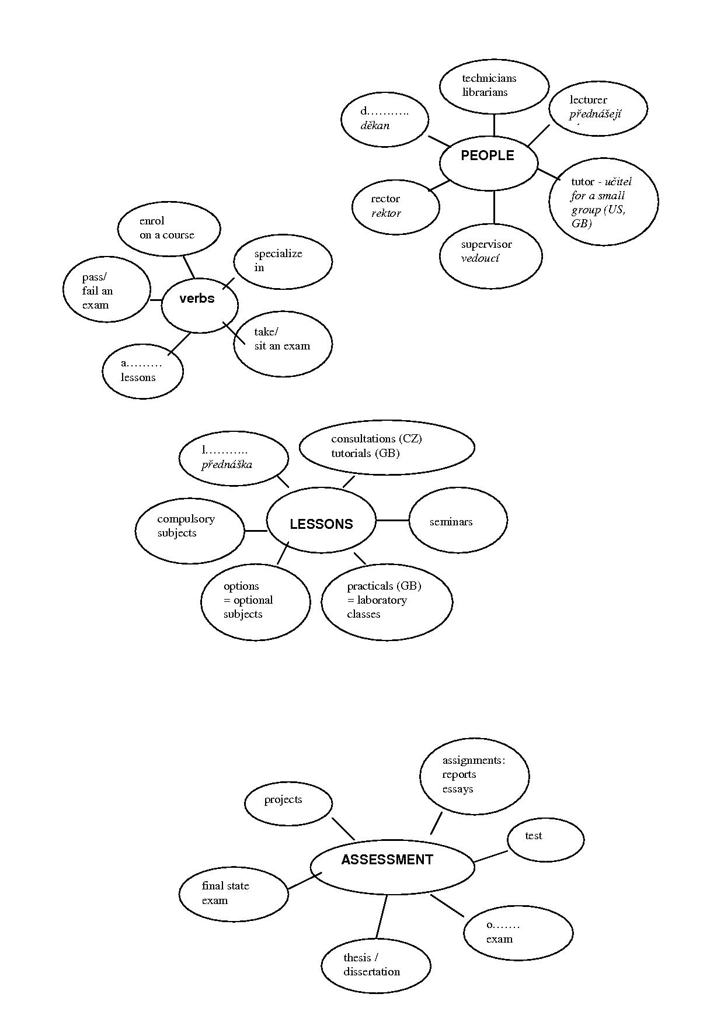

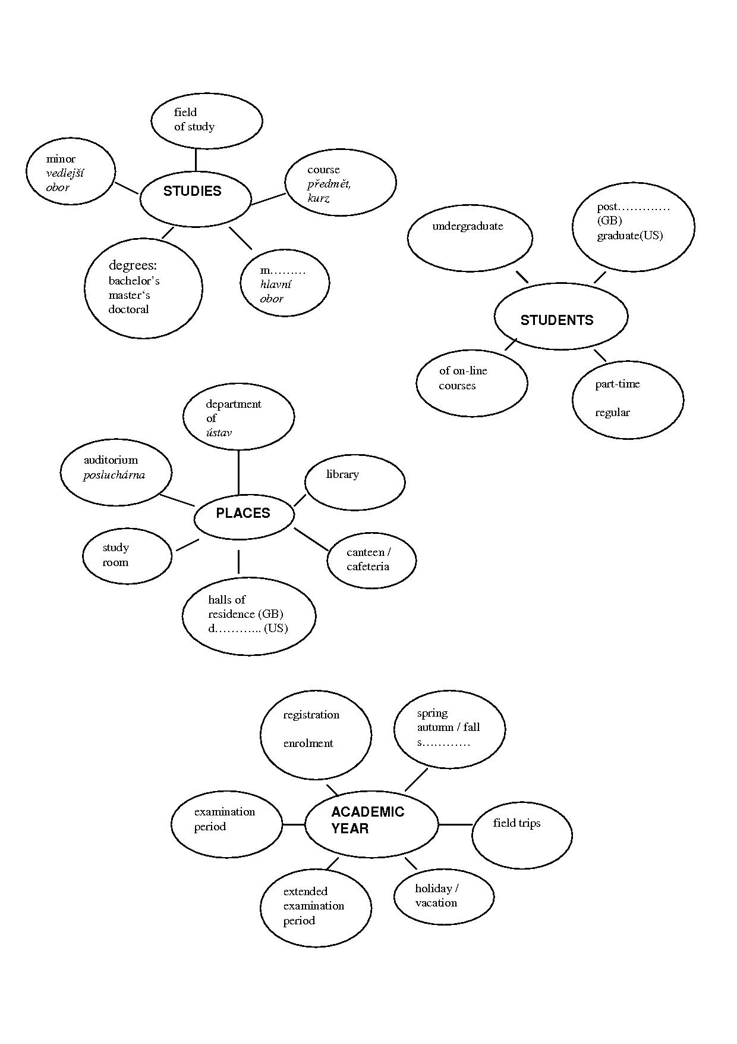

**Answer the questions on your studies.**

How is the academic year organized?

What lessons do you have?

How do you study?

Who are the university staff?

How are you assessed?

Are there any differences between the Czech Republic and Great Britain?

**7. Speaking – Role-play. Work in pairs. One of you is a Czech student; the other is a British student. Talk about your university studies, using information below.**

**Ask your partner about:**

1. the age people go to university
2. the **admission** to a university (entrance exams?)
3. the **degrees you can obtain**, the length of courses
4. the course fee, **scholarships**
5. the beginning and organization of an academic year
6. the kind of lessons you have
7. testing
8. **accommodation**

**A) Czech student:**

1. 19
2. apply directly to universities, **requirements:** must pass **school-leaving exams, entrance exams**
3. study for Bachelor´s degree, Master´s degree, 3 / 5 years
4. at state universities you don´t have to pay for your studies
5. lasts from late Sept. to June, 2 semesters, 2 **exam periods**
6. **lectures**, seminars, lab practicals, consultations
7. tests, oral+written exams
8. halls of residence or sharing a private flat

**:**

**B) British student:**

1. 18
2. apply through 1 central body – the UCCA, no entrance exams, **requirements**: 3 A levels
3. study for Bachelor´s degree, Master´s degree, 3 / 5 years
4. you have to pay a course fee, can get a grant or a **scholarship**
5. late September – July, 3 terms, at some universities 2 semesters
6. lectures, seminars, practicals, tutorials (individual lessons with a tutor)
7. mostly by writing essays
8. share a flat / house, halls of residence

**Sources:** 1 **Adapted from:** T.Lynch and K.Anderson: *Study Speaking*, CUP1992.

Lesson adapted from Hana Němcová and Milada Pavlovová.

**HOMEWORK**

* **Read the texts on British and American universities (IS, study materials: Higher education UK, US, USxUK).** **Then complete the tables.**

Who would say the following sentences? An American (A) or a British (B) student?

|  |  |
| --- | --- |
| Are you faculty or student? |  |
| The faculty will have to come to a decision on this? |  |
| I attended Masaryk University. |  |
| I went to university in Slovakia. |  |
| She graduated from university in 2011 |  |
| They took some fascinating courses at college. |  |
| I went to secondary school in Boskovice, then I went to university in Brno. |  |
| Paul went to school at Stanford. |  |
| He is a freshman. |  |
| sophomore, junior, senior |  |
| first year student, second-year student, third-year student, fourth-year student |  |

|  |  |  |  |  |
| --- | --- | --- | --- | --- |
| **Type of study**  **UK** | **Degree awards** | **Length of the course** | **Abbreviation (science)** | **Degree in full (science)** |
|  |  | 3-4 | B.Sc | Bachelor of Science |
| Postgraduate | Master´s degree | 1-2 |  | Master of Science |
|  |  | 3-more | Ph.D |  |

|  |  |  |  |  |  |
| --- | --- | --- | --- | --- | --- |
| **Type of study**  **US** | **Degree awards** | **Length of the course** | **Courses** | **Abbreviation (science)** | **Degree in full (science)** |
| undergraduate | community college → |  | terminal→employment |  |  |
|  |  | 2 years | academic→transfer to a 4-year college/univ. | A.S. | Associate in Science |
|  |  | 4 years  freshman sophomore junior senior | * core (1-2) (general basic/ distribution requirements) * major (3-4) * elective | B.S. | Bachelor of Science |
|  | Master´s degree | 1-2 |  |  | Master of Science |
|  | Doctorate degree |  |  | Ph.D. (Sc.D.) | Doctor of Philosophy |