2. STUDIES AND RESEARCH

1. STUDYING ABROAD

Speaking. Work in small groups. Ask and answer questions:

- Can you describe your last holiday? What about your best holiday? What is your plans for the next holiday?
- Have you ever been to an English speaking country? When and for how long?
- Have you ever spent more than a month abroad? What was the reason (au-pair, work, tourism etc.)?
- Which country would you like to visit most and why?
- Would you like to study abroad? If so, what would be your main reasons to do so? Would you prefer an exchange programme or a doctoral degree abroad?
- What country would you most likely choose for your foreign studies? Why?
- How would you choose the institution? What would be your criteria?
- Have you heard of Erasmus-Socrates exchange programme? Do you know any other similar programmes?

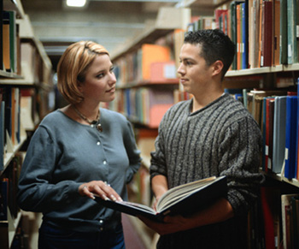

2. Fill in this application form for Erasmus/Socrates exchange programme. Complete as many blanks as you can. You can say the truth or invent some information.

ECTS - EUROPEAN CREDIT TRANSFER SYSTEM¹

SOCRATES/ERASMUS

STUDENT APPLICATION FORM
(Photograph)

ACADEMIC YEAR 2005/2006

FIELD OF STUDY: .........................................................

This application should be completed in BLACK in order to be easily copied and/or faxed.
SENDING INSTITUTION
Name and full address:
Masaryk university in Brno, Žerotínovo námìstí 9, 601 77 Brno, Czech Republic
Department coordinator - name, address/faculty, telephone and telefax numbers, e-mail
.....................................................................................................................................................................
.....................................................................................................................................................................
Institutional coordinator - name, address, telephone and telefax numbers, e-mail
Veronika Camacho, Office for International studies, Žerotínovo nám. 9, 601 77, Brno. camacho@rect.muni.cz. Tel.: +420-54949 3022, fax.: +420-54949 1113
STUDENT’S PERSONAL DATA
(to be completed by the student applying)
Family name: .....................................................  Date of birth: .....................................................  Sex: .............. Nationality: .................................  Place of Birth: ....................................................  Current address: .................................................  ...........................................................................  ...........................................................................  ...........................................................................  Current address is valid until: .............................  Tel.: ................................................................... | First name (s): ...............................................................  E-mail address:…………………………………………  Permanent address (if different): ....................................  ......................................................................................  ......................................................................................  ......................................................................................  ......................................................................................  Tel.: ..............................................................................
Receiving institution:
Institution | Country | Period of study  from to |  | Duration of stay (months) | N° of expected ECTS credits
1. ......................................

Sending institution: Masaryk university in Brno Country: Czech republic

Signature of department coordinator:……………………………………Date:…………………………….

Signature of Institutional Socrates coordinator:…………………………Date:…………………………….

LANGUAGE COMPETENCE
Mother tongue: ................... Language of instruction at home institution (if different): ..................................
Other languages | I am currently studying this language |  | I have sufficient knowledge to follow lectures |  | I would have sufficient knowledge to follow lectures if I had some extra preparation
 | yes | no | yes | no | yes | no
..........................  ..........................  .......................... | □  □  □ | □  □  □ | □  □  □ | □  □  □ | □  □  □ | □  □  □
WORK EXPERIENCE RELATED TO CURRENT STUDY (if relevant)
Type of work experience  ............................................  ............................................ | Firm/organisation  .......................................…  ........................................... | Dates  ...........................  ........................... | Country  ......................................  ......................................
PREVIOUS AND CURRENT STUDY
Diploma/degree for which you are currently studying (Bc/MA/Ph.D.): .......................................................
Number of higher education study years prior to departure abroad: ...............................................................
Have you already been studying abroad ? Yes □ No □
If Yes, when ? at which institution ? ..............................................................................................................

RECEIVING INSTITUTION
We hereby acknowledge receipt of the application, the proposed learning agreement and the candidate’s Transcript of records.
The above-mentioned student is □  □  Departmental coordinator’s signature  ...........................................................................  Date: ................................................................. | provisionally accepted at our institution  not accepted at our institution  Institutional coordinator’s signature  ......................................................................................  Date ..............................................................................

3. Speaking. Roleplay. Work in pairs. One of you is applying for studies at a foreign university. The other one is a personnel officer who is in charge of choosing the right applicant for the programme. Ask and answer questions (e.g. What´s your name and adress?What languages can you speak?) Then swap roles.

- Listening: Pavel Zemánek is talking of his studies.

- Vocabulary: Match words that go together. There are more possible options.

1) postgraduate | a) ecotoxicology
2) do research in | b) results
3) interesting | c) a flat
4) update | d) student
5) apply for | e) a particular field of study
6) specialize in | f) a CV (Curriculum Vitae)
7) share | g) a job

b) Complete these questions about Pavel Zemánek.
Example: What does he do?
What is he doing at the moment?

- Where does he …………. from?
- What ………. he doing research in?
- Why ………. …………. updating his CV?
- Where ……… ………. living at the moment?
- Who ………. ………. going to share a flat with?
- Why is he …………….. to share a flat?

c) Now listen to the recording and and answer these questions.

- TALKING OF ONE´S STUDIES / RESEARCH. ³

Work in small groups. Each group chooses one report (A/B) Try to complete the report by writing one or two words into each space (there are more possible options).

A: A report on my studies
I am (1) __________ for an M.A. in (2)____________________
in the Department of (3)________________________. It is a
one-year course which (4) ____________________of lectures,
seminars, essays, an examination, and a (5) _________________.
I (6) _______________ the course at the (7) _________________
of October last year; the examination will be in June this year, and the dissertation must be (8) ———————————
in September this year.
Generally, I have enjoyed the course and I feel that I (9) _____________________ a lot.

B: Report on my research
I arrived at the university (1) __________ the beginning of October last year to (2) ________________________ my
studies. I am (3) ____________________ for a Master's degree in
Economics — M.A. (Econ.) — by research. It will take me (4) ___________________ one and two years to complete.
At the beginning of last term I discussed my research with my (5) ______________________, Dr. M. Jones, in the Department
of Economics. He (6) ______________________ me to draw up a
research outline in the area I had (7) ____________________ for
my research - 'A case study in foreign aid to developing countries'. After further (8) __________________ with Dr. Jones
my outline was approved and accepted by the Faculty of Economics.

6. Work in small groups. Write a short report on your studies and research (you can say the truth or invent an imaginary student). Then change groups and read your description to the others. Together decide for the most interesting one.

Organize the report so that it is in three paragraphs.
- introduction: outline of studies; the beginning
- development: description/explanation; now
- conclusion: difficulties or success; the future
Some commonly used verb tenses in reports are:
present continuous (e.g. I am studying)
present perfect (e.g. I have experimented)
past simple (e.g. I started)

Examples of sentences with alternatives that may be useful for your report:

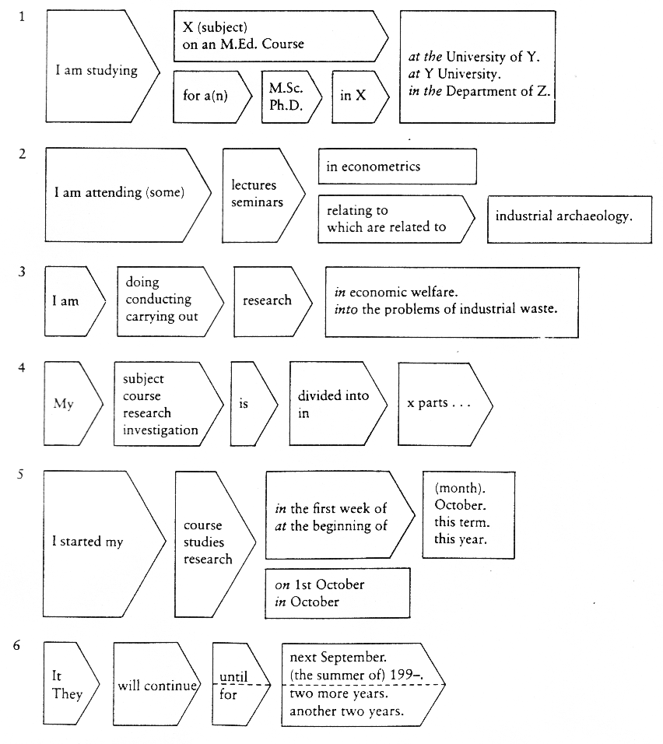

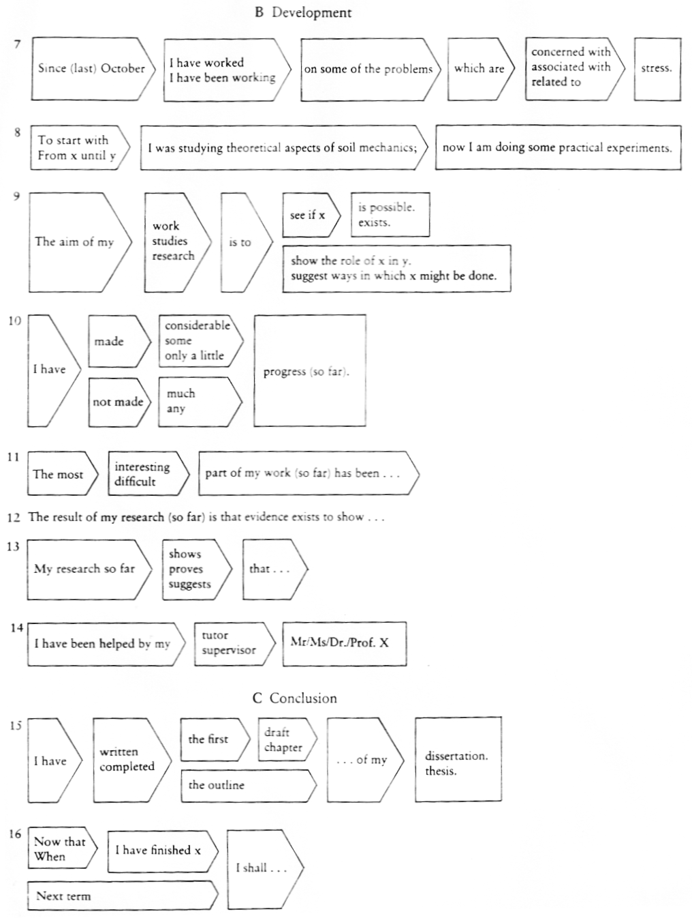

- HOMEWORK. Vocabulary revision and extension: Fill in the gaps with the words below. ⁴

assignment form play truant sit/take an exam course lecture revise fail staff-room enrol mark scholarship study pass seminar tutorial vacation

- My daughter is in the fifth …………………………… of the local comprehensive school.
- The teacher gave him a very high ……………………… for her essay.
- If you get a ……………………………… to a school or university, your studies are paid for by the school or some other organization.
- When he was a student at university he used to work during the summer ……………………… as a waiter.
- A …………………………. is a prepared talk to a group of students given by a teacher at a university or college.
- You don’t usually talk about homework at university. You use the word …………………………… instead.
- The ………………….. is where teachers in a school relax and prepare their lessons.
- A …………………… is a lesson in which a teacher at a university or college discusses a subject with a group of students.
- She went on a …………………………………. to learn about word-processing.
- A ………………………… is an individual lesson given by a teacher to one or more students.
- I can’t come out tonight, I’m afraid. I’ve got to ……………………….. for a test.
- This course is very popular. If you want a place on it you’d better ……………………. today.
- She went to university to ……………………………………..mathematics.
- He was very upset when he ………………………………. his exams, especially as he thought he had done so well.
- We are going to …………………………………. the Cambridge First Certificate examination at the end of the month.
- To …………………………………..means to stay away from school without permission.
- She was extremely intelligent and found it very easy to …………………………. all her exams.
Sources: ¹ Available at http://czs.muni.cz
³ Jordan. Academic Wrirting. Adapted from Marie Sabolová.
^{2, 4} Adapted from Hana Němcová and Milada Pavlovová .

Useful Websites - Information on study abroad:
http://czs.muni.cz
http://www.sci.muni.cz/NW/VVZ/INFO_STUDENT/home.htm

