INORGANIC NOMENCLATURE II
1. Revision - Conditional Clauses. Ask and answer questions in pairs.¹
If you had only 24 hours to live, what would you do?
If you could be invisible for a day what would you do and why?
If you could change one thing in the world, what would it be?
If you found a suitcase full of $1,000,000, what would you do?
If you could change one thing about yourself, what would it be?
If you could live anywhere, where would you live?
If you had time machine, where would you go and why?
If you could have dinner with anyone, who would you choose, and why?

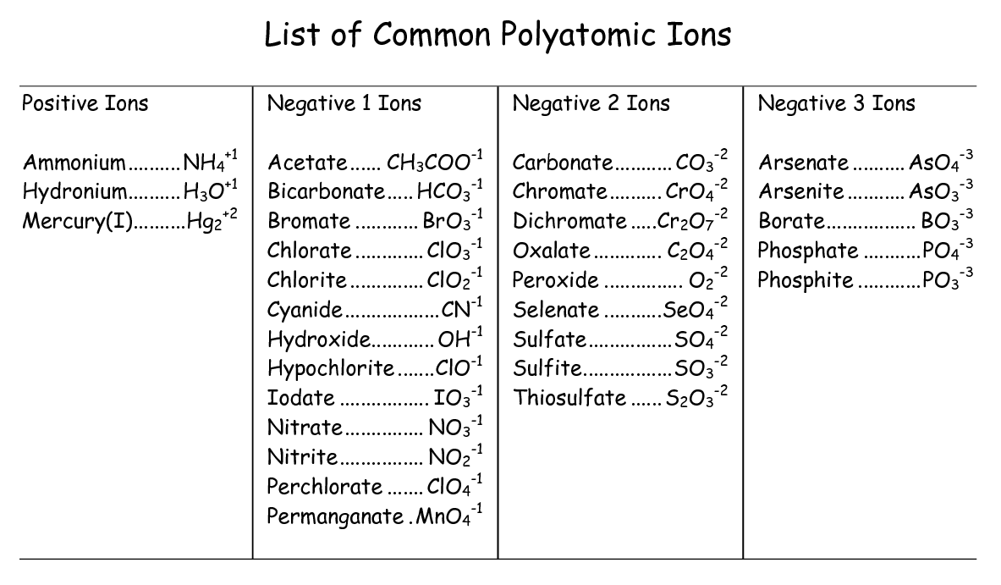
ACIDS
- Hydroacids: - hydrogen + non-metal hydro ....ic acid

HCl hydrochloric acid HCl → NaCl sodium chloride (salt)
HF hydrofluoric acid
HCN hydrocyanic acid
Note: H₂S hydrogen sulfide
- Oxyacids: polyatomic ion + acid
- only one oxyacid: -ic acid H ₃BO₃, - boric acid → Na₃BO₃ sodium borate (salt) H₄SiO₄ - silicic acid
- two oxyacids with different oxygen content:
Polyatomic ion –ate - suffix -ic - indicates higher oxygen content Polyatomic ion –ite - suffix -ous - indicates lower oxygen content
SULFATE ion…. H₂SO₄ sulfuric acid (higher oxygen content)
SULFITE ion…. H₂SO₃ sulfurous acid (lower oxygen content)
H₂S₂O₇ disulfuric acid

H₃PO₄ phosphoric acid
H₃PO₃ phosphorous acid
HNO₃ nitric acid
HNO₂ nitrous acid

- more than two oxoacids:
Remembering the number of oxygens
Largest: per -ate ClO₄ ¯ perchlorate ion perchloric acid HClO₄
Large: -ate ClO₃¯ chlorate ion chloric acid HClO₃
Smaller: -ite ClO₂¯ chlorite ion chlorous acid HClO₂
Smallest: hypo -ite ClO¯ hypochlorite ion hypochlorous acid HClO¯
prefix hypo [, haipә] means less than. prefix per [pәr ] means more

SALTS OF OXYACIDS
- ternary compound containing oxygen ends in -ate if there is only one such compound.
Example:
Na₂CO₃ sodium carbonate [´ ka:rbә,neit ], (no carbonite is known)
Na₃BO₃ sodium borate [´ bo:reit ], (no borite is known)
Na₄SiO₄ sodium silicate [silәkeit], (no silicite is known)
- If there are two compounds, differing only in their oxygen content and oxidation number of the central atom, there are two ways of nomenclature:
Older (trivial) names: the one which contains more oxygen ends in - ate and the other, with less oxygen, ends in -ite.
Example: sodium salts:
lower oxygen content higher oxygen content
NaNO₂ sodium nitrite ['naitrait ] NaNO₃ sodium nitrate [' naitreit ]
Na₃PO₃ sodium phosphite[´fosfait ] Na₃PO₄ sodium phosphate[´fosfeit ]
Na₃AsO₃ sodium arsenite [´arsә,nait ] Na₃AsO₄ sodium arsenate [´arsә,neit]
Na₂SO₃ sodium sulfite Na₂SO₄ sodium sulfate

Example: sodium salts of the oxyacids of chlorine:
ACID SALT
- HClO hypochlorous acid → NaClO sodium hypochlorite [, haipә ´klourait ]
- HC1O₂ chlorous acid → NaCIO₂ sodium chlorite [´klourait]
- HClO₃ chloric acid → NaClO₃ sodium chlorate [ ´klou,reit]
- HClO₄ perchloric acid → NaClO₄ sodium perchlorate [, pәr´kloureit]
KMnO₄ - potassium permanganate [,pәr´mәngә,neit].
Rational nomenclature (named according to IUPAC regulations)
Since the oxygen-acid nomenclature of ternary compounds does not give the absolute number of oxygens involved, the name must be derived from experience. That´s why chemists use prefixes mono-, di-[dai], tri-[trai], tetra-, penta- which express the absolute number of oxygens. Roman numerals express the oxidation number + suffix - ate
Example:
Na₂SO₃ sodium trioxochlorate (IV) - 3 oxygens, sulphur: oxidation number IV Na₂SO₄ sodium tetraoxosulfate (VI)
sodium salts:
NaClO₄ sodium tetraoxochlorate (VII)
NaClO₃ sodium trioxochlorate (V)
NaClO₂ sodium dioxochlorate (III)
NaClO sodium oxochlorate (I)
2. Exercises a) Write the chemical formula for:
1. sodium tetraoxochlorate (VII)
2. sodium trioxochlorate (V) 3.sodium phosphite
4. sodium phosphate
5. sodium sulfate
6. sodium sulfite
b) Write the name for:
1.Ca(NO3)2
2. Ca(NO₂)₂
3. BaSO₄
4. NaClO₃
5. NaClO₂
6. NaHSO₄
HYDROXIDES: (bases containing the OH group) – the same rules applied
NaOH sodium hydroxide
Ca(OH)₂ calcium hydroxide
Mg(OH)₂ magnesium hydroxide
Fe(OH)₂ iron (II) hydroxide = ferrous hydroxide
Fe(OH)₃ iron (III) hydroxide = ferric hydroxide
OTHER IMPORTANT COMPOUNDS:
Hydrates
3CdSO₄. 8 H₂O cadmium sulfate - water ( 3/8)
[Al(H₂O)₆ ]³⁺ hexaaquaaluminum (3+) ion
[ CoCl (NH₃ )₅ ]²⁺ pentaaminnechlorocobalt (2+) ion

3. Exercises: a) Write the formulas for:
1. phosphorous acid
2. carbonic acid
3. disulfuric acid
4. nitric acid
5. hydrobromic acid
b) Write the names for:
1. H₃PO₄
2. H₂SO₄
3. H₄SiO₄
4. HClO
5. H₃BO₃ 6. Ba(OH)₂
7. KOH
8. CaSO₄ .2 H₂O
9. [Al(H₂O)₆]³⁺
4. LISTENING / WATCHING. Listen and fill in the gaps with names of chemicals.⁴

A solution of ……………………………. and dilute ………………………… covers a drop of ……………… in a watchglass. An …………. nail is positioned so that it nearly touches the mercury. Eventually, the mercury drop starts to beat rhytmically, like a beating heart. The dichromate oxidizes the mercury to …………………………….., which combine with ………………………… at the surface of the mercury drop to form a film of an insoluble …………………................... This film decreases the surface tension of the mercury, allowing the drop to flatten. Eventually, the mercury drop expands to touch the iron nail, at which time electrons flow from the nail to the mercury. The electrons reduce the ……………………….. to mercury, destroying the surface film. The surface tension increases and the mercury drop becomes more spherical. Point back from the nail, then the mercury and the iron nail no longer touch, …………………………. again builds up on the surface and the process repeats.

HOW TO READ CHEMICAL EQUATIONS IN ENGLISH³:
Example: HCl + NaOH → NaCl + H₂O

We spell as: H Cl plus Na OH gives Na Cl plus H₂O

We read as: hydrochloric acid reacts with sodium hydroxide to form sodium chloride and water
Reading chemical formulae:

+ | is read „reacts with, „combines with “ "plus", "and" or "together with"
= | is read "give", "form", "pass over to", "yield" or "go to"
--> | is read "give", "pass over to" or "lead to"
<--> | is read "forms and is formed from"
C₃H₂ | c three h two
2 CO₂ | two molecules of c o two
CO₂ + CaO → CaCO₃ | c o two plus c a o give c a c o three  c o two reacts with c a o to give give c a c o three
Ca(OH)₂ | c a o h twice

You can also use time clauses / conditional clauses to describe the reactions:

When we mix ………… with …….., we will get ………… .

If ………… mixes together with ………… , it will lead to ………. .

If we mixed …............ and ………, it would lead to ……. .
- Read these equations in pairs. First spell them, then express in words. You can use a time / conditional clause. a) CO₂ + H₂O ---> H₂CO₃ b) CaCO₃--->CaO + CO₂ c) 2 CO + O₂-->2 CO₂ d) 2 Na + Cl₂ → 2 NaCl e) ZnO + H₂SO₄ → 2 ZnSO₄ + H₂O f) 2 Na + 2 H₂O → 2 NaOH + H₂
6. Work in small groups. Write down two or three equations on a piece of paper. Then present the equations to to the others.



HOMEWORK: VOCABULARY IN CONTEXT
Circle the letter of the answer that best matches the meaning of the italicized word.

1. Frayed electrical wires are potential fire hazards.
a. probable b. unlikely

2. The velocity of the wind increases during the storm.
a. sound b. speed

3. The conservation of natural resources, such as rivers and forests, is an important issue of our time.
a. preservation b. observation

4. When the temperature dropped, vapour accumulated on the inside of the window.
a. steam b. dust

5. Pasteur´s germ theory proved to be valid and was a major breakthrough in the history of medicine.
a. false b. true

6. When the bottle was uncapped, all the pressure inside was released.
a. set free b. increased

7. Energy is released by the fission of atomic nuclei.
a. splitting b. combining

8. The cold on top of the mountain got more intense later in the evening.
a. extreme b. moderate

9. An alloy is a fusion of two or more metals that makes a stronger metal.
a. combination b. separation

10. The best way to solve a problem is to find the source.
a. origin b. effects

11. Flemming revealed that his discovery of penicillin was accidental.
a. made known b. kept hidden

12. The earth absorbs the water from the rain.
a. drinks in b. gives off

13. The driver went in the reverse direction.
a. identical b. opposite

14. Air is the medium through which sound travels.
a. process b. environment

15. The old building was transformed into an emergency hospital.
a. enlarged b. changed

Sources: ¹ Available at http://iteslj.org/questions/
- Adaptefd from www.fch.vutbr.cz/angl2/ Zpracovala Lenka Fišerová a Gabriela Clemensová
- Available at http://jchemed.chem.wisc.edu/JCESoft/CCA/pirelli/pages/cca3heart.html
Lesson adapted from Marie Sabolová and Milada Pavlovová.

