6. INORGANIC NOMENCLATURE I
1. SPEAKING. Grammar – Time Clauses.

Complete these sentences with your ideas. Then ask about them in pairs.
Example: When I get home … I´m going to have a bath.
Q: What are you going to do when you get home?

a) When as I get home today …………………………………….
b) As soon as this lesson finishes ……………………………………
c) After I finish my studies ………………………………………..
a) When I was a child ………………………………………………..
d) When I attended secondary school ………………………….. …….
e) …………………………………………………….. before I get too old.
f) When I´m on holiday …………………………………………………

2. Elements and compounds. Revision. Work in small groups. Try to answer these questions.

- What is the difference between an element (e.g. H) and a compound (e.g. H₂SO₄)? Try to write a definition of an element and a compound.
- What types and groups of elements do you know?
- Do you know any names of elements? What do you know about them?
- What is an ion? What types of ions do you know? What is their charge?
- What is an isotope? Give examples of isotopes.
- What is the difference between binary and ternary compounds?
- Give examples of some organic and inorganic compounds, acids and bases, salts, oxides, hydroxides. What do you know about them? What are their properties? What is their use?
- Explain these terms: chemical symbol, chemical formula, chemical equation. Give examples.

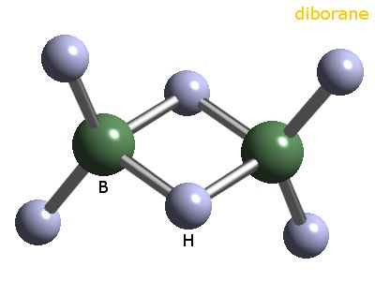

3. Listening. Listen to the Song of the elements by Tom Lehrer and fill in the gaps. ¹

There’s antimony, arsenic, aluminum, selenium,  And hydrogen and and nitrogen and rhenium.  And nickel, neodymium, neptunium, germanium,  And , americium, ruthenium, uranium,  Europium, zirconium, lutetium, vanadium,  And lanthanum and osmium and astatine and _____________ .  And gold, protactinium and indium and gallium,  And and thorium and thulium and thallium. | There’s holmium and helium and hafnium and erbium,  And and francium and fluorine and terbium.  And manganese and mercury, molybdenum,_____________________  Dysprosium and scandium and cerium and cesium,  And lead, praseodymium, and platinum, plutonium,  Palladium, promethium, , polonium,  Tantalum, technetium, titanium, tellurium,  And cadmium and and chromium and curium.
There’s yttrium, ytterbium, actinium, . And boron, gadolinium, niobium, iridium.  And strontium and and silver and samarium,  And bismuth, bromine, lithium, beryllium and barium. | There’s sulfur, californium and fermium, berkelium,  And also mendelevium, einsteinium and nobelium.  And argon, , neon, radon, xenon, zinc and rhodium,  And chlorine, carbon, cobalt, copper,  Tungsten, tin and .
These are the only ones of which the news has come to Harvard,
And there may be many others but they haven’t been discovered.

Now look at the at the periodic table with pronounciation.

4. Quiz – matching. Match each phrase with an element²:

1. a twenty-fifth wedding anniversary A. mercury
2. maybe the first metal used by man B. nickel
3. a can is made of it C. oxygen
4. an American coin D. nitrogen
5. 1st place medal E. copper
6. breathe in F. phosporus
7. good for your teeth G. silver
8. think of matches H. iron
9. 80% of the air I. tin
10. nuclear power can come out of this J. hydrogen
11. the most widely used metal of all K. gold
12. describes a particular type of blond hair L. plutonium
13. think of the bomb M. calcium
14. gives out light in the dark N. sulphur
15. used in thermometers O. platinum

5. What alloys or other substances will you get if you mix the following?

1. copper and tin A. brass
2. copper and zinc B. cement
3. iron and carbon C. concrete
4. lime, clay, sand and water D. bronze
5. the above plus gravel E. steel

Now say it in a sentence. e.g. When / if we mix copper and tin, we get …

INORGANIC NOMENCLATURE:

A. IONS.
Cations H⁺ h plus / hydrogen ion / univalent positive hydrogen ion Cu²⁺ c u two plus / divalent positive cuprum (copper) ion
Fe²⁺ Fe two plus / iron (2 +), iron (II), ferrous ion, divalent positive iron ion
Fe³⁺ Fe three plus / iron (3+), iron (III), ferric ion, trivalent positive iron ion Hg₂²⁺ h g two two plus / mercury (I) ion
Anions: Cl ⁻ c l minus / negative chlorine ion / negative univalent chlorine ion OH⁻ OH minus / hydroxide ion
6. Nomenclature quiz. Complete these sentences.
a) The chemical symbol for the calcium ion is …………………..
b) The chemical symbol for the fluoride ion is ……………………
c) The chemical symbol for the ammonium ion is............
d) The chemical symbol for the magnesium ion is...........
e) The chemical symbol for the sodium ion is..............
f) The chemical symbol for the aluminum ion is............
Then check the exercise in pairs. Ask and answer questions. (What is the chemical symbol for…?)
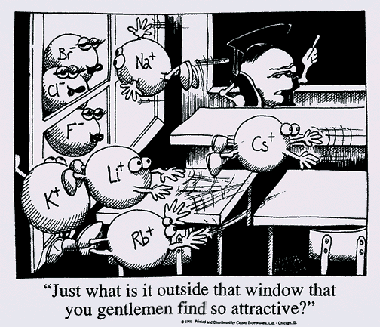

B. BINARY COMPOUNDS (compounds that consist of a combination of two elements).
a) METALS WITH A FIXED CHARGE (one oxidation state) Salts of oxo-acids, metal oxides and other binary compounds.
- metal + nonmetal with -ide [ aid ]

E.g. NaCl - En : sodium chloride [aid] Cz : chlorid sodný (note: in Czech different order of elements than in English)

NaCl sodium chloride [kloraid]
ZnCl₂ zinc chloride
CaC₂ calcium carbide [ka:baid]
MgS magnesium sulphide [salfaid]
KHS potassium hydrogen sulphide
Ca₃N₂ calcium nitride [naitraid]
KNH₂ amide [ә´maid ]
KCN cyanide [ ´sai´naid]
K₂O potassium oxide
ZnO zinc oxide
CaO calcium oxide
7. Nomenclature quiz: Write the chemical formulas of :
a) sodium fluoride
b) potassium hydrogen sulphide
c) silicon carbide
d) potasium cyanide
e) aluminum chloride
f) calcium nitride g) zinc oxide
8. Write the names of these compounds:
a) Na₂C..................................
b) NaCN...................................
c) BaS....................................
d) CaCl₂.................................
e) Mg₃N₂ ................................
f) NaNH₂.................................
g) CaF₂................................... h) CaO …………………….......
Now check your answers in pairs. Spell the formulas.
b) METALS WITH A NON-FIXED CHARGE (occur in more than one oxidation state) Metal oxides and other binary compounds with a non-fixed charge
2 methods of nomenclature:
Rational nomenclature (named according to IUPAC regulations)
Roman numeral expresses oxidation state
FeO iron (II) oxide
Fe₂O₃ iron (III) oxide
Cu₂S copper (I) sulfide
CuS copper (II) sulfide FeCl₂ iron (II) chloride FeCl₃ iron (III) chloride
Older method (Latin name, trivial name)
- suffix -ous [ -s ] - indicates lower oxidation state - suffix -ic [ ic ] - indicates higher oxidation state
Example:
FeO ferrous oxide (lower oxidation state)
Fe₂O₃ ferric oxide are oxides of iron (higher oxidation state)
Cu₂S cuprous sulfide
CuS cupric sulfide are sulfides of copper
mercuric chloride and mercurous chloride are chlorides of mercury arsenic oxide and arsenous oxide are oxides of arsenic plumbic iodide and plumbous iodide are iodides of lead stannic bromide and stannous bromide are bromides of tin, etc
Important: These suffixes have no absolute meaning. They just indicate the lower and the higher valence. Thus e.g. -ic means a valence of 2 in the case of copper and 3 in the case of iron . It is for this reason that Roman numerals are used.
c) NON-METALS (trivial names)
- Greek prefixes indicate the number of atoms of the element in the compound:
mono-, di-[dai], tri-[trai], tetra-, penta-, hexa-, hepta-, octa-, nona-, deca- + ide

Examples: NO₂ nitrogen dioxide = nitrogen (IV) oxide (1 atom of nitrogen, 2 atoms of oxygen)
N₂O₄ dinitrogen tetroxide = dimer of Nit. (IV) oxide
N₂O₅ dinitrogen pentoxide = nitrogen (V) oxide
CO carbon monoxide
CO₂ carbon dioxide
P₂O₃ (di)phosphorus trioxide
OsO₄ osmium tetroxide
P₂O₅ diphosphorus pentoxide
PCl₃ phosphorus trichloride
CCl₄ carbon tetrachloride
CS₂ carbon disulfide
d) PEROXIDES
An oxide containing more oxygen than some other oxide of the same element is called a peroxide.
H₂O₂ hydrogen peroxide [´haidrәdž әn pә ´ro,ksaid] Na₂O₂ sodium peroxide
Exercises:
9. Write the formulas of the following binary molecular compounds:
nitrogen monoxide...........................
dinitrogen monoxide.........................
sulfur trioxide.............................
iron (II) sulphide..........................
iron (III) sulphide.........................
dichlorine monoxide.........................
tetraphosphorus decoxide....................
oxygen difluoride...........................
iron (II) cyanide........................... sodium peroxide …………………………….
10. Write the names for the following formulas:
PI₃
SbF₅
P₂O₅
SO₃
FeCl₃
FeCl₂
ZnCl₂
CaO H₂O₂
Now check your answers in pairs.
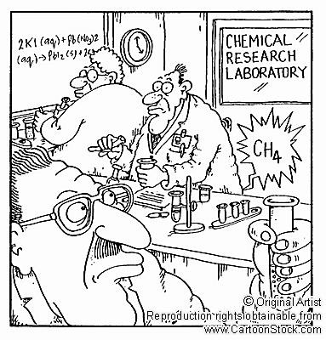
11. HOMEWORK: CONDITIONALS - PODMÍNKOVÉ VĚTY³

1. GRAMATICKÁ KONSTRUKCE TYPU I:
If I (+ čas přítomný)................................, I´ll ..........................................
If we go by bus, it will be cheaper.

Příklady:
If we go by bus, it will be cheaper.
Jestli pojedeme autobusem, bude to levnější.
If you don´t hurry, you´ll miss the train.
Jestli si nepospíšíš, zmeškáš ten vlak

POZOR NA ZÁMĚNU IF A WHEN!
If I go out = je možné, že půjdu ven, ale nejsem si jista. → Jestli půjdu ven....
When I go out = určitě půjdu ven. → Až půjdu ven....

2. GRAMATICKÁ KONSTRUKCE TYPU II:
If I (+ čas minulý)..................................., I would
If we went by bus, it would be cheaper.

Po if se používá tvar minulého času, nejde ale o minulost, význam je přítomný.

Příklady:
Jane lives in s city. She likes cities. She wouldn´t be happy if she lived in the country.
Jane žije ve městě. Má ráda města. Nebyla by šťastná, kdyby žila na venkově.
I´m sorry I can´t help you. I´d help you if I could. (but I can´t)
Bohužel Vám nemohu pomoci. Pomohla bych Vám, kdybych mohla (ale nemůžu)
If we had a car, we would travel more.
Kdybychom měli auto, víc bychom cestovali.

Vedle tvaru was se běžně používá were. Obojí je správně.
It would be nice if the weather were (was) better.
It´s cold. If I were (was) you, I´d put your coat on.

Věty typu I wish you were here.
Vazby I wish se použije, chceme-li vyjádřit, že je nám líto, že něco není tak, jak bychom si to přáli.
I wish I knew Paul´s phone number. (je mi líto, že jej neznám)
Kdybych tak jen / Kéž bych znala Paulovo telefonní číslo.

3. GRAMATICKÁ KONSTRUKCE TYPU III:
If I + (tvar předminulého času)...........I would (infinitiv minulý)
If we had gone by bus, it would have been cheaper.

I didn´t see you when you passed me in the street. If I´d seen you, I would have said hello.
Neviděla jsem Tě, když jsi mě na ulici míjel. Kdybych Tě byla (bývala) viděla /Kdybych Tě viděla, byla bych Tě (bývala) pozdravila / pozdravila bych Tě.
I decided to stay at home last night. I would have gone out if I hadn´t been so tired.
Rozhodl jsem se, že zůstanu doma. Byl bych (býval) někam šel / Šel bych někam, kdybych nebyl (býval) tak unavený / kdybych nebyl tak unavený.

Srovnejte typ II a typ III:
I´m not hungry. If I were hungry, I would eat something. (now)
I wasn´t hungry. If I had been hungry, I would have eaten something. (past)

Exercises:

a) Dejte slovesa do správného tvaru (čas přítomný nebo tvar s will):
- If you say (say) that again, I´ll scream (scream).
- I ........................ (be) surprised if she ......................(manage) to sell the car.
- If the boys .................... (come) to supper, I .................. (cook) the chicken breasts.
- I .................. (need) some money if we ........................ (go) out tonight.
- I .................... (miss) you if we ..................... (move) to Wales.
- If you ..................... (wash up), I....................... (dry).

b) If nebo when? If: něco se možná stane, when: něco se určitě stane.
Doplňte a převeďte do češtiny:
- .......................I become a President
- ......................it gets dark
- .................... the film finishes
- ...................... she passes her exam
- .....................it doesn´t rain tomorrow

c) Dejte slovesa do správného tvaru:
- They would be rather offended if I didn´t go to see them. (not/go)
- If you took more exercise, you would feel better. (feel)
- If I was offered the job, I think I ................................................ it. (take)
- I´m sure Amy will lend you the money. I´d be very surprised if she ........................................... (refuse)
- If I sold my car, I .............................................. much money for it. (not/get)
- A lot of people would be out of work if the factory ....................................... . (close down)

d) Dejte sloveso do správného tvaru:
- I didn´t know you were in hospital. If I´d known (I/know), I would have gone (I/go) to visit you.
- Ken got to the station in time to catch his train. If ............................................(he/miss) it, ....................................................................... (he/be) late for his interview.
- It´s good that you reminded me about Ann´s birthday. .............................................. (I/forget) if ....................................................................................... (you/not/remind) me.
- Unfortunately, I didn´t have my address book with me when I was in New York. If ..................................................... (I/have) your address, .............................................. (I/send) you a postcard.
- A: How was your holiday? Did you have a nice time? B: It was OK, but .................................................................... (we/enjoy) it more if ........................................................................ (the weather/be) better.

Sources: ¹ Available at http://www.privatehand.com/flash/elements.html , Transcript http://www.edu- cyberpg.com/iec/elementsong.
- Adapted from Milada Pavlovová.
- Adapted from Marie Sabolová.

