**JAF01 Lesson 12 Revision**

**A. VOCABULARY AND CONCEPTS**

1. **States of matter**
2. **Complete the sentences**

*Matter can be divided/ grouped/ classified ____________ types/ groups etc.*

*Matter can be classified/ categorised ____________ solid, etc.*

1. **What states of matter do we distinguish? What is characteristic for each of them in terms of molecular interrelationships?**
2. **Describe the transition phases among individual states of matter using the terms:** *vaporisation, ionisation, deionisation, freezing, sublimation, condensation, melting*
3. **Elements**
4. **What elements do these symbols represent?**

*C, Cu, Ca, Mg, Fe, N, Na, O, F, Al, I, Hg, Cr, Cl, Pb*

1. **Explain the difference:** *primordial – synthetic – from decay*
2. **Complete the table with relevant categories:**

|  |  |
| --- | --- |
|  | As |
|  | 33 |
|  | poisonous |
|  | Earth´s crust |
|  | alloys, pesticides, herbicides |
|  | by heating appropriate minerals in the absence of air |
|  | by taking in small amounts in food, water, air |
|  | health problems, even death |

1. **Properties of materials**

What do you call the property of a material which:

1. is not affected by corrosion
2. can burn easily
3. can be pressed into different shapes
4. can take in liquids
5. is heavy in relation to size
6. can be broken easily
7. bends easily
8. does not bend easily
9. tends to show chemical change when mixed
10. is thick and sticky, does not flow easily
11. can be made into a thin wire
12. can stretch and return to original size
13. dissolves easily
14. produces a lot of friction
15. is neither transparent nor translucent
16. **The atom and bonding**

Describe ionic bonds. Use the following words and collocations:

*low/high electronegativity – charged - cation – anion*

1. **Describing objects**
2. **Name the objects below:**
3. **Complete the blanks:**

The cross section of a cone is ________ .

The longitudinal section of a cylinder is _________ .

The sides of a cone are ___________ .

A ball is _____________ (like a sphere).

A funnel is __________ (like a cone).

1. **Study the picture and then complete the blanks.**

2 cm

1 cm

3 cm

1. This brick has a _________ of 3 cm. 4. It has a ____________ of 2 cm2.
2. It has a ____________ of 1 cm. 5. It has a ____________ of 22 cm2.
3. It has a ____________of 2 cm. 6. It has a ____________ of 6 cm3.
4. **Give definitions of:**

Astronomy - astronomical unit - telescope

An incompatible device – cranky device - a user-friendly gadget

Rotation – revolution

The mantle – the crust of the Earth

Billion in the short and long system

1. **Describe the relationship between stress and high blood pressure in 3 ways.**
2. **Complete the sentences with suitable words.**
   1. Scientists…………………. experiments to find a cure for cancer.
   2. Radio signals are now often ……………..by satellite.
   3. Computers are able to ………………… vast amounts of data very quickly.
   4. Solar power stations are able to ……………….. the energy of the sun.
   5. Other …………… energy sources include wind and wave power.
   6. In some types of power station steam is used to ………………turbines.
   7. The weight of lead is greater than that of aluminium, in other words lead ………………………more than aluminium.
   8. The ………………………….. of water is 100°C.
3. **Describe the graphs below:**

(http://www.ecenglish.com/learnenglish/lessons/describing-graphs)

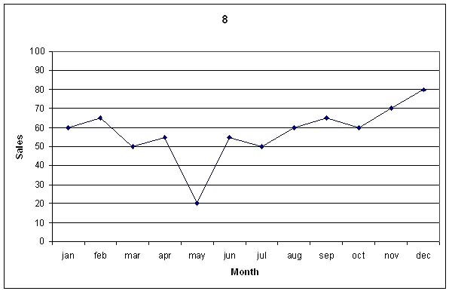

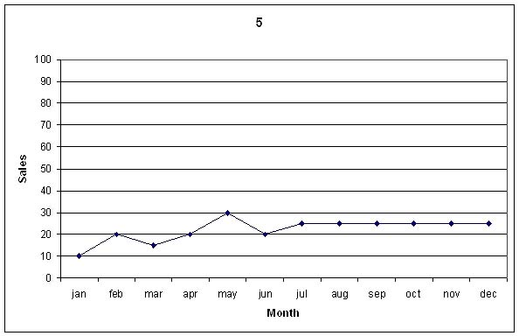

**B. GRAMMAR**

**I. Transform the sentences into passive voice:**

1. Researchers are developing new drugs. New drugs …

2. Researchers will develop new drugs. New drugs…

3. Researchers developed new drugs. New drugs …

4. Researchers have developed new drugs. New drugs…

5. Researchers may have developed new drugs. New drugs …

**II. Expressing regrets. Complete the sentences.**

Researchers have developed a new drug, but now they regret it. They make an announcement:

*We wish we …* (develop the drugs)

*We wish the drug …* (not be available anywhere)

*We wish governments …* (ban manufacturing the drugs)

**III. Tenses. Fill in the blanks with the correct form of the verb in brackets.**

Researchers of the Institute of Mayhill ________(currently develop) a new anti-inflammatory drug. Despite the involvement of distinguished scientists in the project, they ___________ (not make) much progress yet. Nevertheless, they __________ (already test) hundreds of samples, and the total cost of the associated investigations _____________ (double). Dr. O´Connor __________ (coordinate) the efforts of the international team since the beginning of the project. However, as he is to retire due to health problems, Dr. Julia Dorson __________ (take over) in March. It is expected that the team _______________ (complete) the final stage of the research by the end of May next year.

**IV. Ask question only about the underline phrase.**

The instrument is used primarily in medicine.

It was prof. Cladmont´s suggestion to try the other method.

The machine is controlled by a computer.

Students submit their essays to their supervisors.

I talked to a colleague of mine.

We encountered serious problems due to careless preparation.

**V. Translate from Czech:**

málo informací – málo zkušeností – pár zážitků - hodně peněz – trochu energie – málo geologů – pár psychologů – málo znalostí – trochu hmoty – pár sekund – málo tepla – trochu času – hodně výzkumů – málo pokusů – pár rad