Unit 3: PROPERTIES OF MATERIALS

1. What materials do you know?
In about one minute, write down names of as many materials as you can think of.
Compare the list with your partner. Discuss the use of the listed materials and their advantages/disadvantages.
(http://www.bbc.co.uk/learningzone/clips/2483.html)

2. Can you guess which material is described below?
1. ________ is made by melting sand and other minerals together at very high temperatures.
It is normally transparent and can be made into many different shapes.
2. ________ come from rocks called ores. They are strong, hard and shiny materials that can be hammered into different shapes without breaking. Many _______ are good conductors of heat and electricity.
3. _________ are materials made from chemicals and are not found in nature. They are strong and waterproof, and can be made into any shape by applying heat. They are good electrical insulators as they do not conduct heat or electricity.

3. Read the following adjectives describing properties and give more examples of materials or things with this property. Form nouns from the adjectives:¹
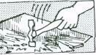 | A brittle material or thing breaks easily;  e.g. glass, egg,. .  noun: | 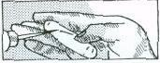 | A soft material is easy to scratch  e.g. chalk  noun:
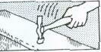 | A tough material / thing does not break easily;  e.g. steel,. . .  noun: | 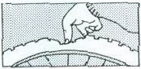 | A flexible material bends easily: e.g. rubber, ..  noun:
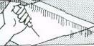 | A hard material is difficult to scratch. e.g. glass, .. .  noun: | 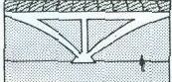 | A rigid material does not bend easily; e.g. concrete,...  noun:

4. Now ask and answer these questions in pairs:
a) Example: Why does a glass break if you drop it? Because it is brittle.
b) Why doesn't a plastic glass break?
c) Why is butter easy to cut?
d) Why can a diamond cut glass?
e) Why do the branches of a tree bend in the wind?
f) Why don't the walls of a house bend in the wind?
g) What are the different properties of green wood (on a tree) and dry wood?

5. Now complete these:
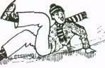 | Some materials have a smooth surface;  they produce little friction when they are rubbed; e.g. ice,...  noun: | 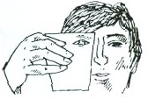 | You can see through transparent materials; e.g. water,. …  noun:
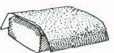 | Some materials have a rough surface and produce a lot of friction;  e.g. sandpaper, . ..  noun: | 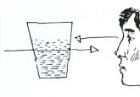 | You cannot see through translucent materials but the light passes through them;  e.g. dirty water, . . .  noun:
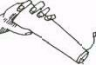 | Soluble materials dissolve easily; e.g. salt,…  noun: | 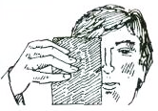 | You cannot see through opaque materials and the light cannot pass through them; e.g. metal,. . .  noun:
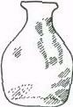 | Materials which are insoluble do not dissolve; e.g. glass,...  noun: | 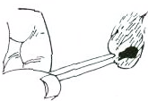 | Combustible materials burn easily e.g. wood,...  noun:

6. Complete the sentences below with appropriate words from exercises 3 and 5
a. The carbonates and phosphates of all metals are _______________ in water but _______________ in dilute acids.
b. The pale pink colour of quartz, which can range from ______________ to translucent, is known as rose quartz.
c. Some colloids are ______________ because of the Tyndal effect, which is the scattering of light by particles in the colloids.
d. _______________ materials are liable to catch fire very easily and burn.
e. _______________ is an important property of steel.
f. This PVC tubing offers excellent wear resistance and rubber-like _________________.
g. A _____________ substance or object is stiff and does not bend, stretch or twist easily.

7. Some other properties of materials. Form adjectives from these nouns.

Czech translation | Noun | Adjective
- pružnost | elasticity | elastic
- křehkost | fragility
- tažnost | malleability
- kujnost | ductility
- vodivost | conductivity
- žáruvzdornost | heat-resistance
- zápalnost | flammability
- jedovatost, toxicita | toxicity
- reaktivita | reactivity
- netečnost | inertness
- lehkost | lightness
- těžkost | heaviness
- savost, absorpčnost | absorbency
- viskozita, lepkavost | viscosity
- hustota | density
- trvanlivost, odolnost | durability
- odolnost proti korozi | corrosion resistance
- síla | strength

8. Choose the right word in a sentence:

a) A conductive / conductivity material can be used to conduct electricity.
b) If a material is easy to stretch under stress, we call it elastic / elasticity.
c) If you want to improve durable / durability of a machine, clean it regularly.
d) Hard / hardness is an important property of steel.
e) Concrete is used for building because it is strong / strength.

Now choose one noun and one adjective from the table in Exercise 7 and use them in a sentence. Read the sentences to your neighbour.

9. Speaking:

Work in pairs. One student describes something, using as many adjectives as he or she can. The second one asks questions. You should guess what it is. You can describe the colour, size, shape, origin, appearance, use etc. Then swap roles.

- Describe two materials.
- Now choose two objects from this room.

Useful phrases:
The object | is | slightly  relatively  quite  extremely  very | small  soluble in water  hot  silvery  old

The | colour  shape  durability | of | the object | is | blue  circular  high

10. Video: Advanced Materials Safety
Listen and complete the gaps in the summarising sentences:
(https://www.youtube.com/watch?v=nP2bERhM7d4)

- Over the past hundred years we have discovered how the arrangement of atoms in materials influences how those materials _________ .
- The combination of new knowledge, tools and techniques is enabling scientists to create _________ that were unimaginable a few years ago.
- Our knowledge is still quite __________ in some areas.
- Scientists are creating materials that are lighter, stronger and _________ than before; materials that generate, bend and _________ light in unusual ways; materials that _________ sunlight to electricity.
- Scientists are creating materials that enable faster, more __________ computers.
- Soon we will see more and more ____________ materials being developed – like materials that __________ to their surroundings and change their behaviour accordingly and _________ materials that combine different advanced materials into super-advanced materials, even materials that _________ the boundaries between living systems and everything else.
- Now we are only limited by the laws of physics and our ____________ .

11. GRAMMAR REVISION: tenses

I. Put verbs in brackets into the correct form and tense

Glass 1 _________ (have) many useful properties, but it 2_________ (be) not a tough material, in fact it 3 _________ (be) very brittle. However, for many years already car producers 4 __________ (use) specially tough glass, with which they 5 _________ (make) car windows. Wood is a good building material but it is combustible. In the past people 6__________ (build) mainly wooden houses and now we can observe that this kind of lodging 7 _________ (become) more and more popular. People like the cosy atmosphere and the nice smell that such material 8 ___________(produce). Who 9_____________ (know), maybe in the future, with yet another kind of modern technology we 10 ____________ (be able) to live in fir but non-combustible cottages?

Adapted from: ¹Jirků, Dana et al. English for Future Engineers. Praha: ČVUT, 2007.

