**LESSON 5: THE ATOM AND BONDING**

**Task 1: Identify the concepts defined below:**

* the smallest unit of all matter that has all the chemical properties of a particular element. It consists of a nucleus that is made of protons which are positive, and neutrons, which are neutral
* the amount or type of electrical force that something holds or carries
* a chemical substance that consists of two or more elements that together form a molecule
* one of the forms of a chemical element that have the same atomic number (=the same number of protons) but a different number of neutrons, and therefore have a different mass
* the number of protons and neutrons in an atomic nucleus (=the nucleon number)
* the central part of an atom, consisting of protons and neutrons, and containing most of its mass
* an extremely small piece of matter e.g.an electron

**Task 2: Listening - Jiggling atoms**

**Watch the video and note down the examples Richard Feynman uses to describe atoms.**

(https://www.youtube.com/watch?v=v3pYRn5j7oI)

**Task 3: Models of the Atom**

1. **Give answers for the blanks.**

Billiard ball

b. __________

Electron cloud

d. ___________

Nuclear

a. ___________

J. J. Thomson

c. _____________

Niels Bohr

e. ____________

1. **Now read the excerpts and match them with the models above.**
2. The hydrogen atom is the simplest atom, which is why __________ chose it for study. Its nucleus is a single proton, and ___________´s theory assumes that its one electron revolves around the nuclear proton in a circular orbit – in much the same way as a satellite orbits the Earth or a planet orbits the Sun.
3. ________________ studied electrical discharges in tubes of low pressure gas. He discovered that when high voltage was applied to the tube, a “ray” was produced at the negative electrode and sped to the positive electrode. Unlike electromagnetic radiation, the ray was deflected by electric and magnetic fields. _______concluded that the ray consisted of a stream of negatively charged particles, now called electrons. … ____________ ´s model conceived of the atom as a sphere of positive charge in which negatively charged electrons were embedded.
4. This is a very sophisticated, highly mathematical model that treats the electron as a wave and can explain more data and predict more accurately. This model is harder to visualise than the previous models. The location of a specific electron becomes more vague and can be given only in terms of probability. However, the important point is that this model enables us to determine accurately the energy of the electrons in multielectron atoms. For scientists, knowing the electron´s energy is much more important than knowing its precise location.
5. ____________´s major hypothesis was that each chemical element is composed of tiny, indivisible particles called atoms, which are identical for that element but different (particularly in their masses and chemical properties) from atoms of other elements. ___________ thought of atoms as essentially featureless, indivisible spheres of uniform density.
6. __________________ discovered that 99.97% of the mass of an atom is concentrated in a very tiny core called the nucleus. ___________ ´s model of the atom pictured the electrons as circulating in some way in the otherwise empty space around this very tiny, positively charged core. Yet, even this model has undergone modification.

(adapted from Shipman, J.T.; Wilson, J.D.; Todd, A.W. *An Introduction to Physical Science.* Houghton Mifflin, 2006.

For more information go to: http://profmokeur.ca/chemistry/history_of_the_atom.htm)

**After you read: Collocations**

**In the excerpts above, find collocations for these words:**

* Theory
* Ray
* Electron
* Atom
* Model

**Task 4: LISTENING: Bonding**

**Available at** <http://bcs.whfreeman.com/thelifewire/content/chp02/02020.html>(Click on ANIMATION – NARRATED)

1. **COVALENT BONDS**
2. **Watch the animation and answer the question: What elements or compounds are mentioned?**
3. **Listen again and fill in the gaps:**

A covalent bond results when two atoms share electrons. In the case of two______________, each shares its single electron with the other. This sharing allows each to fill its electron shell with two electrons. The pair of shared electrons __________a covalent single bond.

Let´s now consider _____________, an atom with eight electrons. Two electrons fill the_________________, and the other six electrons reside in the next shell. This outer shell needs two more electrons to complete it (the____________). Two ___________atoms form a covalent double bond by sharing two electron pairs from their outer shells.

Carbon is perhaps the most ___________________ on Earth, in large part because it contains only four electrons in a shell that can __________eight. To fill its outer shell, carbon forms four covalent bonds with up to four other atoms.

In a molecule of ___________________, carbon shares electrons with_________________ , forming four covalent single bonds. Although this molecule is relatively simple, carbon often forms _____________________of large, complex molecules. With each carbon atom able to bond to four other atoms, _____________ molecules are incredibly diverse.

Triple bonds are rare, but nitrogen gas molecules (the most abundant molecule in_____________________) form triple bonds. The two nitrogen atoms share three pairs of electrons, allowing each to have eight electrons in its _____________ electron shell.

**Now answer these questions:**

1. What is a covalent bond?
2. Which element forms a single covalent bond?
3. What is the most versatile element?
4. What is the most abundant molecule in the air?
5. What kind of bonds does it form?
6. **IONIC BONDS**
7. **Watch the animation and note down key words.**
8. **Watch it again and make notes of the main points.**
9. **Work with your neighbour. With the help of the pictures, describe ionic bonds.**

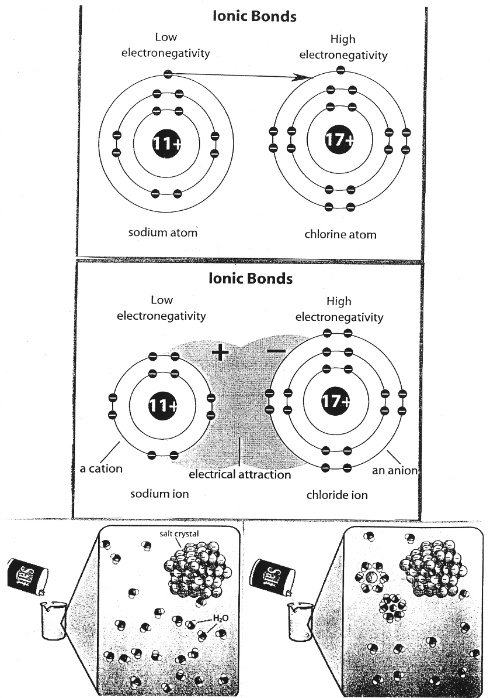

<http://bcs.whfreeman.com/thelifewire/content/chp02/02020.html>(Click on ANIMATION – NARRATED)

**Task 5: Reading: Fastest View of Molecular Motion**

**1. Read the first part of the text (until the headline “Ultra-fast process”) and try to answer the following questions:**

1. What was the timescale that the researchers watched molecules on?
2. Where could the study be used in the future?
3. Where was the study published?
4. What instrument was used in the experiment?

**2. Read the whole text and give the English equivalents of the following Czech expressions:**

1. vědci provedli pozorování
2. pochopení podstaty
3. vynalézt novou techniku
4. uvolní se rentgenové paprsky
5. řízení chemických reakcí
6. provádět testování

**Fastest view of molecular motion**

|  |  |  |  |
| --- | --- | --- | --- |
| **Scientists have made the fastest ever observations of motion in a molecule.**  They "watched" parts of a molecule moving on an attosecond timescale - where one attosecond equals one billion-billionth of a second.  The researchers say the study gives a new in-depth understanding of chemical processes and could be used in future technologies such as quantum computing.  The study, which relies on short pulses of light from a specially built laser, was published in the journal Science.  "Understanding how something changes in time means really understanding its essence, and we are now looking at changes on a very, very fast timescale," said team member Dr John Tisch, of Imperial College London, UK.  **Ultra-fast process**  The researchers devised a new technique to "see" the motion of protons, one of the building blocks of an atom, in molecules of hydrogen and methane.  The technique involves firing a very short but intense laser pulse at a molecule, which rips an electron away, leaving the molecule in an excited ionised state. | **1**  **2**  **3**  **4**  **5**  **6**  **7** | The electron is then drawn back to the molecule, and when it collides a very short burst of x-rays is released.  "That has encoded information within it about the state of the molecule at the point of re-collision, and can give us information about the motion of the protons in this molecule," Dr Tisch told the BBC News website.  The process is ultra-fast, and the team was able to observe the effect the laser had on motion in the molecules with an accuracy of 100 attoseconds - the fastest ever recorded.  The team said being able to see detailed molecular motion would help scientists understand how molecules behaved in chemical processes, thus providing possibilities for controlling molecules.  "Control of this kind underpins future technologies, such as control of chemical reactions, quantum computing and high brightness x-ray light sources for material processing," said Professor Jon Marangos, another Imperial College author on the Science paper.  "We now have a much clearer insight into what is happening within molecules and this allows us to carry out more stringent testing of theories of molecular structure and motion."  **Article Available at** ©<http://news.bbc.co.uk/2/hi/science/nature/4766842.stm>  **From The BBC News** | **8**  **9**  **10**  **11**  **12**  **13** |

**After you read:**

**Complete the word-formation table. The first has been provided as an example.**

|  |  |
| --- | --- |
| **Noun** | **Verb** |
| *observation* | *to observe* |
| researcher |  |
| motion |  |
| effect |  |
| study |  |
|  | to control |
|  | to collide |
|  | to behave |
| testing |  |
| reaction |  |

**Now choose 2-4 of these words and use them in a sentence.**

***Example:***

*I´ve read an interesting study of how animals adapt to their environment.*

**HOMEWORK: Vocabulary in Context**

**Circle the SYNONYM (=word of similar meaning) of the word in *italics*.**

**1.** Atoms are *infinitesimal* in size.

a. tiny b. huge

**2.** Chemists study the composition of natural *substances*.

a. materials b. machines

**3.** The fish suddenly *emerged* from the water.

a. arose b. disappeared

**4.** All matter is either liquid, solid, or gas, and solids may be *subdivided* into crystalline and amorphous.

a. built up b. broken down

**5.** At one time the atom was thought to be *indivisibl*e.

a. unable to be divided b. unable to be seen

**6.** The moon *revolves* around the earth.

a. stretches b. circles

**7.** Some scientists suspect that the planet Uranus once *collided* with another object in space.

a. crashed b. orbited

**Based on:** Zimmerrman, F. *English for Science*. New Jersey, 1989. **Lesson adapted from Marie Sabolová**

**Vocabulary – Atom and Bonding**

|  |  |
| --- | --- |
| covalent single bond (adj+adj+n) | jednoduchá kovalentní vazba |
| double bond (adj+n) | dvojná vazba |
| triple bond (adj+n) | trojná vazba |
| versatile (adj) | všestranný |
| backbone (n) | páteř |
| incredibly diverse (adv+adj) | neuvěřitelně rozmanitý |
| to result (v) | být výsledkem |
| to constitute (v) | vytvářet |
| to consider (v) | považovat za, uvažovat o |
| to reside (v) | sídlit, spočívat v |
| carbon-based molecules (adj+n) | molekuly na bázi uhlíku |
| scientists make observations | vědci provádějí pozorování |
| to observe (v) | pozorovat |
| motion (n) | pohyb |
| to move (v) | pohybovat se |
| researchers (n) | výzkumníci |
| scientists (n) | vědci |
| to publish a study (v+n) | publikovat studii |
| to release x-rays (v+n) | uvbolnit rentgenové paprsky |
| to behave (n¨v) | chovat se |
| behaviour (n) | chování |
| effect (n) | vliv |
| to affect (v) | mít vliv |
| excited ionised state (adj+adj+n) | excitovaný ionizovaný stav |
| timescale (n) | časová škála |
| encoded information (adj+n) | zakódovaná informace |
| understanding the essence (n+n) | pochopení podstaty |
| accuracy (n) | přesnost |
| to fire a laser pulse | vypálit laserový impuls |
| to devise a new technique | vynalézt novou techniku |
| to rip an electron away | odtrhnout elektron |
| to draw back (v) | vtáhnout zpět |
| to collide (v) | srazit se, kolidovat |
| collision (n) | srážka, kolize |
| to provide (v) | poskytnout |
| to rely on (v) | záviset na |
| control of chemical reactions | řízení chemických reakcí |
| carry out testing (v+n) | provádět testování |
| to collide (v) | srážet se, kolidovat |