

Using fossil fuels
Plants and animals that lived and died long ago have been a source of very important products called fossil fuels - petroleum (crude oil), natural gas, and coal.
Choose the most suitable word to complete the text:
bent fibers float fuel least next note occupy seek until through
Both petroleum, whose name comes from the Greek words for rock and oil, and natural gas can ……………… the tiny spaces between grains of sediment, and they can also fill pores and cracks in rocks. Both are actually frequently found …………. to each other.
Water is also able to penetrate nearly all pore spaces and cracks in rocks, even to great depths below the surface. Figure shows areas of a porous rock layer whose pore spaces are saturated with water, petroleum, and natural gas. The rock layer containing the water, petroleum, and natural gas has been ………… by some movement of the earth's crust. You will …………, however, that the layers of pore spaces that are filled with water or petroleum or natural gas do not bend with the rock layer. Rather, they tend to …………. their own levels.
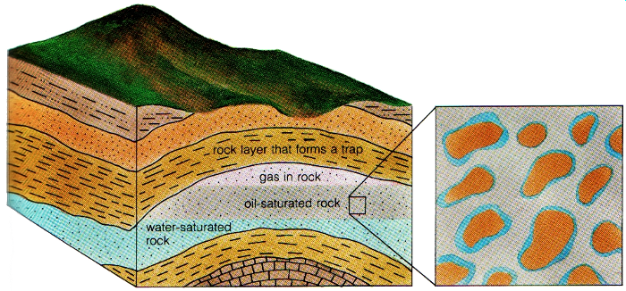
The petroleum is located above the water because petroleum tends to …………. on water, even underground. And the natural gas, the ………….. dense of the three materials, is located above the petroleum. Petroleum and natural gas move slowly up through sediments and rocks …………. they are blocked by a material that is too solid to let them pass …………….. . This kind of blockage is called a trap - that is what geologists look for when they explore for petroleum and natural gas.
A trap causes an oil to accumulate. The impermeable rock(s) that make a trap effective in preventing oil from migrating further is referred to as a cap rock.
Traps are of two types: structural and stratigraphical. Examples of structural traps are anticlines, synclines, domes and faults. Stratigraphical traps include unconformities and variations in lithology, which gives the general character of a rock, or a sedimentary formation, more particularly as seen in exposures and hand specimens.
(Source: Longman Dictionary of Geology)
Petroleum has more uses than just about any other substance on earth. Many forms of ………… and lubricating oils and also hundreds of chemical products called petrochemicals are made from it. Petrochemicals are used to make fertilizers, insecticides, plastics, synthetic ……………., and many other products that are in wide use throughout the world.

Formation of petroleum and natural gas
No one knows for sure how petroleum and natural gas formed. The most common theory is that they formed from the remains of microscopic plants and animals that lived in the earth's oceans. As the plants and animals died, their remains accumulated on the bottom of the sea. Bacteria in the water caused the plant and animal remains to decay. At the same time, the decaying material was covered with sediment that washed into the sea from the land. Over a long period of time, the sediment piled up to great depths. This caused heat and pressure on the decayed material beneath the sediment. All four factors—time, heat, pressure, and decay by bacteria—may have changed the plant and animal remains into petroleum and natural gas.
Note: Bacteria in the water caused the plant and animal remains to decay. (object + verb)
may have changed = minulý infinitiv
- Describe how petroleum and natural gas become trapped beneath the earth's surface.
In your description, include the terms water, pore spaces, blockage, and trap.

- Describe how petroleum and natural gas may have formed.

Choose one of the following words to complete the final part:
associated grade failed steel successive thought uses value
Coal is a solid fossil fuel that is mined both at the surface and underground. Coal is ………….. to have formed from layers of plant material, called peat, which became buried in a wet environment, …………… to decay completely, and then changed through heat and pressure into coal.
In the formation of coal, the plant material passes through a number of stages. With each stage, the plant material increases in hardness and in heat value. Heat value is the amount of heat given off by a certain amount of fuel. As the peat becomes buried under …………………….. layers of overlying material, heat and pressure change the peat, which is very soft, into lignite. Lignite is a soft coal that has a low heat ………………..…. Continued and increasing heat and pressure turn the lignite into
a better ……………… of soft coal called bituminous coal. Finally, the great heat and pressure ………………………. with deep burial produces a hard coal called anthracite coal, which has the highest heat value of the various forms of coal.
Coal has many ………………… . It can be processed to make artificial gas. It is burned to produce steam, which is then used to produce electrical power. It is used to make various chemical products. Also, bituminous coal is especially valuable because it can be changed into coke, a fuel used in making ……………………… .
Describe how coal may have formed.

Learn some more terms:
Borehole - a hole drilled into the Earth for oil, gas, water, etc. or to gain information about the rocks below the surface.
Core-drill rig - vrtná souprava pro jádrové vrtání
Drill logging / well-logging - the use of physical measurements from instruments lowered down boreholes to obtain information about the rocks below the surface (dokumentace vrtu).
Permeability is a measure of the ease with which a fluid can pass through a rock.
Reservoir - beds in which oil accumulates.
Oil shale - an argillaceous rock containing a solid material that when distilled gives off oil.
Argillite - a sedimentary rock with an average grain size less that 1/16 mm in diameter; clays, silts, mudstones, etc.; a hard mudstone.
Migration is the upward movement of oil from the rocks in which it was originally formed to other rocks that are porous and permeable.

Geothermal energy
Geothermal energy is powered by heat from deep within the earth's crust. This heat is believed to come from radioactive elements in minerals and from the friction of internal movements. The outer part of the earth's core may be molten, and this heat adds to the other heat sources.
The heat in the earth is high enough in some places to melt rock and form magma. In such places, any water will be in the form of steam, which can be brought to the earth's surface and used to turn the turbines of electrical generators.
If no water is present, two wells can be drilled down into the rock. Cold water can be forced down one well, heated by the rock, and brought back to the surface in the other well. In some places, the rocks at depth may not be hot enough to produce steam. Even so, the returning water from such wells is hot enough to heat buildings.
Sum up how geothermal energy may be used for heating, or even for the production of electric energy:
Sentence transformations:
We believe that the heat in the earth´s crust comes from radioactive elements in minerals.
The heat in the earth´s crust …
We suppose that it also comes from the friction of internal movements.
It is also …
We suppose that coal formed from layers of plant material, called peat.
Coal is ………….. to have ….
We think that petroleum and natural gas formed from the remains of microscopic plants and animals that lived in the earth's oceans.
Petroleum and natural gas ….
Adapted from Fariel, R. - Hinds, R. - Berey,D.: Earth Science, Addison-Wesley 1987
Definitions also from Longman Illustrated Dictionary of Geology, York Press 1982

Careers in Mining
Download this Power Point presentation to see descriptions of some of the mining-related careers.
http://www.mineralseducationcoalition.org/careers-mining

