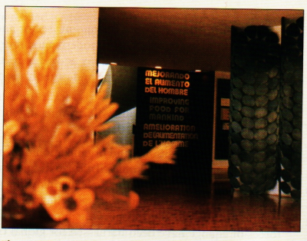

Figure 8.D The CIYMMT headquarters The Centre International de Mejorimiento de Maiz yTrigo (CIMMYT) (International Center for the Improvement of Maize and Wheat) in Texcocu, Mexico, is involved in plant breeding and research. High-yield-variety seeds were developed here for the Green Revolution. The center holds the world's premiere collection of corn and wheat germplasm. Modern, refrigerated storage vaults store many thousands or" varieties. Today, in addition to the static, cold storage, scientists are working with farmers to preserve seeds dynamically.

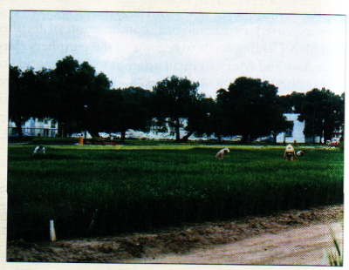

Figure 8.E Green revolution experimental plots The CIMMYT includes numerous plots for breeding and testing seed varieties.
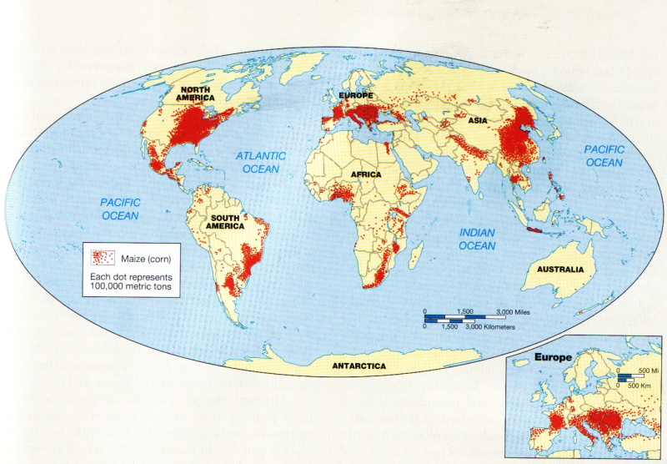
Figure 8.F Global distribution of maize production The widespread production of grains throughout the globe, particularly maize, has been one of the successes of the green revolution (After J. P. Goode,). C. Hudson, and E. P, Espanshade, Jr., Rand McM'ally'5 Coode's World Atlas, 20th ed., Rand McNally, 2000, p. 41.)

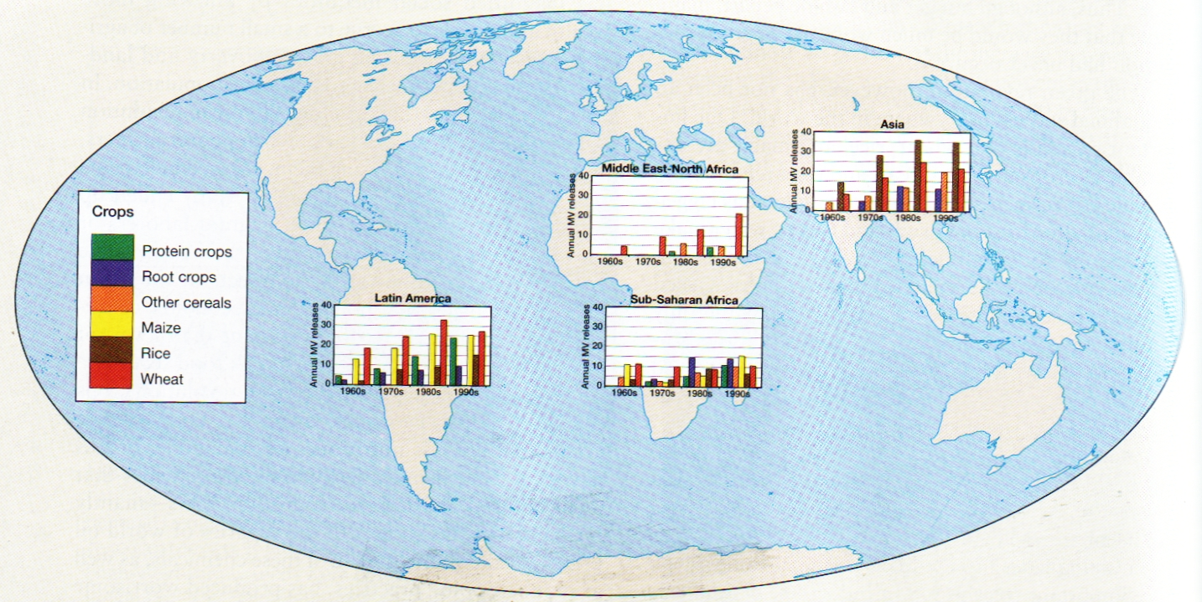
Figure 8.G Effects of the green revolution
This map illustrates the increased yields of protein crops, root crops, other cereals maize, rice and wheat brought about by the green revolution in selected countries in Latin America, Asia, Sub-Saharan Africa and the Middle East and North Africa. (Data from; R. E. Evenson and D. Gollin, "Assessing the Impact of the Green Revolution, 1960-2000," Science 300 (2 May 2005), p. 7 59.)

