TRIGATRÓN – spínané iskrište

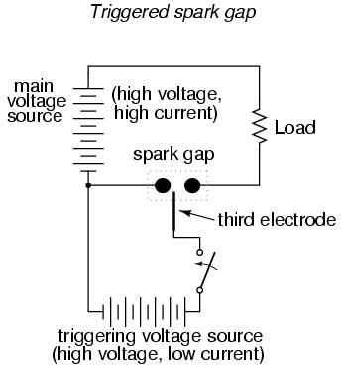

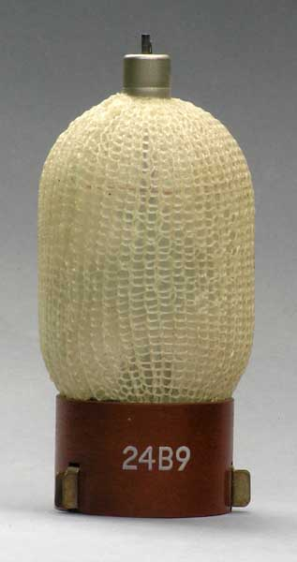 | CV6008, CV6173  Gas-filled triggered spark gap.  For in-line discharge modulators.  Gap voltage: 7.2 kV  Trigger voltage: 3.2 kV  PRF: 1200 /s  Peak power output: 160 kW  EEV datasheet 1971.  See also:  Mike's electric stuff / spark gaps .  Photo left  © Andy Cowley,  M1EBV, 2005. | 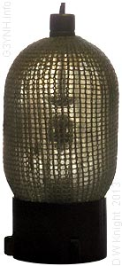

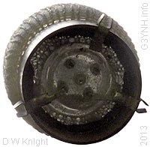 | Left: Bottom View.  The bulb contains a considerable quantity of loose powder. This is possibly a radioactive material included to promote fast triggering.

