1. STUDYING AT MASARYK UNIVERSITY

1. What do you know about MU ? In small groups try to answer the quiz.

- When was Masaryk University established?
- How many students studied here last year (approximately)?
- How many faculties does the university consist of?
- Which faculty is the youngest?
- Where is the farthest research station of the university?
- When did the Bohunice campus officially open?
- How many students and employees are there on the campus?

2. Pronunciation practice.
These are names of some departments and scientific disciplines. Can you pronounce them?

biophysical chemistry  general chemistry  department of biochemistry  centre for biomolecular research  chemoinformatics and bioinformatics | chemistry of conservation-restoration  applied biochemistry  department of chemistry  analytical chemistry  centre for environmental chemistry and ecotoxicology

3. Some more interesting facts about the university
Complete the statements with the following words.
e-learning disabilities leading transfer scientific reputation

- It has an excellent (1)_________ and it is one of the (2)__________ universities in the Czech Republic.
- It supports student mobility. It has a credit (3)__________ system, which means students can follow up their studies at foreign institutions.
- It accepts students with physical (4)_________, and has a centre for helping students with special needs.
- It uses information technologies in all academic areas – for registration, (5)__________, communicating, and informing.
- It has a recently built (6) __________ centre of international research in new modern disciplines.

Read about CEITEC and answer the questions below the text, then find words in the text that were formed from words in the table below.

The Central European Institute of Technology is an independent institute at Masaryk University which includes the leading Brno universities and research institutes that joined forces in order to establish a centre of scientific excellence. CEITEC priorities include international research cooperation as well as its interdisciplinary character. Its unique facilities create a base for addressing questions in the fields of nanotechnologies, microtechnologies, structural biology, genomics and proteomics, advanced materials, and biomedicine.
extract from CEITEC presentation in is.muni.cz

- What does CEITEC stand for? _________________________________________________________
- What institutions participate in the project? _____________________________________________
- What is the mission of the centre? ____________________________________________________
- What scientific disciplines does the centre cover?________________________________________

1 | Europe
2 | dependence
3 | science
4 | discipline
5 | excellent
6 | facilitate
7 | nation

4. My studies
Read this student’s introduction of himself. Try to guess the missing words. Then listen and compare.

Hello. My name is Libor Novák and I come from Jeseník, a small town with a population of about 10,000, in the mountains of northern Moravia but I’m (1)_________ living and studying in Brno. I study Chemistry at the Faculty of (2)_________, which is very demanding but I am enjoying the challenge. I’m in the second year of a five-year (3)_________ which means that next year I’ll be able to start specializing by choosing (4)_________ in those areas which interest me most.
Before coming here I attended the grammar school in Jeseník where my favourite subjects were Mathematics and Chemistry. On the other hand, I found languages more difficult and had to put in a lot of extra work to (5)_________ my school leaving exams.
At the moment I am living in the (6)_________ of residence in Komárov although next year I will have to leave and find a place to stay privately since there are not enough rooms for all the students who want them. I (7)_________ a double room with another student from Jihlava called Radek Kašpar who studies Geology. He would have studied Physics if it had been possible but he didn’t get a high enough mark in his (8)_________ exams.

Discuss the questions on your studies.

Look at your schedule and name lessons which you have.
What types of lessons do you have?
How do you study?
How are you assessed?
Who are the university staff?
How is the academic year organized?
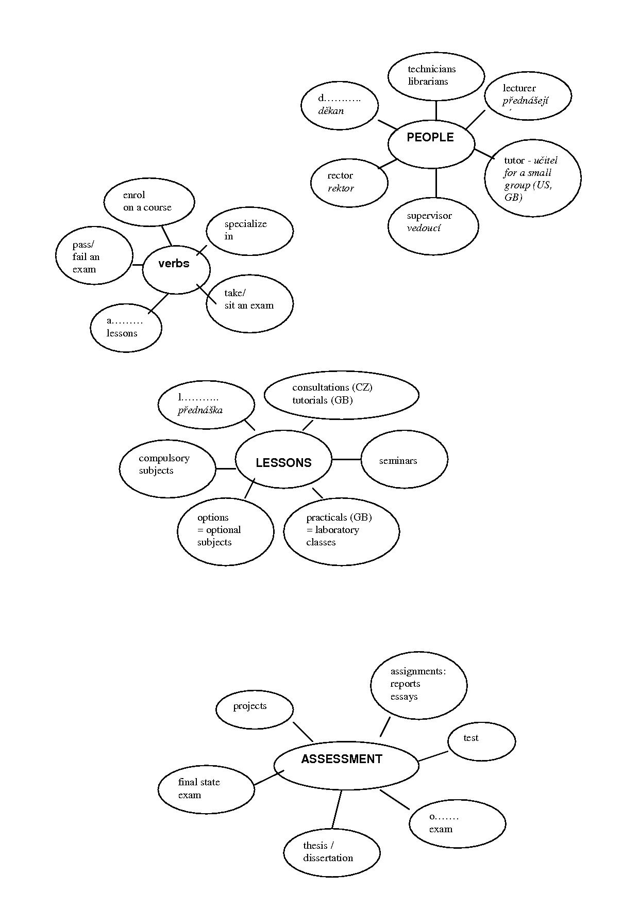
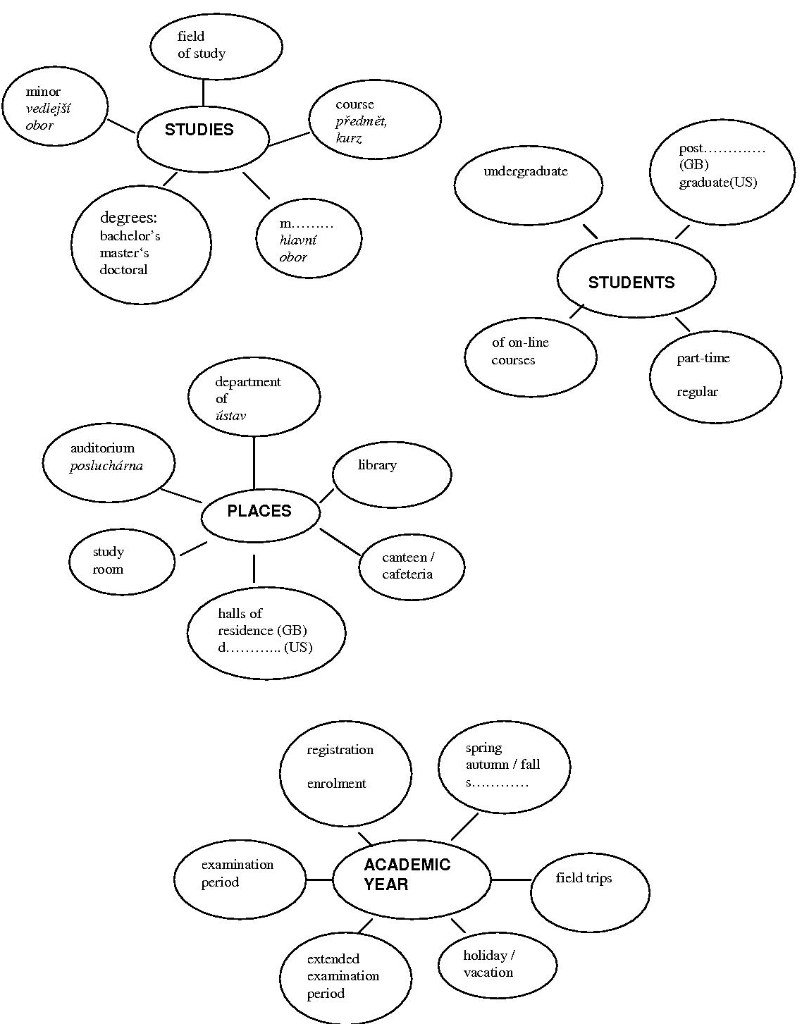
Pavel Zemánek is a postgraduate student. You want to ask him some questions.

Where (to come from)?
What (to study, currently)?
What (to do research in)?
Why (to update CV)?
What (like to do)?
Where (to live, currently)?
Who (to share a flat)?
Why (to share a flat)?

Listen to the recording about Pavel Zemánek and answer the questions above.

5. Prepare a short talk about yourself using the vocabulary from this lesson. Mention some personal information, where you are staying now, your field of study, seminars and lectures, your academic goals, future…etc. Then in pairs, introduce yourselves to each other.
Lesson adapted from H. Němcová, English for Biologists
A. Rozkošná, D. Dlabolová, English for Chemists

HOMEWORK

1.Read the texts on British and American universities (IS, study materials Higher Education UK, US, USxUK)

2. Search the internet and prepare information about a foreign university of your choice. Be prepared to share the information at next class.

What is the name and location of the University?
Why have you chosen it?
What is the official position of the head of the University?
What is the structure of the University? (faculties, colleges, schools, departments)
What degrees does the University offer?
How is the academic year organized?
What and why would you like to study there?
What are the language requirements?
How much will you have to pay?
How, when and where will you apply for admission?

