# 

# The Green Revolution

***Abstract: The author explains some positives and negative impacts of the green revolution in spite of its important role in fighting the famine and hunger.***

***Task 1: Choose the correct word from the clue to complete the first paragraph. There are three words that you will not need to use.***

Clue: accounted additional attempt attributed donations innovations   
 input output sufficient this thus

The green revolution was an _____________ to find ways to feed the growing population. It was started by U.S. agricultural scientists in 1943. Thanks to green revolution ________________, rice pro­duction in Asia grew 66 percent between 1965 and 1985. India, for example, became largely self-______________ in rice and wheat by the 1980s. Worldwide, green revolution seeds and agricultural techniques ________________ for almost 90 percent of the increase in world grain ____________ in the 1960s and about 70 percent in the 1970s. In the late 1980s and 1990s at least 80 percent of the _______________ production of grains could be _______________ to the use of green revolution techniques. Figure 8.F shows the distribution of maize production world­wide. ____________, although hunger and famine persist, many argue that they would be much worse if the green rev­olution had never occurred.

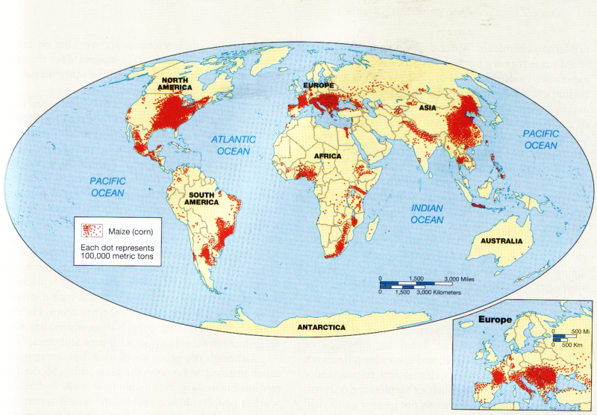

**Figure 8.F Global distribution of maize production** The widespread productionof grainsthroughout theglobe**,** particularly maize, has been one of the successes of the green revolution (After J.P. Goode,). C. Hudson, and E. P, Espanshade, Jr.,*Rand McM*'ally'5 *Coode's World Atlas,* 20th ed., Rand McNally, 2000, p. 41.)

***Task 2***

***Use one of the linkers from the clue to complete the text.***

**Clue:** - In addition - whereas - while - with regard to - yet

The green revolution, however, has not been an **unqualified success** everywhere in the world. One im­portant reason is that wheat, rice, and maize are un­suitable as crops in many areas, and research on more suitable crops, such as **sorghum** and **millet**, has lagged far behind. In Africa poor soils and lack of water make progress even more difficult to achieve. Another im­portant factor is the vulnerability of the new seed **strains** to pest and disease **infestation**, often after only a couple of years of planting. _____________ traditional va­rieties often have a built-in resistance to the pests and diseases characteristic of an area, the genetically engi­neered varieties often lack such resistance.

Another problem is that green revolution technol­ogy has decreased the need for human labor. In south­eastern Brazil machines replaced workers, creating significant unemployment. Green revolution technology and training have also tended to exclude women, who play important roles in food production. _______________, the new agricultural chemicals, especially pesticides, have contributed to ecosystem pollution and worker poison­ings, and the more intensive use of irrigation has creat­ed salt buildup in soils (salinization) and water scarcity.

________ another criticism is that the green revolution has magnified social inequities by allowing more wealth and power **to accrue to** a small number of agri­culturalists _____________ causing greater poverty and landlessness among poorer segments of the population. In Mexico a black market developed in green revolution seeds, fertilizers, and pesticides when poorer farmers, who were coerced into using them, accrued high debts that they could not begin to repay. Many ended up losing their lands and becoming migrant laborers or moved to the cities and joined the urban poor. Some critics who have monitored the effects of the green revolution suggest that political and economic condi­tions may, in fact, be more important than levels of production _________________ a country's food security.

***Task 3***

***a) Explain the meaning of these expressions from the text above. They are in bold type.***

**unqualified success =**

sorghum =

millet =

strains =

infestation =

to accrue to =

***b) Find the words that match the explanations. Look for only 1 word for each explanation.***

delayed -

prevent from being accepted -

rareness -

injustice because of not being fair to all -

forced -

money that somebody owns to somebody else -

***c) Check the correct pronunciation of these words.***

sorghum - millet - inequities - accrue - coerce - debt

***Task 4***

***Read and explain the words in bold type.***

Even regarding quality, the green revolution crops often fall short. The new seed varieties may produce grains that are less nutritious, less palatable, or less flavorful. The chemical fertilizers and pesticides that must be used are derived from fossil fuels—mainly oil—and are thus subject to the **vagaries** of world oil prices. Furthermore, the use of these chemicals, as well as monocropping practices, has produced worrisome levels of environmental contamination and soil ero­sion. In many countries these practices have posed sub­stantial threats to public health, especially among farm workers who are frequently exposed to poisonous (if not **lethal**) chemicals. Water developments have ben­efited some regions, bur less well-**endowed** areas have experienced a **deterioration** of already existing regional inequities. Worse, pressures to build water projects and co acquire foreign exchange to pay for importation of green revolution inputs have increased pressure on countries to grow even more crops for export, often at the expense of production for local consumption.

***Task 5***

***Sum up the negative impacts of the green revolution.***

***a)***

***b)***

***c)***

***d)***

***e)***

***f)***

***g)***

***Task 6***

***Explain the vicious circle (začarovaný kruh)in a few sentences by showing causes and effects of the green revolution.***

***Task 7***

***a) Read and suggest a suitable title for the next paragraph.***

***b) Translate the words in bold type and check their correct pronunciation.***

In recent years scientists have **endeavore**d to de­velop seeds with greater pest and disease resistance and more drought tolerance. The new focus is best re­vealed in Africa. The International Institute of Tropi­cal Agriculture in Ibadan, Nigeria, focuses on foods for the humid and sub humid tropics of Africa, in­cluding **cassava** (imported to Africa from South Amer­ica by the Portuguese in the sixteenth century), **yams**, sweet potatoes, maize, soybeans, and **cowpeas**. The International Crops Research Institute for the Semi-Arid Tropics (located in Hyderabad, India, but with a major research center near Niamey, Niger) focuses on researching **staple**s of the Sahel region, such as **sorghum**, **millet**, **pigeon pea**, and **groundnut**. Research in Africa on new varieties emphasizes testing under very **adverse** conditions (such as no **plowing** or fertil­izing). New varieties are chosen not just for good yield but because they will provide stable yields over good and bad years. A focus also exists on developing plants that will increase production of **fodde**r and fuel **residue**s, as well as of food, and that give optimal yields when **intertilled**—a very common practice in Africa. In the Sahel, scientists are working on crops that **mature** more quickly to compensate for the seri­ous drop in the average length of the rainy season recently experienced in the region.

***Task 8***

***Skim the last paragraph to give two final criticisms.***

***a)***

***b)***

There are two final criticisms that have raised concern about the overall benefits of the green revolution. The first is that it has decreased the production of bio-mass fuels—wood, crop residues, and **dung**—traditionally used in many peripheral areas of the world. For example, in India, as tractors have replaced **draft animals**, less dung is produced and thus less is available as fuel. Instead, a greater reliance is being placed upon oil to fuel both tractors and other energy needs; this means that if farmers are to be successful, they increasingly must depend upon the most costly of energy resources. The second is that the green revolution has contributed to a worldwide loss of genetic diversity by replacing a wide range of local crops and varieties with a narrow range of high-yielding varieties of a few crops. Planting single varieties over large areas (monocultures) has made agriculture more vulnerable to disease and pests.

Although the green revolution has come under much justified attack over the years, it has focused attention on finding innovative new ways to feed the world's peoples. In the process the world system has been expanded into **hitherto** very remote regions, and important knowledge has been gained about how to conduct science and how to understand the role that agriculture plays at all geographical scales of resolu­tion, from the global to the local (Figure 8.G).

***Task 9 Consult the words in bold type.***

***Task 10 Describe the increased yields in groups.***

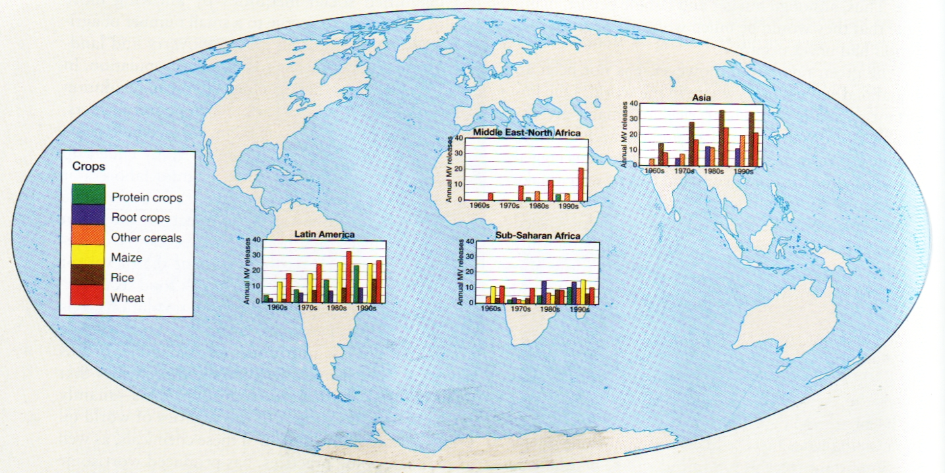

**Figure 8.G** **Effects of the** **green revolution**   
This map illustrates the increased yields of protein crops, root crops, other cereals maize, rice and wheat brought about by the green revolution in selected countries in Latin America, Asia, Sub-Saharan Africa and the Middle East and North Africa. (Data from; R. E. Evenson and D. Gollin, "Assessing the Impact of the Green Revolution, 1960-2000," *Science 300 (2 May 2005), p. 7 59.)*

Source of the text: Knox,P. - Marston, S.: ***Human Geography*** : *Places and regions in global context*, Pearson Prentice Hall 2007

Tasks by Věra Hranáčová, 2013