10. CARTOGRAPHY
Reading: Part A

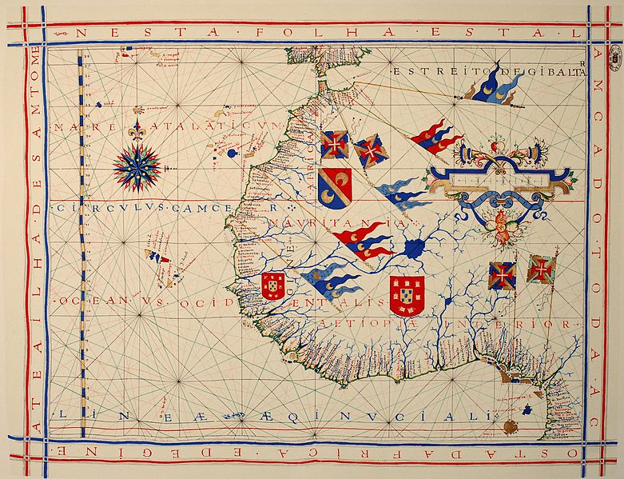

A pre-Mercator nautical chart of 1571, from Portuguese cartographer Fernão Vaz Dourado (1520 – 1580). It belongs to the so-called plane chart model, where observed latitudes and magnetic directions are plotted directly into the plane, with a constant scale, as if the Earth were a plane (Portuguese National Archives of Torre do Tombo, Lisbon).

http://en.wikipedia.org/wiki/Cartography

- What does cartography deal with?

- What questions are considered in the map making process?

- Complete the text with the words from the list.

information projections editing (= arranging) practice

traits modeled traditional agenda (=list of things)
Cartography is the study and 1) …………….. of making maps. Combining science, aesthetics, and technique, cartography builds on the premise that reality can be 2) …………….. in ways that communicate spatial information effectively.
The fundamental problems of 3) …………….. cartography are to:
- Set the map's design and select 4) …………….. of the object to be mapped. This is the concern of map 5) ……………... Traits may be physical, such as roads or land masses, or may be abstract, such as toponyms or political boundaries.
- Represent the terrain of the mapped object on flat media. This is the concern of map 6)……………...
- Eliminate characteristics of the mapped object that are not relevant to the map's purpose. This is the concern of generalization.
- Reduce the complexity of the characteristics that will be mapped. This is also the concern of generalization.
- Orchestrate the elements of the map to best convey its message to its audience. This is the concern of map 7) ……………...
Modern cartography is largely integrated with geographic 8) …………….. science (GIScience) and constitutes many theoretical and practical foundations of geographic information systems.

4. Paraphrase the underlined expressions using different words. Keep the original meaning.
a) cartography builds on the premise ………………………..
b) Eliminate characteristics of the mapped object that are not relevant to the map's purpose…………………………….
c) Orchestrate the elements of the map to best convey its message to its audience.
Part B
1. What is the subject of the following passage?

- The difference between general and thematic cartography
- The description of three general map types
- The explanation how to understand maps

In understanding basic maps, the field of cartography can be divided into two general categories: general cartography and thematic cartography. General cartography involves those maps that are constructed for a general audience and thus contain a variety of features. General maps exhibit many reference and location systems and often are produced in a series. For example, the 1:24,000 scale topographic maps of the United States Geological Survey (USGS) are a standard as compared to the 1:50,000 scale Canadian maps. The government of the UK produces the classic 1:50,000 (replacing the older 1 inch to 1 mile) "Ordnance Survey" maps of the entire UK and with a range of correlated larger- and smaller-scale maps of great detail.
Thematic cartography involves maps of specific geographic themes, oriented toward specific audiences. A couple of examples might be a dot map showing corn production in Indiana or a shaded area map of Ohio counties, divided into numerical choropleth classes. As the volume of geographic data has exploded over the last century, thematic cartography has become increasingly useful and necessary to interpret spatial, cultural and social data.
An orienteering map combines both general and thematic cartography, designed for a very specific user community. The most prominent thematic element is shading, that indicates degrees of difficulty of travel due to vegetation. The vegetation itself is not identified, merely classified by the difficulty ("fight") that it presents.

2. Decide whether the statements are true or false.
- General maps are often made in collection.
- "Ordnance Survey" is a mapping service in the US.
- The importance of thematic cartography has grown.
- Shading in orienteering map shows where to travel.

3. The expression “As” in bold print means

A) After B) Similarly C) Because

4. Ask about the underlined information. Formulate questions simply and retain the context.

Listening: Nigerian Activists Google Map Abuja
http://www.voanews.com/content/nigerian-activists-google-map-capital-city-abuja/1591551.html
or https://www.youtube.com/watch?v=CFSSis1fa6o

What do you know about Nigeria?

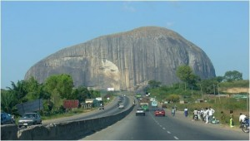
Aso Rock on the outskirts of Abuja
http://www.africatravelblogger.com/is-nigeria-the-king-of-africa/

Introduction
More than a hundred young Nigerians are teaming up with Google to add markets, hospitals, restaurants, and other attractions in the Nigerian capital to Google Maps. For VOA, Heather Murdock reports from Abuja that these volunteers see maps as a tool to improve security, reduce poverty and attract tourists and investors.

1. Watch the report and decide whether the statements are true or false.

- Foreign investors know about the changes in the country.
- According to the project director, emergency services need better maps.
- The cartographers receive money for mapping the city.
- Government and police are against this activity.
- The cartographers are local citizens.

2. Vocabulary from the video. Match the words and their descriptions

A to be unaware of 1 distrustful, cautious, suspecting danger
B resources 2 a person who lives in a particular place permanently
C to be wary 3 not informed about the current developments
D emergency 4 means that can be used to cope with a difficult situation
E resident 5 an unexpected event which requires immediate help

3. Summary of causes and effects. Watch again and complete the notes below.
1. The expected effects of mapping Abuja:
a)
b)
c)
2. Possible causes why the residents are afraid of mapping:

3. Reasons why the police are wary:
HOMEWORK Recommended video: Articles with geographical names – some basic rules
https://www.youtube.com/watch?v=Tqfi6V9tK5U

1. Is the definite article used with these names? Give an example for each item.

Rivers cities
Groups of islands oceans
Lakes continents
Individual mountains geographical regions
Countries mountain ranges
Planets seas

2. Other geographical names:

deserts valleys
peninsulas capes
straits currents
gulfs bays

3. Use the definite article where appropriate:

- United Kingdom
- Germany
- Vltava
- Amazonia
- Mount Everest
- European Union
- Thames
- Holland
- East Borneo
- USA
- Isle of Man
- Northern Africa
- Indian Ocean
- Baltic Sea
- Middle East
- Western Hemisphere
- Cape Horn
- Iberian Peninsula
- Great Britain
- Aleutians
- Niagara Falls
- Mount Fuji
- Himalayas
- Oklahoma City
- North Pole
- Kingdom of Denmark
- Sahara
- Silicon Valley
- Black Hills
- Kalahari Desert

Sources
Reading and homework – E. Čoupková, JAZ 01

