11. Urban development

- Describe the three pictures. Compare what you can see in them. Compare the ways of life in these three places.

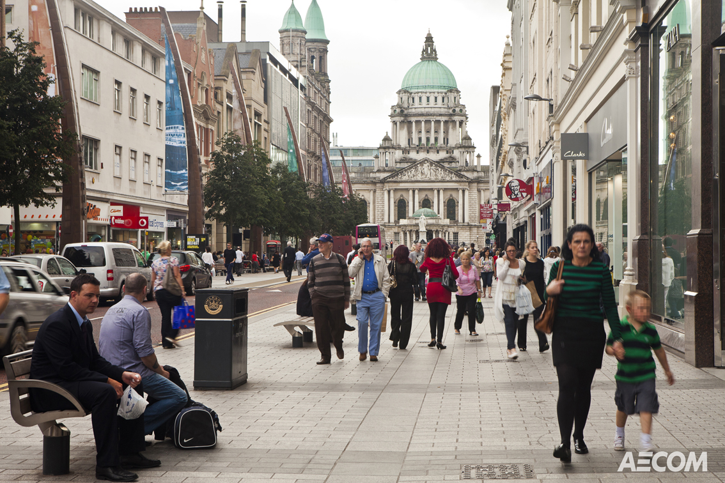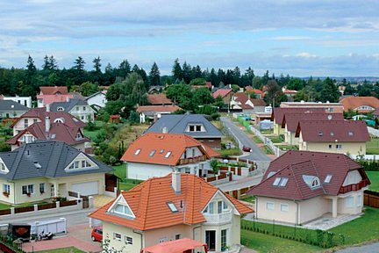

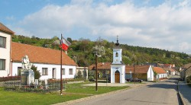

DISCRIBING SIMILARITIES
is similar to
A is comparable to B. A resembles B.
is as expensive as

Both A and B have certain advantages. Firstly,……secondly,……finally…..

DESCRIBING DIFFERENCES
much more expensive than
Living in A is less expensive than living in B.
not as expensive as

Unlike
In contrast to A , B is more polluted. A differs from B.

In comparison to

X is modern, while / whereas Y is more traditional.

- Imagine you decide to live in a new house/flat in a city. In which part of the city would you like to buy your house/flat? Give your reasons.

- Which city areas have the most and the least expensive land?
- Give examples of different functions of a city. Where are they located?
- Can you guess which part of city “CBD” is ? (What does letter B represent?)

The bid-rent theory or land value model

Introduction: The industrial progress in the 20th century also brought about the growth and development of urban settlements. Geographers have tried to map these processes. As a result of studying the structure of cities and conditions of growth, different models and theories have been developed. One of them is the so-called bid-rent theory which characterizes land use in cities from the point of view of economic geography.

Vocabulary
access- přístup
retail – maloobchod
subsidiary – vedlejší
parade – promenáda
estate – complex budov
alter – změnit
interchange - křižovatka

The most expensive or ‘prime’ sites in most cities are in CBD, mainly 1………….. its accessibility and the shortage of space there. Shops, especially department stores, conduct their business using a relatively small amount of ground space and 2 ………… their high rate of sales and turnover they can bid a high price for the land, for which thy try to compensate by building upwards and by using the land intensively. Competing with retailers are offices which also rely upon good transport systems and, traditionally, proximity to other commercial buildings.

Away from the CBD, land rapidly becomes less attractive for commercial activities. Industry, partly 3………… it takes up more space and uses it less intensively, bids for land that is less valuable than that prized by shops and offices. Residential land is found further out from the city centre where the land values have decreased due to less competition. Individual householders cannot afford to pay the same rents as shopkeepers and industrialists.

One basis of this model is ‘the more accessible the site, the higher its land value’. Rents will 4……… be greater along main routes leading out of the city and along outer ring roads. Where two of these routes cross, there may be a secondary or subsidiary land value peak. Here the land use is likely to be a small suburban shopping parade or a small industrial estate. The ‘retail revolution’ of the 1980s, which led to the development of large edge-of-the-city shopping complexes, has altered this pattern. 5…………. large industrial estates and science parks have been located near to motorway interchanges.

1.Read the text and put the conjunctions in right places.
because similarly therefore due to because of

2. Find these expressions in the 1st paragraph of the passage above, keep the given order :
- income received for selling goods and services
- the amount of business done in a given time
- trying to get what other sellers want at the same time
- the sale of goods in small quantities directly to consumers
Give the equivalents in your language.

3.Use the words in capital letters to complete the sentences. Change the form of words.
1. Most prime sites are in the centre, mainly because of its _____________ . ACCESS
2. ___________ land is found further out from the city centre. RESIDE
3. Central Business District has a ______________ of space. SHORT
4. Further out from the centre the land values have decreased due to less ________. COMPETE
5. The ‘retail revolution’ led to the ___________ of large edge-of-the-city shopping complexes.
DEVELOP

Majora Carter’s tale of urban renewal
http://www.ted.com/talks/majora_carter_s_tale_of_urban_renewal

1. Discuss before listening:

- Big cities have some problematic localities. What troubles do residents face there?
- What initiatives can local people have to improve their residential areas?
Do you know any examples?
- What is sustainable development?
- What do you think environmental justice could be?

2. Listen to Majora’s talk and choose the correct answer:

1] Sustainable policy in large urban areas is difficult because
- residents are not interested
- there is not enough money
- responsible people are not worried

2] Majora found an abandoned
- cat
- dog
- horse

3] The area of New York where she lives has
- a lot of parks
- a lot of skyscrapers
- a lot of pollution and garbage

4] Majora managed to
- establish the waterfront park in the area
- collect seeds and plant trees
- save more animals

5] In autumn Majora is going to
- start a new job
- get married
- have a baby

6] The term environmental justice refers to
- cities
- communities
- individuals

3. Listen again and write in the missing words. garner – získat, waterfront - nábřeží

1. you've all heard about how sustainable development will ………
2. most people with decision-making powers, in both the public and the private sector, really………………………... they're in danger
3. In 1998 we were fighting against a …………………..…….planned for the East River waterfront.
4. The area also has one of the lowest …………………….…………. in the city.
5. and you could not ……………….because of all the lovely facilities that I'd mentioned earlier
6. this forgotten little street-end, abandoned like the dog that brought me there, ………
7. We garnered …………… along the way.
8. And the Hunts Point Riverside Park became …………….that the South Bronx had.
9. no community should have more environmental burden and ………………………..than any other

4. Work in pairs. With the help of the answers in ex. 2 and 3 retell Majora’s story to your partner.

Key to ex. 3

1.save us from ourselves
2.don't feel as though
3. huge waste facility
4. ratios of parks to people
5. get to the river
6. was worth saving
7. much support
8. the first waterfront park
9. less environmental benefits

HOMEWORK.
1. Listen and complete the gaps.
If you're here today -- and I'm very happy that you are -- you've all heard about how sustainable development will save us from ourselves. However, when we're not at TED, we are often told that a real sustainability policy agenda is just not 1……………, especially in large, urban areas like New York City. And that's because most people with decision-making powers, in both the public and the private sector, really don't feel as though they're in danger.
The reason why I'm here today, in part, is because of a dog: an abandoned puppy I found back in the rain, back in 1998. She turned out to be a much bigger dog than I'd 2……………. When she came into my life, we were fighting against a huge waste facility planned for the East River waterfront, despite the fact that our small part of New York City already handled more than 40% of the entire city's commercial waste: a sewage treatment pelletizing plant, a sewage sludge plant, four power plants, the world's largest food 3…………… center, as well as other industries that bring more than 60,000 diesel truck trips to the area each week. The area also has one of the lowest ratios of parks to people in the city.
So when I was contacted by the Parks Department about a $10,000 seed grant 4…………… seed grant initiative to help develop waterfront projects, I thought they were really well-meaning, but a bit naive. I'd lived in this area all my life, and you could not get to the river because of all the lovely 5…………… that I'd mentioned earlier. Then, while jogging with my dog one morning, she pulled me into what I thought was just another illegal dump. There were weeds and piles of garbage and other stuff that I won't mention here, but she kept dragging me -- and lo and behold, at the end of that lot was the river. I knew that this forgotten little street-end, abandoned like the dog that brought me there, was worth saving. And I knew it would grow to become the proud beginnings of the community-led 6…………… of the new South Bronx.
And just like my new dog, it was an idea that got bigger than I'd imagined. We garnered much support along the way. And the Hunts Point Riverside Park became the first waterfront park that the South Bronx had had in more than 60 years. We 7…………… that $10,000 seed grant more than 300 times into a $3 million park.
And, in the fall, I'm actually going to -- I exchange marriage 8…………… with my beloved. Thank you very much. That's him pressing my buttons back there, which he does all the time. (Laughter) (Applause)
But those of us living in environmental justice communities are the 9…………… in the coalmine. We feel the problems right now, and have for some time. Environmental justice, for those of you who may not be familiar with the term, goes something like this: no community should be saddled with more environmental 10…………… and less environmental benefits than any other.

Key 1feasible 2 anticipated 3 distribution 4 initiative 5 facilities 6 revitalization 7 leveraged 8 vows 9 canary 10 burden

2. Grammar - word order. Put the phrases into correct order to make sentences

1. are used inner city decay redevelopment and renewal to combat urban

2. is where are demolished houses old, run-down urban redevelopment

3. in new towns or in the suburbs are their inhabitants rehoused

4. are then used commercial purposes, inner city sites mainly for multi-storey car-parks
shops and such as offices, the valuable

5. and other are encouraged are provided, community centres facilities so that
in their old localities to remain existing inner city residents

Key
1 Urban redevelopment and renewal are used to combat inner city decay.
2 Urban redevelopment is where old, run-down houses are demolished.
3 Their inhabitants are rehoused in new towns or in the suburbs.
4 The valuable inner city sites are then used mainly for commercial purposes, such as offices, shops and multi-storey car-parks.
5 Community centres and other facilities are provided, so that existing inner city residents are encouraged to remain in their old localities.

Sources
Pictures http://www.belfastcentre.com/city-centre-healthcheck/
http://www.prozeny.cz/magazin/bydleni-a-zahrada/interier-a-nabytek/16337-satelity-bydleni-v-zeleni-nebo-panelak-nalezato
Mokrá-Horákov http://www.aspida.cz/okres-brno-venkov
Listening E. Čoupková, JAZ01
Reading D. Waugh, Geography, An Integrated Approach, 2002, p. 392

