3. Natural Resources

LEARNING STYLES – homework from week 2

- Work in small groups. Share your comparisons of questionnaire results from the previous lesson.

- Then the class will be divided into 3 larger groups. Each group will conduct an internal survey of learning styles that the students apply. The purpose is to produce a classification of learners in the group.
Procedure 1. preparation - think about what questions you want to ask
2. survey – ask the questions, collect answers
- results – formulate the classification of students according to their learning styles

NATURAL RESOURCES

How can natural resources be classified? Prepare a diagram or word map which describes it. Be ready to present your information in class.

1. Describe your classification of natural resources.

2. Compare different sources of energy - their advantages and disadvantages.

3. Evaluate how people use natural resources.

Video: A New Wind Power Design

https://www.youtube.com/watch?v=fNudnI5tzf8

Introduction

Wind power is one of the fastest growing forms of alternative energy in the world. More and more, wind power mills are seen in the countryside, in large wind farms and for the most part, away from city life. But a new form of "wind power" is now designed to work in an urban environment.

How has the wind power capacity in America changed recently?

Where can the new type of wind turbines be set up?

What size is three-kilowatt version as compared to the one shown there?

Where did the designers find inspiration for the shape of the new turbine?

Where were the new turbines tested?

What are the advantages of the new turbines in comparison with the old type?

What is the height of the windspire?

What kind of information is transferred by the wireless connector?

What characteristic is mentioned as possibly attractive for passersby?

Compare your answers in pairs, then look at the script and check them.

Wind farms, like these ones in California, are becoming more common in rural areas of the U.S. An industry association says last year, alone, wind power capacity in America grew by 45 percent. Mostly wind power is generated by large propellers that can only be placed in the countryside.
But now, a U.S. company is offering a propeller-free personal windmill that can be set up in city or suburb. The president of Mariah Power, Mike Hess, demonstrates what he calls the "Windspire."
"This one generates 25 to 30 percent of the power in your house, but if we are building a three kilowatts version, which is only twice the width, same height, then it generates 100 percent of your power requirements," Hess said.
This new system was part of an environmentally friendly exhibit at the U.S. Botanical Garden in Washington. The design was inspired by a 3,000 year-old windmill the Egyptians used to grind wheat.
The company had the modern version independently tested, here in Utah, to prove it can be competitive with large propellers of traditional windmills.
The large blades have been known to kill birds and bats. And because they move much faster than wind speeds, they can be noisy.
But Hess says the Windspire's verticle-axis wind turbine is not only very quiet, but also bird-friendly.
"Bird friendly yes, because they only spin at two and a half times the speed of wind, so they can see it." He explained.
Hess says the company has begun installing the nine-meter tall devices, which can plug into household power. And customers can see on their home computers how much electricity the Windspire is giving them.
Hess says, "This is the wireless connector which allows them to tell how much power is being produced, it allows them to tell how fast the wind is blowing, all of that comes out in a computer read out," he said.
The new windmill design attracts the curiosity of tourists and passersby, many who might find the Windspire an affordable way to help power their homes.

Questions
- Do you consider this device useful? Why?
- Do people in this country largely utilize alternative technologies to help power their houses?
- Would you like to have a Windspire? What would be good to know before making the decision?

DESCRIBING SHAPES

What words are needed for describing shapes? Try to write three phrases under each picture.

1 2 3
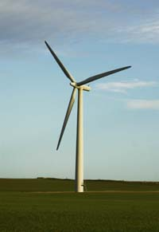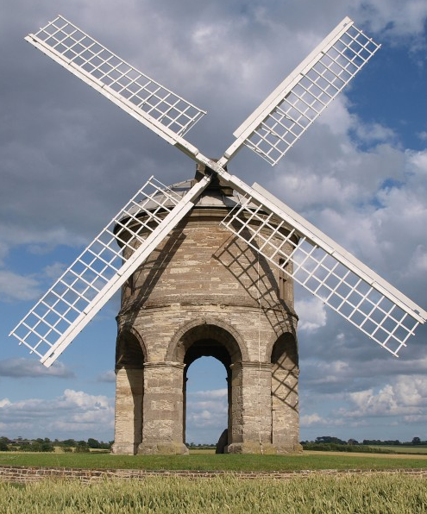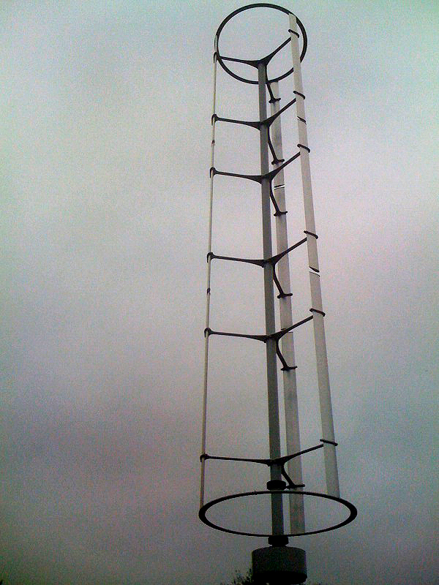

http://plainswindeis.anl.gov/guide/basics/index.cfm http://www.makeenergynow.com/advanta ges-of-domestic-wind-turbines/ http://www.contentdg.com/the-windspire-wind-turbine/

- Complete the chart of shapes
EXAMPLE or PICTURE | NOUN | ADJECTIVE
 |  | circular
 |  | round
 |  | rounded
 |  | semi-circular
 | oval
 |  | rectangular
 | cylinder
 |  | triangular, three-sided
 | square
 |  | spherical
 |  | conical
 | curve
 |  | spiral
 |  | helical
 | tube
 | --- | pointed
 | --- | hollow
 | --- | oblong
 | --- | elongated

- Write three sentences using some of the examples:

o The ball is shaped like a /the sphere.
o The ball is spherical in shape.
o The room is L-shaped.
o The mushroom is umbrella-shaped.
o The bacterium is rod-like.

- Study the table which shows the order of adjectives before a noun.
your opinion | size / weight | age | shape | colour | country of origin | material | NOUN
 | small |  |  | yellow | Czech |  | microscope
beautiful | tiny | ancient |  |  |  | ivory | statue
 | enormous |  | spiral |  |  | wooden | column
 |  |  | tubular | transparent |  | glass | pipette

- Put the adjectives into the correct order.

a - conical - red - organ – small - heart
very – small – unicellular - slightly elongated – bacteria
vessels – long – tubular – blood

exercises from H Němcová, English for Biologists

DISCUSSING PRESENTATION RULES

You have some experience with giving presentations. Have a discussion with a partner and then formulate a few pieces of advice how to do it – write guidelines.
- …
- …
- …
- …
- …
- …

HOMEWORK

Depletion of fish stocks. Match the beginnings and endings of the sentences.

Beginnings

1 Fish is a renewable resource, but overfishing

2 Improved technology

3 Huge fishing trawlers, with factory ships and transport ships,

4 Equipment used to catch large amounts of fish

5 Much of the catch is wastefully

6 All this has led to serious

7 Conservation methods are being employed

8 Large areas of seas has been closed

9 Fishery protection vessels work

Endings

A overfishing and depletion of fish stocks.

B has made fishing fleets over-efficient.

C in an effort to allow cod stocks to recover.

D includes sonar, motorized winches and big nets.

E to prevent poaching.

F and fish quotas have been reduced.

G capture vast fish catches.

H can lead to the depletion of fish stocks.

I made into fish meal or fertilizers.

Words and definitions connected with energy and resources: Complete the terms.

A_ _ae plants that have no roots, stems or leaves and grow in water or in other wet places

A_ _ _fer a layer of earth or rock that contains water, or that water can pass through

C_ _ _ _ment the area of land around a river or lake that it its water from

C_ _ _e oil oil in its natural state, before it has been refined for use

D_ _ letion a reduction in the amount of something or the number of things

E_ _ _ oration a process in which a liquid becomes a vapour without being boiled

E_ _ _ _ itation the process of making use of something so that you gain as much as possible

G_ _ _ rate to produce power

I_ _act an effect or an influence

M_ _ _ _ acture to make goods in large quantities in a factory

O_ _ s_ _ _l leakage of petroleum onto the surface of a large body of water

P_ _ _ _ ication making clean by removing dirty or harmful substances

R_ _ _ _voir a lake, often an artificial one where water is stored so that it can be supplied to houses, factories, etc.
W_ _ _ r t _ _ le the level below the Earth’s surface where water is found

Sources
Kelly, Keith: Geography, Macmillan Vocabulary Practice, 2009, p.139 definitions, Depletion
http://www.voanews.com/content/a-13-2008-06-10-voa14/406691.html text
H. Němcová, English for Biologists, Shapes

Key Depletion 1H, 2B, 3G, 4D, 5I, 6A, 7C, 8F, 9E

