7. The Restless Earth

1. Discuss in pairs or small groups.
What crucial events in the Earth’s history can you name? Do you know when they happened?

2. Here is a description of the events in which the geological history is compared to human life. Notice when the events happened in the different time scale.

A simplified history of the Earth
We can depict Mother Earth as a lady of 46, if her ‘years’ are megacenturies. The first seven of those years are wholly lost to the biographer, but the deeds of her later childhood are to be seen in old rocks in Greenland and South Africa. … Most of what we recognize on Earth, including all substantial animal life, is the product of the past six years of the lady’s life. Her continents were quite bare of life until she was getting on for 42 and flowering plants did not appear until she was 45, just one year ago. At that time, the great reptiles, including the dinosaurs, were her pets and the break-up of the last supercontinent was in progress. The dinosaurs passed away eight months ago and the upstart of mammals replaced them. In the middle of last week, in Africa, some men-like apes turned into ape-like men and, at the weekend, Mother Earth began shivering with the latest series of ice ages. Just over four hours ago Homo sapiens started chasing the other animals and in the last hour it has invented agriculture and settled down. Just one minute has passed, out of Mother Earth’s 46 ‘years’, since man began his industrial revolution, three human lifetimes ago. During that time he has multiplied his numbers and skills prodigiously and ransacked the planet for metal and fuel. N. Calder, The Restless Earth, 1972, abbreviated

3. Vocabulary. Match the verbs from the text with their synonyms:

increase in number
start a stable way of life
take the place of, substitute
come into existence
die out
describe

change into
shake with cold, tremble
follow in order to catch
know or identify
search through
create something new

4. Geologic time scale D. Waugh, Geography, 2002, p.8, http://www.britannica.com/media/full/66800
ERA | PERIOD | Millions of years ago | EVENT
CENOZOIC Quaternary | Holocene | 0.01
 | Pleistocene | 2.6
Tertiary | Pliocene | 5
 | Miocene | 23
 | Oligocene | 34
 | Eocene | 56
 | Paleocene | 66
MESOZOIC | Cretaceous | 145
 | Jurassic | 201
 | Triassic | 252
PALAEOZOIC | Permian | 298
 | Carboniferous | 358
 | Devonian | 419
 | Silurian | 443
 | Ordovician | 485
 | Cambrian | 541

4. When did these events happen? Place them in the table above.

1. end of dinosaurs
2. formation of Pangaea
3. first mammals emerged
4. first vertebrates
5. formation of the Alps
6. emergence of the human
7. the Himalayas begin to form
8. Trilobites
9. first land plants
10. first amphibians and insects

5. The Theory of plate tectonics

Describe the Earth’s structure: Discuss in pairs what you know about tectonic plates

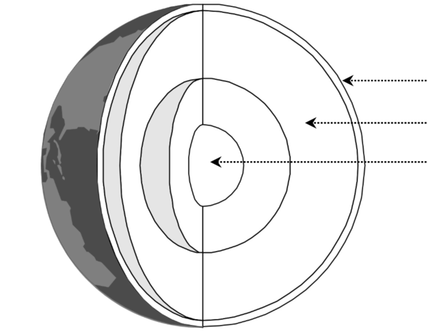

Video
Plate Tectonics Theory https://www.youtube.com/watch?v=mB2pzhWUaiU

- 0-0.50 Watch the first part. Check your terms for the Earth’s structure .
What other information was given about the parts?

- 0.50-2.20 Watch and complete:

- Two kinds of crust:
continental -
oceanic -

- Why plates move:

- In what directions: 1.
2.
3.

- Watch the rest of the video and make notes about the types of meeting zones.

Vocabulary. Check in pairs the meanings of these words:

margin
ooze
solidify
friction
trench
fertile
release
ash
plume
edge
fold
jagged

NAME TYPE OF MOVEMENT EXAMPLE
A)

B)

C)

D)

4. Summary of plate tectonics
Read the text and put the missing words in the gaps. There are more words than gaps, you will not need three of them.

located sideways creates divided zones consists
categories boundaries moved summarizes composed

The lithosphere (the earth’s crust and the rigid upper part of the mantle) is (1) into seven large and several smaller plates. The plates, which are rigid, float on the underlying semi-molten mantle (the asthenosphere) and are (2) by convection currents. There are two types of plate: continental and oceanic. However, these terms do not refer to actual continents and oceans but to different types of crust or rock. Continental crust is (3) of older, lighter rock of granitic type. Oceanic crust (4) of much younger and denser rock of basaltic composition.
As a result of convection currents generated by heat from the centre of the earth, plates may move towards, away from, or (5) along adjacent plates. It is at plate (6) where earthquake, volcanic and mountain-building zones are (7).
The table (8) the major landforms resulting from different types of plate movement.

HOMEWORK
Complete the first column of the table with the types of zones.

- constructive margins (divergent plates)
- collision zones
- passive margins
- destructive margins (subduction zones)

TYPE | DESCRIPTION | EXAMPLE
 | plates move away from each other, new oceanic crust appears forming mid-ocean ridges with volcanoes | Mid-Atlantic Ridge (Americas moving away from Eurasian and African Plates)
 | Oceanic crust moves towards continental crust but, being heavier, sinks and is destroyed forming deep trenches and islands with volcanoes | Nazca sinks under South American Plate (the Andes)
 | two continental crusts collide and, as neither can sink, are forced up into fold mountains | the Himalayas, the Alps
 | two plates move sideways past each other, land is neither formed nor destroyed | San Andreas fault in California
D. Waugh, Geography, 2002, p.14

Key to ex. 4
1 divided, 2 moved, 3 composed, 4 consists, 5 sideways, 6 boundaries, 7 located, 8 summarizes

GRAMMAR – tenses

Put the verbs in the right forms.

1. ………………… (you / see) that movie many times?
2. Peter was in London last Friday. He ………..…….. (arrive) from the airport at 8:00, …………….….. (check) into the hotel at 9:00, and ………………. (meet) the others at 10:00.
3. ………………….. (you/ still watch) TV?
4. The weather is terrible. It ………………… (rain) for days.
5. I ……………….. (study) English in England in summer 2010.
6. We saw an accident when we …………………. (cross) the street.
7. Sorry but you …………………(stand) on my foot.
8. The department ……………………(locate) here since 2012.
9. How many projects …………………..(you / do) in your present role?
10. For many years analysts …………………….(develop) new ways to improve learning strategies.
11. As yet, a solution …………………..(not find), although three attempts …………………(make).
12. In the last two years we ………………………(investigate) new ways to do this.

