8. CLIMATE

1. Introduction

What kind of climate do you live in?

What factors determine the climate where you live?

What effects does the climate have on life in your area?

2. Place these regions in the diagram – which zones do they belong to?

From K. Kelly, Geography, Macmillan, 2009, p.203

North-west Europe Mediterranean basin Siberia 50 degrees N
Kalahari Amazon Serengeti plain

tundra hot desert zone

cold hot equatorial zone

boreal savannah zone
CLIMATIC ZONES
according to temperature

warm

warm temperate cold temperate
oceanic oceanic

Question:

The diagram classifies climate according to temperature. How can you classify climate on the Earth according to a different criterion? (What two climates are distinguished by amounts of moisture?)

LISTENING. Five Factors that Affect Climate

https://www.youtube.com/watch?v=E7DLLxrrBV8

1. Watch the video and write down the 5 factors mentioned there. Answer also the questions.

…………

………… Where are the warmest areas on the Earth?

………… Which examples are given of the topographical features?

What is rain shadow?

………… Examples:

………… What are Doldrums?

2. Listen for the second time and fill in the missing information.

a) When you climb a mountain, the temperature would drop ………..ºC for every ……… meters.

b) In July it is warmer in ……………..

c) The tilt of the Earth is …………….

d) Topography means the Earth’s ………………….

e) Mountains play a major role in …………………. levels.

f) The sides of the mountain facing off the ocean are often ………..

g) Summers in St. Louis can be ……………………

h) The warm ocean waters originate near ………………..

i) The winds that meet near the Equator are called ………………

Has Sahara always been a desert?

1.Vocabulary

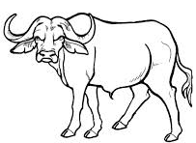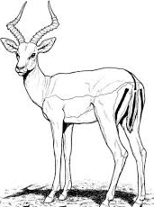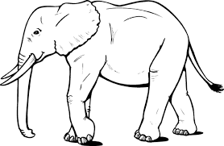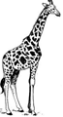

b_ _ f _ _ o a_ _ _ _ _ _ e e_ _ ph _ _ _ g_ _ _ _ _ e

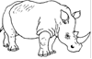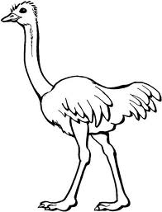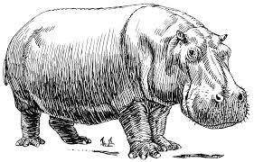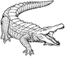

rh _ _ _ _ _ _ _ s o_ _ _ _ _ h h _ _ _ _ po _ _ _ _ s c_ _ _ _ _ _ _ e

2. Here is a description of the Sahara desert.
Continue the description. Speculate about the characteristics of the area in the past.
How much water, what fauna and flora might have been there some millions years ago? Use your imagination, it’s just a speculation. In groups, prepare your characteristics and present it in the class.

Today's Sahara is a huge desert area, with dunes and plains covered by rugged rocks, punctuated by mountains that can be 3,400m high, all in 9 million square kilometres (this is more than Australia), with less than 100 mm of rainfall annually. Sahara really means "desert" in Arabic.
But …

Here is the original article. Are there any similarities with your version? What helps you decide where this description is reliable or not?

6,000-8,000 years ago, the rainfall was abundant, and in Sahara flourished the Neolithic culture which left the famous rock paintings found in Tassili n'Ajjer Mountains and other areas of Sahara, depicting crocodiles, ostriches, rhinos, giraffes, buffaloes, hippos and elephants, encountered today only in Africa at South of Sahara. The Sahara was filled with lakes in the region of modern Niger and people hunted antelopes, while its mountains were covered by forests. Archaeologists encountered from hippopotamus and elephant bones to fishing harpoons.

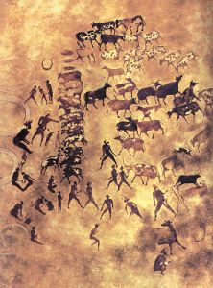

Researchers using radar technology discovered in the depths of the rocks of the wide valleys, a web of "channels", some small, others wider, as broad as the Nile, which represent the dry riverbeds of the rivers that crossed Sahara thousands of years ago. Niger River once originated in Sahara.

http://news.softpedia.com/news/Has-Sahara-Always-Been-a-Desert-47128.shtml

Read about today’s climate in the Sahara.

http://en.wikipedia.org/wiki/Sahara

Pre-reading question

What is dust devil ? A Saharan predator

B small whirlwind

C angry Bedouin

The Sahara has one of the harshest climates in the world. (1) The prevailing north-easterly wind often causes sand storms and dust devils. When the wind blows towards the Mediterranean, it is known as sirocco and often reaches hurricane speeds (2) in North Africa and southern Europe. Half of the Sahara receives (3) less than 20 mm of rain per year, and the rest receives up to 100 mm per year. The rainfall happens very rarely, but when it does it is usually torrential when it occurs after long dry periods.

1. Which term is used for this type of climate?

2. Find words with the same meaning as the phrases below:

the most severe, unpleasant

the most frequent, common

vertical column of air whirling around itself

severe, often destructive storm, esp. a tropical cyclone

pouring or flowing fast, violently, or heavily

3. Grammar. Write questions asking about the underlined parts. They are the answers.

Vocabulary revision - correct wrong information in the text.

There are 7 mistakes, mostly in terminology. Then Listen and check.

Basics of Geography: Climate 3.45 – 5.28 https://www.youtube.com/watch?v=95TtXYjOEv4

23.5ºC N of the Equator is a line of altitude called the Tropic of Cancer. When the Northern Hemisphere is tilted toward the Sun, sunlight falls directly along this line. When the Southern Hemisphere is facing the Sun, sunlight falls upon another line locates at 23.5ºC S of the Equator, called the Tropic of Unicorn. Areas of the world located between these two lines are called the Low Latitudes or the Tropics. South of the Tropic of Capricorn at 66.5ºC S latitude is a line of elevation called the Antarctic Circle. Another line, called the Arctic Circle, is located north of the Tropic of Cancer, at 66.5ºC N latitude. The areas between the Tropics and the two poles are called the Middle Latitudes. The Sun never shines directly at these areas so places located here are cooler than in the Tropics. The Middle Latitudes ate also known as Temperature Regions. North of the Arctic Circle and south of the Antarctic Circle are the Huge Latitude or Polar Regions. These areas receive the least amount of sunlight, so places here are very cold. In fact, for the whole year, these areas get no sunlight at all.

Homework - complete the terms for these definitions

B_ _ _ _ _ of … or relating to the north

C_ _ _ _ _ _ _ on the process by which very small parts in a liquid or gas move and give out heat

C _ _ _ _ _ t a strong movement of water or air in one direction

M _ _ _ _ _ _ e neither great nor small in amount, size, strength or degree

T_ _ _ _ wind a wind that blows continuously towards the equator

D_ _ _ _ _ t a long period of time when there is little or no rain

M _ _ _ _ _ n a period of heavy rain in India and Southeast Asia

T_ _ _ _ _ _ _ _ l kind of rain that falls fast and in large amounts

A_ _ _ -trades winds that blow continuously away from the equator

C_ _ _ _ s a type of thin cloud found very high in the sky

C _ _ _ _ _ _ _ _ _ us a mass of very tall thick cloud that usually brings rain and sometimes thunder

