

Topic 01: Plant Growth- Structure of Fruits and Seeds

Plant growth of vascular plants starts with embryo development (embryonic growth). Then the meristematic growth continues, which is generally described as primary or vegetative growth. Formation of new organs leads to the root and the stem elongation, as well as increase of leaf number. This mechanism is possible due to open, indeterminate, modular growth pattern, which are characteristic pro vascular plants. New meristems, the lateral buds, develop at the nodes, each just above the point where a leaf is attached. When the lateral buds develop, they produce new stem tissue, and thus branches are formed. Big or perennial plants are able of secondary growth. Under special circumstances (such as changes in photoperiod), the apical meristem is converted into a flower bud. This develops into a flower. The conversion of the apical meristem to a flower bud "uses up" the meristem so that no further growth of the stem can occur at that point. However, lateral buds behind the flower can develop into branches. The flower organs form the generative structures like gynoecia and androecia and generative cells inside them. After double fertilization the zygote and the primary endosperm nucleus are formed.

This course is devoted to the fruit and the seed morphology

The zygote undergoes a series of mitotic divisions to form a multicellular embryo. At the micropylar end there develops a basal stalk or suspensor and at the chalazal end (the region opposite the micropyle) is the embryo proper. The embryos of angiosperms form cylindrical shape during early developmental phases. Developed embryo consists of a bipolar axis that bears one or two cotyledons, or seed leaves; in most dicots the cotyledons contain stored food in the form of proteins, lipids, and starch, or they are photosynthetic and produce these products, whereas in most monocots and some dicots the endosperm stores the food and the cotyledons absorb the digested food. The embryos of dicotyledons have two seed leaves, while those of monocotyledons have only one. The endosperm nucleus formed during triple fusion divides mitotically to form the endosperm of the seed, which is a food-storage tissue utilized by the developing embryo and the subsequent germinating seed. The endosperm is consumed in some of plant taxons during the embryo development (exalbuminous seeds) while other taxons have endosperm in ripe seed (albuminous seeds).

Fruits and seeds of angiosperms

- Analyze and draw samples of fruits and classify them according to gynoecia character and its style of opening.

- Analyze and draw seeds of bean (Phaseolus vulgaris L.) and pumpkin (Cucurbita pepo L.). Observe imbibed seeds with the aid of lens at first. Draw the structures visible on the seed coat (testa), then remove the seed coat with the needle and the blade and divide the embryo. The embryonic axis will stay attached to one of the cotyledon. Notice presence or absence of the endosperm.
3. Do you know from which type of the fruit this seed was isolated?

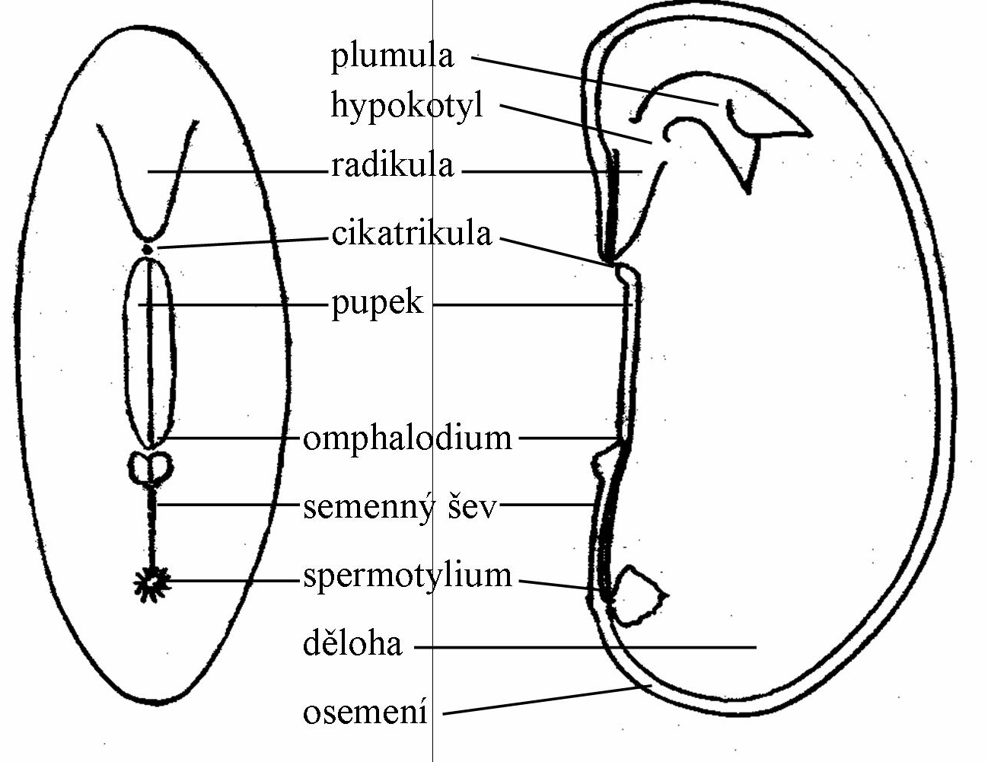

Morphology of bean (Phaseolus vulgaris)
plumula = epicotyl + the first true leaves + SAM, hypokotyl (hypocotyl) = transition zone between the shoot and root, radikula (the radicle), cikatrikula = rest of the micropyle, pupek (hilum) = rest of the funiculus, where the ovum was inserted to the placenta, omfalopodium = rest of vascular bundle, semenný šev (raphe) = rest of the vascular bundle at the anatropic or kampylotropic ovum, spermotylium = small bumb in place of the chalaza, děloha (cotyledon), osemení (seed coat)

Literatura

Baskin C.C. a Baskin J.M.: Seeds: ecology, biogeography, and evolution of dormancy and germination. – Academic Press, New York, 1998.

http://www.britannica.com/plant/angiosperm/Reproduction

