

Topic: 09: Shepherd purse embryo development observation

In cleared seeds and on sections

Methods of cleared preparations of seeds as whole-mount samples are often used for quick information about plant embryo developmental stage. Clearing mixtures allow focus to different optical sections of the object without classic sectioning.
Nevertheless detailed study of seed and embryo structure demands using of histological techniques with embedding the material into paraffin or resin and subsequent microtome sectioning.

A. Method of seed clearing
Material: fruits of shepherd purse (Capsella bursa-pastoris L.) fixed in Carnoy mixture (ethanol : acetic acid 3 :1), clearing medium: saturated solution of chloral hydrate (8 parts of chloral hydrate and 3 arts of distilled water) or saturated solution of chloral hydrate in lactic acid
Procedure:
- Plant material is fixed in Carnoy mixture.
- Fixed objects are washed in ethanol (its concentration is the same which is used in the fixative mixture). Fifed material could be stored in 70% ethanol for longer time. Fixation should be omitted in case when we want to see chlorophyll in embryo cells.
- Isolate the young seeds from fruits in a drop of clearing medium on the microscopic slide.
- Cover with cover slip.
- Observe the preparation after interval of one hour of clearing.
Results:
Observe appropriate optical section and draw schematic picture of young embryo and its position in the seed. Find different embryo developmental stages and document them with microphotography.
B. Paraffin sections
Fruits of shepherd purse (Capsella bursa-pastoris L.) fixed in FAA mixture (35% formaldehyde + acetic acid + 70% ethanol mixed in ratio 5 + 5 + 90) were dehydrated, and paraffin embedded. Paraffin section were stained with alcian blue and nuclear fast red (Beneš and Kamínek 1973).

Literature:
- Beneš, K., Kamínek, M. (1973): The use of aluminium lake of nuclear fast red in plant material successively with alcian blue. - Biologia Plantarum, 15 (4): 294 – 297.
- Braune W., Leman, A., Taubert H. Pflanzenanatomisches Praktikum II. 2nd Ed. Jena: VEB Gustav Fischer Verlag, 1982. 426 s. ISBN 261 700-36-82.
- Herr J. M., Jr (1971): A new clearing-squash technique for the study of ovule development in angiosperms. – Amer. J. Bot. 58: 785–790.
- Lux A., Morita S., Abe J. and Ito K. (2005): An improved method for clearing and staining free-hand sections and whole-mount samples. – Ann. Bot. 96: 989 – 996.

Picture of the cleared shepherd purse seed with torpedo embryo
Photographed in Nomarski DIC

funiculus WB chalazae
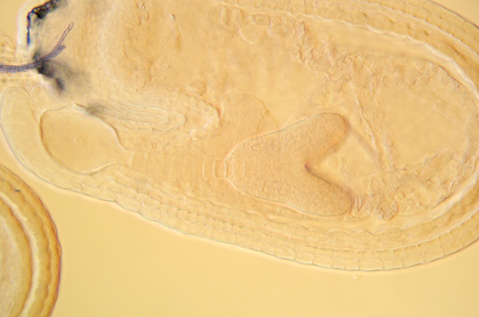
micropyle
basal cell embryo proper endosperm
of the suspensor
antipodes suspensor seed coat

