**Week 9 Maps**

**Task 1 Give as many adjectives collocating with the word MAP as possible.**

**Task 2 Speaking**

**Match phrases with similar meaning:**

1. I´m convinced that… a) I have a negative feeling about…
2. I suspect that… b) I estimate that…
3. I guess that… c) I strongly support…
4. I have my doubts about… d) I believe most strongly…
5. I´m in favour of… e) I have some worries about…

**Prepare a short speech in which you are trying to convince your audience that children should be taught how to read maps. You can use the phrases from above.**

**Task 3 Vocabulary revision**

1. **What do you call:**

* a line on a map connecting points that have the same height above the surface of the earth
* a type of map in which there is a drawing of one side of a globe (there is a lot of distortion but one gets the idea that the globe is being represented)
* the angular distance east or west from the north-south line that passes through Greenwich, England, to a particular location. Greenwich, England has a _______ of zero degrees
* either of two number or letters used to fix the position of a point on a map or graph

1. **Can you give a definition of:**

* **meridian**
* **equator**
* **latitude**
* **parallel of latitude**
* **relative/ absolute location**

## Task 4 Study and describe the maps below

## Political World Map as Pangea 200-300 Million Years Ago

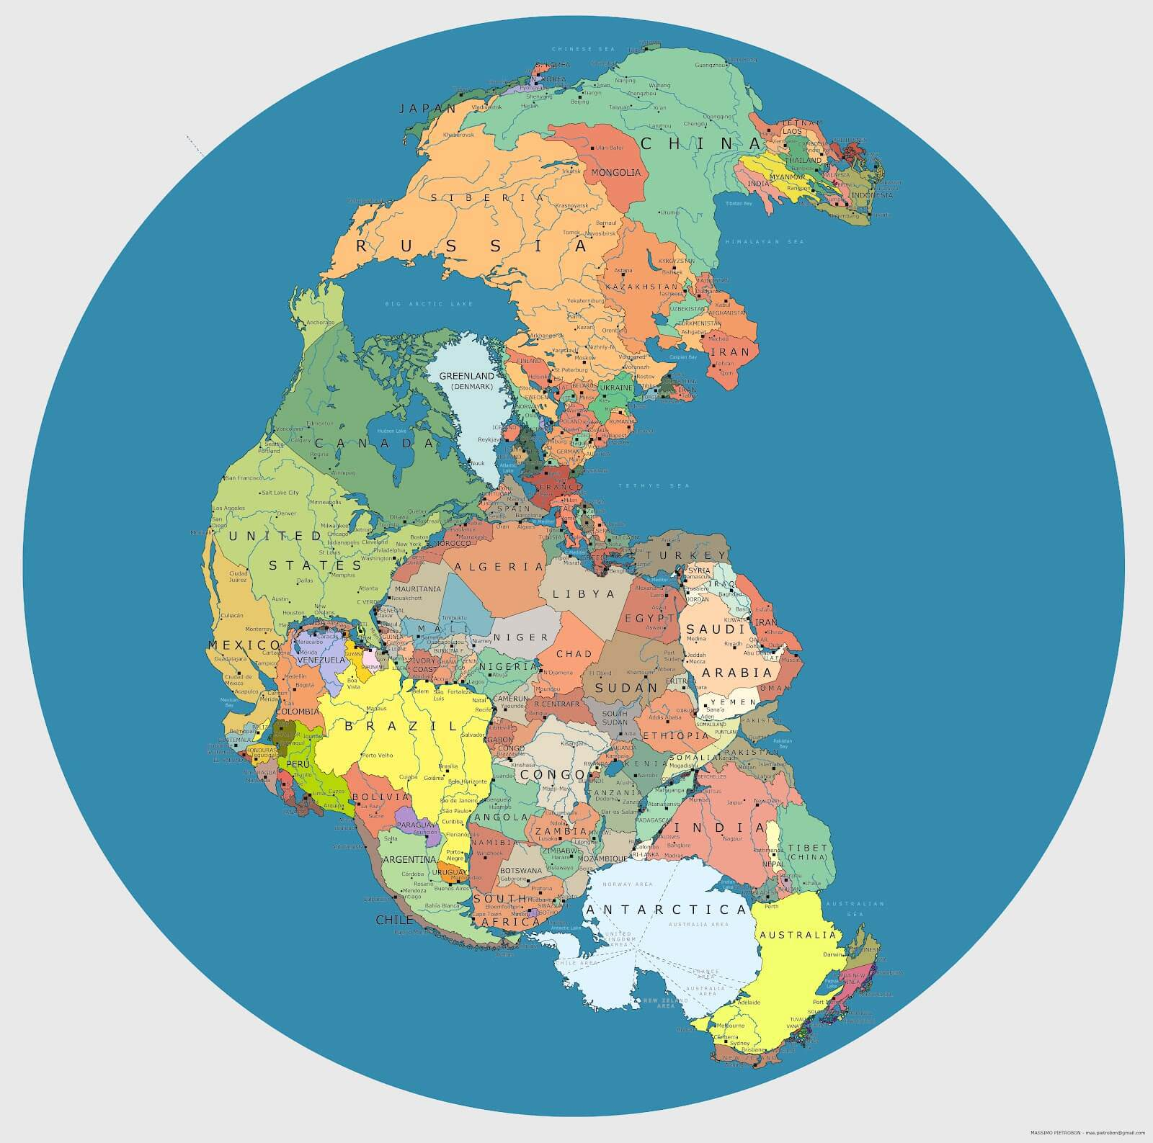

# A surprising map of the countries that are most and least welcoming to foreigners

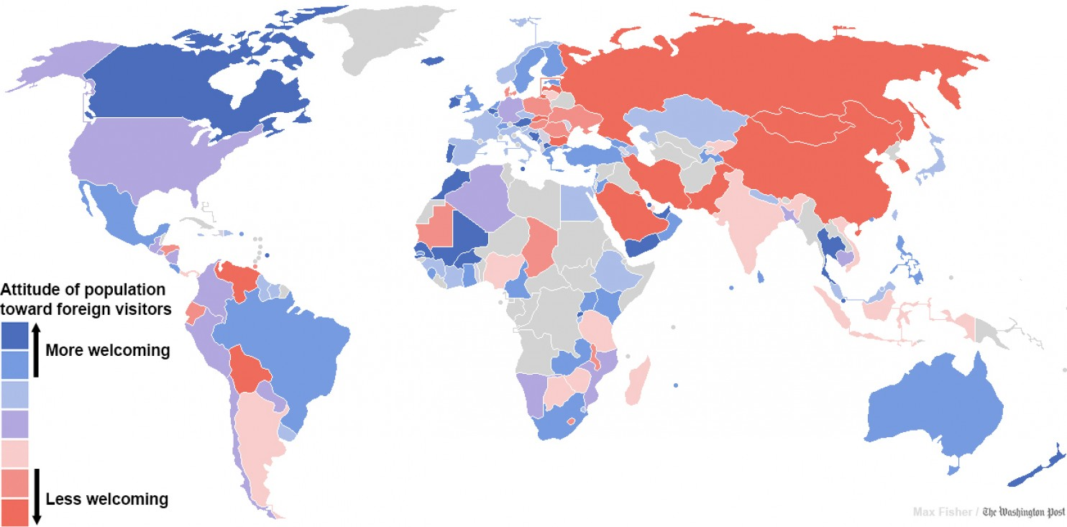

(Source of maps: http://www.boredpanda.com/fun-maps-they-didnt-teach-you-in-school)

**Task 5 How digital maps are changing the way we understand our world**

**Firstly, scan the text to identify the main idea of the article.**

**Next, complete the gaps with suitable forms of the verbs in brackets (present, past, present perfect, passive).**

*Digital maps put us by default at the centre of the world. But do we risk losing our sense of the city as a whole?*

The way we use maps (1) **……………. (change)**. The way we think of the city **………….. (change)** . The way we think of, interact with and navigate the streets, alleys, boulevards, roads, parks, lanes, hills, cracks and gutters is going through a seismic shift, not because the landscape **…………… (change)**, but because of little black rectangles in our pockets.

Apps such as Google maps and Citymapper “smooth out the machine,” says Mike Duggan, researcher in Cultural Geography at Royal Holloway. Duggan **……………… (research)** how digital technologies change our experiences of everyday places, and one of the main things ……………… **(notice)** is the way new technology continues to smooth out the machine that billions of us navigate every day – the city.

“There’s a long history in ‘smoothing out the city’ via technology,” says Duggan. “What’s new is that these mobile technologies (ie smartphones) offer so much in one place - the palms of our hands - and this often **…………….. (seem)** like a revolution because we no longer have to go searching very far for information that makes life easier: we just reach into our pockets.”

Having a map in your pocket at all is relatively recent development. “In the medieval period right the way through to the 19th century, people **…………….. (can)** live perfectly happily in their locality without ever having knowledge of or care for the wider world,” explains Tom Harper, curator of antiquarian mapping at the British Library. As maps became cheaper to produce they became important public tools, able to take the mess of new urban metropolises and make them comprehensible. Pocket maps **……………. (design)** to fit in gentlemen’s coat pockets, and this cheaper production signalled a revolution in mapping. As digital technology becomes more readily available the shifts are just as enormous.

“The other day I ……………(**start)** writing a list of where location-based services could be used in the next 10 years, and within two minutes I quickly realised that the list could go on forever,” says Duggan. “People use them to find food, entertainment, post pictures, videos, for politics … There are maps in more and more aspects of our lives, and now it’s us generating the maps for ourselves. They **…………….. (become)** more personal than collective.”

“You are here” no longer needs **……………… (say)**. We are by default the centre of the world. Our surroundings emanate from us, from a little blue dot that sits on the screen. It’s perhaps the single most important change in how we view the city. Around this blue dot stem not only cafes and banks but our own experiences, our pictures and tweets; past moments pinned to their places of origin. Harper **……………… (explain)** that the earliest maps weren’t navigational plans but rather objects of symbolic pride. Sixteenth century rulers would hang maps in their palaces to represent the might and power of their cities. There are echoes of this in the way we **……………… (encourage)** to spatially integrate our social personae, as if we too have ownership over the frothy coffee shops around us.

But is this sense of ownership illusory? ………… we in fact ………… **(lose)** grip of the city as a collective entity? Flicking through the pages of an atlas or struggling to unfold a tourist map gives a physical sense of scale: here is the city and the edges of the pages are its limits. Zoomed in on the user that scale is lost. We no longer examine maps, we trace from A to B while the world outside the line of direction falls away. “Removing that need to find out where you are is huge,” says Duggan. “It’s an important generational change. I personally can’t use co-ordinates to find out where I am anymore; I could do when I was younger. Now I don’t have to so I don’t bother doing it and people **………….. (bring up)** with these services rarely **………….. (think)** about that process at all.”

(adapted from<http://www.theguardian.com/technology/2014/dec/02/how-digital-maps-changing-the-way-we-understand-world>)

**Task 6 Passive Voice**

**Complete the following sentences using the given verbs. Decide whether each verb should be used in the passive or in active voice. A number of tenses are possible in each case.**

**base belong depend design estimate happen link rise subject undergo**

1. The global incidence of malaria _______________ to be nearly 120 million cases each year.
2. Interviewers _____________ extensive training prior to the research.
3. 35 years later, the population of the city ______________ to 490,000.
4. This analysis _______________ on the works of Lenin and Mao.
5. The present study ______________ to compare quantitatively the relative effectiveness of these two methods.
6. They argue that global economic development ______________ on a strong American economy.
7. Vitamin D deficiency _____________ to higher risk of heart disease.
8. The caracal is an animal found in Africa and western Asia which ____________ to the cat family.
9. The water temperature rise in the lake ____________ at the same time as increased seismic activity in the area.
10. Tiny cracks appeared in the concrete when it ____________ to high temperatures.