**Week 8 People and the Environment**

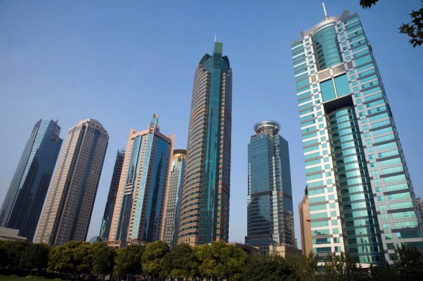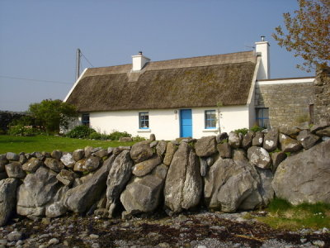

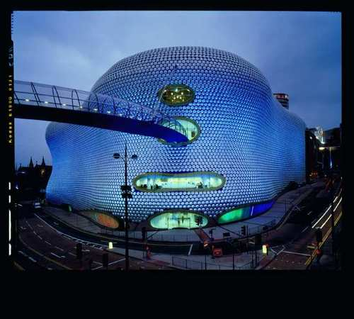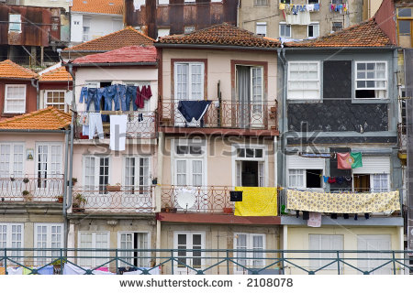

**Task 1** Look at the pictures. Match the buildings with the features a-d.

1. thatched roof
2. terraced houses
3. many storeys
4. curved shell structure

**Task 2** Do you like contemporary or traditional architecture? Why? What does your dream house/flat look like?

**Task 3** Brainstorm your ideas on the essay question below:

*It is more important to use the space in cities well than make them look beautiful. To what extent do you agree?*

**Task 4** Look at the essay plan on page 2. The key points are listed but one supporting detail for each point is missing. Complete the plan with the correct details a-e.

1. e.g. young people tend to want to live in a city – work opportunities. But housing very expensive- not enough of it.
2. e.g. some companies spend money creating beautiful surroundings - improves productivity; many famous buildings used on tourists websites to attract interest
3. e.g. megacities – Tokyo, Mexico city, Mumbai. High population and larger areas covered.
4. e.g. roof-top gardens
5. e.g. in Dubai tallest building created

**Introduction**

1. Cities: have high density of buildings.
2. ______________________________________________________________________
3. I partly agree that space needs to be used well.

**Reason 1 – agree because**

4. Important to use space effectively – population of world increasing/ more people need to live in cities

5. _________________________________________________________________________

**Reason 2 – agree because**

6. Design of high-rise architecture suitable for buildings in city – buildings in cities generally contemporary and high rise – economic use of space

7. _______________________________________________________________________

**Reason 1 – disagree because**

8. Attractive surroundings improve quality of life/ attract tourists and income

9. _______________________________________________________________________

**Reason 2 – disagree because**

10. Nowadays good design includes green space but still economic – also better for environment

11. ________________________________________________________________________

**Conclusion**

Agree space is important but not the only factor to consider

**Task 5** Read the introduction and the first paragraph of a model answer below. Underline the phrases that introduce opinions.

It is generally accepted that contemporary cities are growing in size and population. Various recent reports have indicated growth in megacities such as Mumbai, Tokyo and Mexico city, which cover huge areas and are still developing. Along with the increase in population globally, it is therefore commonly acknowledged that there is pressure on available space and housing. I would therefore maintain that space is an important factor in city planning and must be taken into account in any kind of planning activity. However, although space is key to good city design, it is not the only thing that should be considered and this essay will go on to discuss other factors, too.

To begin with, a primary factor for consideration is population. Experts claim that the population of the world is increasing quickly and it is true that urban societies are growing very rapidly. More young people, for instance, are moving to cities for work opportunities as well as the facilities and opportunities they can find there. For this reason, I believe we need to find more economic ways to live. Good design, with high-rise living space, can help. It seems to me that the cost of accommodation in many cities is prohibitive, which restricts opportunities and could be solved by better town planning.

(adapted from Dimond-Bayir, S. *Writing for IELTS.* Macmillan, 2014)

**Task 6** Add the underlined phrases from 5 to the correct place in the table below.

|  |  |
| --- | --- |
| **Personal opinion** | **Impersonal opinion** |
|  |  |

**Task 7** Add the phrases to the correct place in the table in 6.

*In my opinion*

*It should be noted*

*It is claimed that*

*As far as I am concerned*

*Reports reveal that*

*Personally, I am certain*

*A general assertion is that*

*Predictions suggest that*

**Task 8** Correct each sentence by adding one of the words or phrases below.

*been to argue demonstrated would appears to would say*

1. The latest research indicate that the picture was painted by Michelangelo.
2. Most people that it is normally wrong to lie.
3. It is possible that economic sanctions rarely achieve their primary purpose.
4. Statistics have that the life expectancy between men and women is shortening in Canada.
5. It has suggested that schizophrenia should be regarded as a collection of disorders.
6. It seem that the inspector´s advice on fire safety was ignored by several of the company´s senior managers.

(adapted from Paterson, K. Oxford Grammar for EAP. OUP, 2013)

**Task 9** Traffic congestion is becoming increasingly problematic in major cities. What solutions do you suggest to help solve the problem? Discuss the suggestions below.

* to use waterways as an infrastructural resource for public transport and city logistic systems
* to improve alternative modes – walking, cycling and particularly high quality public transit
* to charge motorists extra if they drive during times of congestion
* to use a smart system that guides drivers quickly and efficiently to vacant parking spots
* to have a great public transport system (e.g. extra lanes for buses)
* to automate the driving process itself
* to enlist the help of drivers negotiating their way through the clogged roads
* to use wireless vehicle-to-vehicle communication

(adapted from: <http://www.bbc.com/future/story/20140611-can-we-ever-end-traffic-jams>)

**Task 10** Write a paragraph on the topic of traffic congestion.