MATPLOTLIB

## 1.importing library

* matplotlib is preinstalled with pyzo

import matplotlib.pyplot as plt

* possible dependencies:
  + **numpy** - extension for arrays, matrices,...
  + **libpng** - loading and saving png files
  + **dateutil** - datetime handling
  + **tk/pyqt** - GUI frameworks
* possible dependecies - cartography
* tutorials
  + <http://matplotlib.org/users/beginner.html>

## 2. **pyplot** basics- linecharts / scatterplot example and basic commands

basic example - linechart

import matplotlib.pyplot as plt

plt.plot([1,2,3,7])

plt.ylabel('some numbers')

plt.show()

pyplot.**plot()** - plots lines/markers to the axes

plt.plot([1, 2, 5, 8])

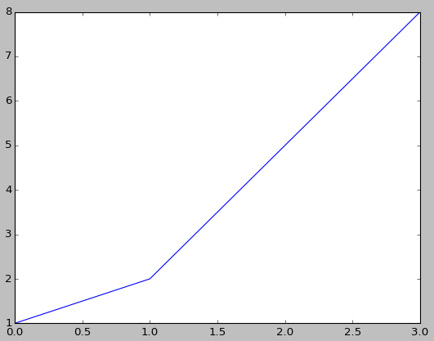

plt.plot([1, 2, 5, 8], [1,3,5,6])

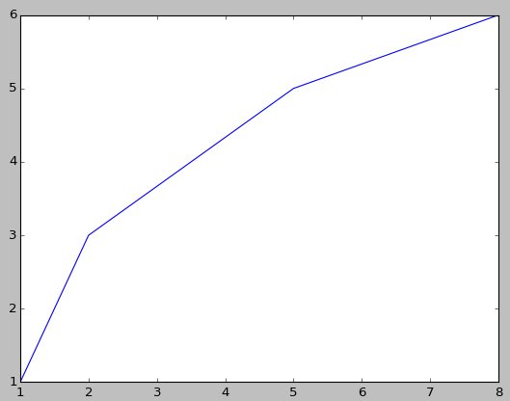

plt.plot([1, 2], [4,9], [1,3], [7,9])

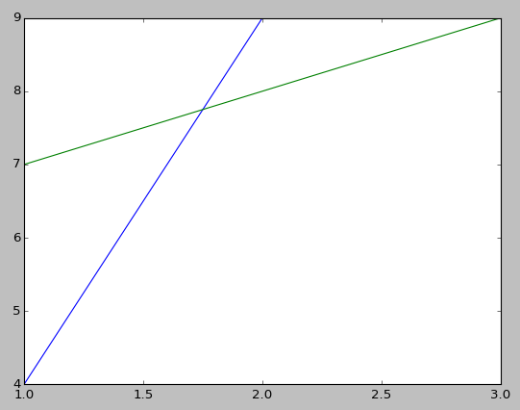

plt.plot([1, 2], [4,9], ‘r--’, [1,3, 6], [4, 6, 8], ‘mv’) # red dashed lines, magenta triangles

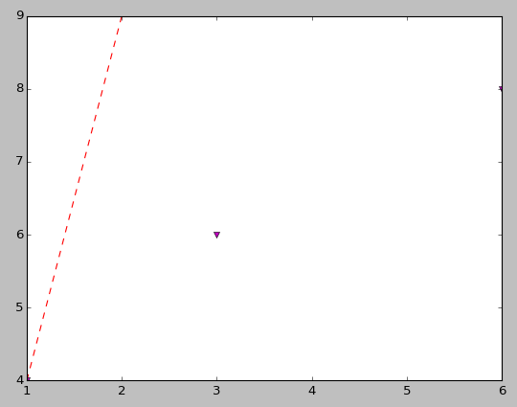

plt.plot([1, 2, 5, 8], [1,3,5,6], linestyle=’dashed’, color=’green’, marker=’o’, linewidth=’5’)

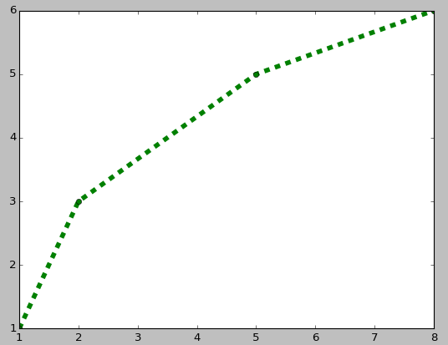

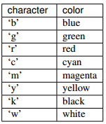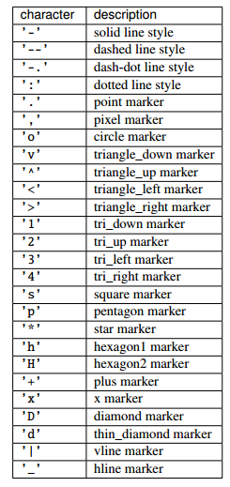

pyplot**.axis** - setting the extent of the axis

plt.plot([1, 2, 5, 8], [1,3,5,6])

plt.axis([0, 4, 4, 50])

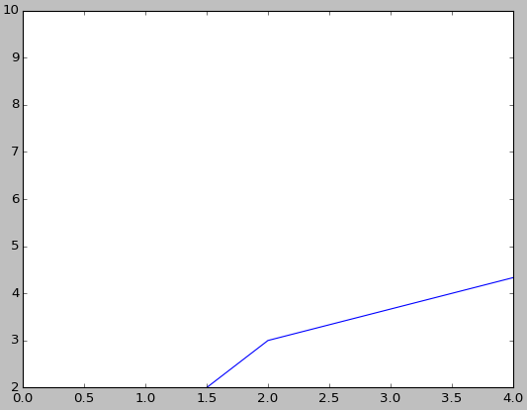

pyplot**.show** - displays a figure

pyplot.**setp** - controlling properties

lines = plt.plot([1, 2, 5, 8], [1,3,5,6])

plt.setp(lines, color='r')

pyplot.**xlabel/**pyplot.**ylabel** - name of the axis

pyplot.**title -** sets title

pyplot.**suptitle** - add a title to the Figure

pyplot.**figtext** - add text at an arbitrary location to the Figure

pyplot.**text** - put title on selected position

pyplot.**grid** - switch grid on and off

import matplotlib.pyplot as plt

plt.xlabel('label for X', fontsize=15)

plt.ylabel('label for Y')

plt.title('the ultimate chart', color='green')

plt.suptitle('blabla')

plt.text(60, .025, r'a random text', style='italic')

plt.axis([40, 160, 0, 0.03])

plt.grid(True)

plt.show()

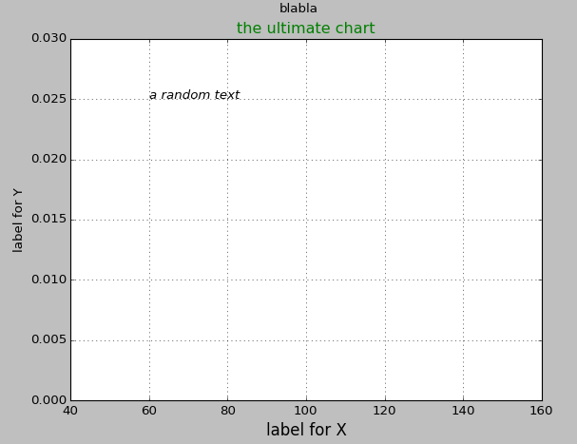

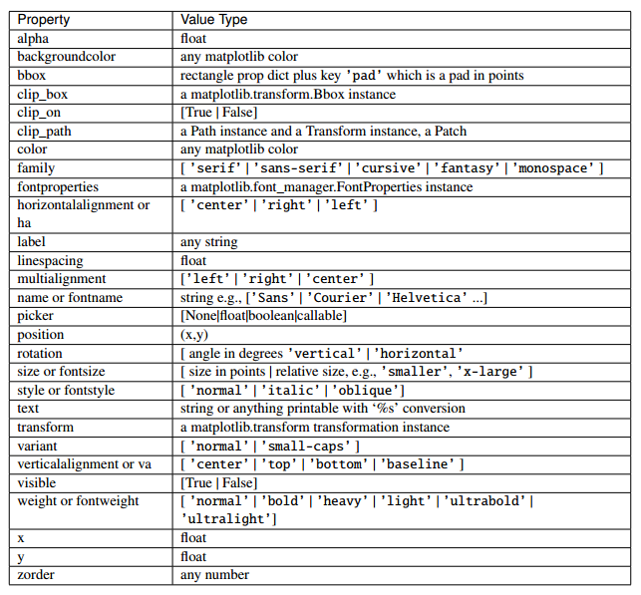

## 3. handling more figures

import matplotlib.pyplot as plt

plt.figure(1)

plt.plot([1, 2, 5, 8], [1,3,5,6])

plt.figure(2)

plt.plot([1,2,3], [1,2,3], 'go-', label='line 1', linewidth=2)

plt.show()

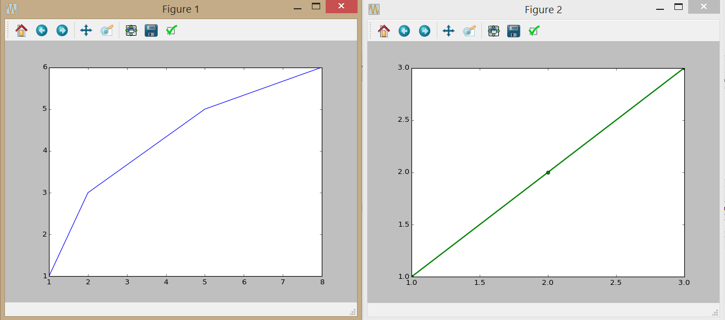

## 4. other types of plots

plt.hist([0,2,1,2,6,7,4,8,9,5,4,1,3,2,3,2], bins=10)

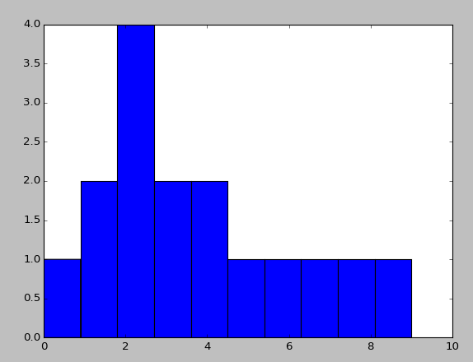

plt.pie([4,5,7,12])

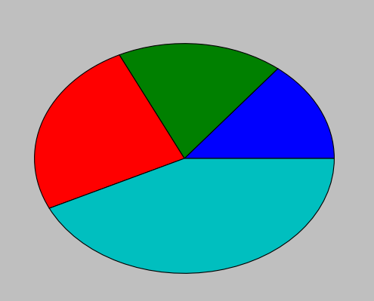

plt.scatter([2,5,8],[4,5,6])

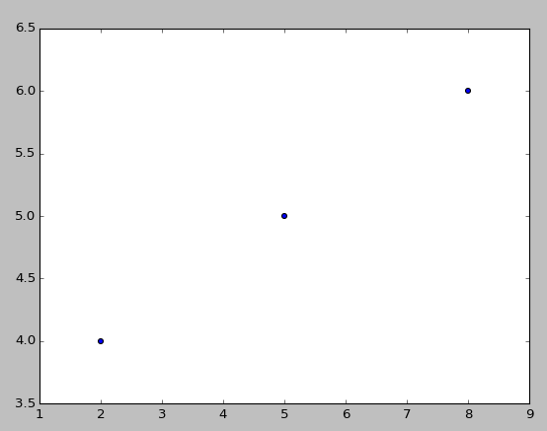

plt.bar([1, 2, 3, 4],[17, 15, 52, 15])

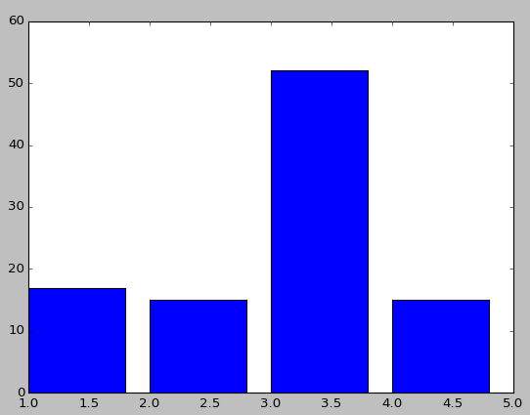

plt.bar([1,2,3,4,5], [20, 35, 30, 35, 27], 0.1, color='g')

plt.bar([1.1,2.1,3.1,4.1,5.1], [25, 32, 34, 20, 25], 0.1, color='r')

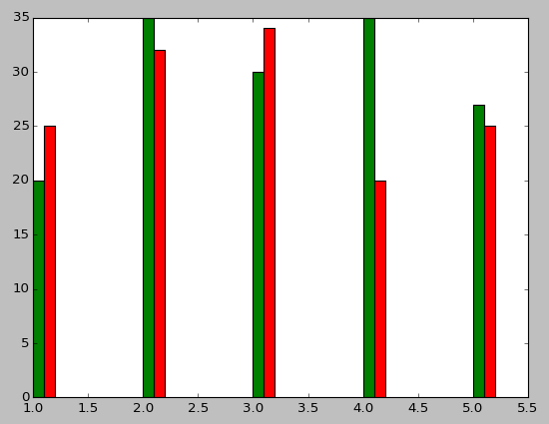

…

online collection of documented examples

<http://matplotlib.org/api/pyplot_api.html>

## 5. Loading external images:

* using matplotlib.image

# request image from url and load it with matplotlib

import matplotlib.pyplot as plt

import matplotlib.image as mpimg

import urllib.request

with urllib.request.urlopen("http://matplotlib.sourceforge.net/_static/logo2.png") as response:

img = plt.imread(response)

plt.imshow(img)

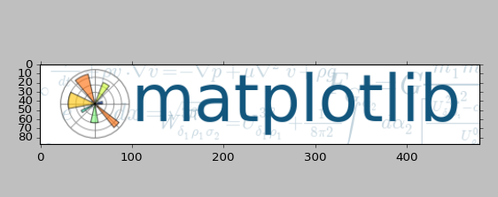

tutorial <http://matplotlib.org/users/image_tutorial.html>

## 6. Example- choropleth map

loading external geojson:

import matplotlib.pyplot as plt

import json

with open ('C:/pathto/countries.geojson', 'r', encoding='utf8') as countriesJson:

countries = json.load(countriesJson)

putting shapes on matplotlib canvas:

for country in countries['features']:

for shape in country['geometry']['coordinates']:

for coords in shape:

x = [i for i,j in coords]

y = [j for i,j in coords]

plt.plot(x, y)

plt.axis('scaled')

plt.grid(True)

plt.show()

defining colormap:

* http://matplotlib.org/examples/color/colormaps_reference.html

from matplotlib.pyplot import cm

colors = plt.get_cmap('copper', 6)

getting number from attribute:

income = int(country['properties']['income_grp'][0])

coloring polygons:

* http://stackoverflow.com/questions/10550477/how-do-i-set-color-to-rectangle-in-matplotlib

plt.fill(x,y, facecolor=colors(income), edgecolor='black', linewidth=0.4)

event handling

* <https://jakevdp.github.io/blog/2012/12/06/minesweeper-in-matplotlib/>
* <http://matplotlib.org/users/event_handling.html>
* setting ax object

fig = plt.figure()

ax = fig.add_subplot(111)

* global list of polygons with attributes.

polygons = []

# http://matplotlib.org/api/patches_api.html

polygon = plt.Polygon(coords)

polygons.append({'shape': polygon, 'props': country['properties'], 'income': income})

ax.add_patch(polygon)

polygon.set_facecolor(colors(income))

* setting event listener

fig.canvas.mpl_connect('motion_notify_event', on_move)

* define on_move function

def on_move(event):

for pol in polygons:

income = int(pol['props']['income_grp'][0])

pol['shape'].set_facecolor(colors(income))

for pol in polygons:

if pol['shape'].contains_point((event.x, event.y)):

pol['shape'].set_facecolor('black')

fig.canvas.draw()

labels

* <http://matplotlib.org/api/text_api.html>
* creating text object

text = ax.text(0,0, '', color='r')

* redefining on_move function

def on_move(event):

text.set_x(event.x - 300)

text.set_y(event.y - 250)

text.set_text('')

for pol in polygons:

income = int(pol['props']['income_grp'][0])

pol['shape'].set_facecolor(colors(income))

for pol in polygons:

if pol['shape'].contains_point((event.x, event.y)):

pol['shape'].set_facecolor('black')

text.set_text(pol['props']['name'])

fig.canvas.draw()

import matplotlib.pyplot as plt

from matplotlib.pyplot import cm

import json

path = 'C:/Users/mu/Desktop/phd/vyuka/Programovani/matplot geojson/'

colors = plt.get_cmap('copper', 6)

polygons = []

def on_move(event):

text.set_x(event.x - 300)

text.set_y(event.y - 250)

text.set_text('')

for pol in polygons:

income = int(pol['props']['income_grp'][0])

pol['shape'].set_facecolor(colors(income))

for pol in polygons:

if pol['shape'].contains_point((event.x, event.y)):

pol['shape'].set_facecolor('black')

text.set_text(pol['props']['name'])

fig.canvas.draw()

fig = plt.figure()

ax = fig.add_subplot(111)

text = ax.text(0,0, '', color='r')

with open (path + 'countries.geojson', 'r', encoding='utf8') as countriesJson:

countries = json.load(countriesJson)

for country in countries['features']:

income = int(country['properties']['income_grp'][0])

for shape in country['geometry']['coordinates']:

for coords in shape:

x = [i for i,j in coords]

y = [j for i,j in coords]

polygon = plt.Polygon(coords)

polygons.append({'shape': polygon, 'props': country['properties'], 'income': income})

ax.add_patch(polygon)

polygon.set_facecolor(colors(income))

fig.canvas.mpl_connect('motion_notify_event', on_move)

plt.axis('scaled')

plt.grid(True)

plt.show()

## 7. Extension - **basemap**

pip install basemap --allow-external basemap --allow-unverified basemap

(SET GEOS_DIR= “C:\OSGeo4W64\lib”)

from mpl_toolkits.basemap import Basemap  
 import matplotlib.pyplot as plt  
 # setup Lambert Conformal basemap.  
 # set resolution=None to skip processing of boundary datasets.  
 m = Basemap(width=12000000,height=9000000,projection='lcc',  
 resolution=None,lat_1=45.,lat_2=55,lat_0=50,lon_0=-107.)  
 m.shadedrelief()  
 plt.show()