**Aktivita askorbát peroxidasy**

**1 2 3 4 5 6 7 8 9 10**

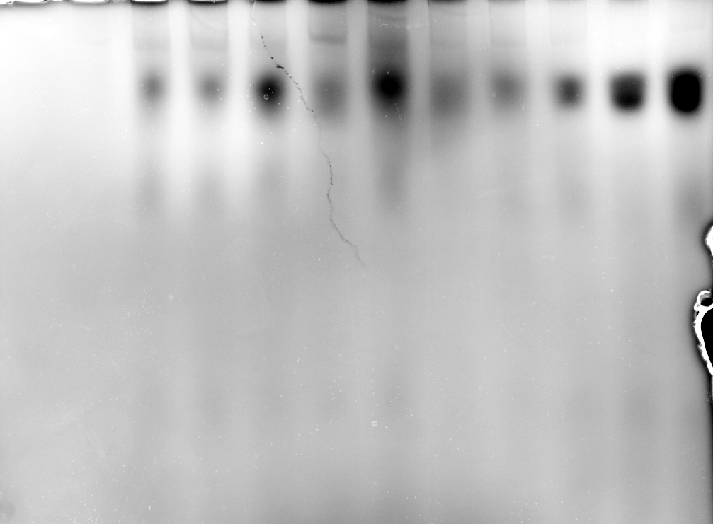

|  |  |  |  |  |  |  |  |  |  |  |  |  |
| --- | --- | --- | --- | --- | --- | --- | --- | --- | --- | --- | --- | --- |
|  | Přímá infiltrace | | | | | | Petiola | | | | | |
| Skupina | **1** | **2** | **3** | **4** | **5** | **6** | | **7** | **8** | **9** | **10** |
| Nekróza |  |  | **+++** | **++** |  |  | |  | **+++** |  |  |
| APX |  |  | **+++** |  | **+++** |  | |  | **+++** | **+++** | **+++** |
|  | **CTRL** | **CTRL** | **Cry** | **Cap** | **SA** | **CTRL** | | **CTRL** | **Cry** | **Cap** | **SA** |