Week 11 GRAPHS AND CHARTS

A picture is worth a thousand words.


This is certainly true when you're presenting and explaining data. Put up a graph or a chart, and suddenly everything you're saying makes sense. Graphs or charts help people understand data quickly. Whether you want to make a comparison, show a relationship, or highlight a trend, they help your audience "see" what you are talking about.
Read more: https://www.mindtools.com/pages/article/Charts_and_Diagrams.htm

1. What are graphs used for in geography?
What information do we have to include when plotting a graph?

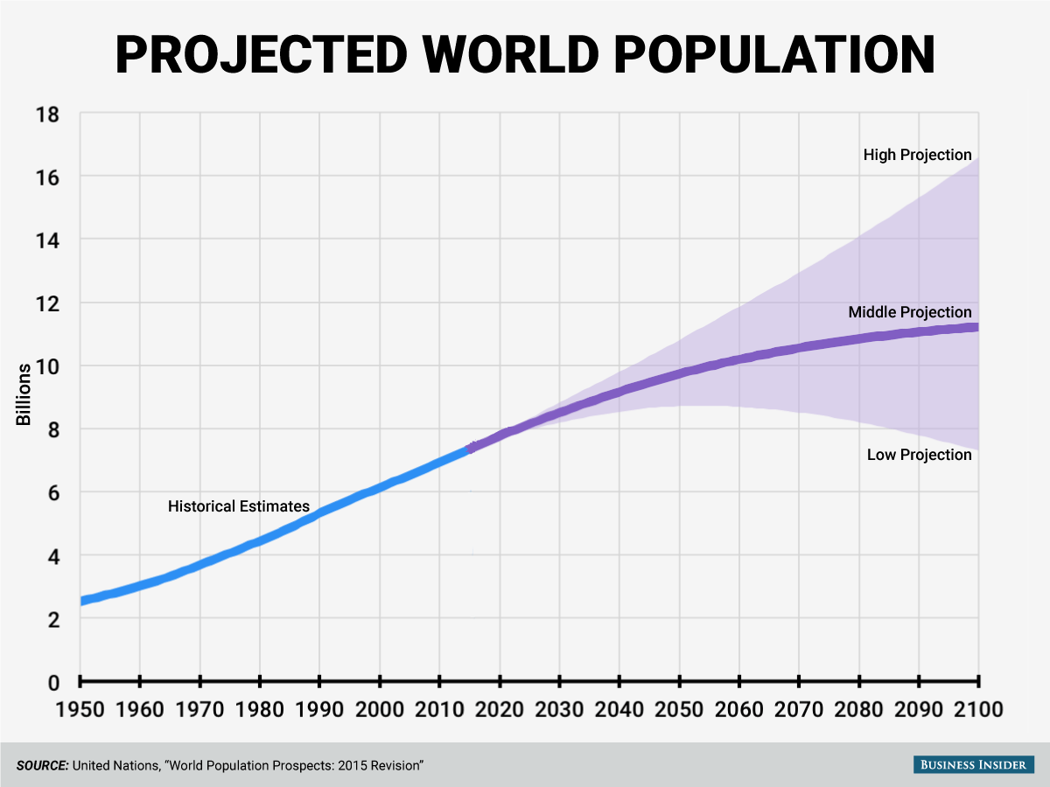

Which of the verbs below are used to refer to graphs?
illustrates shows believes suggests indicates represents states argues reflects

2. Complete the gaps with the verbs below, use the right forms:
range see show remain experience stand decline increase peak
The world population has (1) ___________ continuous growth since the end of the Great Famine and the Black Death in 1350, when it (2) ___________ at around 370 million. The highest rates of growth – global population increases above 1.8% per year – were (3) ___________briefly during the 1950s, and for a longer period during the 1960s and 1970s. The growth rate (4) ____________ at 2.2% in 1963, then (5) ____________ to below 1.1% by 2012. Total annual births were highest in the late 1980s at about 138 million, and are now expected to (6) _________ essentially constant at their 2011 level of 134 million, while deaths number 56 million per year, and are expected to (7) ___________ to 80 million per year by 2040.
Current UN projections (8) ____________ a continued increase in population in the near future (but a steady decline in the population growth rate), with the global population expected to reach between 8.3 and 10.9 billion by 2050. UN Population Division estimates for the year 2150 (9) ___________ between 3.2 and 24.8 billion; mathematical modeling supports the lower estimate. Some analysts have questioned the sustainability of further world population growth, highlighting the growing pressures on the environment, global food supplies, and energy resources. (http://en.wikipedia.org/wiki/World_population)

Now fill in the missing prepositions:
To peak _____ 17% To increase ______ 2% / to increase ________ 2%
To range _______ 4.5 and 5.3 billion / to range ____ A to Z
3. Video Graphs and charts http://www.bbc.co.uk/skillswise/video/graphs-and-charts

- Give examples of three types of graphs
- How are graphs helpful for businesses?

4. Complete the following table supplying the appropriate vocabulary.
VERB | NOUN | ADJECTIVE | ADVERB
RISE |  | SLIGHT
INCREASE |  | SHARP
DECREASE |  | DRAMATIC
IMPROVE |  | STEADY
RECOVER |  | SUDDEN
DROP |  | ABRUPT

5. Match the types of graphs with their representative charts and complete the sentences.
https://support.office.com/en-us/article/Available-chart-types-in-Office-a6187218-807e-4103-9e0a-27cdb19afb90?CorrelationId=75cebd13-9682-4ce3-8257-783efa8aa8e8&ui=en-US&rs=en-US&ad=US&ocmsassetID=HA010342187

1
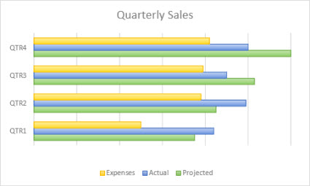
4
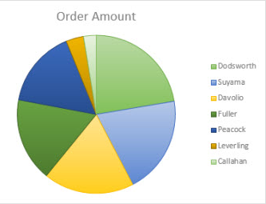

- A doughnut chart
- A line chart
- A pie chart

2
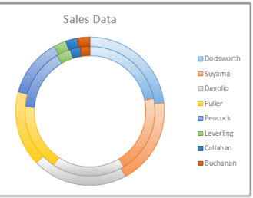

5
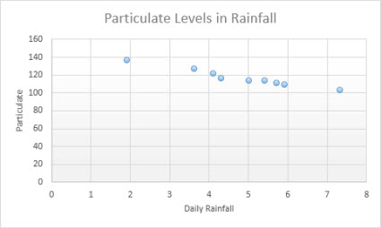

- A bubble chart
- A scatter chart
- A bar chart

3
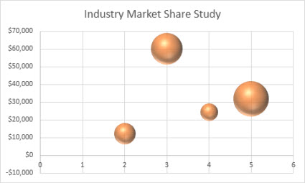

6
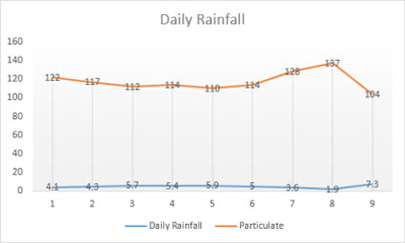

  - …………….. are often a good choice to show comparisons among data
  - You can use …………... to indicate the fluctuation of daily or annual temperatures.
  - …………….. are well suited to show proportion to the sum of items
  - …………… are often a good choice for showing change over time

6. Now transform these sentences using the given word so that they mean the same:

A. There's been a slight decline in sales.
Sales …………………………………….
B. We made a sharp increase in investment.
Investment ………………………………
C. There was an abrupt drop in sales in March.
Sales………………………………………

D. Unfortunately, consumer interest suddenly decreased.
There…………………………………………
E. Profit has been flat over the past two years
There………………………

