TRUE OR FALSE ABOUT YOU?

- When I entered university, I didn‘t know much about geography.
- I came to university thinking ”I want to be a geographer.”
- The study should leave people with questions. / The study should give people answers.
- An important part of university courses should be written and oral communication skills.
- In my bachelor studies, there was a lot of overlap between human geography and physical geography emphasis.
- GIS is fascinating.

California State University, Northridge (CSUN)
http://catalog.csun.edu/about/

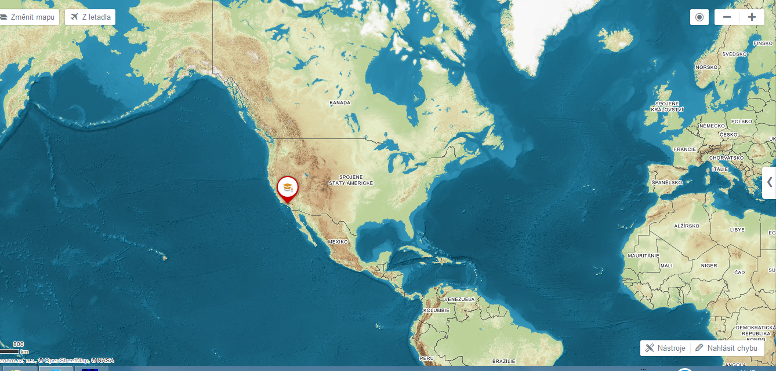

Find out what the professors from the Geography department at CSUN think.
https://www.youtube.com/watch?v=a_h0et9dOyk

VOCABULARY

ARSON RETAIL INTERN RIVER DISCHARGE MAJOR LIGHT BULB

Questions
1 Where can the students find work?
2 What training do they have in crime mapping?
3 What do geographers do for retail companies?
4 Where do the physical geography students intern?
5 The professor’s passions were teaching and travelling but what was his major?
6 ‘Why certain cities are musically innovative?’ From what perspectives did the author look at this question?

Grammar
“I’d already had two degrees, and I was just finishing up an extra class, and I had a class by a brilliant lecturer, and a light bulb came on and I realized I had been studying the wrong thing.”

1 I didn’t know who she was. I ……….. (never see her before)
2 When I last saw him, he ………….. (try to find a job)
3 The house was dirty. They ………. (not clean it for weeks)
4 Ken gave up smoking 2 years ago. He …………(smoke for 30 years)
5 We weren’t hungry. We …………. (just have lunch)
6 He took a photo of me while I ……… (not look)
7 Jane was waiting for me when I ……….. (arrive)
8 We arrived at work in the morning and found out that somebody …. (break into the office)

Pronunciation - Placing stress in compound nouns
Give examples of compound nouns:

Jack and Georgina are university students. They meet on campus. Listen to the dialogue and fill in the gaps using the compound nouns in the box. Then practise the dialogue.

lecture theatre help desk seminar room revision class library card

J: Where are you going? To the 1 ………….. ?
G: No, a 2 …………….. . It’s in 3……………. number six.
J: Oh, right. Hope it’s useful. I’ve lost my 4……………. I’m going to the 5……………… to see if I can get a new one.
G: Good luck. See you later.

