INDUSTRY

1. Warm-up: What is meant by industry?
https://www.vocabulary.com/dictionary/industry
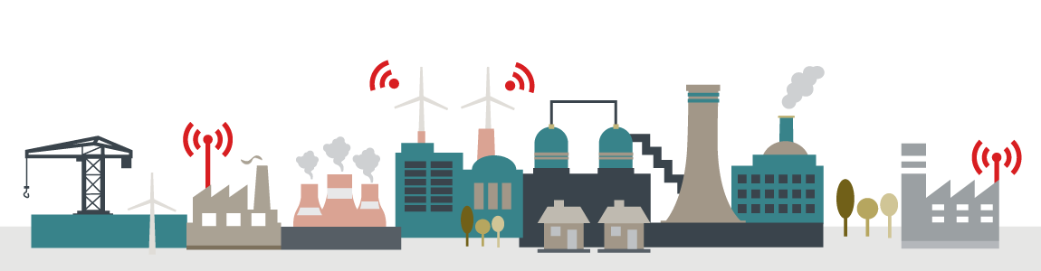

- What is the position of industry in the economy of your country? Which industries play a major role? What part of GDP is made by industry? What percentage of population works in industry?
https://www.cia.gov/library/publications/the-world-factbook/geos/ez.html
- Try predict future of industry in your country. http://www.mpo.cz/dokument177195.html

2. The history of industrialization Knox, Marston: Human Geography, 2007, p.55

Beginning in the late 18th century, a series of technological innovations (in power, transportation and manufacturing) resulted in crucial changes in economic development. The innovations created new demands for natural resources, labour forces and markets. Each technology system dominated economic activity for several decades until improved technologies evolved.

Here are 5 time periods. Decide which innovations and sources of power are relevant for the time.

1790-1840 1840-1890 1890-1950 1950-1990 1990-onward

COAL OIL FUELS WATER POWER SOLAR POWER NUCLEAR POWER

STEAM ENGINE COMBUSTION ENGINE STEEL ELECTRONICS

ELECTRICAL AND HEAVY ENGINEERING RAILROADS AIRCRAFT AEROSPACE

ROBOTICS IRONWORKING RADIO AND TELECOMMUNICATIONS

PETROCHEMICALS MICROELECTRONICS COTTON TEXTILES BIOTECHNOLOGY

- What factors influenced the location of the different industries in the past?

3. Changes in industrial location patterns Adapted from Kelly, Geography – Macmillan, 2013
Read the passage and put each phrase in the most suitable place in the text.

In the past industry was 1………………….. . This was because water wheels were 2…………..…. . Then it changed to coalfield sites as coal was needed for the generation of steam. Nowadays, power can be brought 3……………….. . It can come by electricity cables carried on steel pylons. Because of this industries are no longer tied 4…………………. . New industries are located around towns and cities rather than 5…………………… or being clustered around coalfields. Modern transport facilities are available in these places. These new industries are called footloose, and this change has made 6…………………….. than before. It has brought 7………………….. and to areas of high emigration.

A the source of power less important
B rotated by fast-moving streams
C forming a linear pattern along rivers
D tied to waterside locations
E industry to rural towns
F to the old, traditional locations
G to sites that industry prefers

- What industry is there in your hometown / your region?
- Which factors have influenced the location of this industry here?

4. Differences between light and heavy industries K. Kelly, Geography – Macmillan Vocabulary Practice, 2013
Make a comparison of light and heavy industries considering the following aspects:

demand for space heavy / bulky / light raw materials environmentally friendly

distance from residential areas heavy / bulky / light products

Vocabulary – complete the missing words. There are three of them which will not be used.
K. Kelly, Geography – Macmillan Vocabulary Practice, 2013, p.151

basically brewing markets salaries growing availability ability generally silk leather flour

The food and drink industries are part of what is known as the light industry sector of the secondary economy. 1………… speaking, these areas of the economy are located in many different places. They are influenced by factors such as 2…………, transport, labour and the accessibility of raw materials. The food and drink industry includes 3………… production, oil production, the sugar industry, meat industry, wine and 4………… and also the food processing and canning industry. Another light industry is the textile industry, producing clothing, footwear and 5………… goods. Textile industries are largely dependent on raw materials and the 6………… of labour. Branches of textile industry include wool production, the cotton, 7…………, linen and the carpet industry. These industries have moved from areas where 8………… are high to areas with plenty of cheap labour such as China and India.

COMPANY LOCATION – Facebook Data Centre
Adapted from http://www.i-study.co.uk/igcsegeography/industry.html

Look at the map of the US. You will get information about Facebook company. Where do you think their main offices and their data centres are?

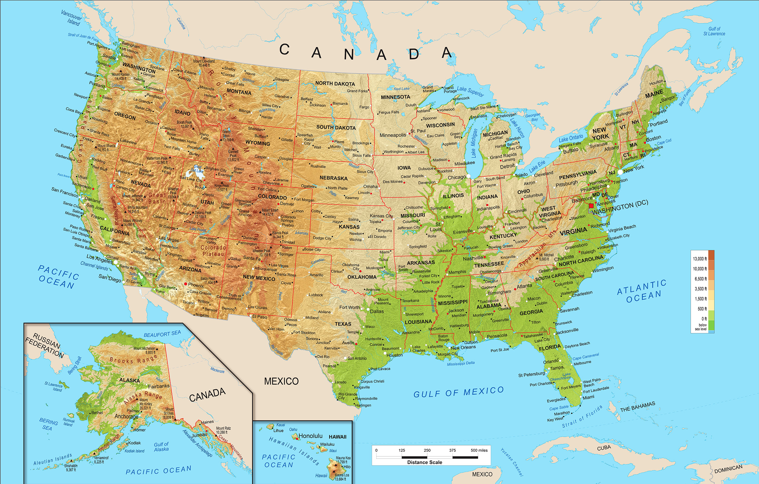

Watch the report about Facebook, Inc. and answer the questions. 0.50 – 3.20
https://www.youtube.com/watch?v=Y8Rgje94iI0&feature=player_embedded

- How much time did it take the corporation to achieve the big market value?
- What equipment is there to entertain the staff?
- What is the average age of the employees?
- How quickly has the number of users been growing?
- How many users does one engineer look after?
- What is the area occupied by the Oregon data centre?

Watch another part to find out why Oregon is a suitable location. 5.00 –5.46

READING
Facebook moves into the Arctic Circle Read the text and then explain the reasons why.

Facebook have their main offices in California. The key inputs being highly skilled labour. California is home to many other high-tech firms and Stanford University which are both sources of highly skilled workers. The environment and urban areas are also desirable to live.
Their data centers are located far away though.

Just south of the Arctic Circle, in the Swedish town of Luleå, Facebook in June opened its latest mega-sized data center, a giant building that comprises thousands of rectangular metal panels and looks like a wayward spaceship. By all public measures, it’s the most energy-efficient computing facility ever built, a colossus that helps Facebook process 350 million photographs, 4.5 billion “likes,” and 10 billion messages a day. While an average data center needs 3 watts of energy for power and cooling to produce 1 watt for computing, the Luleå facility runs nearly three times cleaner, at a ratio of 1.04 to 1.

The location has a lot to do with the system’s efficiency. Sweden has a vast supply of cheap, reliable power produced by its network of hydroelectric dams. Just as important, Facebook has engineered its data center to turn the frigid Swedish climate to its advantage. Instead of relying on enormous air-conditioning units and power systems to cool its tens of thousands of computers, Facebook allows the outside air to enter the building and wash over its servers, after the building’s filters clean it and misters adjust its humidity. Unlike a conventional, warehouse-style server farm, the whole structure functions as one big device.

The next one will go online in Iowa, where cheap wind power is plentiful.

Adapted from source http://www.bloomberg.com/news/articles/2013-10-04/facebooks-new-data-center-in-sweden-puts-the-heat-on-hardware-makers

LANGUAGE WORK
- Find examples of collocations in the text above. A collocation is for example: vending machine.

- Once more look at the text and identify compound adjectives. For example: mega-sized
(composed of 2 words)

PRONUNCIATION

A student is describing life at his university. The compound adjectives are in bold. Listen and identify where the stress is put.

I like it here. The tutors are open-mined and easy-going. One or two of them are world-famous. I have to do a thousand-word essay every fortnight and there is an end-of-year exam. The campus-based accommodation is very good, although it is not cheap. Internet connection is provided, and there is a user-friendly student intranet. The town is densely-populated and has lots of nightlife. Life is worry-free here.
I must go now – I’ve got an hour-long seminar to prepare for.

- Read the passage aloud, putting the stress in the correct places.

3. Think of someone you know. Using the adjectives below, make sentences about him / her, changing the position of the adjective.

well-mannered smartly-dressed fair-minded easy-going quick-thinking good-looking well-travelled warm-hearted good-humoured sports-mad

Sample comparison (Kelly, p. 154) Notice the language for comparing, connecting and exemplifying.
Heavy industries use heavy, bulky goods to manufacture heavy products whereas light industries use lighter raw materials to make lighter products. Steel, which is heavy is used to make heavy ships. On the other hand, textiles, such as clothes, are made from light materials like cotton and synthetic fibres. Heavy industries also need large sites for manufacturing, holding raw materials, waste treatment plants and storage of goods. Light industries do not demand as much space as heavy industries. Generally, they are more environmentally friendly and so are often planned near to residential areas for access to a labour supply. Heavy industries are not people-friendly and so are planned far from residential areas.

