Week 6 TRANSPORTATION

1. Warm-up: Which ideas do you associate with these expressions?

Transport
Traffic

Infrastructure

- Vehicles or pedestrians in transit.
- A way of getting from place to place.
- Systems and facilities serving a country, city, or area.
- Any device used to move an item from one location to another.
- To move or carry (goods, for example) from one place to another.
- The passage of people or vehicles along routes of transportation.
- The business of moving passengers and cargo through a transportation system.
- The basic facilities needed for the functioning of a community, such as transportation and communications systems, water and power lines, and public institutions.

2. OPINIONS
Which phrases are used to introduce personal opinion and impersonal opinion?

In my opinion
It should be noted that
It is claimed that
As far as I’m concerned
Reports reveal that
Personally, I’m certain
A general assertion is
Predictions suggest that

The suggestions below offer possible solutions to traffic congestion problems.
What do you think about them? Which is the best and why?
Based on http://www.bbc.com/future/story/20140611-can-we-ever-end-traffic-jams, prepared by J. Kubricka

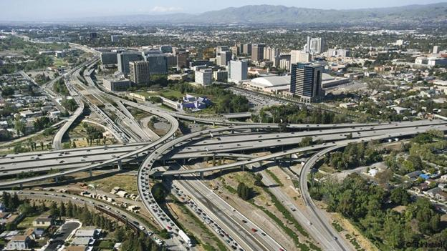

The traditional way to ease congestion has been to build more and wider roads; but this only seems to attract more and more drivers

- a guiding system with smart sensors which indicate whether a spot is occupied or empty (San Francisco, Los Angeles, Moscow)
- wireless vehicle-to-vehicle communication, your car may monitor the motion of a vehicle five vehicles ahead and prepare for what is going to happen
- smartphone app which works like a social network for drivers
- motivating people to travel in off-peak hours (Singapore, London)
- a driverless car, automated driving in cities allows for much denser packing of cars in streets
- a great public transport system with extra bus lanes, nicer train stations and on-board wi-fi
- use of waterways “as an infrastructural resource for public transport“ (Vancouver, Istambul)

3. COMPARING CHARACTERISTICS OF TRANSPORT SYSTEMS

Which system is 1. relatively environmentally friendly? Give reasons for your answers.
2. suitable for bulky cargo?
3. the fastest?
4. independent of weather conditions?
5. most affected by congestion?

 | CANALS, RIVERS | OCEANS | RAIL | ROAD | AIR | PIPELINES
WEATHER  PROBLEMS | - can freeze.  Drought /heavy rains make rivers unnavigable. | Storms, fog, icebergs. | Heavy snow blocks lines. Heavy rain – landslides. | Fog, ice, snow, cross-winds.  Sun – dazzles. | Fog, icing, snow.  Airports better if sheltered from wind.
RELIEF  FACTORS | Width of channels. Need of flat land / gentle gradient. Discharge - constant. | Harbours need to be deep, wide, sheltered. |  | Avoids/ takes detours around high land. Valleys may flood. | Needs large areas of flat land or land needs reclamation. | Difficult to lay.
SPEED | Slowest.  Possible delays at locks. |  | Fast over medium-length distances. | Fast over short distances. Urban delays. | Fastest over long distances. | Very fast as continuous flow.
GOODS/  PASSENGERS |  | Heavy, bulky, non-perishable, low-value goods. Cruisers. | Heavy, bulky and rapid goods. Large numbers of passengers. |  | Mainly passengers. Freight is light, perishable or high-value. | Bulk liquid (oil, gas, slurry, water)
CONGESTION | Very little. | Very little. | On commuter trains. | In urban areas, and at holiday times. |  | None.
ENVIRON-MENT | Some oil discharged, but few problems. |  | Noise and visual pollution. | Major noise and air pollution. Uses up farmland.  Vibrations. | High noise levels. Air pollution. Much land for airports. | Leakage when disrupted.
Adapted from D. Waugh, Geography, An Integrated Approach, 2002, p.605

Glossary
shelter chránit
negotiate překonat
gradient stoupání
haulage přeprava zboží
navigable splavný

detour objížďka
reclamation rekultivace, opětovné využití
lock zdymadlo, plavební komora
freight přepravované zboží, náklad
economical úsporný

bulk velký objem
slurry tekutý cement
leakage unikání
cruise výletní plavba
discharge průtok

Which types of transport are the statements related to? Put them in the right place in the table above. 1. Perishable, smaller loads by lorry. Few people in one vehicle.
2. Tankers discharging oil. Much land for ports, warehouses.
3. Cannot negotiate steep gradients so avoids hills.
4. Only at peak holiday times.
5. Not greatly affected.
6. Slow, yet most economical.
7. Heavy, bulky, non-perishable, low-value goods. Tourists.
4. AIRPORT INNOVATIONS

Which airports you have been to? Were they very different from each other?

You will listen to a presentation about airport innovations in which three names of airports are mentioned:
Kai Tak – old airport in Hong Kong
Chek Lap Kok – new airport in Hong Kong
Heathrow - London

Speakers in presentations need to comment on slides. They use phrases which address listeners, attract attention and make it easier to understand the information.

So, let’s look first at …
On the right-hand side you can see…
…is in the bottom half, to the south.
…here on the left of the slide, off the north coast of the island.
…in the center of the map
…at the top of the slide

A) Use the phrases to complete the comment on this slide showing Hong Kong airport

A in the top right hand corner
B at the top of the slide
C on the opposite side
D on the north-west side
E to the south
F in the center of the slide

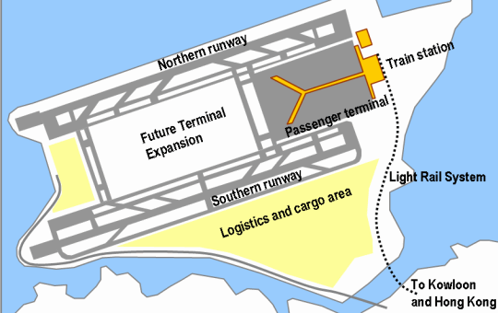

As you can see 1_________ , in Hong Kong International Airport, the northern runway is situated 2_________ of the island of Chek Lap Kok. 3_________ is the southern runway, while 4_________ of that is the logistic and cargo area. The train station is located 5_________ of the island, and if you look here 6_________ , there is a large area designated for expansion.

Source E.deChazal, L. Rogers: Oxford EAP B1+, OUP, 2013, p107
Key to 4A) 1B 2D 3C 4E 5A 6F
B) Watch the 1st part of the presentation about Hong Kong airport.
- What reasons for innovation were there?
- Why was the old airport risky?
- What kind of construction work was needed?
- How long did the building last?

Watch the 2nd part.
- Which parts are there on the plan of the new airport?
- What is the role of the airport in 2010?
- What reason for innovation were there in Heathrow?
- Where is Heathrow located?
- How did its size develop during the time?
- Give an example of innovative techniques from Terminal 5.

C) Are there any plans for transport innovations in your city (country)? What are the reasons, problems, possibilities…?

