Beddington Zero Energy Development https://en.wikipedia.org/wiki/BedZED

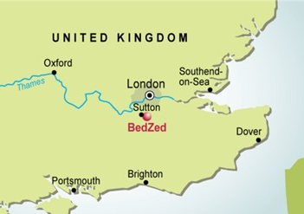
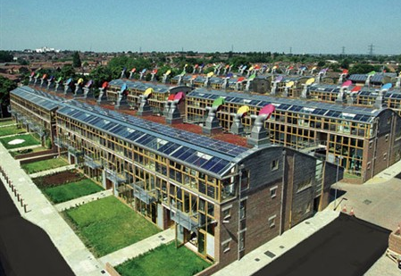

PRINCIPLES
- Zero energy—The project is designed to use only energy from renewable sources generated on site. There are 777 square metres of solar panels. Tree waste fuels the development's cogeneration plant (downdraft gasifier) to provide district heating and electricity. The gasifier is not being used, because of technical implementation problems, though the technology has been and is being used successfully at other sites.
- High quality—The apartments are finished to a high standard to attract the urban professional.
- Energy efficient—The houses face south to take advantage of solar gain, are triple glazed, and have high thermal insulation.
- Water efficient—Most rain water falling on the site is collected and reused. Appliances are chosen to be water-efficient and use recycled water when possible.
- cars are discouraged; the project encourages public transport, cycling, and walking, and has limited parking space. There are good rail and bus links in the immediate area. They also have a car-share scheme.

PERFORMANCE
Monitoring conducted in 2003 found that BedZED had achieved these reductions in comparison to UK averages:
- Space-heating requirements were 88% less.
- Hot-water consumption was 57% less.
- The electrical power used, at 3 kilowatt hours per person per day, was 25% less than the UK average; 11% of this was produced by solar panels.[3] The remainder normally would be produced by a combined-heat-and-power plant fuelled by wood chips, but the installation company's financial problems have delayed use of the plant.
- Mains-water consumption has been reduced by 50%, or 67% compared to a power-shower household.
- The residents' car mileage is 65% less.

PROBLEMS
A review of the BedZed development in 2010 drew mainly positive conclusions. Residents and neighbours were largely happy. However, a few significant failures were highlighted, for example:
- The biomass wood chip boiler (biomass gasifier) was no longer in operation and the backup power source, a gas boiler, was now used. The downdraft wood chip gasifier CHP (combined heat and power) had reliability problems due to technical problems and the intermittent schedule of operation (no late-night operation) imposed by the local authority.
- The 'Living Machine' water recycling facility had been unable to clean the water sufficiently. The cost of the facility also made it unviable.
- Passive heating from the sunspaces had been insufficient.
- Despite best efforts, residents were on average still leaving an ecological footprint of 1.7 planets, which is more than the target of 1.0 planet (but much less than the UK average of 3 planets).

Slum Dwellers International
https://www.youtube.com/watch?v=vxJsgOF8CIc

Key methodologies and outcomes
SDI claims that it makes partnerships work – partnerships between communities, partnerships with Government and with other stakeholders. SDI makes every effort to ensure that the poor themselves are at the centre of urban poverty eradication strategies and actions. After 21 years SDI has a proud record of securing tenure for hundreds of thousands of its members, providing incremental housing solutions and contributing to infrastructure delivery, especially water and sanitation, in thousands of slums. It has formalized relationships between organized communities of the urban poor and Governments and ensured, as its South African partner alliance puts it, that "no development takes place for us without us being directly involved"

Savings
Each day groups of women in slum neighborhoods and settlements walk from home to home, and gather small change from each other in order to collectively address the livelihood struggles they share. Through daily interactions, and weekly community gatherings, savings group members begin to articulate what problems exist within their community, creating a sense of shared identity for the women of urban poor communities. Whilst SDI does not exclude men, the reality is that the savings groups are mainly women. Women are often at the center of the household – responsible for the provision of food, school fees, clean water, and a place to sleep. By targeting the poorest women in a settlement, one can be sure that the settlement’s most vital needs will be addressed. Additionally, the structure of savings groups allows members to access short-term loans, which are otherwise largely unavailable to the urban poor. This system of savings & credit prepares communities for medium and large-scale financial management necessary in the slum upgrading projects they are likely to pursuit.

Enumerations and mapping
Community planning activities build political capital for communities both internally and externally. Within communities, activities like enumeration (household-to-household socio-economic surveys) and mapping create space for communities to: identify developmental priorities, organize leadership, expose and mediate grievances between segments of the community, and cohere around future planning. Such activities serve as a platform for engagement with governments and other stakeholders involved in planning and setting policy for development in urban centres. A key aspect of community planning activities is that communities own the information they collect. When they share the data with government, they are able to create new relationships — and even institutions — that make the poor integral role players in the decisions that affect their lives.
There is not, and never will be, a one-size-fits-all approach to upgrading of informal settlements. Each settlement is unique in its challenges, but there are common themes. Informal settlement upgrading is not simply “site and service” or the provision of a “top structure” house. Upgrading is any intervention that improves the physical conditions of a settlement, which in turn enhances the lives of its inhabitants.

