**Synthesis of Molecular Precursors of Phosphates and Oxides of Metals and their Processing into Materials**

**Ján Podhorský**

The usage of phosphate materials as a catalysts and sorbents is well known and well documented. We have focused on preparation of porous phosphate materials of aluminium, using non-hydrolytic sol-gel methods. Reactions of chosen trialkylesters of phosphoric acid (RO)3PO (R = Me, Et, *i*Pr, *n*Bu) with EtAlCl2 were used. Reaction pathway, reagent ratio, reaction and processing conditions were carefully investigated. Using our reaction route and optimizing the processing, we have obtained obtained amorphous aluminophosphate xerogels with surface area (BET) up to 400–500 m2 g–1 provided by small mesopores (2–8 nm).

Thin metaloxide layers have found their applications in various dielectrical and optical coatings. Our work focused on precursors for MOCVD, containing volatility-increasing –CF3 group. We used N,O–β heteroarylalketonates as ligands (3,3,3-trifluoro(pyridin-2-yl)propen-2-ol (PyTFPH)), 3,3,3-trifluoro(dimethyl-1,3-oxazol-2-yl)propen-2-ol (DMOTFP) and 3,3,3-trifluoro(1,3-benzthiazol-2-yl)propen-2-ol (BTTFP)), as well as certain aliphatic alcohols containing –CF3 group (2,2,2-trifluoroethanol (TFEH) and 1,1,1,3,3,3-hexafluoro-2-propanol (HFPH)). The source of metal was either R2AlCl for aluminium, or Sn(O*t*Bu)4 for tin, respectively. The number of novel obtained structures was obtained. The properties of our metallorganic complexes were determined, particularly using TG/DSC analysis, their volatility was investigated.

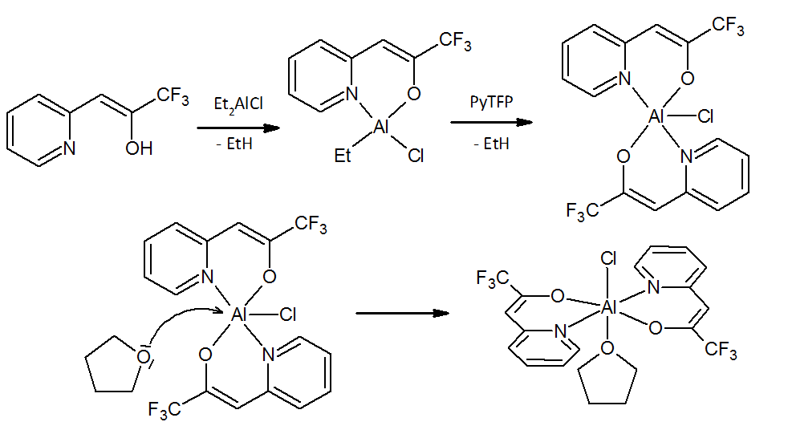

Figure 1: Reaction pathway of Et2AlCl with PyTFPH in THF as coordinating solvent