**Laser/Plasma Assisted Synthesis of Gold-Iron Nanoparticles and Laser Desorption Ionisation for Generation of Au*m*Fe*n+/-* (*m* = 1-35; *n* = 1-3) Clusters**

Ravi Madhukar Mawale1, Mayuri Vilas Ausekar1, David Pavliňák2, Oleksandr Galmiz2, Pavel Kubáček1, Josef Havel1,2,3,

*1Department of Chemistry, Faculty of Science, Masaryk University, Kampus Bohunice, Kamenice 5/A14, 625 00 Brno, Czech Republic, e-mail: 431548@mail.muni.cz*

*2Department of Physical Electronics, Faculty of Science, Masaryk University, Kotlářská 2, 611 37 Brno, Czech Republic, e-mail: havel@chemi.muni.cz*

*3CEPLANT, R&D Center for Low-cost Plasma and Nanotechnology Surface Modifications, Masaryk University, Kotlářská 2, 611 37 Brno, Czech Republic*

Gold-iron or gold-iron oxide nano-particles (NPs) are of particular importance because of their bio diagnostic and medicinal applications. Applying either plasma (8.3 kHz) or electrochemically we produced a kind of Au-Fe nano-composite, in case of plasma a giant gold nano-flowers (1-2 000 nm). The product was analysed by EDX and SEM. Mass spectrometry with LDI (laser 337 nm) yields single charged Au*m*Fe*n*± (*m* = 1-35; *n* = 1-3) clusters. Structures of clusters in neutral and mono-charged forms were designed by DFT calculations (ADF; scalar relativistic ZORA geometry optimization). The structures in local minima of potential energy surface always have Fe atoms coordinated to several Au atoms (most often to 4 to 6) and possess few odd electrons (4 to 9). The distances of a Fe nucleus from adjacent Au nuclei lie in the interval 2.5 – 2.7 Å.

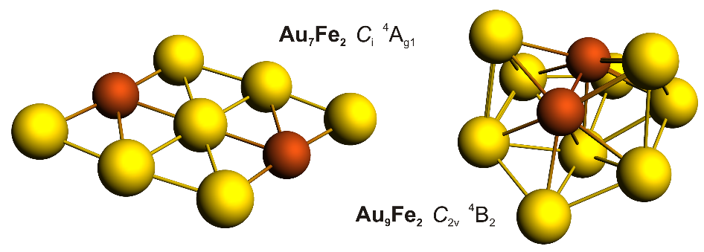

References:

1] Ravi Madhukar Mawale, Mayuri Vilas Ausekar, David Pavliňák, Oleksandr Galmiz, Pavel Kubáček, Josef Havel, Laser Desorption Ionization Quadrupole Ion Trap Time-of-Flight Mass Spectrometry of Au*m*Fe*n*+/- Clusters Generated from Gold-Iron Nanoparticles and their Giant Nanoflowers. Electrochemical and/or Plasma Assisted Synthesis. J. Am. Soc. Mass Spectrom. (2016).

Acknowledgements:

This project was funded with support from the Grant Agency of the Czech Republic (Project No.13-05082S). This research was also supported by the project R&D Centre for Low-Cost Plasma and Nanotechnology Surface Modifications CZ.1.05/2.1.00/03.0086 funding by the European Regional Development Fund. This research has been supported by the project LO1411 (NPU I) funded by Ministry of Education Youth and Sports of Czech Republic.