**Preparation and characterization of new bioinspired molecules for organic electronics**

**Jan Richtár**

**Brno University of Technology, Faculty of Chemistry**

In the present proposal we consider naturally occurring organic nitrogen-rich materials, as a promising environmentally friendly electron-transporting materials for organic-electronic devices.

Our attention is focused on the synthesis of the pyrazine type of molecules depicted on picture 1. The new pyrazine approach consists of two different building blocks (R, A) arranged in original manner. Part A represents the strong electron-withdrawing diimide functional groups. Their highly extended π-conjugated structure produce strong π−π intermolecular interaction, and the controllable physicochemical properties by introducing a variety of alkyl chains on the N-position in diimide group [1]. On the other hand, R represents more sophisticated construction of aromatic and heteroaromatic fragments for increasing the electron-accepting abilities through expansion of π-system. In order to ensure the delicious tailoring of desired molecules, fragment R can be modified by polyaromatic and polyheteroaromatic compounds containing electron-donating as well as electron-withdrawing groups.

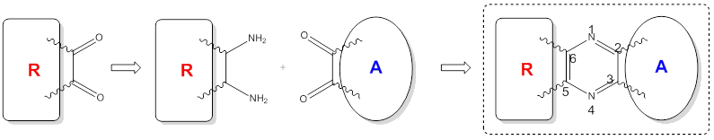

Picture 1: Scheme of the synthesis of the target compounds. Central ring represent the pyrazine building block. A – electron-accepting diimide moiety. R – aromatic and heteroaromatic fragments.

Novel bioinspired-materials topic spreads the wide experience of our multidisciplinary team on the field of preparation and characterization of smart organic systems [2,3].

References:

[1] Vasimalla S.; et al. *Chem. Mater.* **2014**, 26, 4030-4037.

[2] Krajčovič J.; et al. *Journal of Luminescence* **2015**, 167, 222-226.

[3] Krajčovič, J.; et al. *Journal of Luminescence* **2016**, 2016, 175, 94-99.